Creating a Line Item for an Asset
*Asset > is a required field in which you must select Yes or No from the dropdown menu. For transactions with multiple line items you may do this at the header level in the transaction or
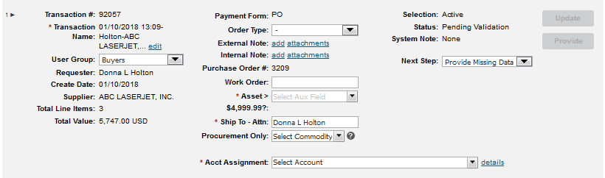
you may do it on each individual line item.
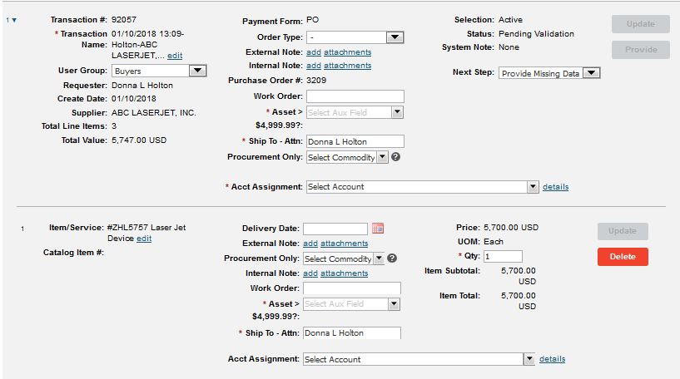
Once you have answered the asset question whether it was at the header level or line item level, go to Details at the end of the Acct Assignment box to enter the fund and GL Code.

Enter the fund number in the Fund box and the GL Code in the General Ledger box >> in the top right corner of box click on UPDATE & then click on APPLY. For equipment with a value of $1,500.00 - $4,999.99 use GL Code 439400. For equipment with a value of $5,000.00 or more use GL Code 461200.
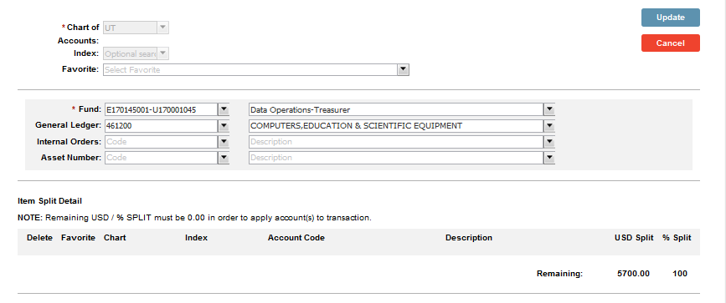
When you are ready to pay the invoice in IRIS using MIR7, in the PO Reference section at the bottom of the MIR7 screen, select the Acct Assgt box for the asset line item you are paying for.
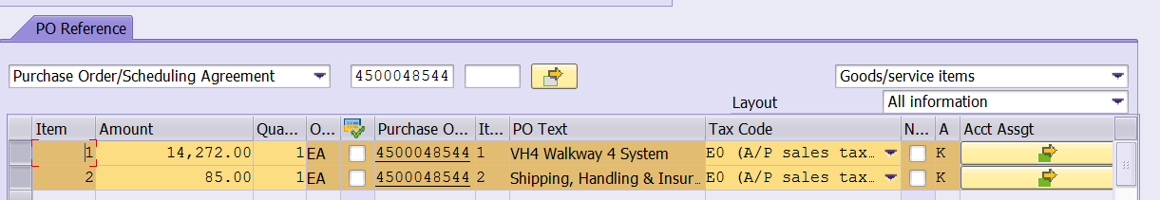

Take out all information (GL Code, Cost Center, Fund) except for the dollar amount on that account assignment line >> enter the asset number in the Asset Column >> Click on Check >> click on Back.
