Change Orders/PO Amendments

See FI0405’s section on “change orders”

Step 1: Obtain proper documentation from the department and supplier, verifying the change.

Step 2: Revise the SAP/IRIS PO to ensure that you (1) reflect the change for audit purposes, and (2) allow the department to pay their invoices, by following these steps:

- Make appropriate changes in the “Header Text Before Line Items” field.
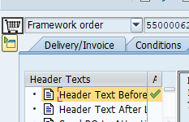

Wording for header text
- Choose one
  - FO – Notice of Modification
  - Reg. PO – Amendment #
- State summary of change (i.e. Adding item #’s, changing item # to read)
- If changing an item I include - Did read:
- State reason for change

- Change the dates, as needed.

- Change line-items, as needed.

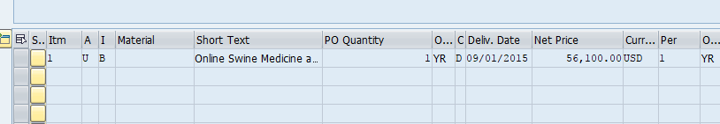

Step 3: Reissue the revised PO.

If you use the ESM PO, you will need to make appropriate revisions to that PO, also.

Step 4: Attach appropriate documentation and the revised PO to the PO attachments area in SAP/IRIS.

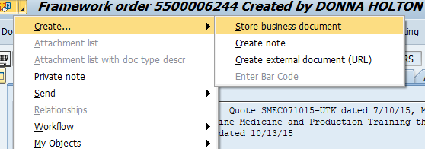

Optional Step:

SAP has a field where SAP will allow you to print only the changes you’ve made to the PO. If you use this optional field, you must still change the dates, line-items, etc., as needed. And, you must attach a copy of the revised PO in SAP as an attachment.

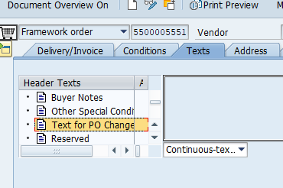
The “text for PO changes” field is a text-only field (does not change line-item descriptions, quantities, or pricing, etc.). You might consider using this field when you want to issue an amendment/change order that only includes text related to the PO changes.

