Framework Order Renewals Report in IRIS

The ESM Purchasing Agreement system will send you an email when you have an agreement that is reaching the end of its term. These notices arrive 90 days before expiration. It is suggested to also run a report in IRIS to make sure you have captured all of your expiring agreements. Occasionally, ESM does not pick up all agreements so it is important to run this report in addition.
IRIS Transaction: ZME_FO_EXP_DT
Fill out the date range you want to run your report for.
Enter your buyer number to pull only your own agreements or enter the plant number to pull all agreements for a particular campus.
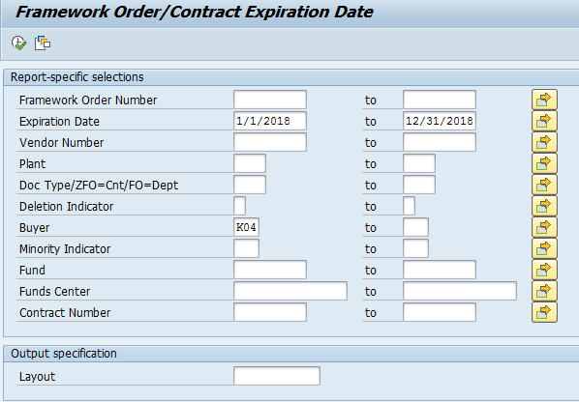

You can export this to excel by choosing “spreadsheet.”

