Looking Up Master Agreements
Access this through the contract system

Click on the Contracts table. This will pull up all contracts in the right hand side of your screen.
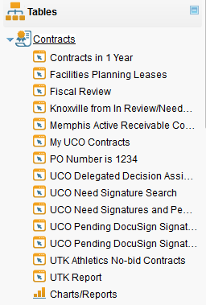

In the search bar, select Contract Category → Equals → UT system-wide master agreements
