PO Website Instructions

Viewing purchase orders

Logging In
- Go to https://apps.tennessee.edu/apex/f?p=112
- Enter your netID and password and click Log In
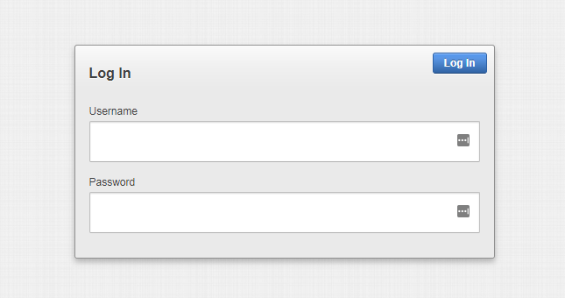

Searching & Filtering
- You can search by keyword, which can be supplier name, category, etc. Enter your keyword in the search box and click Go.
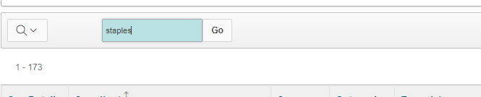

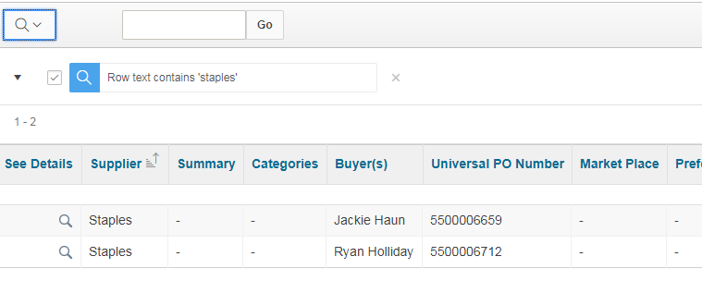
- To see details about a PO, click the magnifying glass next to the supplier name. The detail page for the PO will open.
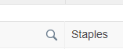
- Documents for the PO are linked at the bottom of the page, and will be in two cells: the title is to the left of the “Download” link.
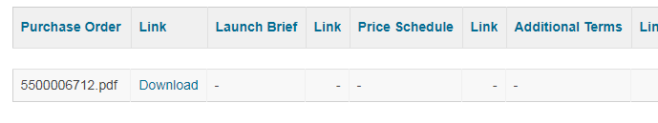

Editing purchase order entries
- On the main page, click the “Buyers >>” button
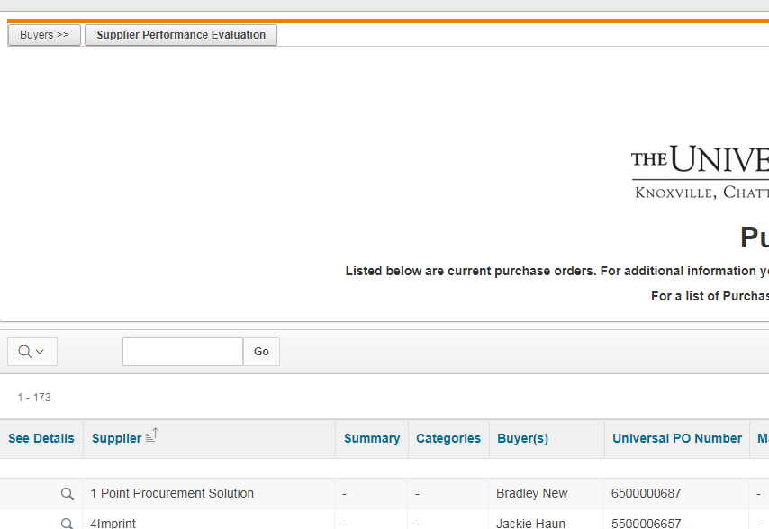

- Click the pencil icon to the left of the PO you want to edit
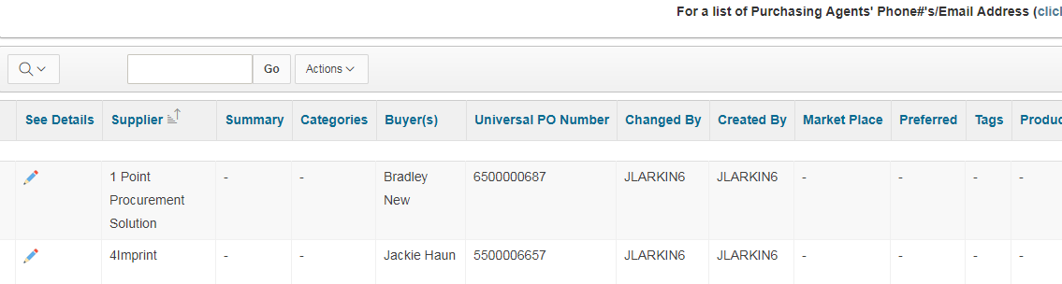

- Upload the correct documents as needed – you can include the PO, price documentation, order form templates, etc, and any other documents related to the PO.
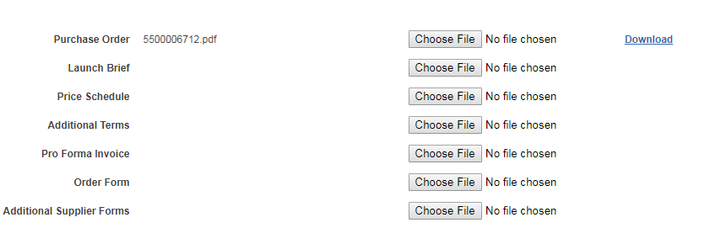
- Use the checkboxes to select the appropriate categories for the PO. You can select as many as apply.
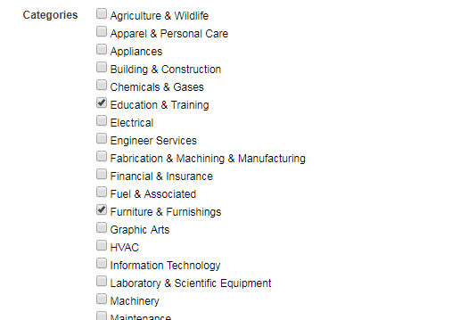
- Type “Preferred” or “Market Place” if the supplier is preferred or a Market Place supplier.
- Complete the remaining fields as applicable.

- For Supplier’s Website, if the supplier is a Market Place supplier, just type “Market Place” instead of entering the actual website, to avoid end users creating accounts outside the Market Place.

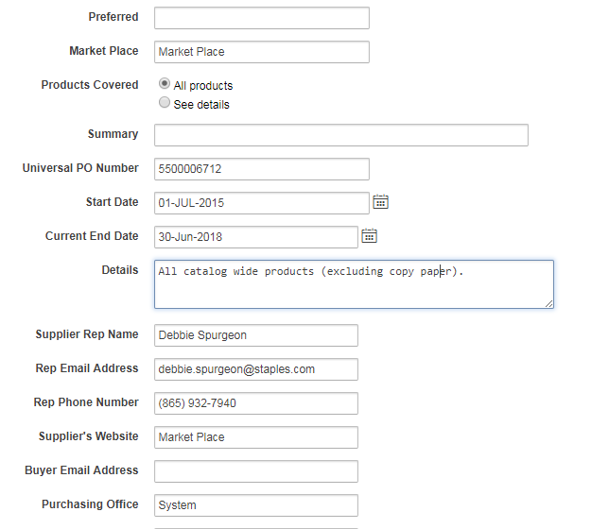
- When you are finished updating, click Apply Changes
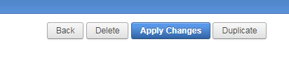

Adding new purchase orders
- Click the “Buyers>>” button
- Click “Create”
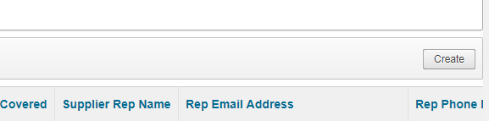
- Complete the information as described in the instructions for editing an entry, and click “Create” when you’re finished.

