Purchasing Agreement System (Renewals)
This system is for the purpose of tracking renewable purchase agreements. Framework purchase orders are brought over from IRIS to the ESM Purchase Agreement system every night. These can be accessed through Purchasing Folders.
You can search by:
- All PAs which will show all campuses’ agreements
- My Department PAs which shows only the PAs for your specific campus/budget entities
- Or My PAs which restricts the view to only your agreements.
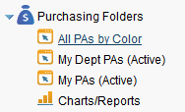

You will notice that your purchase agreements will show up in different colors.
- Red means the current agreement end date has passed
- Blue means the agreement will be expiring soon
- Black means that the agreement is currently active and not about to expire
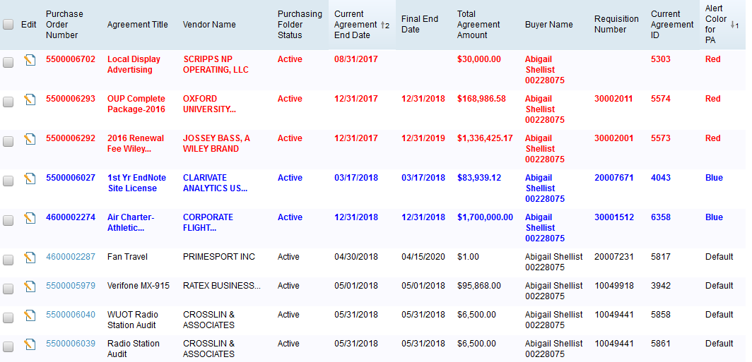

General Tab
Click on the edit icon next to the PO number you would like to edit.
This brings you to the General information tab. All of the fields marked with a red asterisk are required fields.
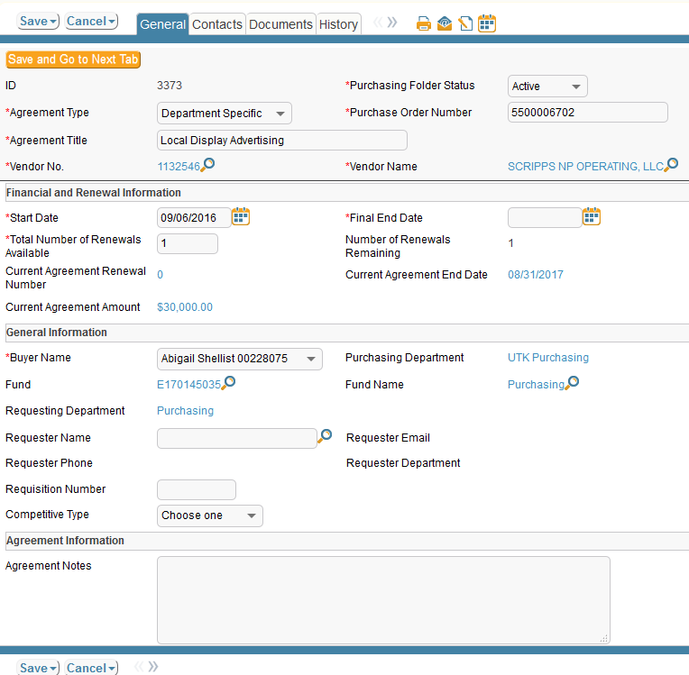

The top portion of the screen has a gray background and this information will appear on every tab you select as the “header” information.
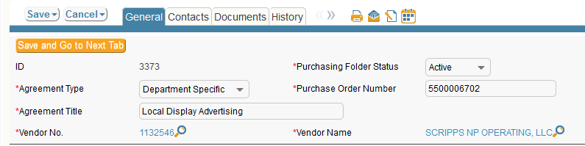
- Choose the Purchasing Folder Status
- Choose the Agreement Type

- Name the Agreement Title
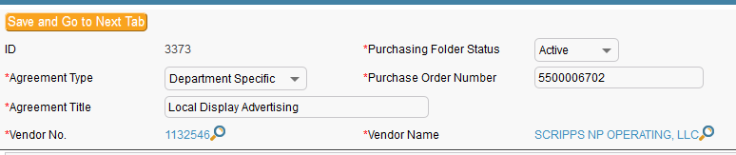

Financial and Renewal Information
In this section, you will need to enter the following
- start date
- final end date
- The total number of renewals
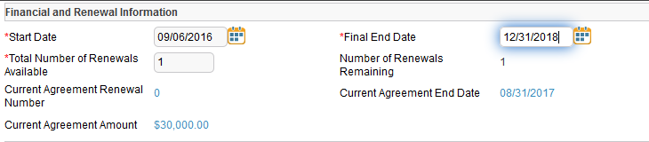

General Information
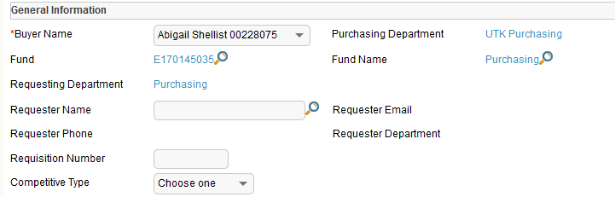

In this section you can add the name of the requester. Once you put this information in, the email, phone, and department will auto populate.
You can begin typing a name into the requester name field or you can click on the magnifying glass.
Typing into the field:

Using the magnifying glass:
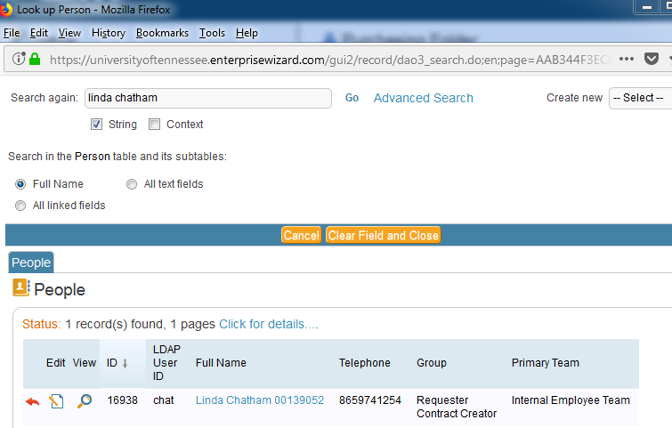

You will see Linda’s name shows up in the People section. Click on the red arrow to import Linda into the record.
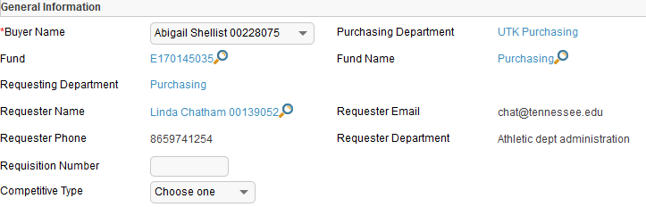

Competitive Type
You can now select the competitive type

Agreement Notes
In this field, you can put any relevant notes.
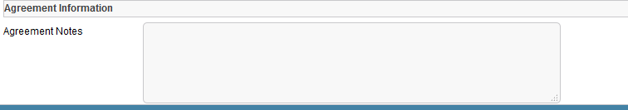

Contacts Tab
The information in the Vendor Company fields auto populates based on the vendor number associated with the purchase order.
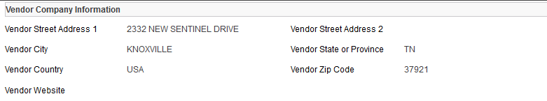
You are able to change the vendor number on the agreement but please remember it has to match the vendor number in the actual PO.

Vendor Contacts
If you already had a vendor contact added to this purchasing folder, you would see it in this field. If there is no vendor contact here, you can use the magnifying glass icon to search records for the contact. In this case I clicked on the search (magnifying glass) and all contacts currently associated with this vendor number popped up.
I see the contact I want to add, so I click on the status box next to her name and click Import/Replace.

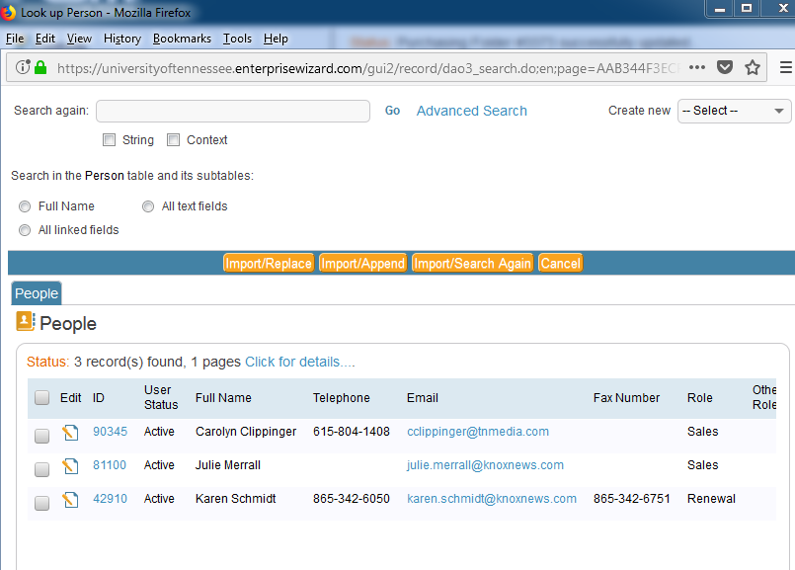
Now she is showing up in the vendor contacts field.
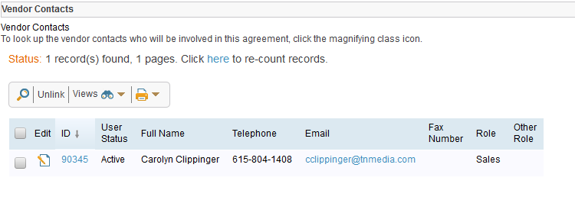
If there had been no record of the person I wanted to add, I would use the Add Vendor Contact section to fill out the required information and then I would click Add Vendor Contact.
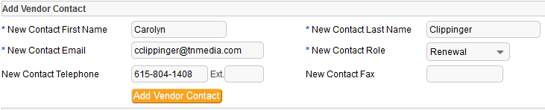

Renewal Contact Information
This field is partially populated with the information you entered in the requester name field in the general tab. Here you may change the department contact by clicking on the magnifying glass.
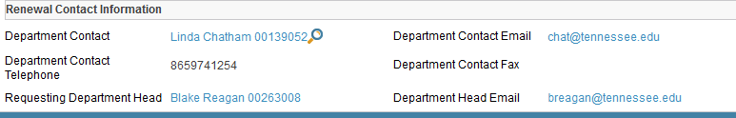
Because this is a framework order PO, there is no account number associated with the requisition or PO. The Requesting Department Head then defaults to the director of purchasing at whatever campus the buyer works at.
To update this information, you will need to go to the General Tab and click on the magnifying glass next to Fund.
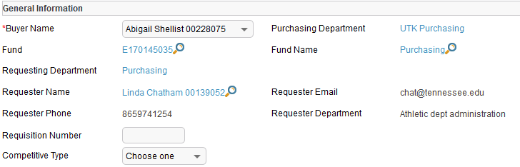

Enter the fund number in the search field and when you see the fund come up, click on the red arrow.
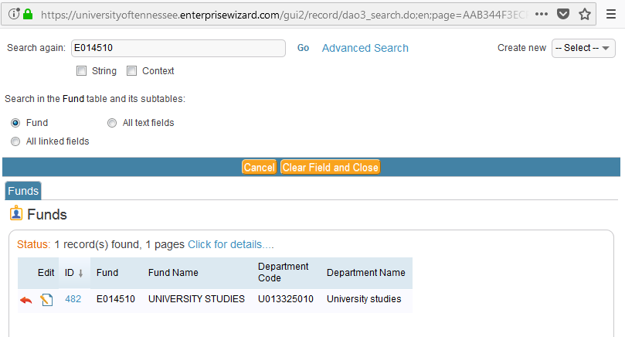
Now, if you go back to the Contact Tab, you will see the correct Requesting Department Head listed.
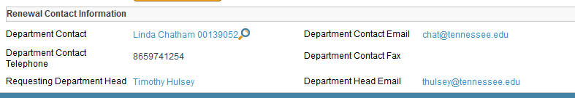

Documents Tab
This is the tab where all of the documents associated with the purchase agreement are stored. This includes the PO, the certificate of insurance or any other document that needs to be tracked for renewal.
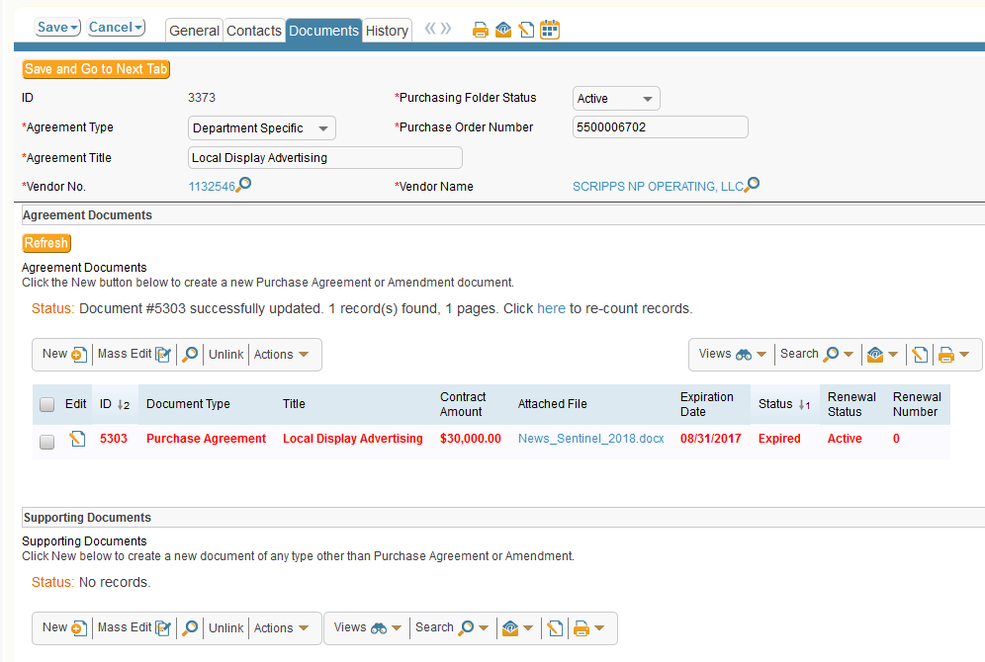

In the example above, there is already a document attached. Click on the edit button to open the page with information about the document.
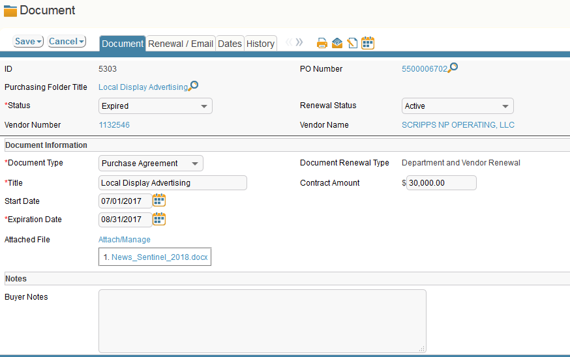

In order to add another document, I click on the New button.

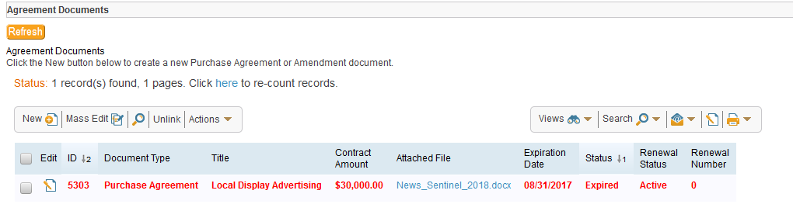

Document Types to choose from:
- Purchase agreement
- Amendment
- Contractor’s license
- Final contract
- Insurance certificate
- NCJ
- Performance bond
- Pricing list
- Shipping manifest
- Written correspondence
- Attestation form
- Other
Depending on the type of document you select, different fields will pop up for you to enter information into. In this case I am choosing insurance certificate.

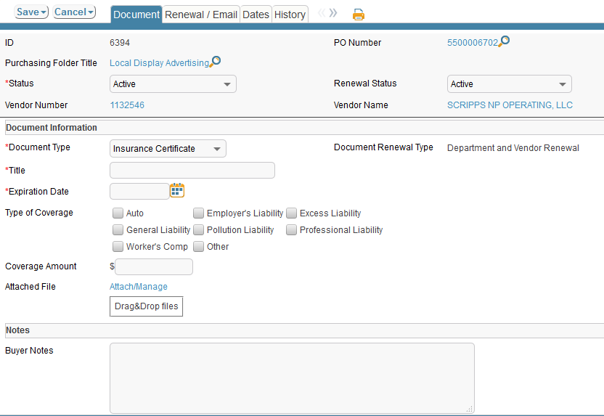

You can just drag and drop your document into the drag & drop files box and click save.

Renewal/Email
In order to email your department and vendor contacts when it is time to renew, go to your purchasing agreement folder and click on the document you want to renew.
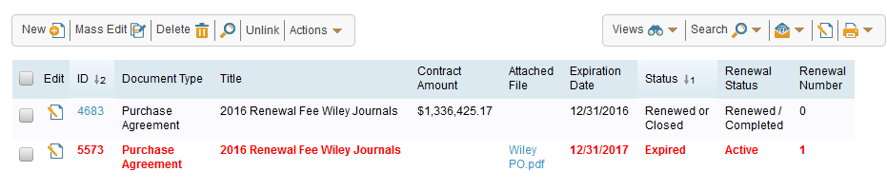
A new window opens for that document. You will now see a tab for Renewal/Email.

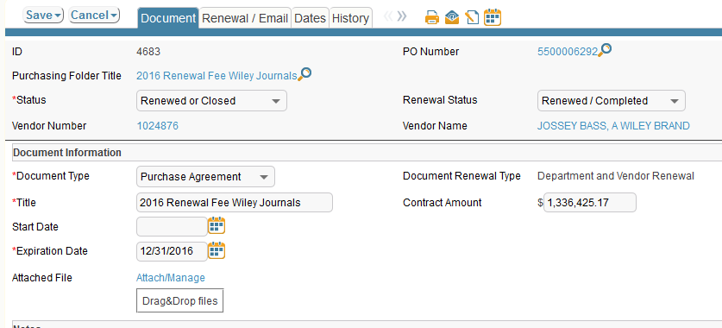

Click on that tab and go to the section titled Send Email.
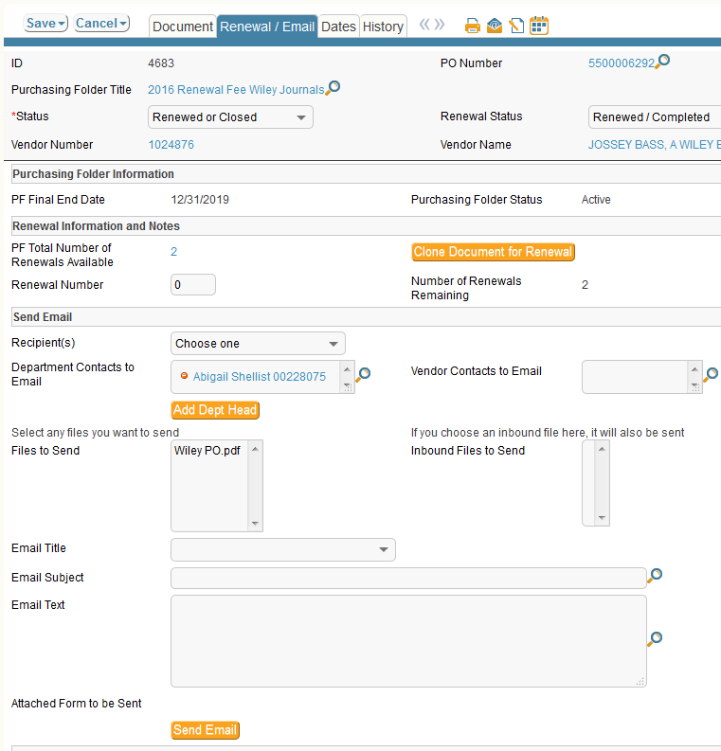

- Chose recipient
  - Vendor only
  - Department only
  - Both vendor and Department
You have the option to add Department Head
You will see the files to send with the email
Choose the email title from the dropdown which will indicate to the recipient which notification it is (1st, 2nd, expiring, final)

Depending on which email title you chose, the email subject and the email text will auto populate.
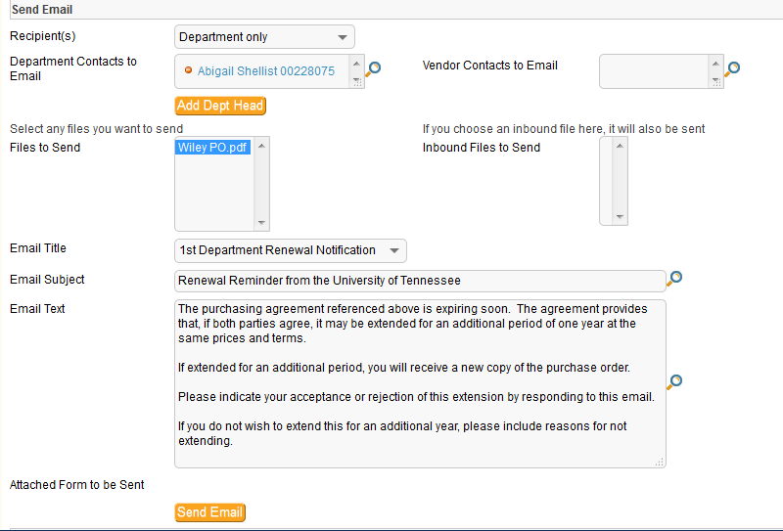

The final step is to click on send email.

The system keeps a log of all outgoing and incoming email correspondence.
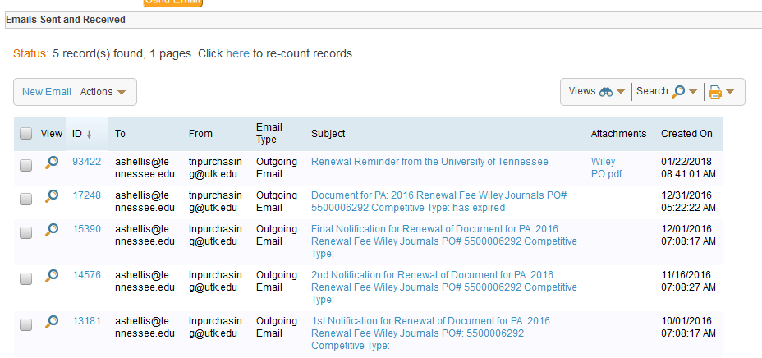

Clone Document for Renewal

When you are ready to renew your agreement you will go back into the document you want to renew and click on the Renewal/Email tab.
Click on the button Clone Document for Renewal
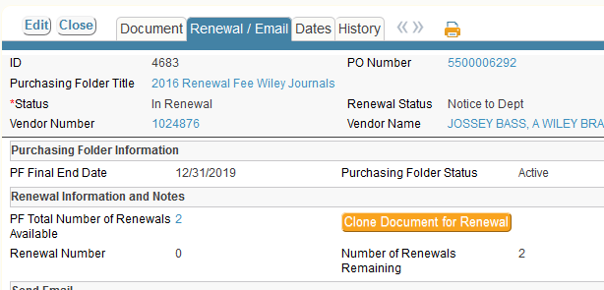
A new window opens for the document and you will fill in the pertinent information for that document.
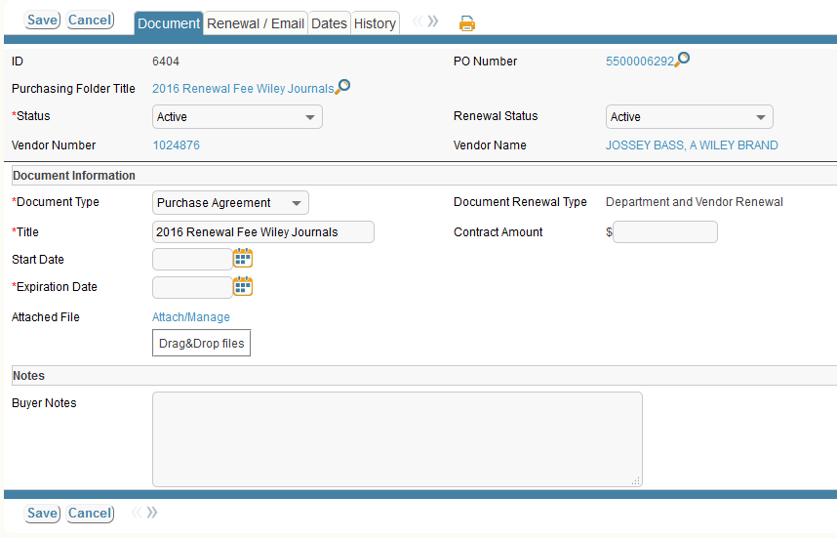

Click save and you will see your renewal has been added as a new document. Click save again and you are finished.
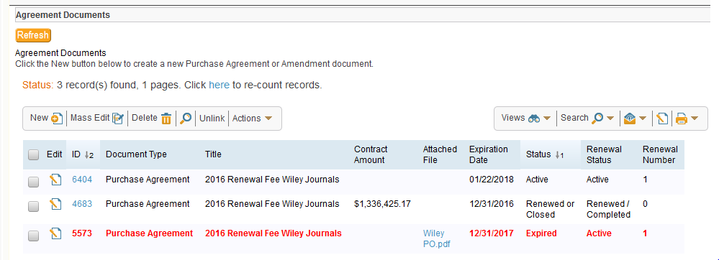

Delete

If you need to delete a documents click on the box next to the document and then click on the delete button.
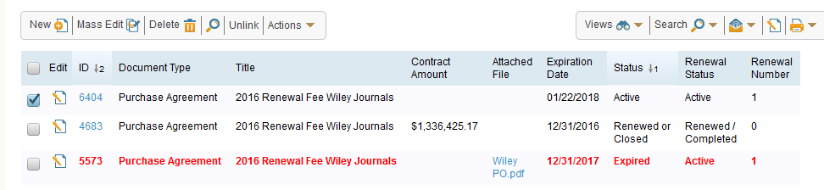

Supporting Documents
In the supporting documents field, you can add a document other than the PO (certificate of insurance, etc.)
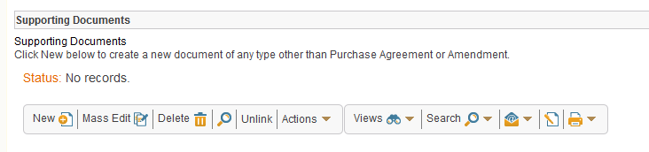

History Tab
This tab gives you a history of all of the action taken with the agreement/documents.
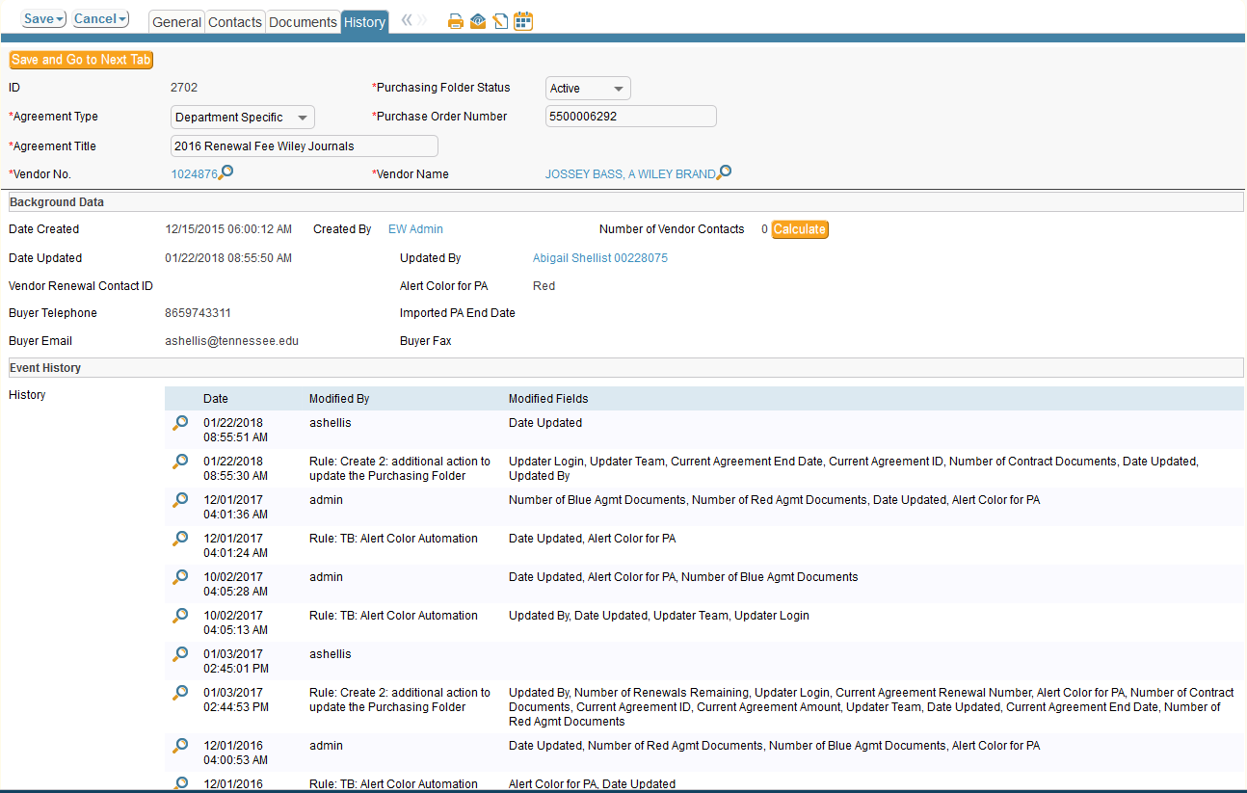

Status
You can change the status of both the purchasing folder and the documents.
Purchasing Folder Options:

Documents Status:
Documents Renewal Status:

