Reviewing Contract NCJs

NCJs will appear in the “My Final Approvals” search.
- Click on the edit icon
- Click on the contract ID and a new window will open with the full contract view.
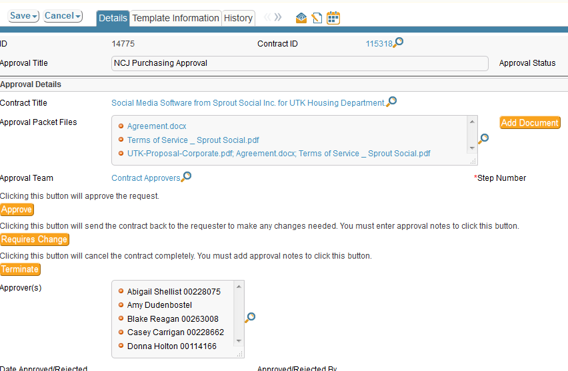

- Read the notes in the No Bid Explanation field. If there is not an adequate explanation, email the department for more information and enter it into the approval notes or return the NCJ back to the department for them to fill in the required information.
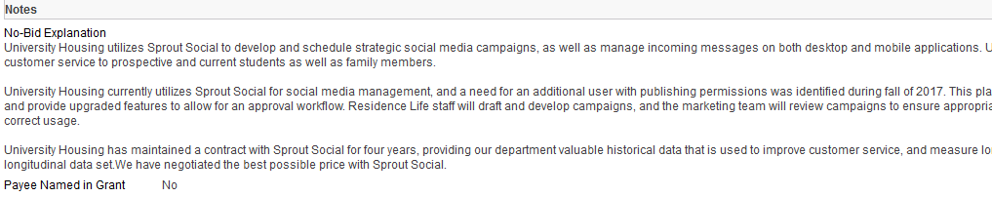

- Click on the Document tab and open the attachments to make sure they match the information in the contract
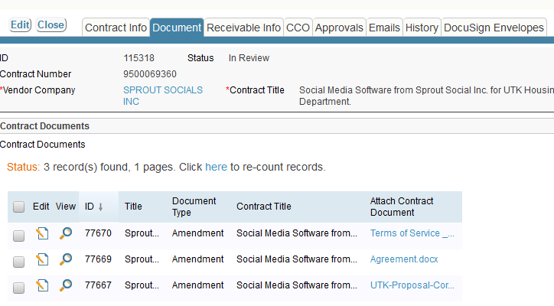
- Close out of that window and you will return to the Approval page.

- If the contract requires a change, you will enter notes into the Approval Notes field explaining what changes are requires and then click on Requires Change.
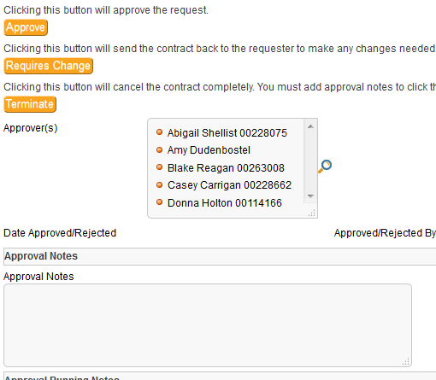
- If no changes are required and you are ready to approve, just click on the Approve tab.

- If you are rejected the contract because it is not needed, click on Terminate. By deleting, the department cannot make changes and resubmit.

- If you want to see the workflow, click on the Approvals tab

