Reviewing Requisitions

From the Market Place Manage tab you will see all transactions that need action.
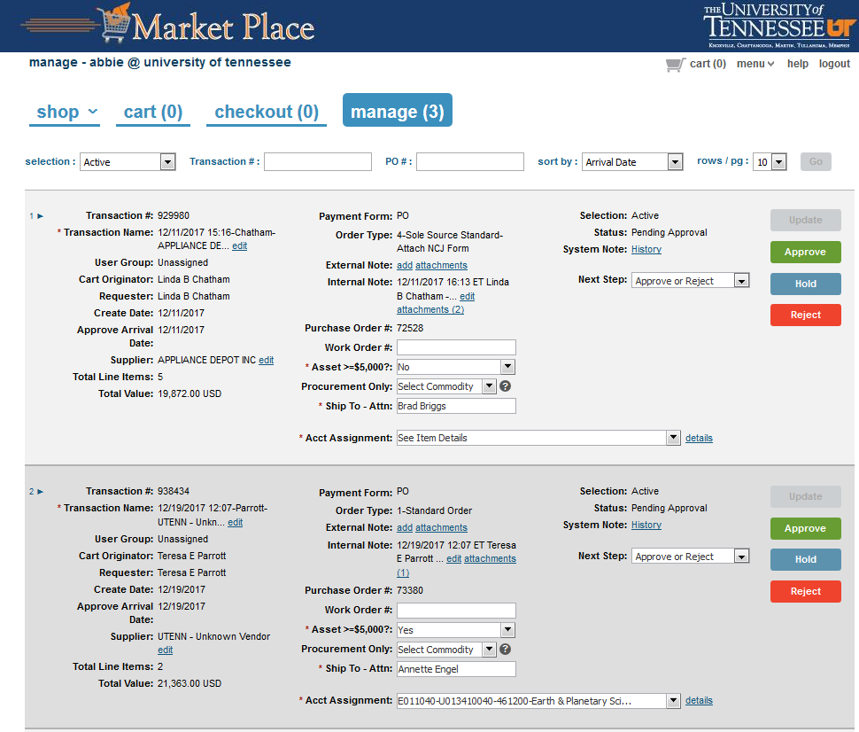
From the selection drop-down menu, you can search for transactions other than active.
For instance, you can select “all” and all transactions will pull up. This selection includes transactions that have already had purchase orders created and those that are waiting for purchase orders.

NCJs (sole source)
- First look at the order type to screen for NCJs (sole sources).
  - Make sure that the NCJ form is attached and contains adequate information in order to determine if the purchase qualifies as a sole source.
  - For a framework NCJ, there should be a begin and end date as well as a total dollar amount. This is used to screen for purchases which might need to be reviewed for Fiscal Review (over 1 year and $250,000 or over).
  - If the transaction is an amendment, you must also make sure that with the amendment, the transaction does not equal over 1 year and $250,000 or over.
  - If you need to make notes on the NCJ form because you received additional information from the department, you will need to open the attachment and save it to your desktop, make approval notes and then upload it back to the requisition and delete the old

Informal Bids
- First check to make sure the department is an approved department for informal bidding.
  - The purchase must be for $49,999.99 or under (except for Facilities Services which has a bid limit of $25,000.00).
  - The department should have attached all related bid documents.
  - A bid tab should also be attached

Standard Order
- A standard order could be one of the following
  - Exempt from NCJs
    - Library subscription which is exempt from the NCJ
    - Utilities
    - Specifically named in a grant; including sub contractors
  - Small purchase under $10,000 but the vendor requires a purchase order
  - Purchase based on a cooperative, GSA, or state contract
  - Something that needs to be bid

Approve/Reject/Assign Requisitions
Once you have determined what kind of transaction you are looking at you are ready to approve, reject or assign the transaction.

NCJ- Approval
- Always view the workflow first to make sure the transaction isn’t already at the stage to create a PO. For example, if it’s an NCJ and the CBO has already approved, if you select approve when you intend to approve at the purchasing level, you will accidentally create a PO instead. Check first to make sure the CBO hasn’t already approved when you are reviewing an NCJ.
- If the NCJ has all the correct information attached, and meets the standards for a sole source, you can approve. A dialog box will pop up asking if you want to approve once or multiple. Always choose multiple. If you choose “once” it will automatically create a PO after the CBO approves.
- The NCJ transaction will come back into your workflow after it has been approved by the CBO.

NCJ-Rejection
- If you need to reject an NCJ, please click on the reject button. A box will pop up asking for you to enter the reason for rejecting. If you are rejecting the transaction because it will need to be bid, please put instructions in the dialog box asking the department to change the order type to standard order and resubmit.
- You can also reject the NCJ if the department needs to make changes to the requisition. They can make the changes and resubmit it.

Assigning Requisition to a Buyer
- If the transaction is ready for a buyer to bid or issue a purchase order, select forward from the next step drop down menu. And click on the forward button
- You will need to enter the name of the buyer you are forwarding this to. This assigns the transaction to a buyer and from here it can become a purchase order or can be converted to a bid.

Running a Report for Assigned Requisitions
- In order to keep track of the assigned (forwarded) transactions, you will need to run a forward report.
- Go to menu – reporting
- Select Forward Report- System and then click on the export button and choose XLS
- Enter a date range and click “ok.”
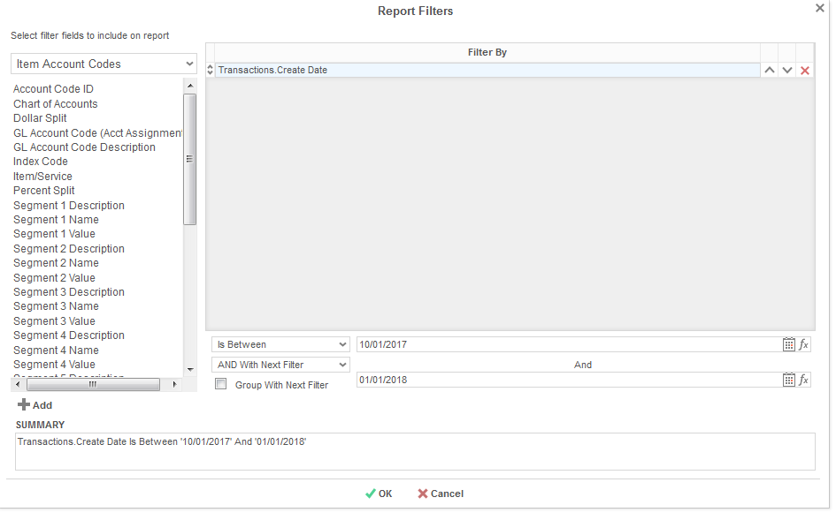

The report will have a line for every line item of the requisition so you may need to go in and clean up the report by deleting the extra line items.

