Accessing Tennessee Central Procurement Office Statewide Contracts
Tennessee statewide contracts (“SWCs”) are stored by the Central Procurement Office in Edison, the State’s ERP system. You can access the SWCs through a web interface.
This interface is somewhat limiting, and searching for a specific contract may require multiple steps, but you should be able to find any SWC by using one of the following methods.
After you have located a specific contract, you can download the bid documents and the resulting contract document.

1. Searching by Contract Name or SWC Number
If you know the contract name (ie, “Checkpoint & Body Scanners”) or the SWC number, you can retrieve the contract documents easily.

Navigate to the SWC listing
Go to https://www.tn.gov/generalservices/procurement/central-procurement-office--cpo-/state-agencies-/statewide-contract-listing.html and click “Statewide Contract (SWC) Search”:
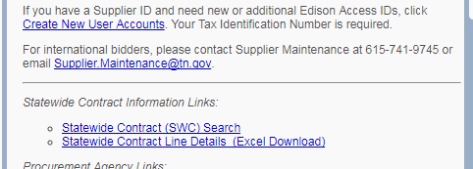

Choose the contract
You can sort the list of contracts by SWC number or by SWC name by clicking at the top of the appropriate column
If you would prefer to search, you can also click the “Find” link and enter the SWC number or name. This will only search the contract name or number – it is not a keyword search. If you need to search by keyword, follow the instructions in section 2.
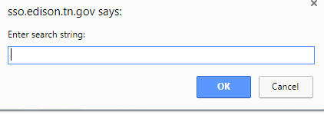
You can select the contract by clicking the “open folder” icon to the right of the contract in the list.
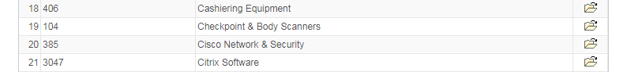

Review the contract documents
If the CPO awarded contracts to multiple suppliers, there will be a contract entry for each supplier:
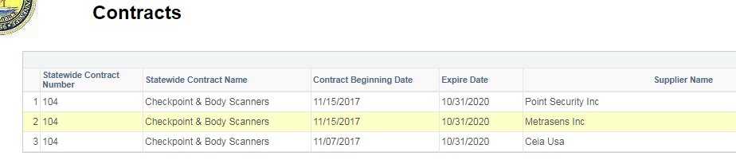
Choose the “open folder” icon to the right of your selected supplier in the Contract Documents column.
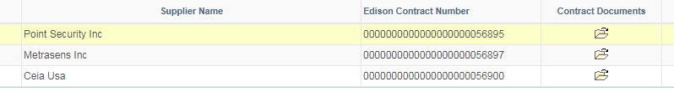
If you would prefer to see a summary of the contract line items, you can also click the “open folder” icon in the Line Items column.
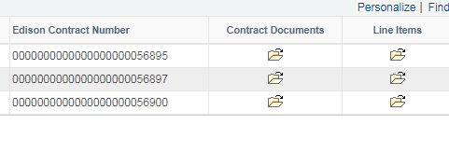
One you click through the Contracts Document icon, the website will display a table that lists all of the contract documents. You can download the documents by clicking the icon in the Contract Documents column.
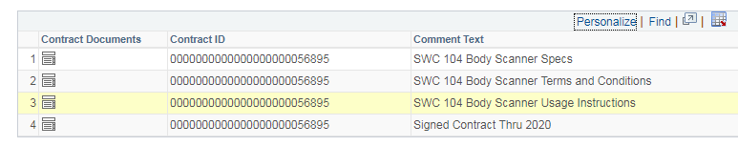

2. Searching by Keyword or Line Item
If you need to find a contract but do not know the contract name or the SWC number, you can also search by contract line items. This process is more complicated, but should still allow you to find an SWC based on a keyword.

Navigate to line-item details
Go to https://www.tn.gov/generalservices/procurement/central-procurement-office--cpo-/state-agencies-/statewide-contract-listing.html and click “Statewide Contract Line Details”
This will download an Excel file that contains every line item from every SWC.

Search by keyword
You can perform a keyword search in the Excel file by pressing Ctrl F or by clicking the Find & Select button on the ribbon and selecting the “Find” option from the dropdown menu.
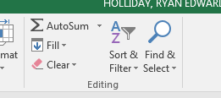
Enter the keyword or line item you want to search for in the search box, and proceed through the results until you find the line item you need.
Column A of the worksheet contains the SWC number.
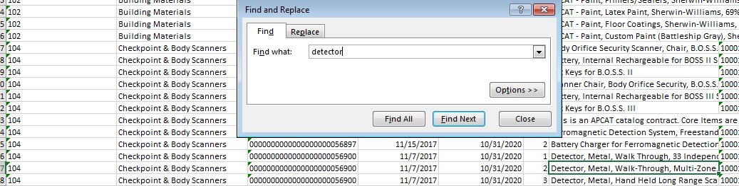
Use the instructions from Section 1 to locate that SWC and retrieve the contract documents.

