Checking a Purchase Order’s Balance

IRIS transaction ZMM_PO_BAL
Enter the PO you wish to check and then click execute.
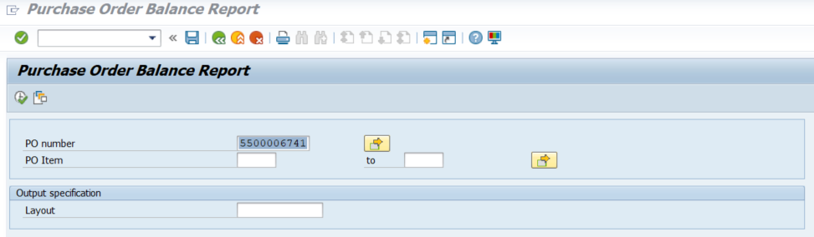
You can see the starting amount for each line item and the remaining balance amount.
