Editing an IRIS Purchase Order Generated by an ESM Requisition

ME22N – use this transaction to edit an ESM generated purchase order.

Header section

Delivery/Invoice Tab:
Incoterm: In the Incoterms box delete FOB and enter appropriate Incoterms (select UT4 if there are no shipping charges, UT1 if there are shipping charges) >> Delete ESM PO from the box to the right 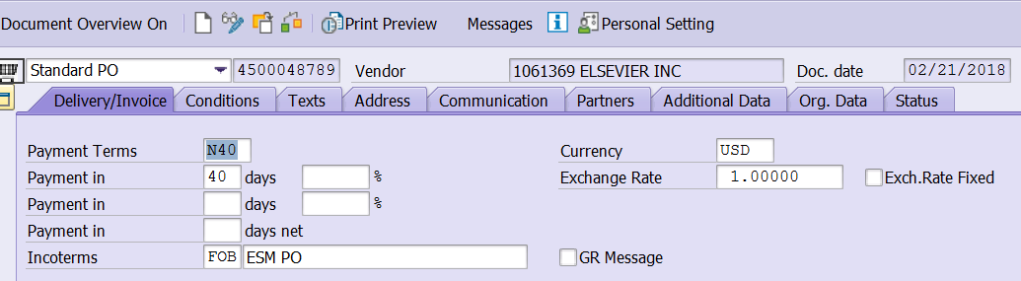

Additional Data Tab:
Reas. For Canc. – See Basis of Award Reason for Cancellation spreadsheet. If you are not sure, ask someone!
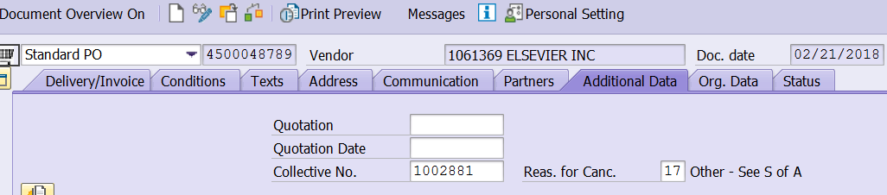

Orig. Data Tab:
Purch. Group: Replace ESM with your buyer code
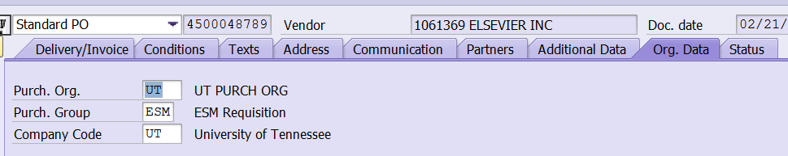

Texts Tab:
Header Text Before Line Item box: Text from the internal notes section of the ESM requisition automatically copies over to the Header Text Before Line Item section of the IRIS purchase order. 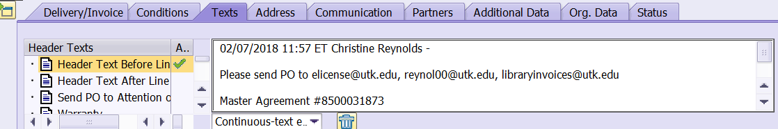
Buyer Notes box: Copy and paste the above mentioned text into the Buyer Notes box on the Texts Tab
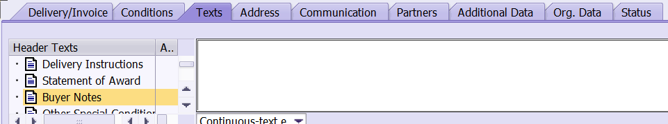
Go back up to the Header Text Before Line Item box and enter: Reference: Quote/Invoice # (which ever applies) dated ____________. Any special delivery information would go here also. See attached purchase order copies for examples of text for this box (library purchase orders should also have the master agreement statement-get this from your IRIS clipboard)
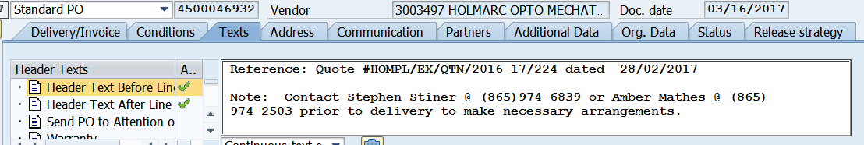
Header Text After Line Item box: In this box enter any warranty information & shipping statement (if applicable to the purchase order).
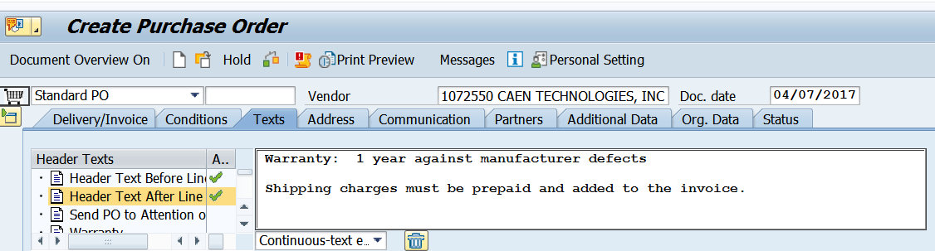
Statement of Award box: Enter the information showing on what basis was this purchase order created. This could vary with each requisition. Double-click in this box to expand to full screen. (see attached examples of statement of award language)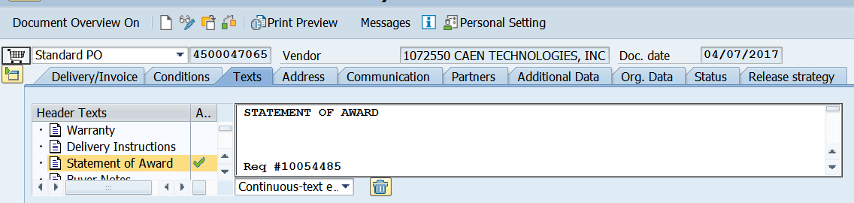

Item Overview Section
Line items: Edit your line item information to match the quote or invoice including item#, model#, etc. Delete ESM_00000 from line item description. On orders where there are validity period dates, the delivery date in this section should be the same as the validity start date. Enter the appropriate material group number in the Matl Group column (for library subscriptions use 42-938-00, library purchases (non-subscriptions) use 24-999-99).
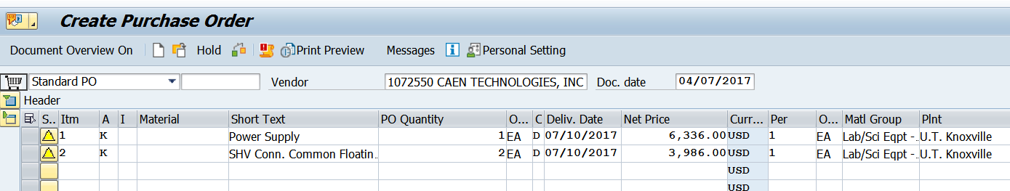
Item Details Section
Account Assignment Tab: The Cost Center or WBS Element, GL Code should be populated with account information from the ESM requisition.
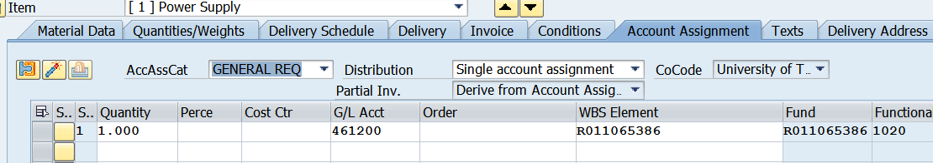

Delivery Address Tab: Delivery address information does not copy over from the ESM requisition. Check the ESM purchase order copy that you saved when you approved the ESM requisition to see how the delivery address should read, search in IRIS for that delivery address number that matches that address. You may need to modify an existing address or create a new one in IRIS (use IRIS transaction MEAN to do that). 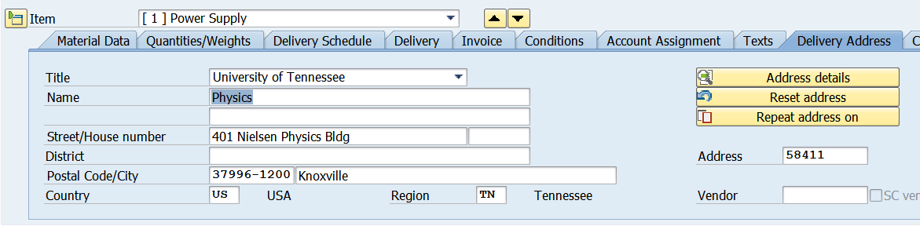
Texts Tab – In the Item Texts column on right, you will see Item Desp/Specs, this field is used for any additional description of the item. If validity dates apply to the order show those dates under the item description.
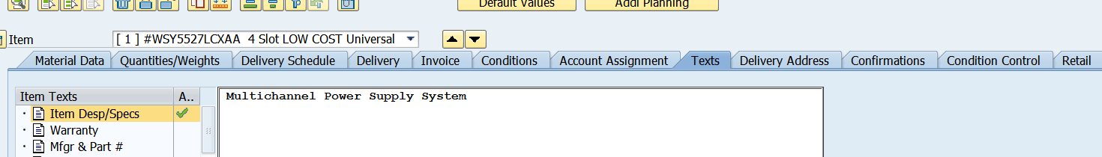
Save Final Pdf copy of IRIS Purchase Order
Click on Messages button at the top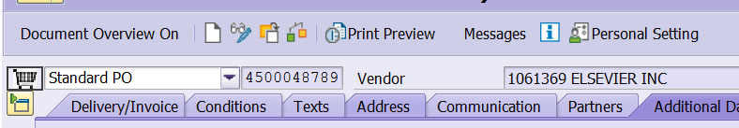
Select and highlight the top line with the Yellow Triangle icon >> click on Trash Can icon >>> hit enter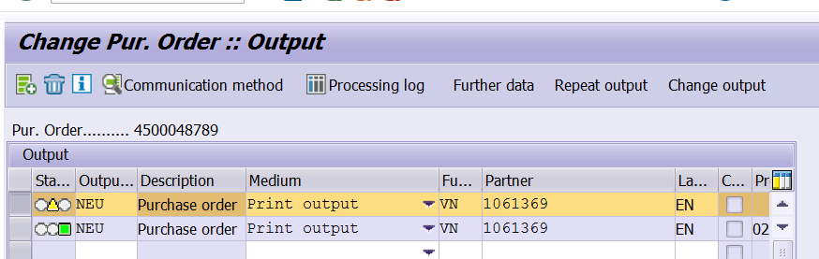
Select and highlight the top line with the Green icon >> click on Repeat output button >> click on SAVE icon at the top
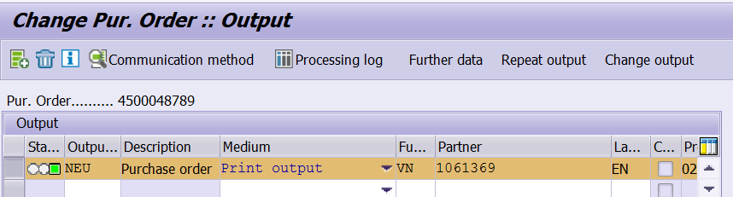
ME29n – Release Individual Purchase Order
The purchase order should automatically show the Release Strategy tab >> click on this icon >> click on the SAVE icon at the top >> this will generate a pdf spool copy of the finalized IRIS purchase order.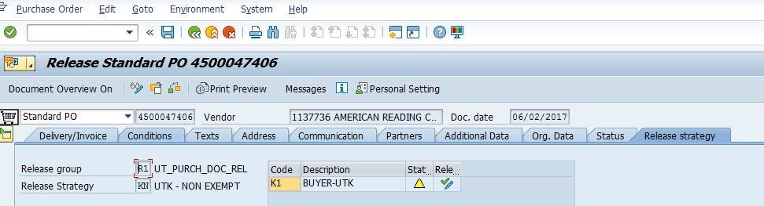
ME28 – Release a Group of Purchase Orders:
You will see the below screen >> enter information as shown below >> then click on the clock icon at the top to
Execute.
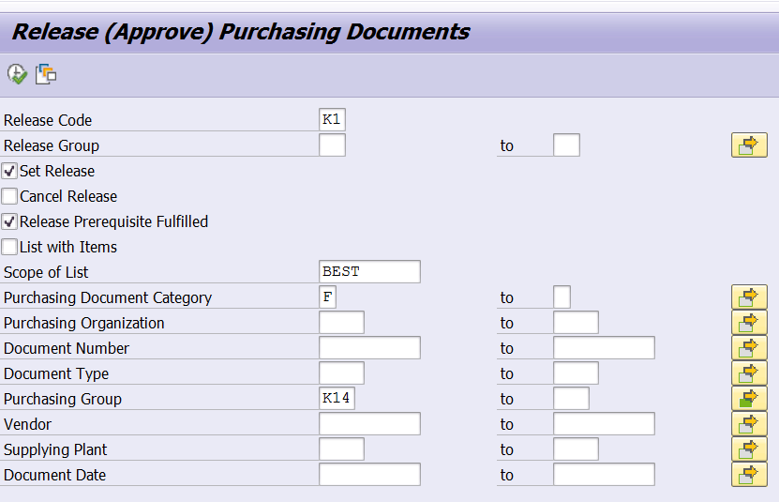

You will then see the below screen. Click on this icon >> it will change to a single green check mark >> this will generate a pdf spool copy of the finalized IRIS purchase order for those purchase orders.
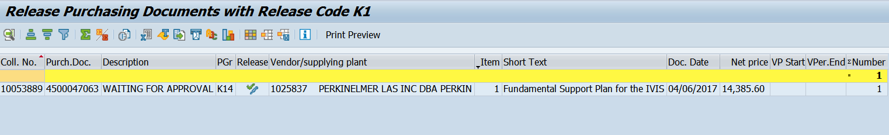
SP02 - Look Up Spool# For Purchase Order
SP02 screen will look like one below. Use IRIS transaction SP02 to look up spools created within the last 8 days to get your spool# for purchase orders you’ve created. You can view the document by clicking on the paper icon. Save that spool copy of your purchase order to a folder created for those. To save the document click to check the box to the left of the spool# >> go to Spool Request in the top left corner Forward >> Export as PDF. When saving the spool copy in the file name box enter purchase order# followed by .pdf. You can digitally sign the purchase order using either Adobe Acrobat or DocuSign.
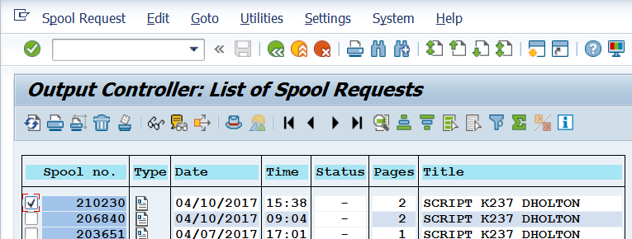
Send The Purchase Order To The Department/Vendor
Always check with the creator of the requisition to see if the vendor needs a copy of that purchase order. If yes, get contact info for vendor from quote or department. Most of the time the department will agree to send the purchase order on to the vendor themselves.
Digitize THE Purchase Order (Attach all related documents to the purchase order in IRIS)
Attached the following documents to the IRIS purchase order in this order:
- Purchase order, documentation showing what price is based on (quote, invoice, price list, etc.)
- Copy of NCJ form (if applicable to the order)
- Copy of grant documentation (if applicable to the order)
- Copy of Master Agreement (if applicable to the order)
- Copy of all emails pertaining to the transaction and purchase order (convert those emails to pdf’s)

