ESM Buyer Requisition Instructions
The University of Tennessee
Version 1.7

7/29/2019

Contents
Logging In 3
Transaction Summary 5
System Note 5
Notes and Attachments 6
General Details 7
Order Types 7
User Group 7
Procurement Only 7
Delivery Details 9
Billing Details 9
GL Details 10
Line Item Details 10
Splitting Accounts by Line Item 11
Notes and Attachments 11
View Workflow Details 12
Rejecting a Transaction 13
Bid 13
Releasing a Purchase Order 13
Editing an IRIS Purchase Order Generated by ESM 15
Delivery/Invoice Tab: 15
Additional Data Tab: 15
Texts Tab: 16
Searching 23
Manage Tab 23
Order Summary 23
Forward Report 24
Change Order 26

Buyer Instructions

Logging In
When a requisition has been forwarded to you, you will receive an email notification from ESM. It is best practice to log into the IRIS Portal several times a day to check any work that may have been assigned to you.
*Make sure your browser allows pop-up windows*
After you log into the IRIS Portal, click on the “Shop” tab. A new window will open up and you will have access to the Market Place.
Click on the “Manage” tab to access your assigned transactions.
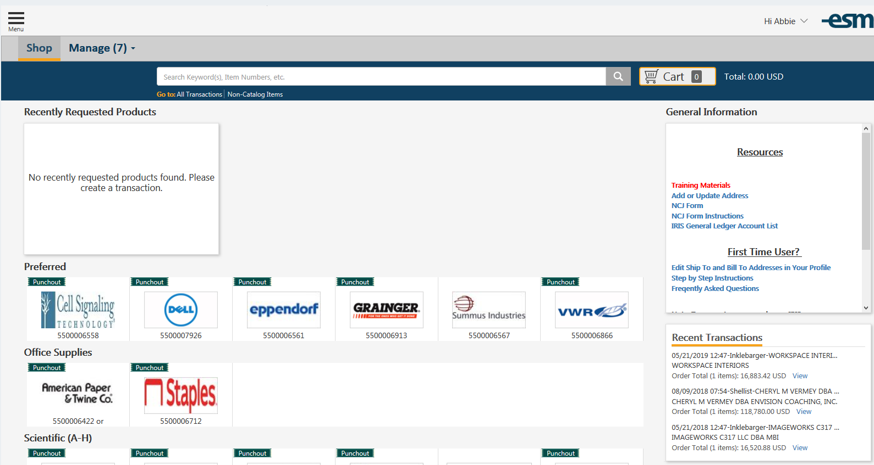

Make sure your search filter in the manage tab is set to “Showing: All”

Click on the blue req name in your queue to expand the view of the requisition.
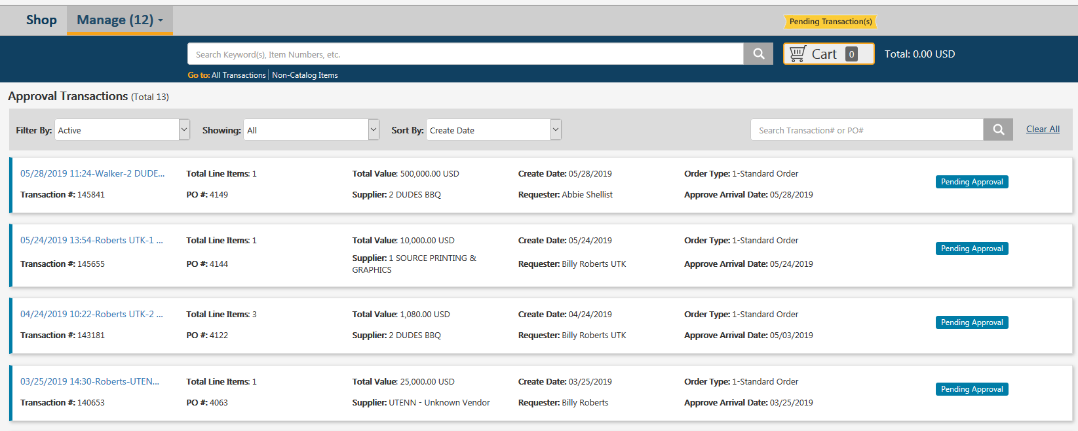

An opened transaction:

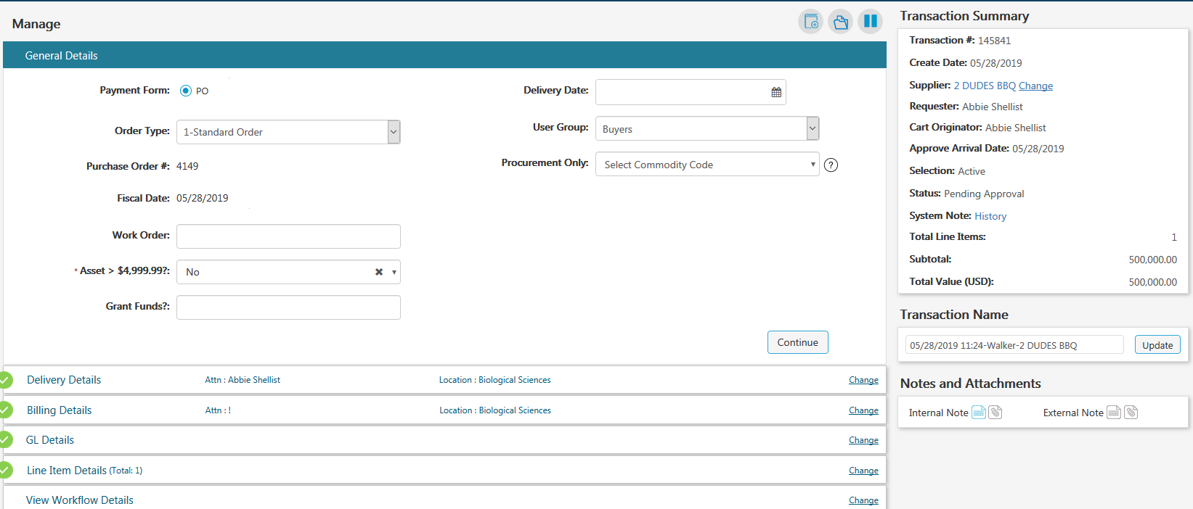

Transaction Summary
To the right of the requisition, you will see the transaction summary. There are a couple of important components to the summary.
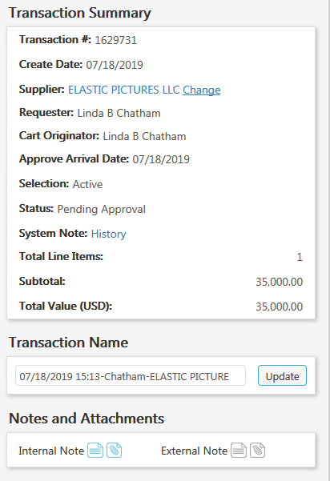

System Note
The system note will tell you if there was a requisition (encumbrance) created in IRIS. The only order types that will have an IRIS req created and will have an encumbrance are “standard orders.”
Sole sources, framework orders, and informal bid order types do not encumber and will not have an IRIS requisition. When you click on the system note “history,” you will see pre-encumbrance of “1” for the previously listed order types. This means there is not corresponding IRIS requisition.
A standard order will create an IRIS requisition with an encumbrance. The pre-encumbrance ID will show a number that begins with the number 99. This pre-encumbrance ID can be looked up in IRIS using the display requisition transaction (ME53N).
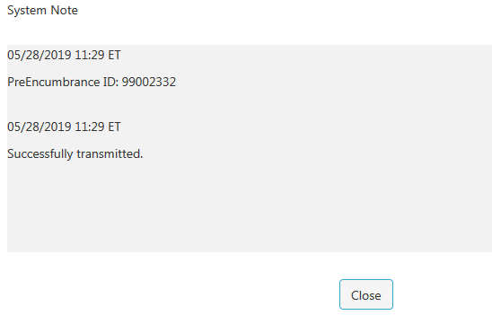

Notes and Attachments
You can find both internal and external notes and attachments here. Normally, this is where a department will attach specifications, invoices, quotes, NCJ forms and other related documents. If the note or attachment icon is blue, you can click on it to access those documents.

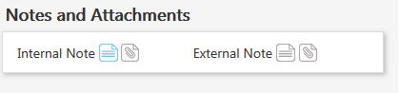

General Details

Order Types
Order types include:
- Standard Order
- Informal Bid
- Framework Order
- Sole Source- Standard
- Sole Source- Framework
If the department has selected the incorrect order type (they choose “standard” instead of “framework,” you may change that. You must make the change before creating the PO or flipping to the sourcing system.
You should never change the order type from a “sole source” to “standard order” or “framework order” as this will disrupt workflow.

User Group
When a department submits a requisition, the user group will default to “unassigned”. When a buyer needs to create a requisition, the buyer should chose “buyers.” By choosing “buyers,” the requisition will bypass any workflow so you can begin working with the requisition immediately.
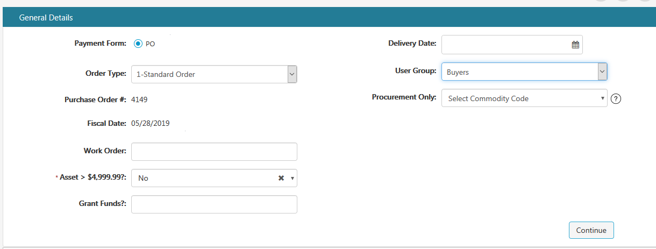

Procurement Only
This field should be left blank by a department although sometimes they do make a selection. This is for the buyer to select the reason for the purchase order and this field should be selected before converting the requisition to a purchase order. If you forget to make a selection, you will have to do a change order on the PO once the PO is complete.
It is very important to make the correct selection since this information is used in reports to the state.
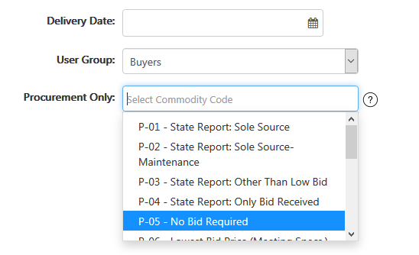

1 | State Report: Sole Source | Use for all sole-source P.O.s, unless a sole-source P.O. falls under category 2 or 17.
2 | State Report: Sole Source -- Maintenance | Use for all maintenance-related sole-source P.O.s.
3 | State Report: Other than low bid | Use when you award to a bidder that was not the low bidder meeting specs.
4 | State Report: Only Bid Received | Use when you award to the only bidder (no other bidders submitted a response).
5 | No bid required. | Use when: 1) buying off an existing UT framework order; 2) when issuing a PO under $10,000; or 3) when issuing a PO for a net-receivable transaction (e.g. NIKE sponsorship).
6 | Lowest Bid Meeting Specs | Use for Requests for Quotes when awarding to lowest bidder meeting specifications.
7 | Other bid: RFP or RFQ-S | Use when awarding via an RFP or RFQ-S (Request for Qualified Suppliers).
8 | TBR | Use when awarding off a Tennessee Board of Regents or LGI contract. (LGI = Locally Governed Institution, the former TBR universities).
9 | State of TN Cooperative | Use when awarding off a cooperative agreement issued by any State of Tennessee government agency, other than TBR or an LGI.
10 | GSA | Use when issuing an award off the U.S. Federal Government's General Services Administration ("GSA").
11 | National IPA | Use when awarding off National IPA.
12 | Buy Board | Use when issuing an award off Buy Board.
13 | MMCAP | Use when issuing an award off MMCAP, the Minnesota Multi-state Contract Alliance for Pharmacy.
14 | Texas Supply Chain Alliance | Use when issuing an award off the Texas Supply Chain Alliance ("TSCA").
15 | Other State or Local Government | Use when issuing an award off a cooperative agreement issued by a state government other than Tennessee, or when issuing an award off a cooperative agreement that was issued by a local government agency, whether in TN or outside TN.
16 | Other Cooperative | Use when issuing off a cooperative/consortium/group purchasing organization/GPO other than one of the cooperatives listed in codes 10-14.
17 | Library License | Use when issuing a PO for a library license (subscription, journal, database, electronic resource, newspapers, etc.).

Delivery Details
This tab is editable and shows the ship to address
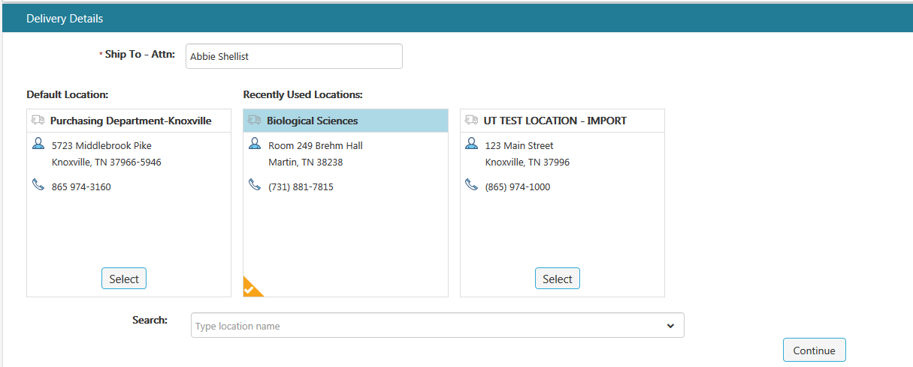

Billing Details
This tab is for the bill to address and is editable
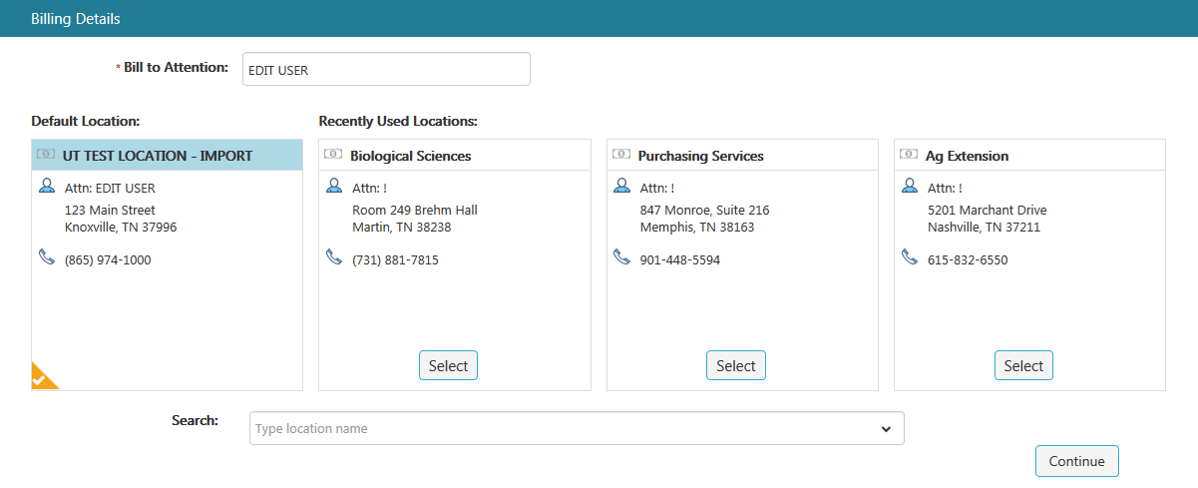

GL Details
In this tab, the account number and GL codes are selected. The system will not let you move forward without a GL code.
You can also chose to split the cost between multiple accounts. If you or a department choses to split the cost in this tab, the cost of the entire PO will be split here but it can only be split by percentage. For example, this entire requisition has been slit 50/50.
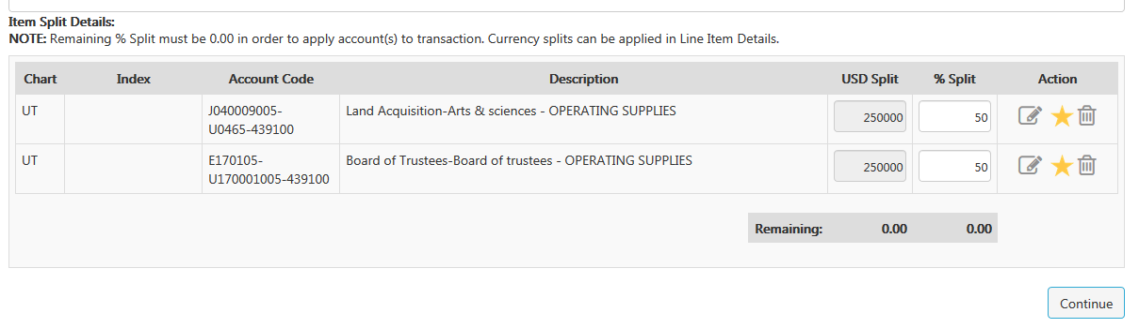

Line Item Details
This tab will show a short description of the line items. By clicking on “edit” under the name of the transaction, you can edit the description, unit of measure, quantity, list price, manufacturer part numbers, etc.
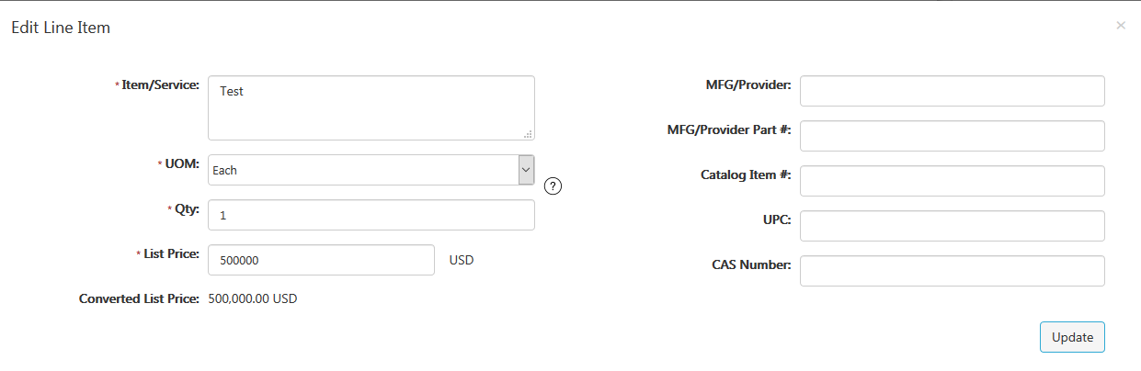

Splitting Accounts by Line Item
You may split accounts by line item. To do this, click on “more.”
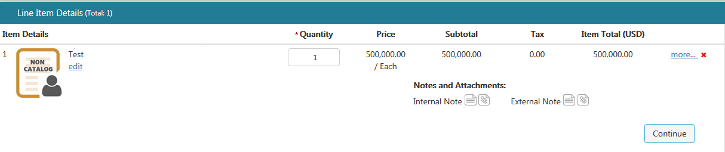

And then click on the GL Details tab. 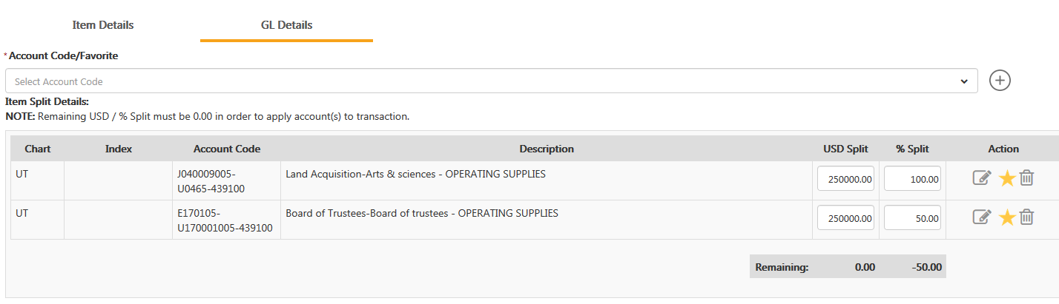

Here, you can split the accounts by either dollar amount or by percentage.

Notes and Attachments
There could be internal and external notes and/or attachments on each line item. If so, the icon of the note or attachment will be blue and will open when you click on it.

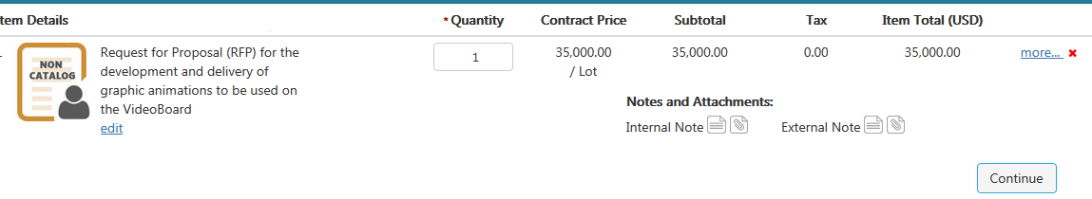

Note: An external note or external attachment, will be visible to bidders if you flip the requisition to a bid.

View Workflow Details
This tab will show you the workflow for the transaction and who has approved.
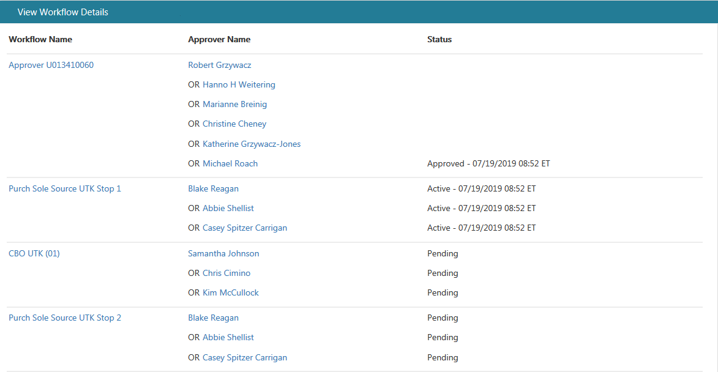

Status:
Approved = approved
Active = transaction is in this person’s/peoples’ workflow waiting for their approval
Pending = this will be the next step after the active step is approved

Rejecting a Transaction
If you need to reject or return a requisition back to the department, you will click on the reject button at the bottom of the requisition. When you click this, the internal note will open and you will be required to enter a reason for rejecting and then click update.
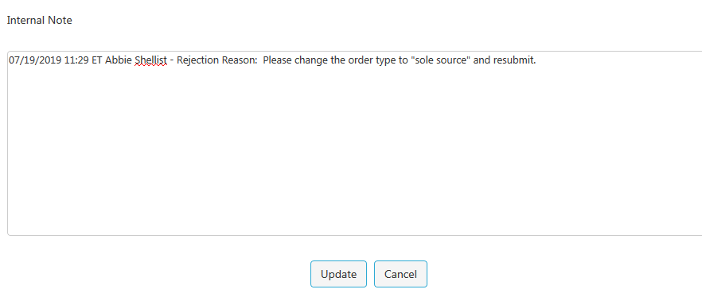

Bid
When you are ready to send the requisition to the sourcing system to bid, at the bottom of the requisition, you will see a button that says “sourcing.”
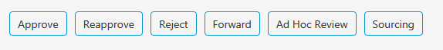
See ESM Sourcing Instructions for more details.

Releasing a Purchase Order
If you are ready to release (create the PO), click on “approve.”
A screenshot of the ESM PO will open and you will click on “Place Your Order.” As soon as the ESM PO is created, a PO is simultaneously created in IRIS. The IRIS PO number will populate in ESM and you can then go into IRIS and edit the PO if you are using the IRIS PO to send to the vendor and department.

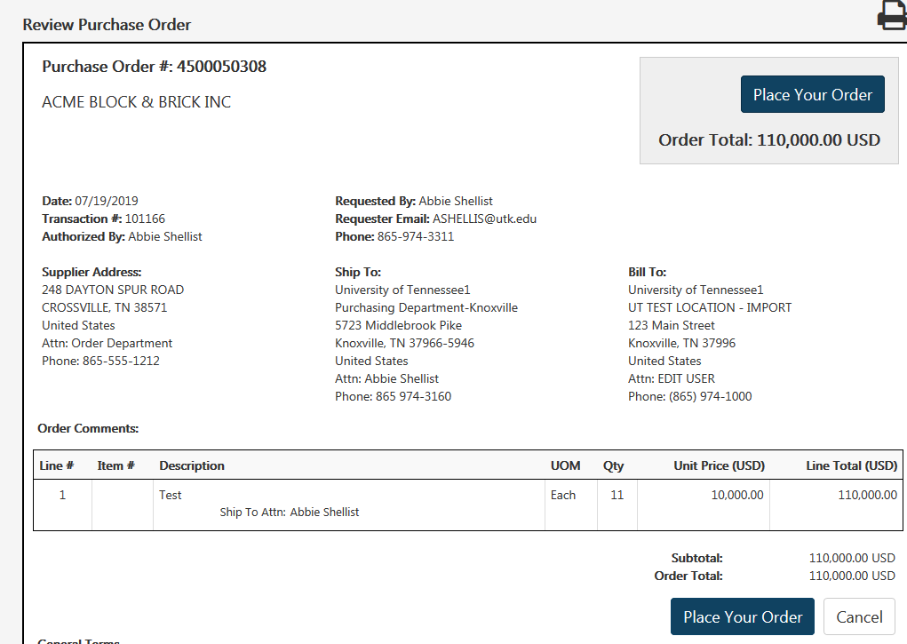

Editing an IRIS Purchase Order Generated by ESM
ME22N – use this transaction to edit an ESM generated purchase order.
Header section
Delivery/Invoice Tab:
Incoterm: In the Incoterms box delete FOB and enter appropriate Incoterms (select UT4 if there are no shipping charges, UT1 if there are shipping charges) >> Delete ESM PO from the box to the right 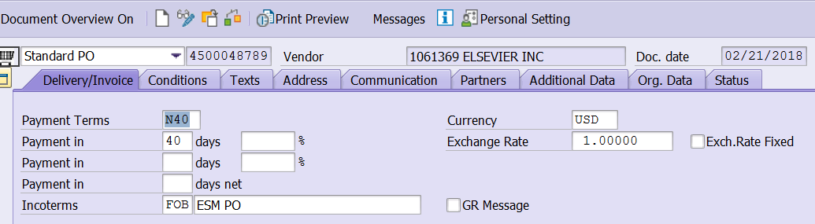
Additional Data Tab:
Reas. For Canc. – See Basis of Award Reason for Cancellation spreadsheet. If you are not sure, ask someone!
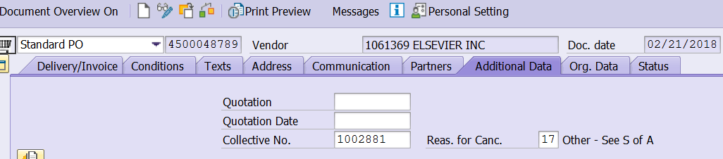
Orig. Data Tab:
Purch. Group: Replace ESM with your buyer code
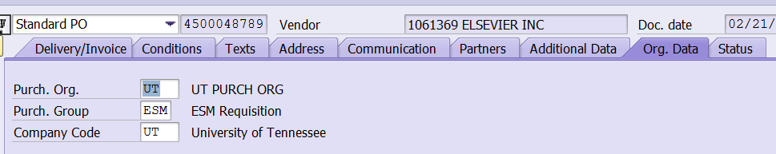

Texts Tab:
Header Text Before Line Item box: Text from the internal notes section of the ESM requisition automatically copies over to the Header Text Before Line Item section of the IRIS purchase order. 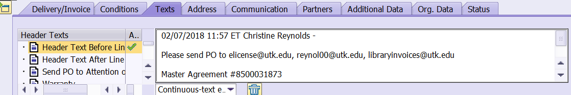
Buyer Notes box: Copy and paste the above mentioned text into the Buyer Notes box on the Texts Tab
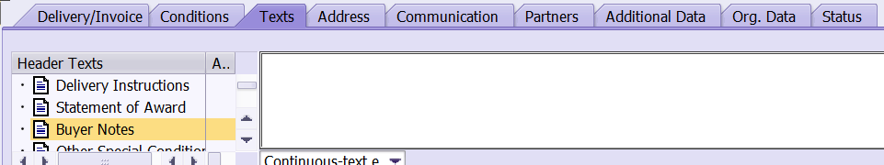
Go back up to the Header Text Before Line Item box and enter: Reference: Quote/Invoice # (which ever applies) dated ____________. Any special delivery information would go here also. See attached purchase order copies for examples of text for this box (library purchase orders should also have the master agreement statement-get this from your IRIS clipboard

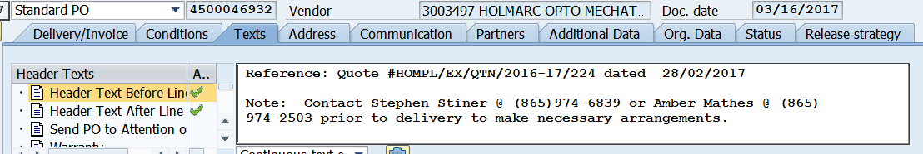

Header Text After Line Item box: In this box enter any warranty information & shipping statement (if applicable to the purchase order).
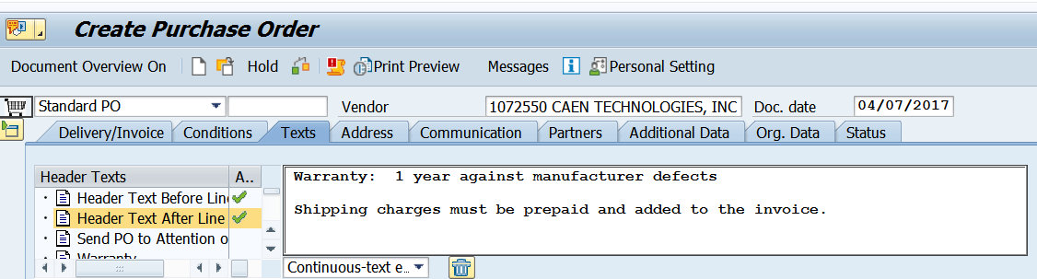
Statement of Award box: Enter the information showing on what basis was this purchase order created. This could vary with each requisition. Double-click in this box to expand to full screen. (see attached examples of statement of award language)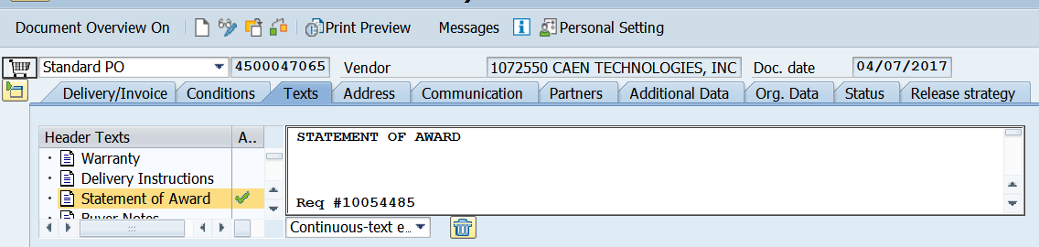

Item Overview Section
Line items: Edit your line item information to match the quote or invoice including item#, model#, etc. Delete ESM_00000 from line item description. On orders where there are validity period dates, the delivery date in this section should be the same as the validity start date. Enter the appropriate material group number in the Matl Group column (for library subscriptions use 42-938-00, library purchases (non-subscriptions) use 24-999-99).
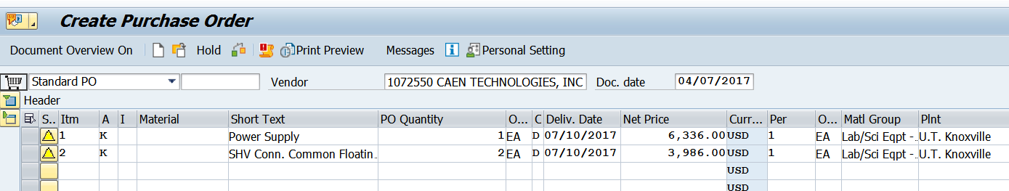
Item Details Section
Account Assignment Tab: The Cost Center or WBS Element, GL Code should be populated with account information from the ESM requisition.
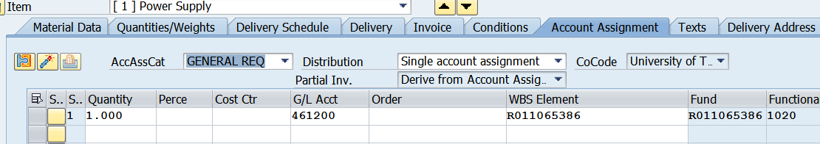
Delivery Address Tab: Delivery address information does not copy over from the ESM requisition. Check the ESM purchase order copy that you saved when you approved the ESM requisition to see how the delivery address should read, search in IRIS for that delivery address number that matches that address. You may need to modify an existing address or create a new one in IRIS (use IRIS transaction MEAN to do that). 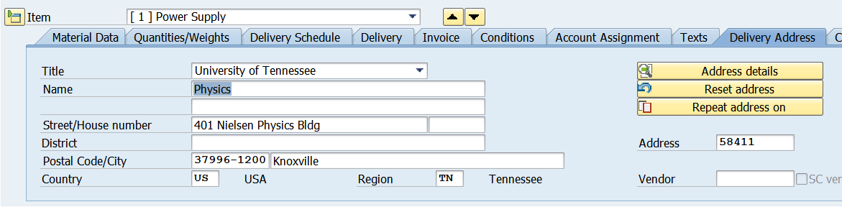

Texts Tab: In the Item Texts column on right, you will see Item Desp/Specs, this field is used for any additional description of the item. If validity dates apply to the order show those dates under the item description.
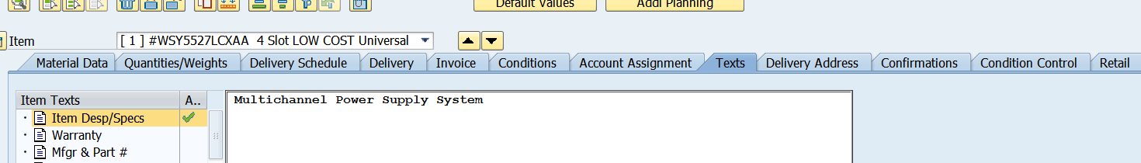

Save Final Pdf copy of IRIS Purchase Order
Click on Messages button at the top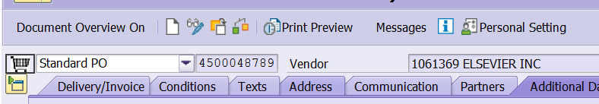

Select and highlight the top line with the Yellow Triangle icon >> click on Trash Can icon >>> hit enter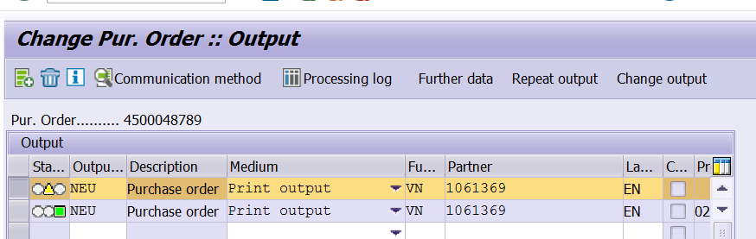

Select and highlight the top line with the Green icon >> click on Repeat output button >> click on SAVE icon at the top
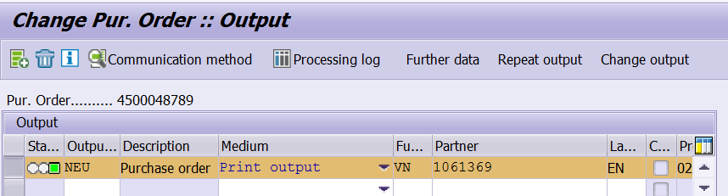
ME29n – Release Individual Purchase Order
The purchase order should automatically show the Release Strategy tab >> click on this icon >> click on the SAVE icon at the top >> this will generate a pdf spool copy of the finalized IRIS purchase order.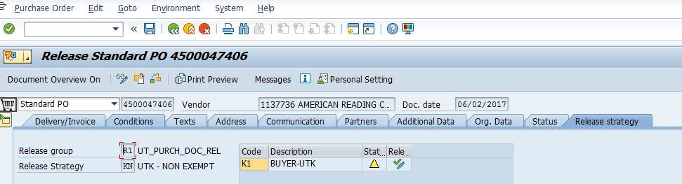

ME28 – Release a Group of Purchase Orders:
You will see the below screen >> enter information as shown below >> then click on the clock icon at the top to
Execute.
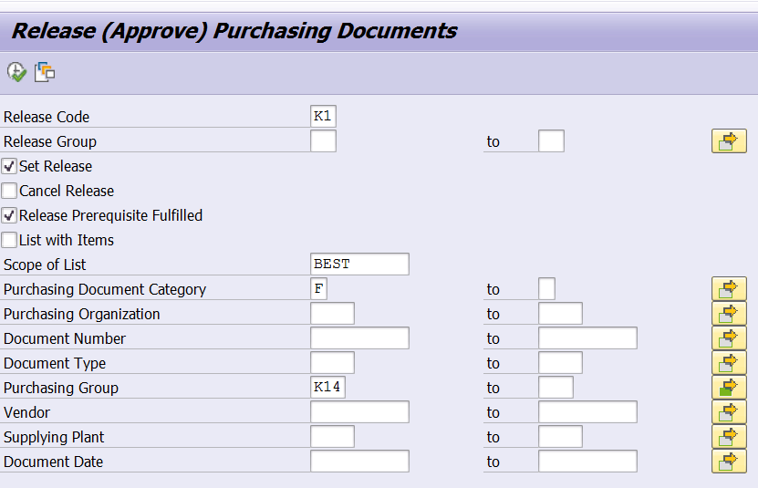

You will then see the below screen. Click on this icon >> it will change to a single green check mark >> this will generate a pdf spool copy of the finalized IRIS purchase order for those purchase orders.
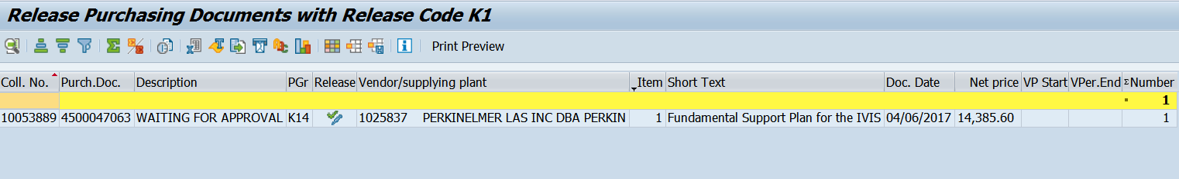

SP02 - Look Up Spool# For Purchase Order
SP02 screen will look like one below. Use IRIS transaction SP02 to look up spools created within the last 8 days to get your spool# for purchase orders you’ve created. You can view the document by clicking on the paper icon. Save that spool copy of your purchase order to a folder created for those. To save the document click to check the box to the left of the spool# >> go to Spool Request in the top left corner Forward >> Export as PDF. When saving the spool copy in the file name box enter purchase order# followed by .pdf. You can digitally sign the purchase order using either Adobe Acrobat or DocuSign.
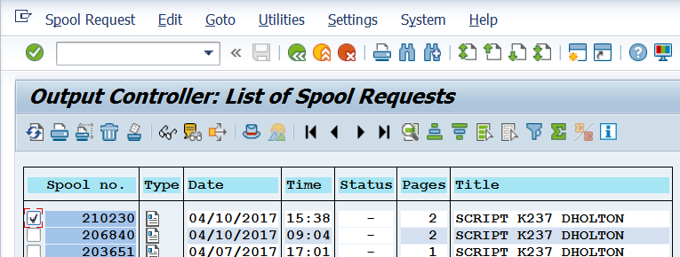
Send The Purchase Order To The Department/Vendor
Always check with the creator of the requisition to see if the vendor needs a copy of that purchase order. If yes, get contact info for vendor from quote or department. Most of the time the department will agree to send the purchase order on to the vendor themselves.
Digitize THE Purchase Order (Attach all related documents to the purchase order in IRIS)
Attached the following documents to the IRIS purchase order in this order:
- Purchase order, documentation showing what price is based on (quote, invoice, price list, etc.)
- Copy of NCJ form (if applicable to the order)
- Copy of grant documentation (if applicable to the order)
- Copy of Master Agreement (if applicable to the order)
- Copy of all emails pertaining to the transaction and purchase order (convert those emails to pdf’s)

Searching

Manage Tab
You can search in your manage tab using the search filters. This will only bring up transactions that have come through purchasing workflow. If a transaction has been submitted by a department but has not come to Purchasing, it will not show up in the manage tab search.

Order Summary
You can search in order summary for all Market Place orders (catalog and non-catalog). Search here if the transaction does not appear in the manage tab search.
First click on the menu icon and then click on order summary
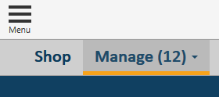

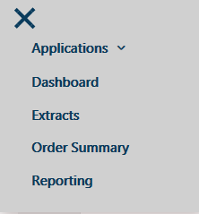

Order summary allows you to search in a variety of ways including by the requester.
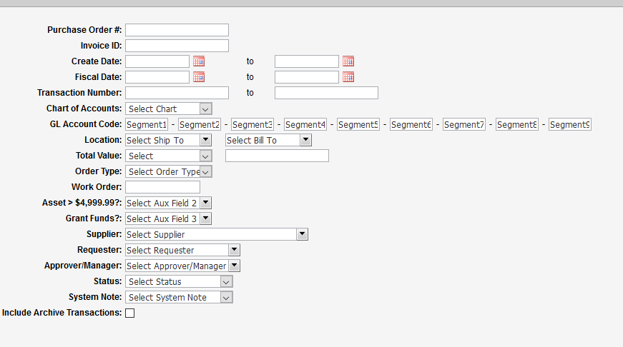

Forward Report
This report allows you to see requisitions that have been forwarded (assigned) to buyers.
Click on menu and then reporting.
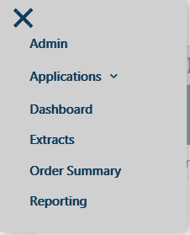
Under “Forward Reports,” click on the one for your campus.
Choose export as and Excel
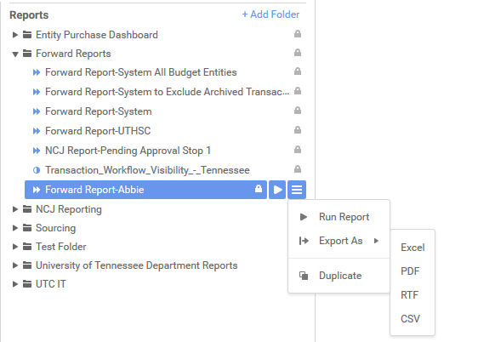

Put in a time frame for running the report and click ok.
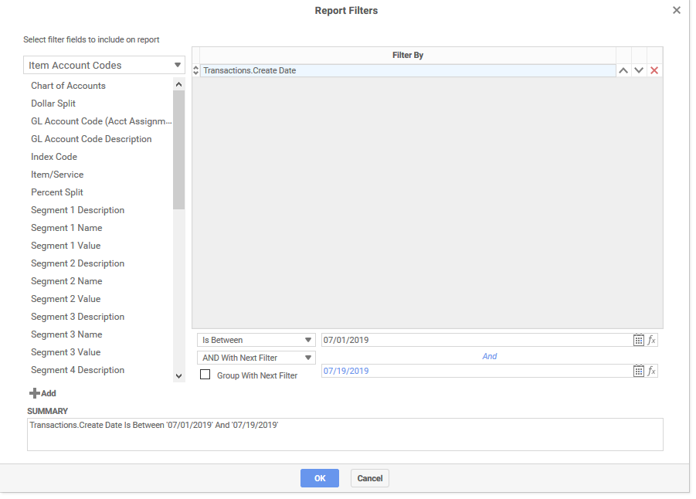

Change Order
If you need to make certain changes to a PO once it has been released, you will need to go back into that requisition and click “Change Order” at the bottom of the screen.
- Click on the Shop tab
- Go to “All Transactions”
- Filter by “Active”
- Enter your requisition (transaction) number
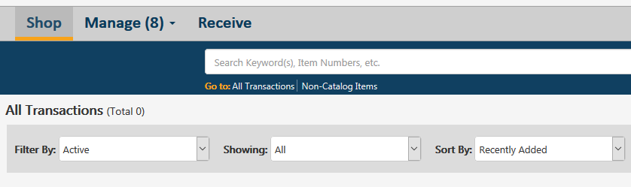
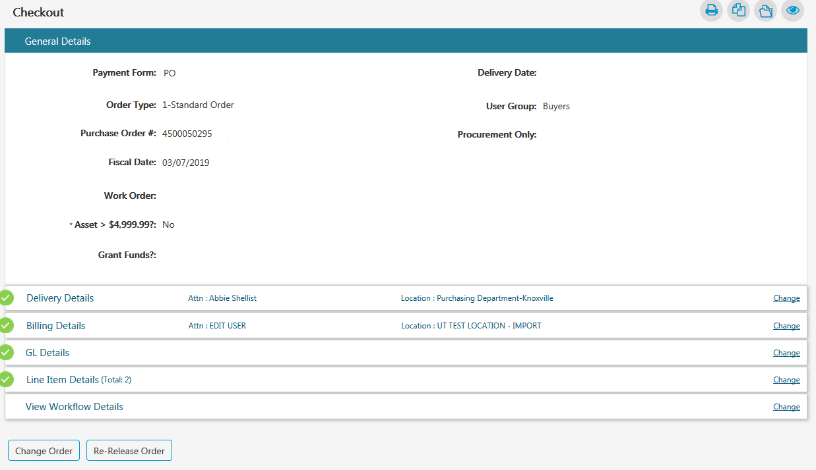
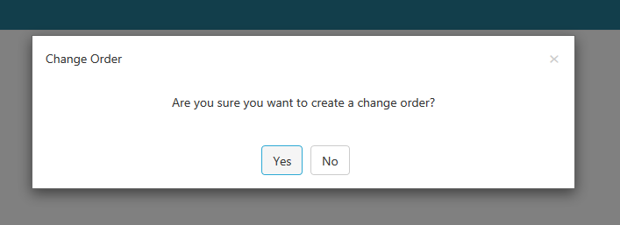

Make the changes and click on “Release PO” and “Place Your Order.”
