|  |
| --- |
| ESM Sourcing System |
| The University of Tennessee |
| Version 3.4 |
|  |
| **3/5/2020** |

Contents

1. ESM Help Desk
2. Moving a Requisition to Sourcing
3. Template Selection
4. Addendum 1: System Office Instructions
5. Accessing Sourcing System
6. Naming the Event
7. Requested By
8. Mandatory Fields
9. Sealed Event
10. Attachments
11. Invitation Type
12. Invitation Only
13. Supplier Terms & Conditions
14. Display Awardee
15. Q&A
16. Event Sections
17. RFP
18. Allow Attachments
19. Adding Event Sections
20. Event-Specific Terms
21. Line Item
22. Changing the Order of Sections
23. Importing a Spreadsheet
24. Attaching a Document
25. Saving Bid File
26. Publishing
27. Publishing to Posting Board
28. Addendum
29. Attaching an Addendum Document
30. Addendum History
31. Bid Responses
32. Checking Response Status
33. Reviewing Bid Responses
34. Bid Tab
35. Bid Tab Report
36. Removing Bid from Posting Board
37. Linking Vendor
38. Unlinking Vendor
39. Propose Award
40. Award to No Responses
41. Retract Award
42. Create PO
43. Walk-In Bids
44. Copy a Sourcing Event
45. Rebid
46. Bid that Results in a Contract
47. Clearing your Browser Cache

## ESM Help Desk (top)

Under your name click on “help” and you will be directed to ESM’s website where you can find additional instructions.

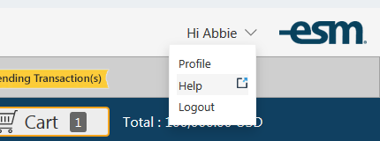

## Moving a Requisition to the Sourcing System (top)

Assigned requisitions can be accessed through your manage tab. At the bottom of the requisition you will click on the sourcing button.

NOTE: It is important to know that if you need to make any changes to the line items when you do a bid, or if you need to change the order type from standard to framework, you must do so BEFORE you push the req over to the sourcing system. Once you have pushed to sourcing, you can change the line items but those changes will not be reflected when you push it back to Purchase in order to create the PO.

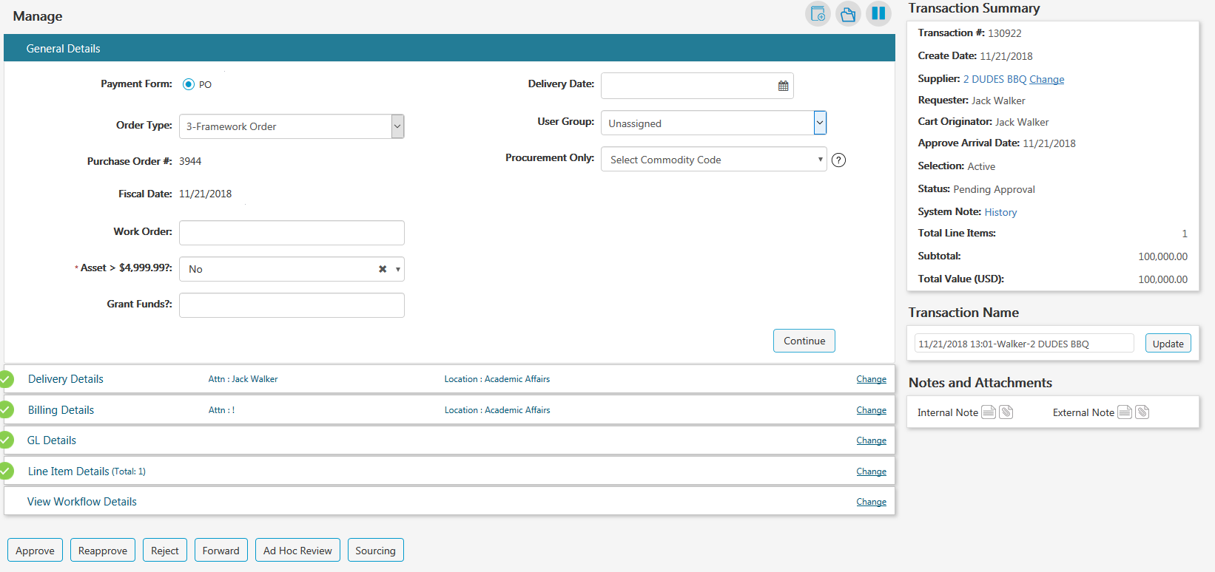

## Template Selection (top)

You have three choices: RFQ, RFP or RFQ-S. If you are in the System Office, you will need to select the template that starts with “System.”

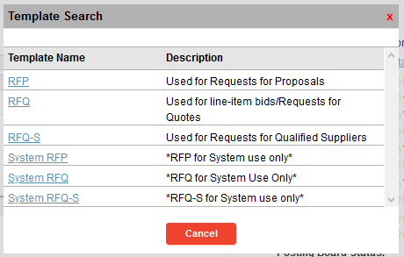

**\*\*System Office\*\*** – Please see Addendum 1 for system-specific instructions on the bid templates.

## Accessing Sourcing System (top)

From the Menu, select Applications and click on ESM Sourcing



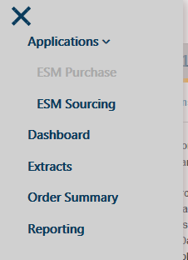

Search for your event, and then click on the event name.

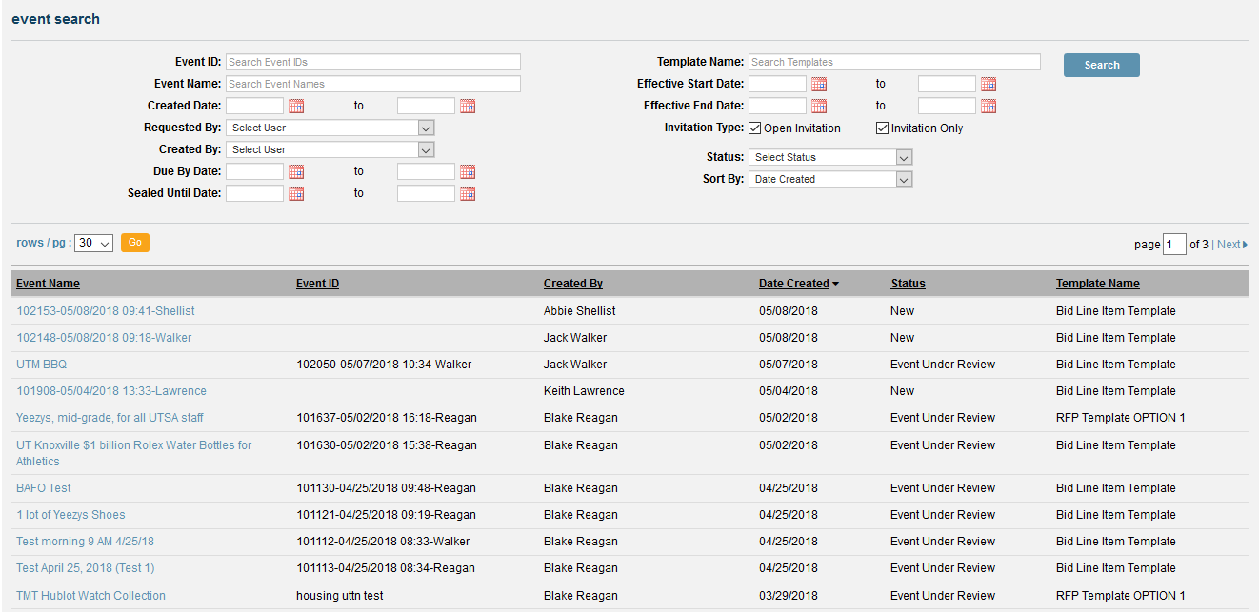

## Naming the Event (top)

Drag or cut and paste the Event Name into the Event ID field and change the Event Name using the following format:

**Campus: Requisition Number, brief description of the sourcing event (category of purchase)**

*Example: UT Knoxville: 1084531, Labrador Retriever Puppies (Animals)*

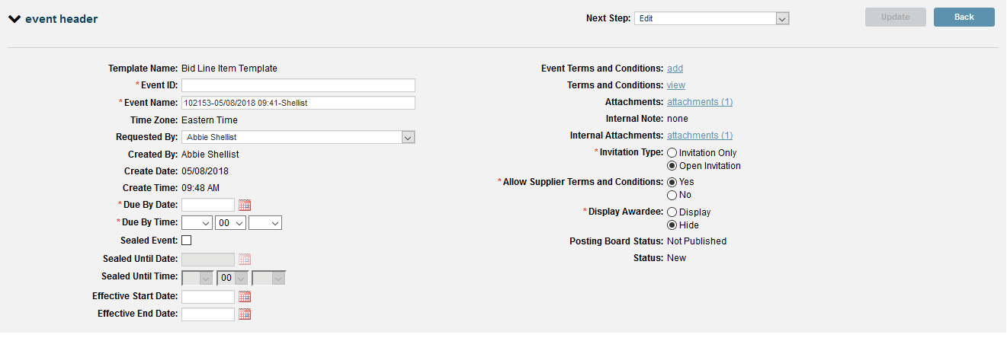

## Requested By (top)

This is a **VERY IMPORTANT** step

The requested by field is populated with the name of the person who created the requisition. You will need to replace this person’s name with your own name by entering it into the search field.

*\*If you do not change the requested by field to your name, the email notification that goes out to all potential bidders will have the name and email address of the department person who entered the requisition in it and not the buyer contact info.*

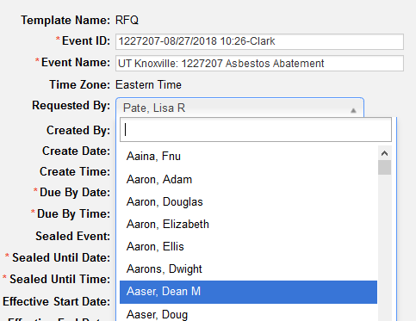

## Mandatory Fields (top)

Fill out the following mandatory fields:

* Event ID
* Event Name
* Due by Date
* Due by Time
* Sealed Event
* Sealed Until Date (should match your due by date)
* Sealed Until Time (should match your due by time)

## Sealed Event (top)

You must always choose that the event is a sealed event. Without selecting sealed event, the responses would be open for viewing at any time.

## Attachments (top)

On the right side of the screen you will be able to add documents and attachments. Remember, any external and internal attachments on the requisition will appear in the sourcing event. You may need to remove or edit attachments that come over. You will attach your RFP, RFQ-S, or RFQ document to “Attachments.”

Internal attachments will not be visible to the bidders.

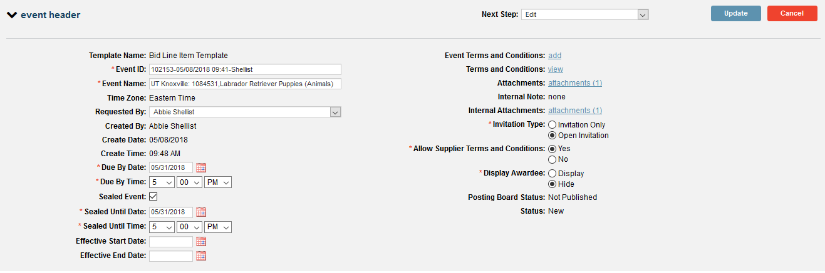

## Invitation Type (top)

Invitation only allows you to select suppliers when publishing. Open invitation allows all suppliers within the ESM supplier community to respond.

This defaults to open invitation which is the preferred invitation type.

Choose invitation only or open invitation

Best practice is to choose open invitation.



## Invitation Only (top)

To invite specific suppliers only, click on “invitation only” and then click Publish.



A screen will open and allow you to invite suppliers that are already registered with ESM Solutions or you can also invite unregistered suppliers. The Advanced Search option gives you more methods of searching, including a search by NIGP code.

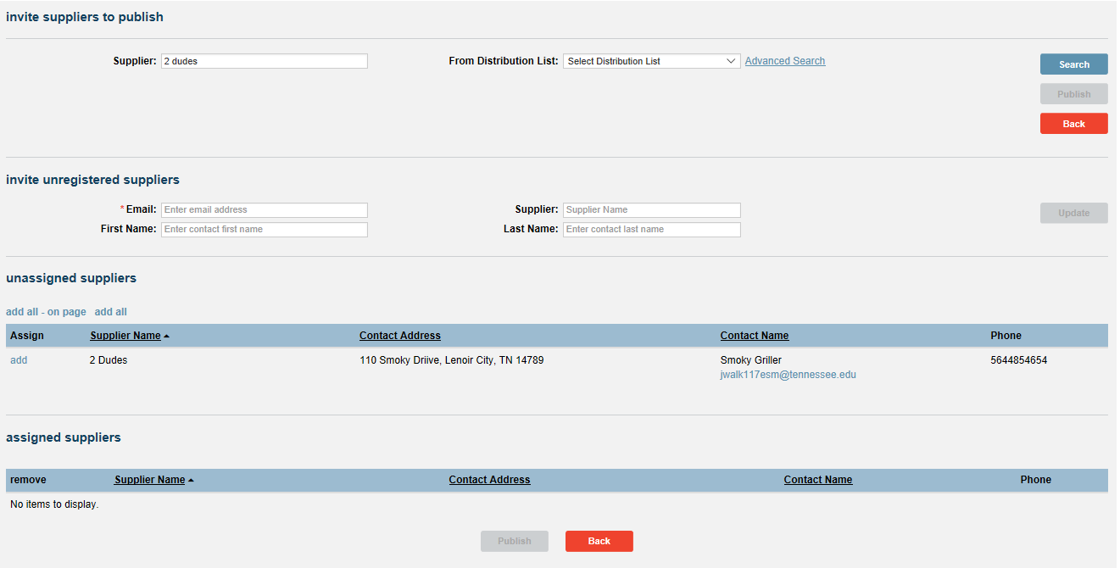

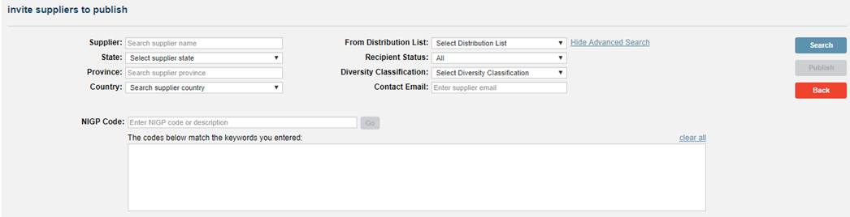

After you have added them, click on Publish.

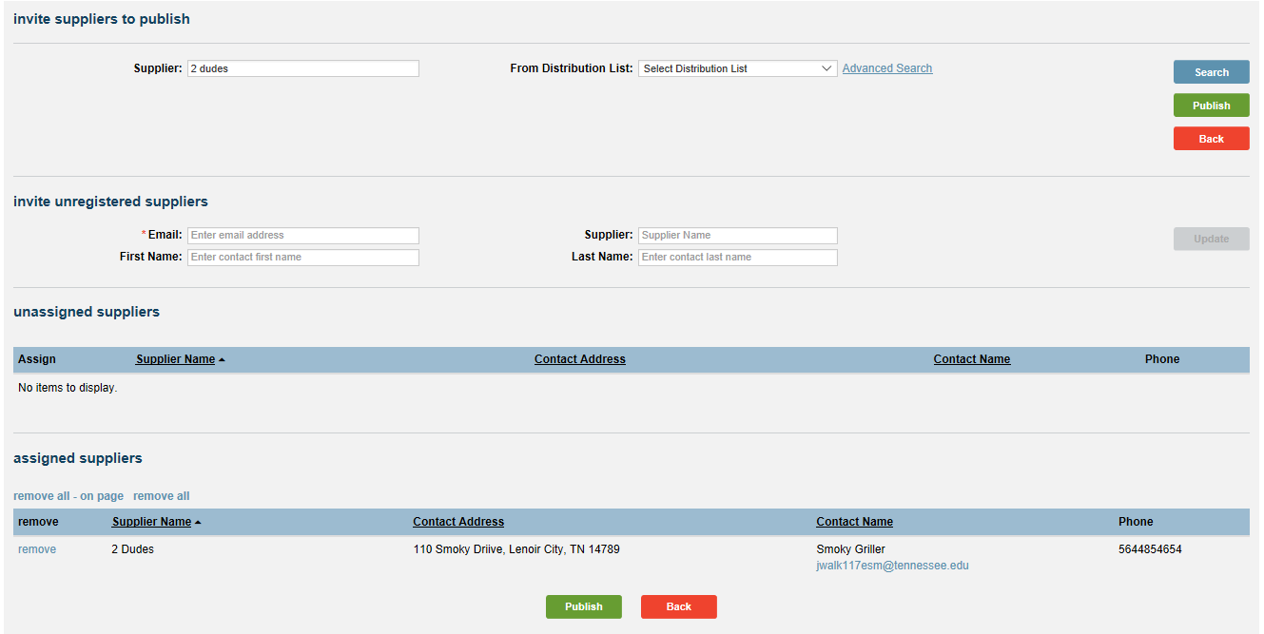

## Allow Supplier Terms and Conditions (top)

This defaults to “No.”



## Display Awardee (top)

Make sure this is always set to hide. If you select display, this would allow all non-awarded suppliers to view the awarded supplier.



## Q&A Field (top)

The ESM Sourcing System contains a section called Q&A. We do not want to use this functionality since the solicitation documents advise proposers to submit questions via email directly to the solicitation coordinator.

Right before you are ready to post your bid, please set the Q&A cutoff date and time to the minute or two after you will be posting the bid. This will ensure that proposers will not be able to use the Q&A functionality.

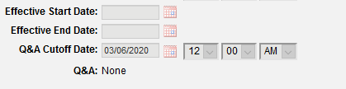

## Event Sections (top)

The RFQ, RFP and RFQ-S templates will load into the event section box (depending on which solicitation type you choose). In addition, the DBE introduction letter and business classification form load in to each bid.

## RFP (top)

When you select the RFP or RFQ-S templates, Event Section 1 RFP or Section 1 RFQS will include directions for submission.

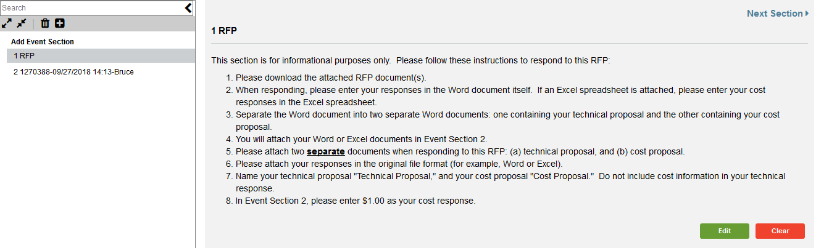

Section 2 (the line item from the requisition) is automatically named the event ID. Rename the line item and call it Event Section 2 for all RFPs and RFQ-S and click “update.” This corresponds with the directions to proposers.

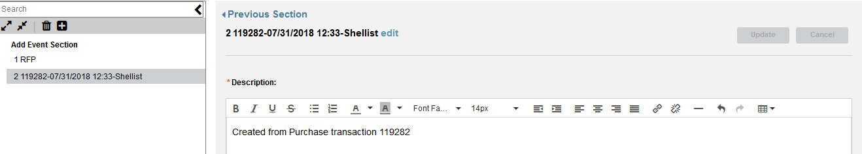

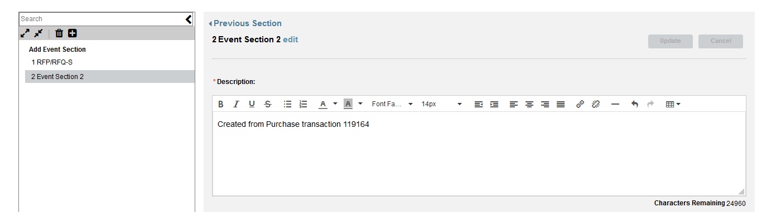

## Allow Attachments (top)

Be sure to click on the boxes for Supplier Attachments. This is what will allow the supplier to attach their RFP or RFQ-s responses. If you do not check these boxes, the suppliers cannot attach anything.

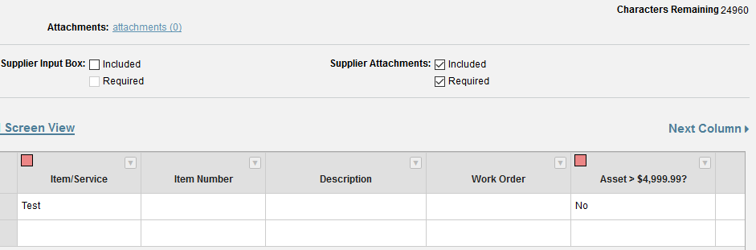

## Adding Event Sections (top)

To add additional section, just click on the plus sign and choose the type of section to add from the “section type” drop-down menu. This would be helpful for adding an additional line item, question and answer section, etc.

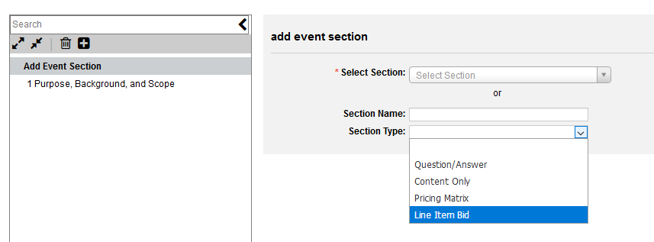

## Event-Specific Terms & Conditions (top)

Please do not use this section. Any event-specific terms should be included in your RFP or RFQ-S template and any event-specific terms for an RFQ should be included in the Purpose, Scope and Background.

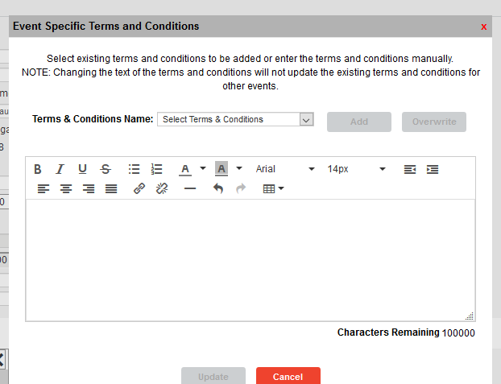

## Line Item (top)

Click on the event ID to get to the line items.

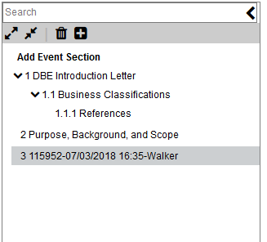

Click on the arrow next to one of the column headings.

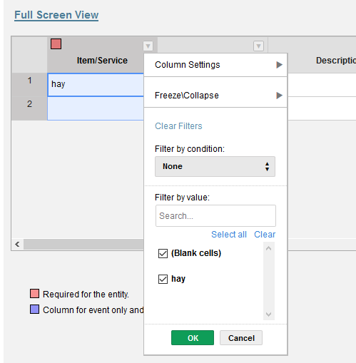

Go to Column Settings → Edit Column Configurations

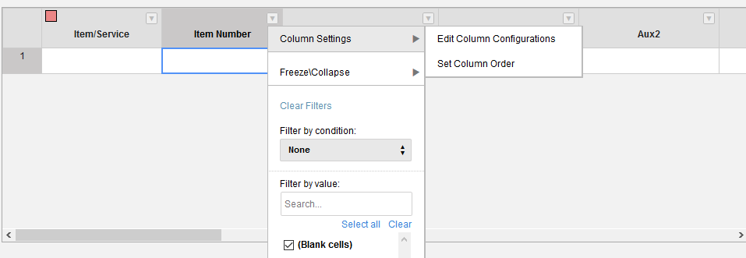

For column labels Aux 1 and Aux 2, click on hidden for both supplier & entity then click Update.

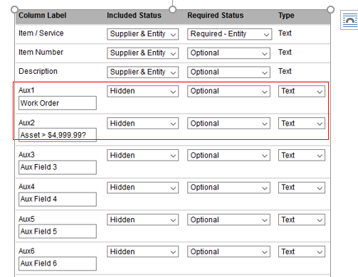

## Change the Order of Sections (top)

You can rearrange the order of the columns by Go to Column Settings → Set Column Order and drag the column headers into the order you want them. The click update.

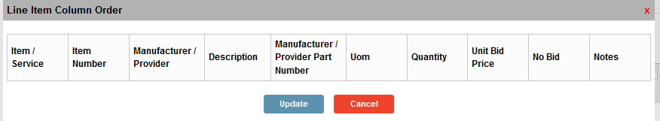

*Columns with a purple square in the upper left corner are only visible to the buyer.

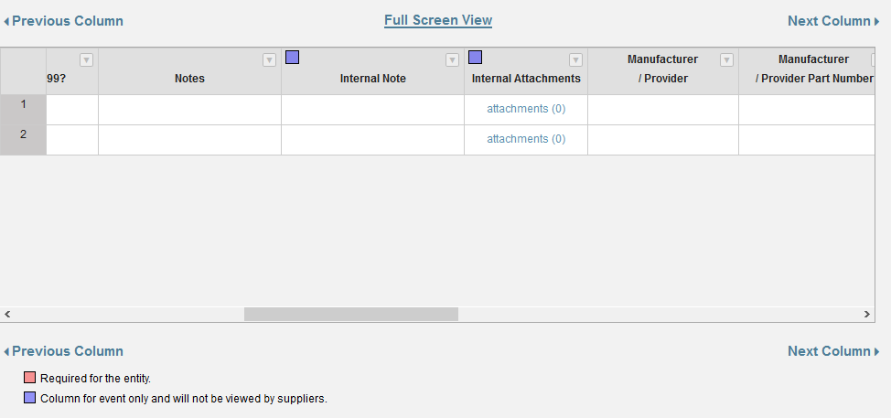

## Importing a Spreadsheet (top)

**Note, currently the ESM system will not convert altered line items in a bid to transfer over into the purchase order. You must change the line items in the requisitions BEFORE pushing that requisition to the sourcing system.

If you have a spreadsheet of line items, you can copy and paste them into the line item section.

First copy the spreadsheet you want to import. In the first cell of the line item section, use control v to paste the copied spreadsheet.

## Attaching a Document (top)

In the line item click on attachments.

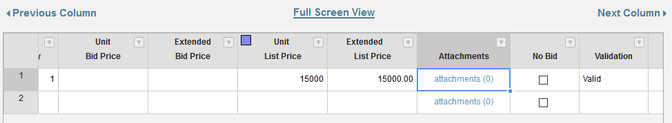

After you select the document to attach, you will need to name the file in the file description field and click update.

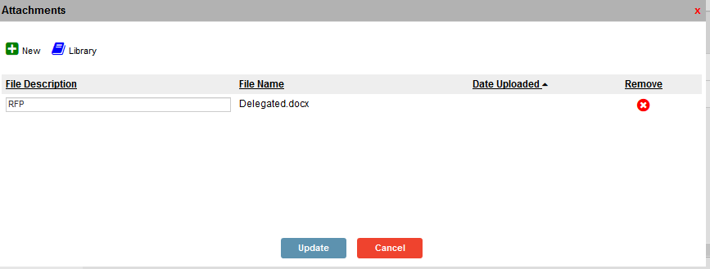

Your line Item will now show there is an attachment.

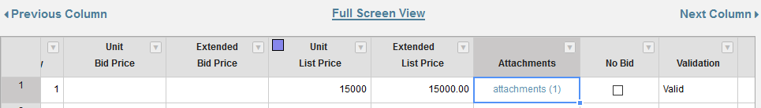

Click update when you have entered all the information and made any changes.

## Saving a Copy of Your Bid for the Bid File (top)

You must “print” your bid prior to the bid closing to make sure you have a copy of the bid to attach in IRIS as part of your bid file. From the next step menu, select print.

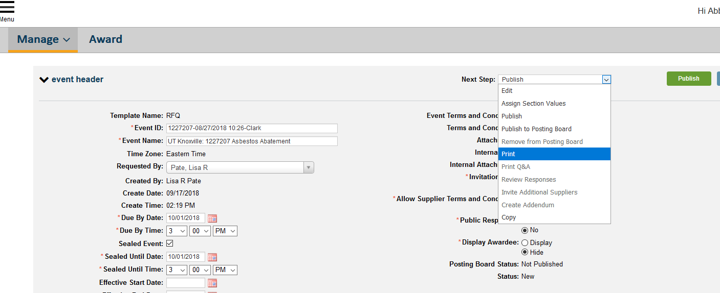

Save your file.

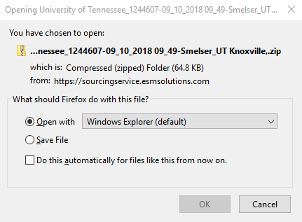

The Excel worksheet has two tabs. On tab 1 you will see the line item detail. You will need to expand the columns and wrap the text to make it readable. Both the excel file and the PDF should become part of your bid file (in addition to any attachments that are associated with the bid).

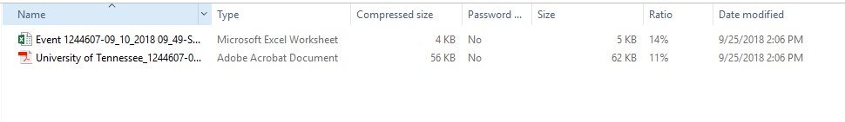

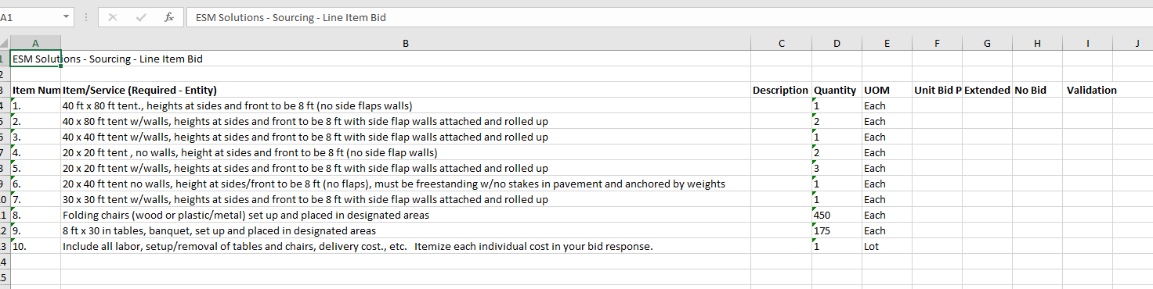

## Publishing (top)

When you click Publish for the first time, this publishes the bid to the supplier database.

Click on Publish again and you will get this message:

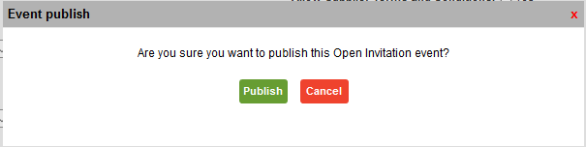

## Publishing to Posting Board (top)

You will manually need to publish your bid to the posting board.

In the next step dropdown menu, select *publish to posting board*.

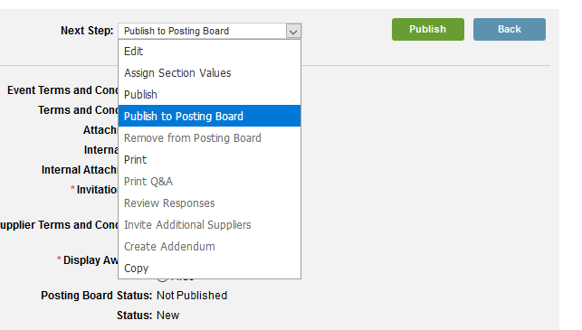

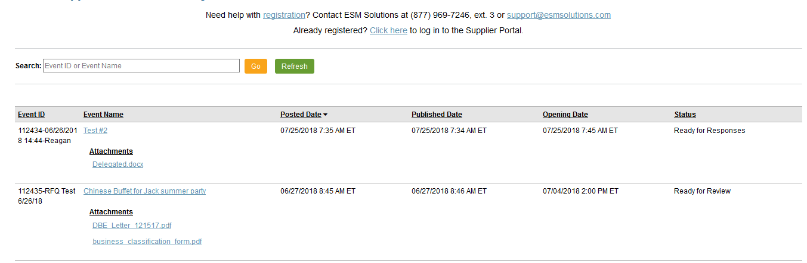

## Addendum (top)

If you need to make an addendum, go to the Sourcing System and select your sourcing event. In the next step, you will see Create Addendum.

Make the changes to your event (for example, change the due by date) and click update.

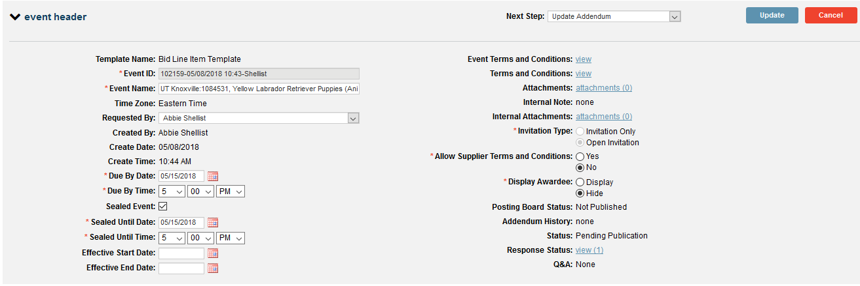

It is a best practice to create a document and number it Addendum #1, #2, etc. You can upload the document before publishing the addendum to the Posting Board. First, you will create your addendum and then you will publish it.

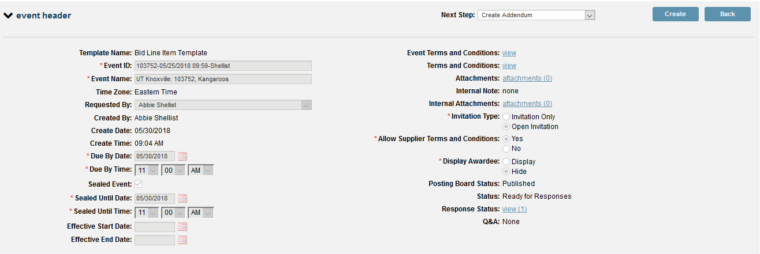

Click on Publish to publish your addendum.

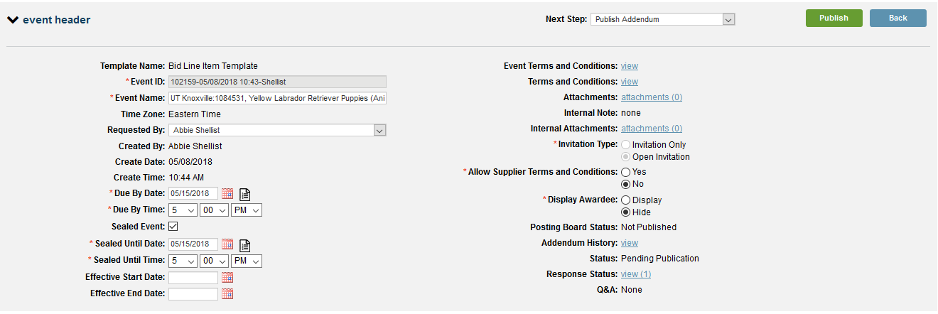

## 

## Attaching an Addendum (top)

To add an attachment (use this method when creating an addendum to an RFP or RFQ-S), click on the attachment link

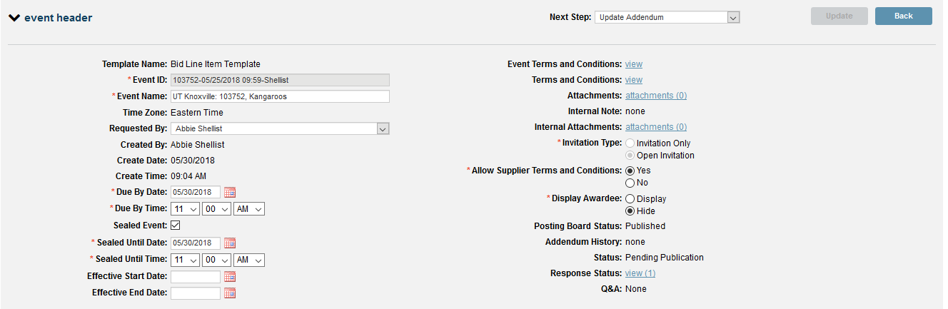

Click on the new button and select the attachment you want to upload.

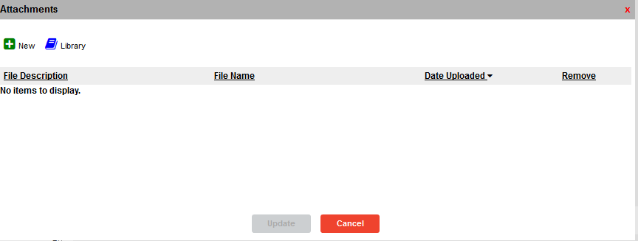

Give your attachment a name and click update.

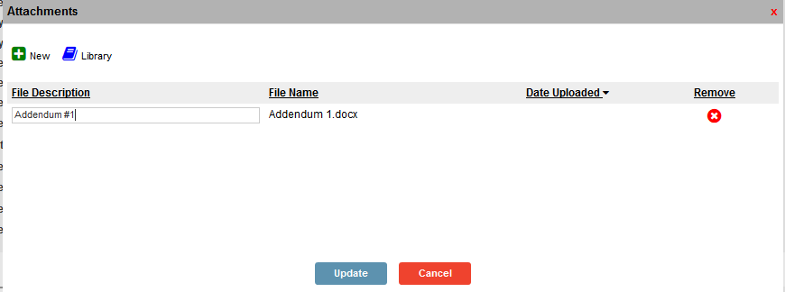

Then click on the Next Step: Update Addendum and click the blue update button.

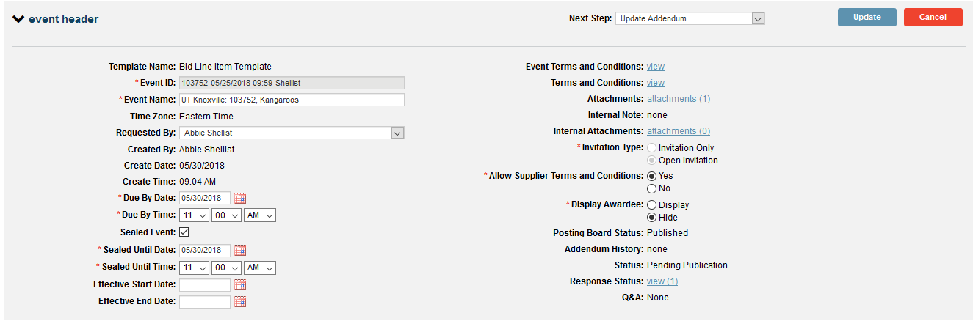

Publish the Addendum

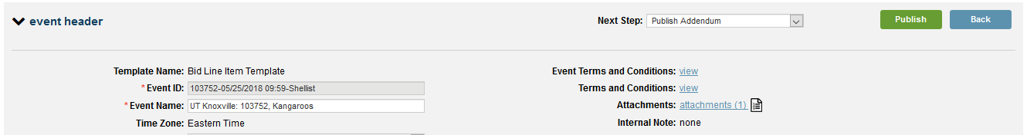

You will be asked to review your changes. Once you do, click publish to send it to the posting board. The text you enter into the Addendum Note will be sent to suppliers.

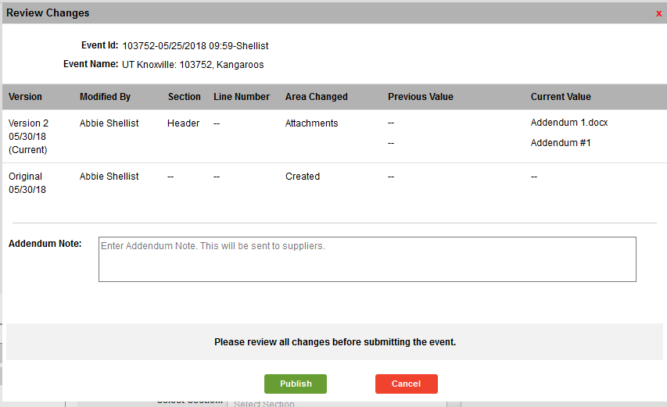

You will be shown the changes that were made and you can add an addendum note that will be sent to suppliers.

Here you can see your addendum (attachment) on the posting board.

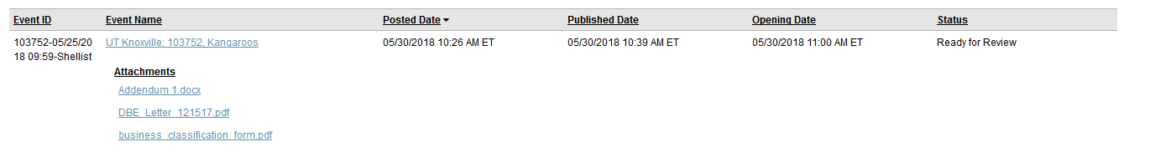

## Addendum History (top)

In the event header of your bid, you can check the addendum history by clicking “view.”

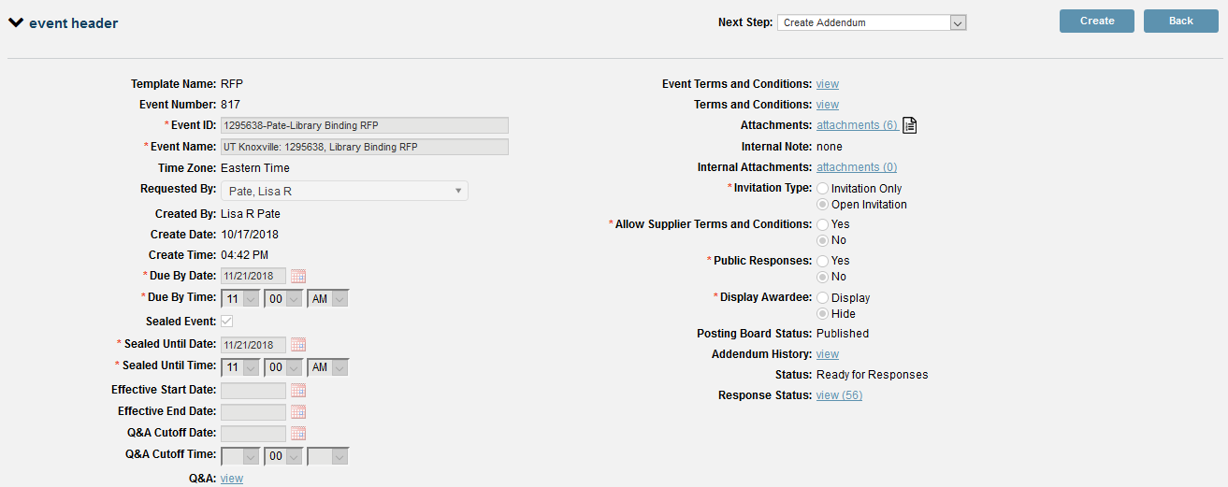

This will give you a log of all the changes made to the bid through addenda. Because this screen isn’t printable, it is best practice to issue your addenda as Word documents so you will have a record for your bid file.

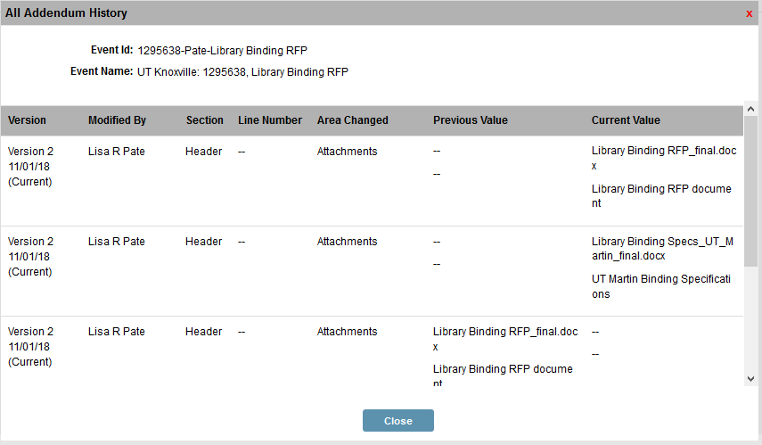

Bid Responses (top)

When a vendor responds to a bid, you will receive an email like this:

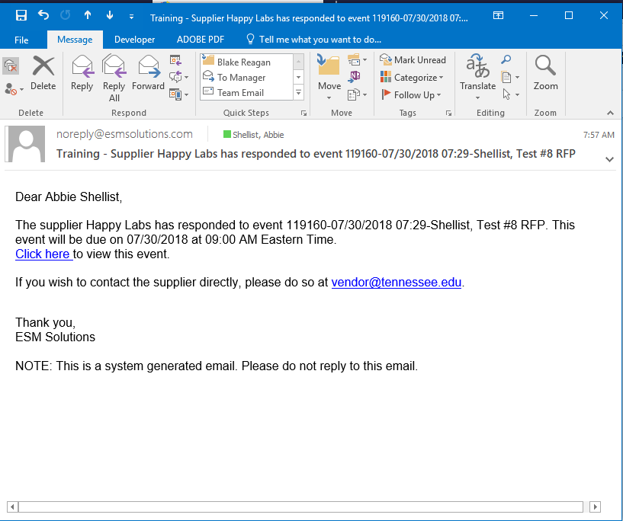

## Checking Response Status (top)

You can click on “response status” to see how many people have viewed and responded to the bid.

## 

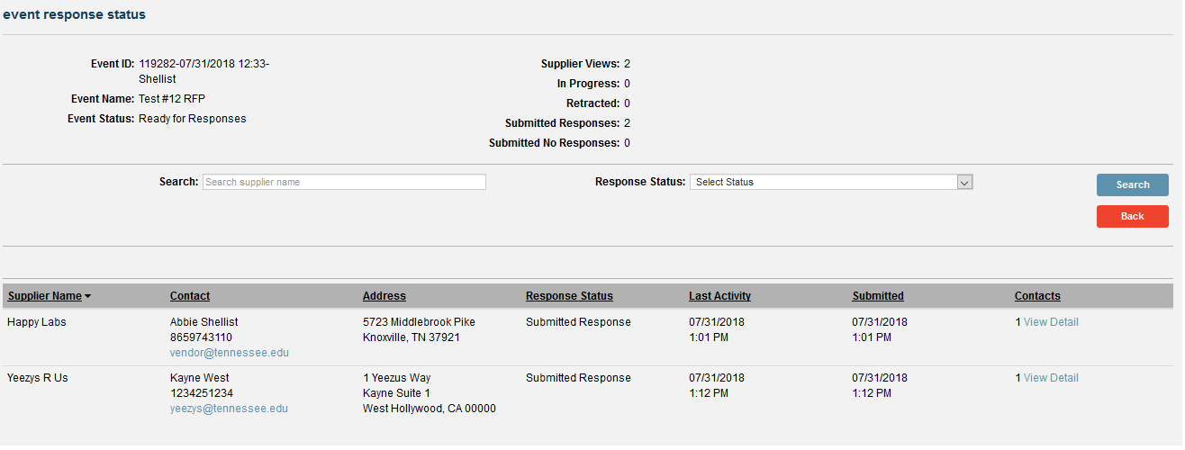

## Reviewing Bid Responses (top)

Under Manage, click on existing and choose your event.

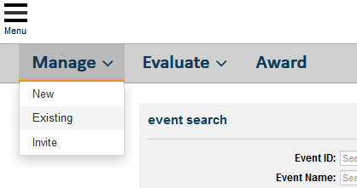

Click on the event you want review.

Under next step, click on review responses.

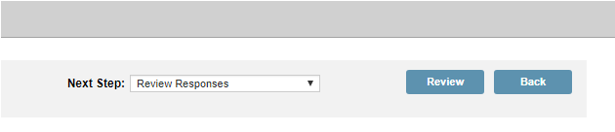

You will get the following message. Click yes.

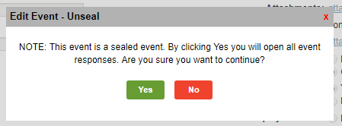

Next step: review responses

Review responses unseals the bid. Once someone has reviewed the response, it is open and others can compare responses.

## Bid Tab / Compare Responses for an RFQ (top)

From the “review responses” step, select “print” from the next step drop down menu.

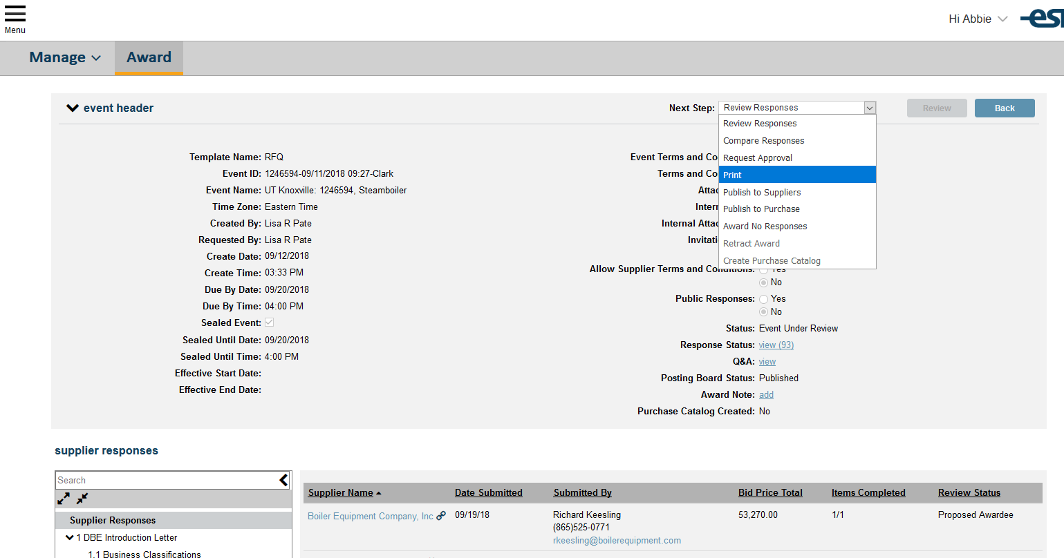

Open the Excel document from the compressed file.

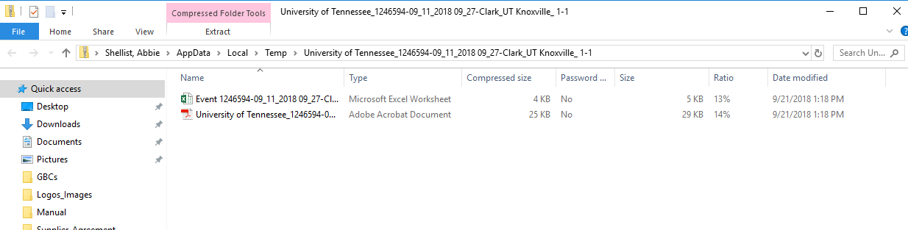

Click on the tab of the spreadsheet labeled “1” and you can compare the responses

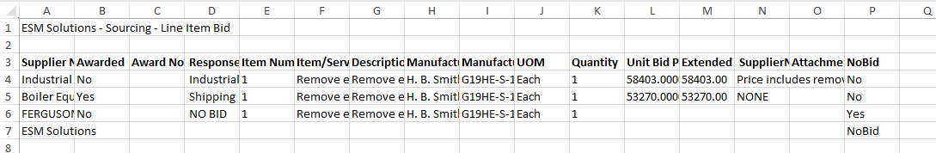

## Bid Tab Report (top)

To get your bid tab into a more readable comparison (especially when you have multiple line items being bid) you will need to run a report.

1. From the Market Place menu, select “Reporting.”

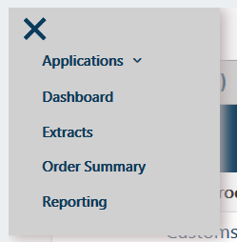

1. Go to the Sourcing folder and select Supplier Tabulation Report and export it to Excel.

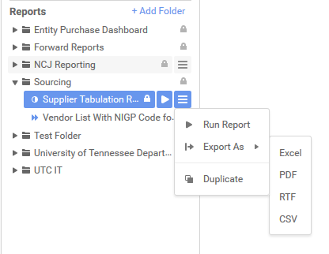

1. In the report filter, enter the event number and click OK.



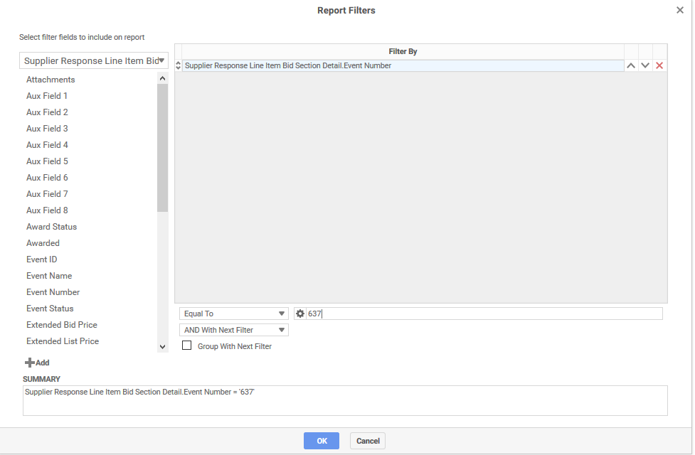

1. Your report will generate and look like this:

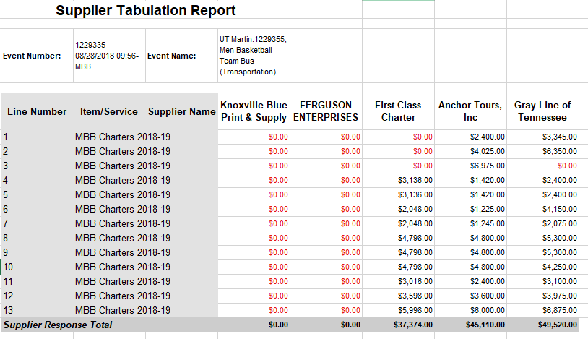

## Remove Bid from Posting Board (top)

Once your bid has closed, please remove it from the posting board. To do so, you must be in the **manage tab**.

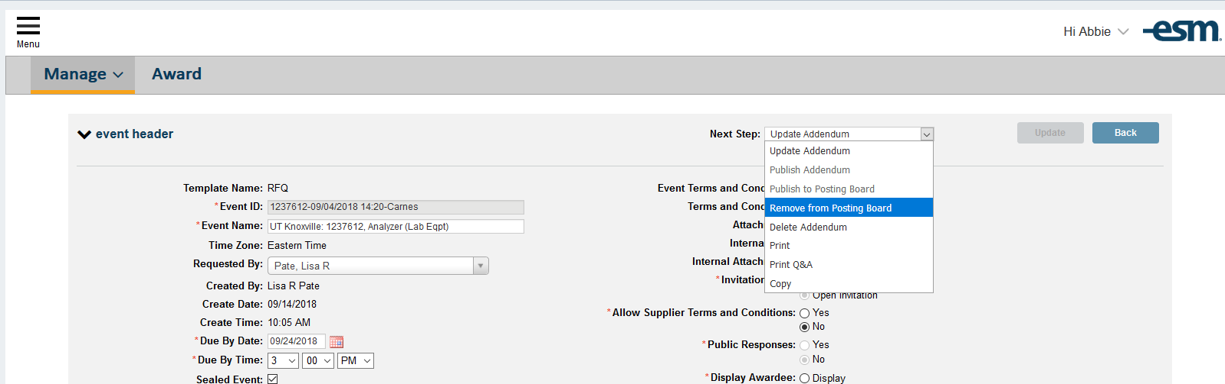

## Linking the Vendor (top)

Before you can push the award to the purchase system, you must make sure your vendor is “linked” to a vendor that has a vendor number in SAP. If you make a mistake and link to the wrong vendor, you can change the link to the correct vendor but *only prior to awarding* the bid.

Here the vendor has a broken link next to the vendor name. This means it is not linked to an existing vendor number.

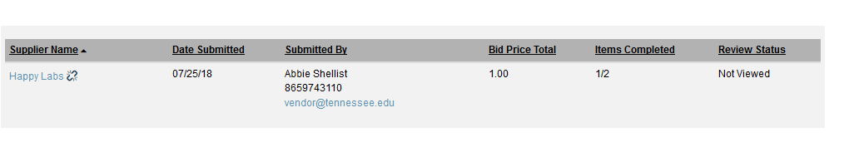

Click on the vendor name and another window opens where you can enter in an existing vendor name.

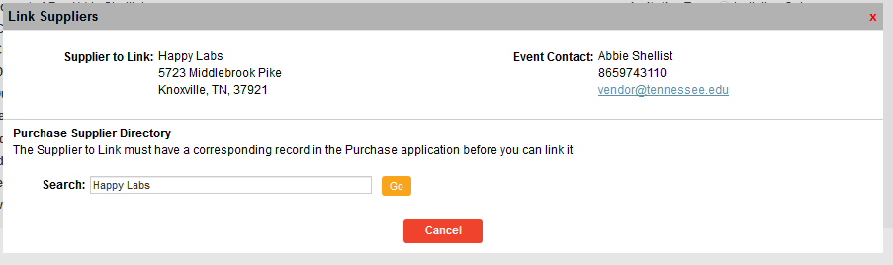

Once you pick the correct vendor name, clink on “link” and the bidder is now associated with that vendor.

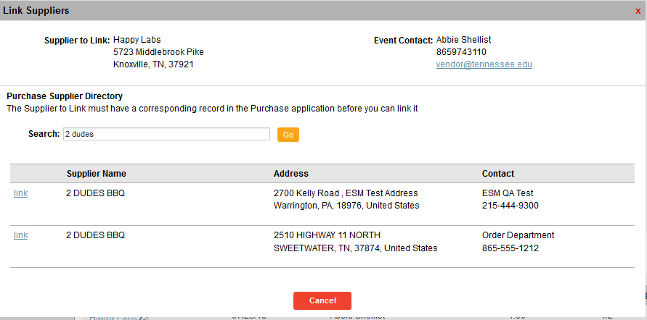

Once linked, you will see the link is no longer broken.

## 

## Unlinking Vendor (top)

To change the link from one vendor to another, click on the link.

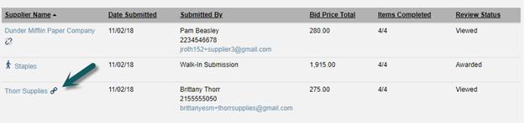

This will bring up information on the current vendor. If you enter the vendor you want to change the link to, enter the name in the Purchase Supplier Directory.

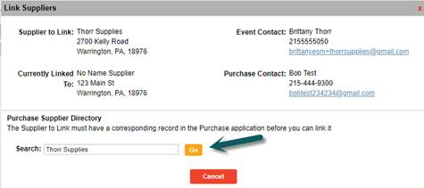

## 

## Propose the Award (top)

Once you have decided which proposer to award to, you will need to click on “Propose Award” next to the line item of their proposal and click update.

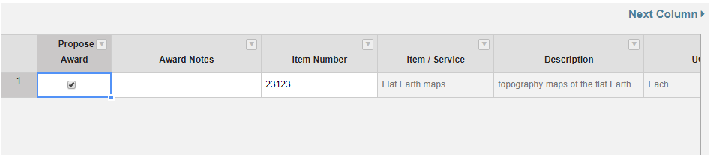

## Award to No Responses (top)

If you will not be making an award, choose “Award to No Responses” in the Next Step dropdown menu.

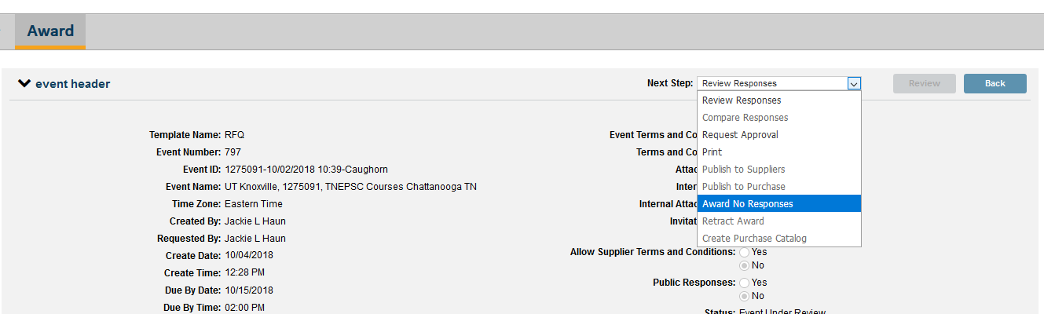

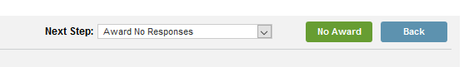

When you award to none, the requisition associated with that bid will disappear from your manage tab. You can still look up the transaction but your only options are ad hoc review or archive.

## Retract Award (top)

From the Award Tab you are able to retract the published event award using the Next Step dropdown.

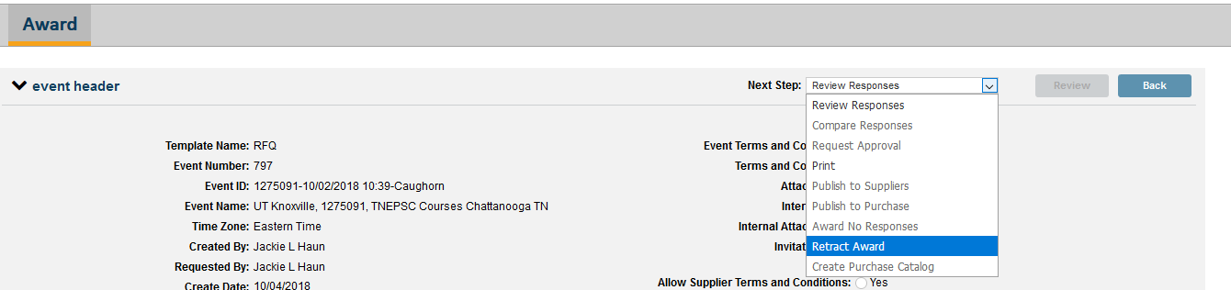

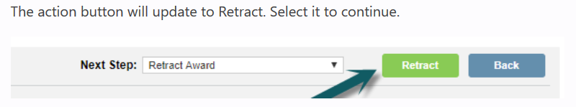

The buyer has two options regarding supplier communication:

1. Send an email notification to all suppliers who responded to the event
2. Do not send a notification of the retraction

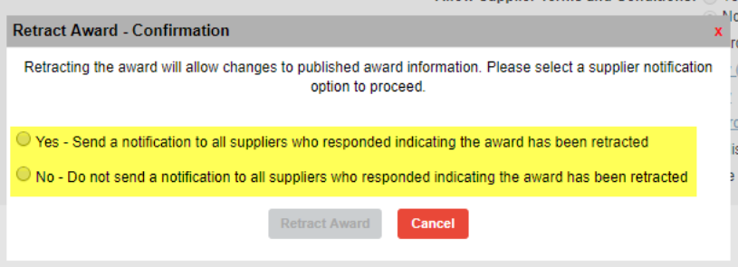

Select the appropriate option and confirm the action. You may publish the award to a different supplier after the retraction is complete.

## Creating a Purchase Order (top)

In order to “flip” your bid into a PO, you will need to select “Publish to Purchase” from the next step dropdown menu and click Publish.

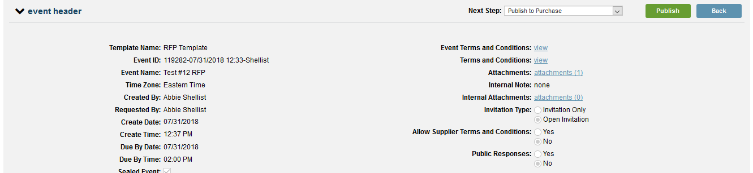

Click “yes”

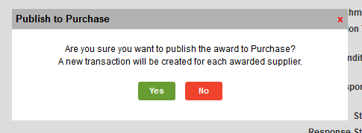

Your next step is to go into ESM Purchase and work on the PO that has been created.

## Walk-In Bids (top)

Creating a walk-in bidder

The best practice for handling walk-in bidders is for each procurement agent to create a unique ESM Solutions Sourcing profile for each walk-in bidder.

The first step is important: please notify the bidder of what you are doing. They will receive an email about their account, so please let them know to expect the email from ESM.

Go to esmsolutions.com. Click on “login.”

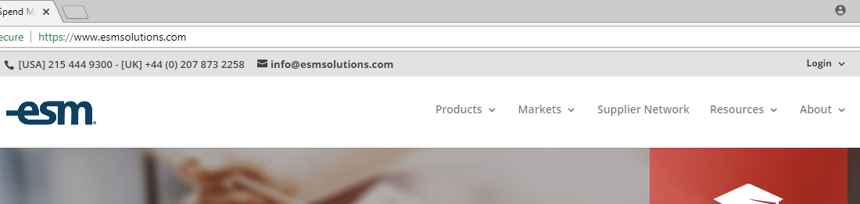

Click “Supplier Login.”

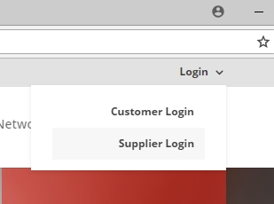

Be sure to locate the ESM Solutions version. Do not select eSchoolMall or Mercury.

Click “Not Registered?”

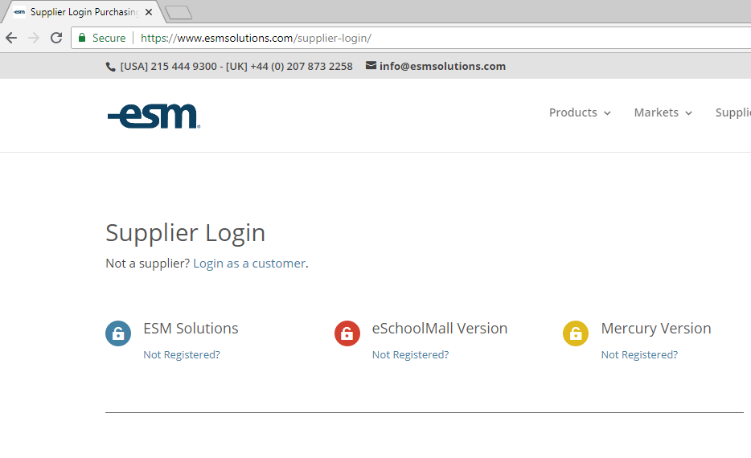

Fill in correct information for the supplier/bidder, and complete the registration. Be sure to use a password that you will remember so you can log in as the bidder.

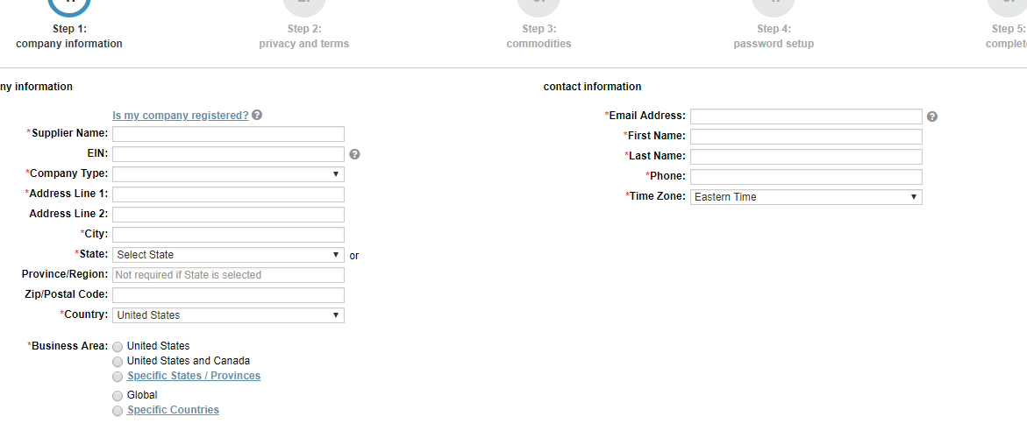

## Entering the Walk-in Bid

Supplier Portal

Click on the bid you want to enter a walk-in bid for.

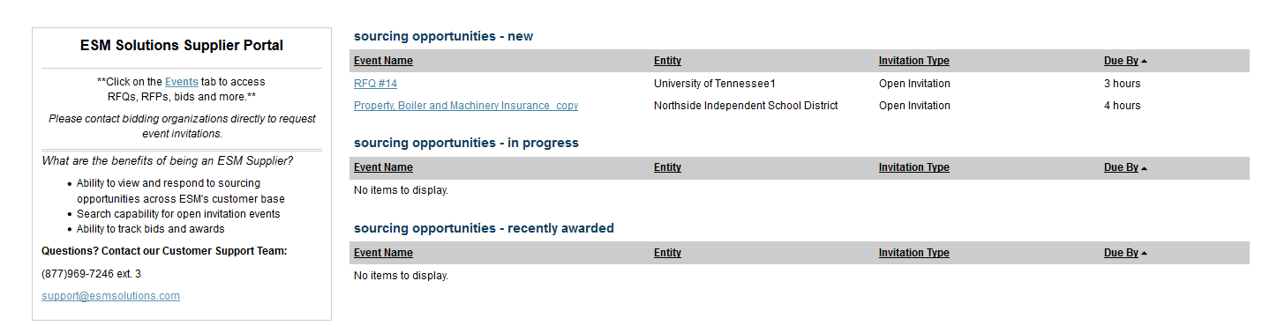

Go through each section and enter the information required.

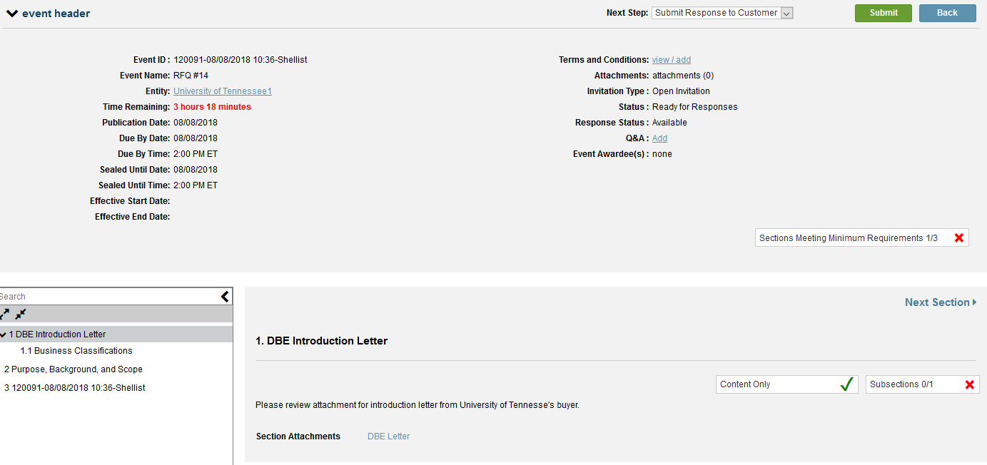

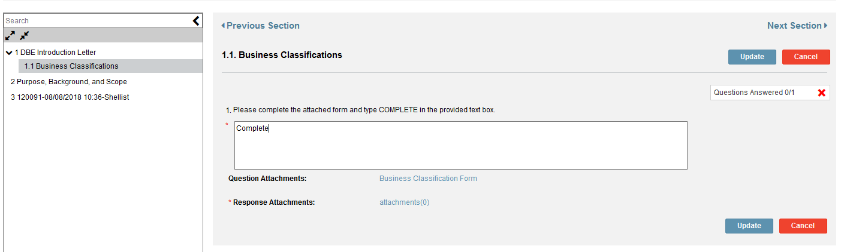

Insert pricing into the line item

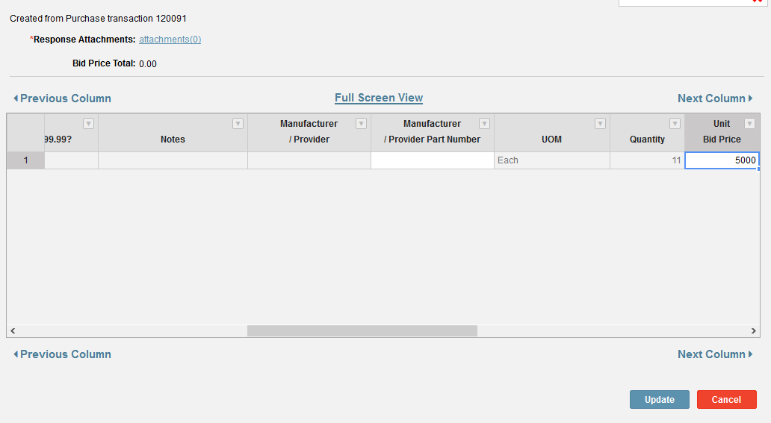

Click Submit

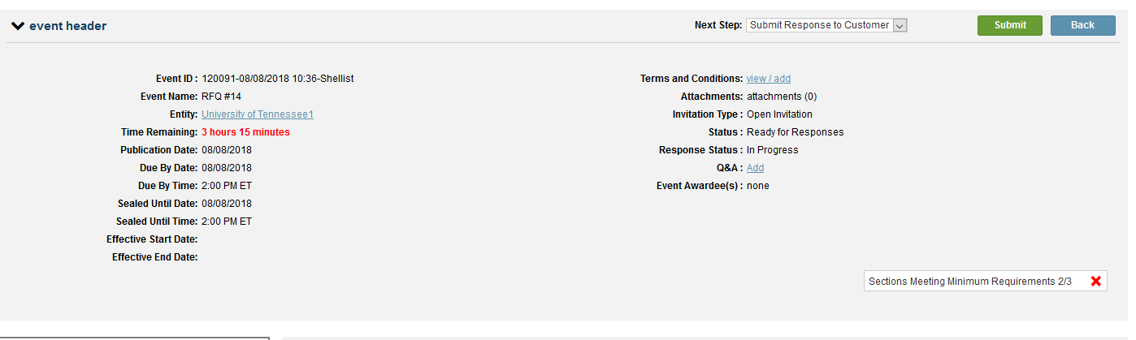

You will need to accept the university’s general bid conditions and your bid will be submitted.

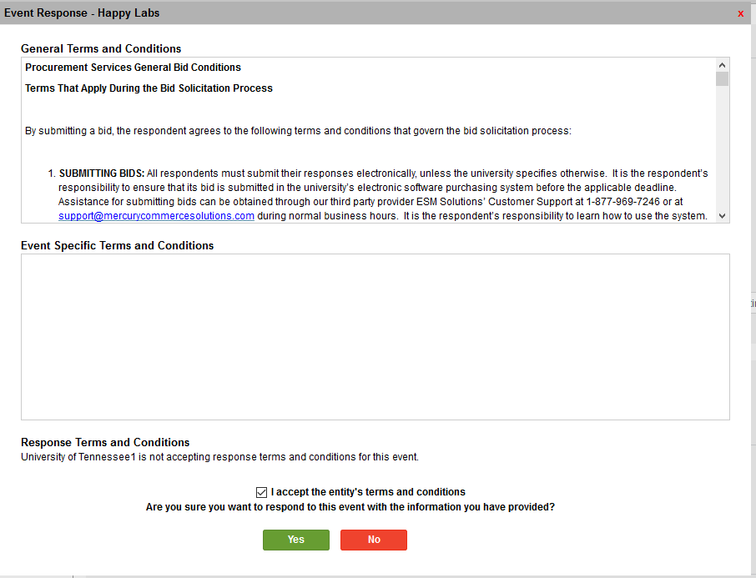

## Copying a Sourcing Event (top)

There is an option to copy your sourcing event. If you copy a bid, it is important to note that you **cannot** “flip” the award into a PO. Instead, you will need to manually create a PO.

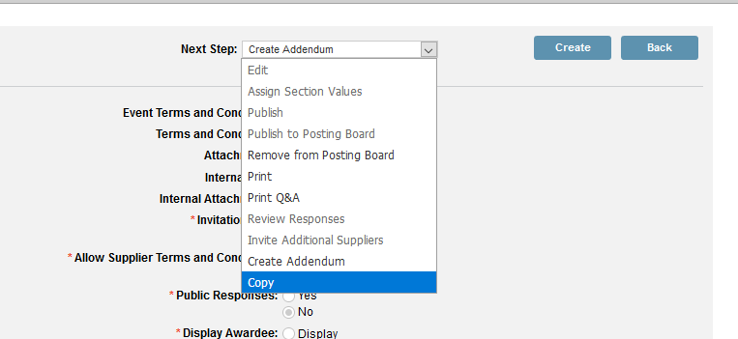

## Rebid (top)

Once a transaction (non-catalog order) has been pushed into Sourcing, it cannot be used again if the sourcing event needs to be rebid.

1. Create a new requisition using the “buyers” user group. This will ensure that the requisition does NOT go through workflow and you should be able to send it to sourcing immediately.

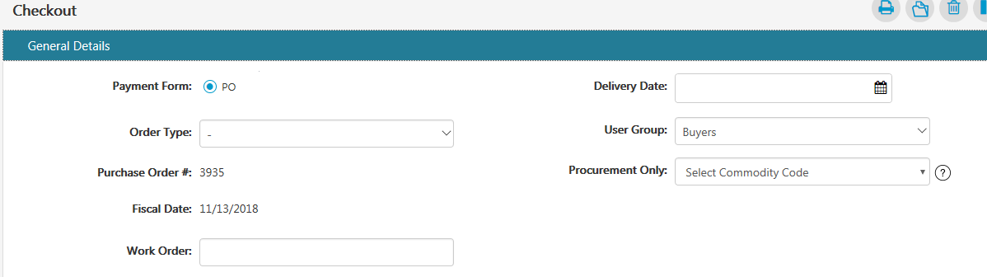

1. Make sure you title the bid a rebid.



## Bid that Results in a Contract (top)

If the result of your bid is going to be a contract, you will still have a requisition that will need flipping into a PO. The best way to handle that is to make the PO a “tracking” PO and set the dollar value at $1.00 or .01. You will need to build a bid file and attach all of the bid documents to the purchase order.

## Clearing your Browser Cache (top)

Unless you have cleared your browser cache, you may not have complete functionality in the sourcing system.

Mozilla:  Click the menu > Options > Privacy & Security > Cookies and Site Data > Clear Data > Click “Clear”

Chrome:  Menu > History > Clear Browsing Data > Click “clear data”, but be sure to select “all time” on the time range drop-down menu.

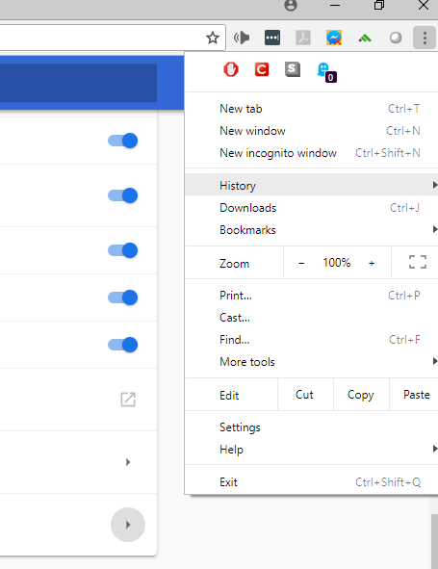

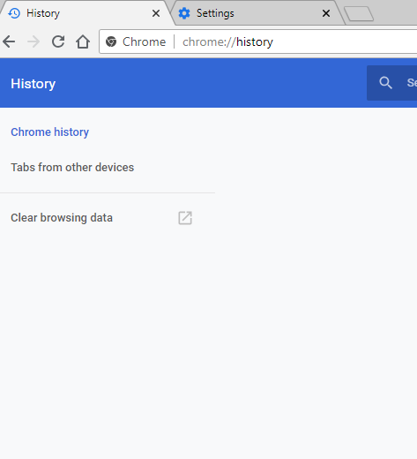

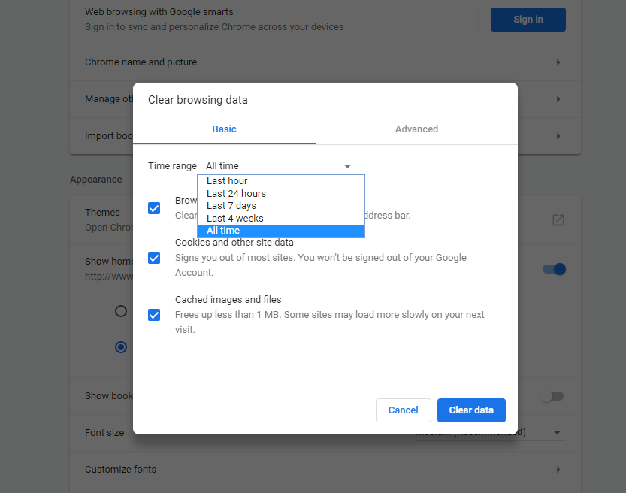

## Addendum 1

## System Office Instructions (top)

When you select “System RFP, RFQ, or RFQ-S” templates, the field with terms and conditions will no longer be populated with the Purchasing Terms & Conditions. The terms and conditions are now included in all bid templates. Instead it will say the following:

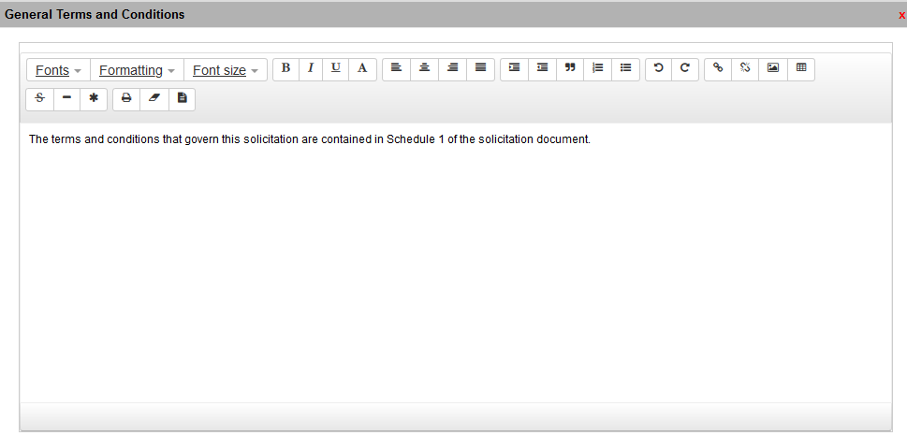

You will attach your “Contact Me” letter, Bid template, and any other relevant attachments into the event header section.

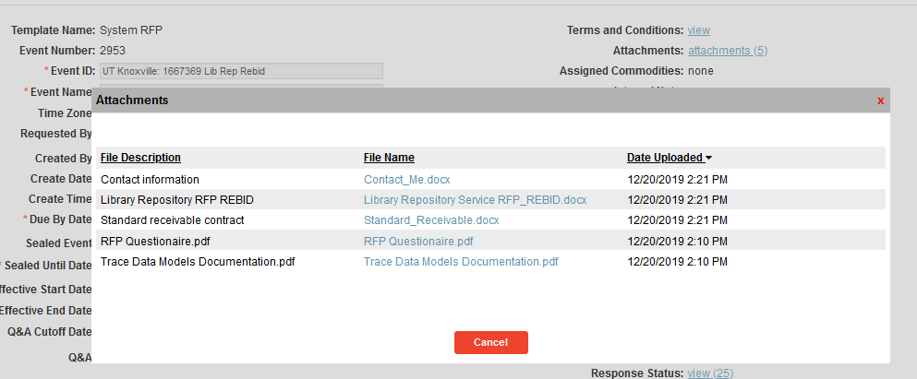

For the RFP and RFQ-S templates, Event Section 1 will be populated with instructions.

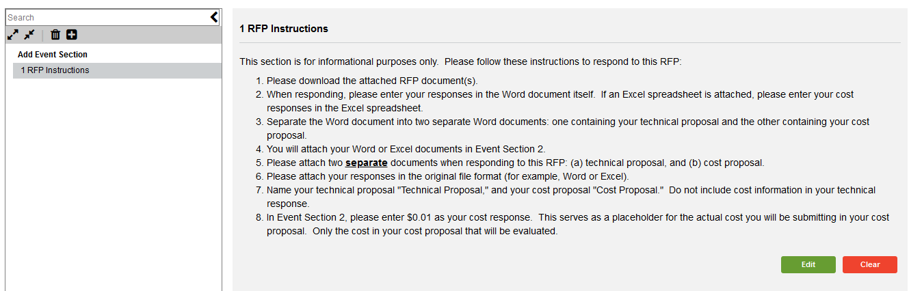

In Event Section 2 (line item) you will need to put some instructions in the description field otherwise the field will default to “created from purchase transaction 123456.” Make sure you enable suppliers to be able to make attachments.

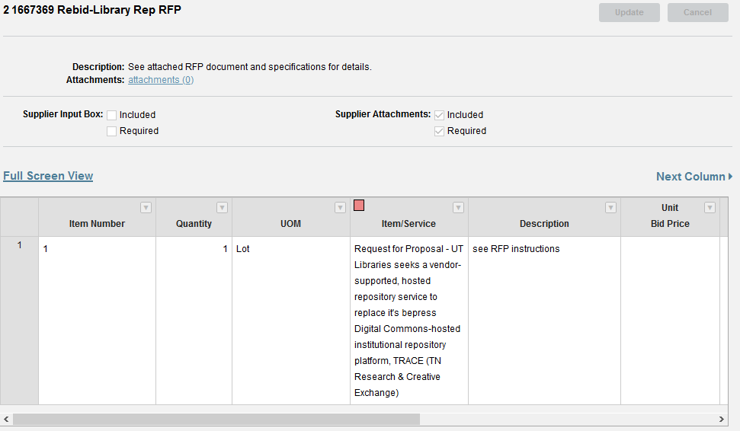

For RFQs it is very important to put instructions in to the line item section so bidders will understand that there is a Word document attached at the header level with instructions and specifications.

