Contract Management System Instructions
The University of Tennessee
Version 3.2
9/28/2020

Contents
Logging into the Contract Management System 5
Enabling Pop-ups 5
Navigating the Contract Management System Homepage 5
Setting Up a Back-up Person in “My Profile” (Contract Approvers Only) 6
To set an as-needed substitute in the Contract Management System: 7
To activate your backup person: 7
Entering a New Contract 7
Select a vendor by searching for the vendor (company) name: 7
To Search by IRIS (SAP) Vendor Number: 8
Contract Title 8
Record Type 8
Financial & Budget Entity Information 8
Contract Description 9
Contract Categories 9
Contract Type 10
Payable/Receivable Contract 10
Encumbrance 10
Foreign Contract 11
Contract Start and End Dates 11
Notification Names 11
To add your department head to email notifications: 11
Add Additional Relevant Employees to Email Notifications: 11
Remove a Name from Email Notifications: 12
Payable Amount 12
Receivable Amount 12
Competitive Type 12
Existing Purchasing Requisition Number 12
No-Bid Explanation 13
Purchase Order Information 13
Vendor Number 13
Vendor Contact 13
Search for Vendor Contact 13
Add a Vendor (Company) Contact to the “Vendor Information” Section: 14
Save as Draft 15
Completing the “Contract Info” Tab 15
Document Tab 16
Upload a Document: 16
Title 16
Document Type 16
Attach Contract Documents 16
Preloaded Documents 17
Documents Table 17
When you are Finished Uploading Documents 18
Receivable Info Tab 18
Approvals Tab 18
Approval Notes 18
Submit for Review 19
Creating an Amendment 19
To create an amendment: 19
Copy an Existing Contract 20
To copy a contract: 20
What Happens to my Contract After I Submit for Review? 20
Complete a Contract Previously Saved as a Draft 21
To open an existing contract: 21
Locked Records 21
Check Contract Status 21
Check Approval Status 22
Searching in the Contract Management System 22
Text Search 23
Search Bar 23
View Amendments Associated with a Contract 25
To view amendments associated with an original contract: 25
To navigate to an amendment from the original contract: 25
To navigate to an original contract from an amendment: 25
Change an Incorrect Contract Type 26
Change an Incorrect Record Type 27
Department Approval 28
Understanding Contract Status in the Contract Management System 29

Logging into the Contract Management System

- Using Mozilla Firefox or Google Chrome, navigate to https://irisweb.tennessee.edu. Please note that the Contract Management System does not work correctly with any other browsers.
- Enter your UT net ID and password.
- Select the “Other” tab.
- Click the “Contract Management” link.

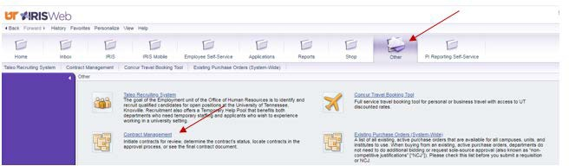

Enabling Pop-ups

Choose your preferred web browser, Google Chrome or Mozilla Firefox. Enable pop-ups.

Navigating the Contract Management System Homepage

The Contract Management System home page includes all or some of the following icons, depending on your permissions:
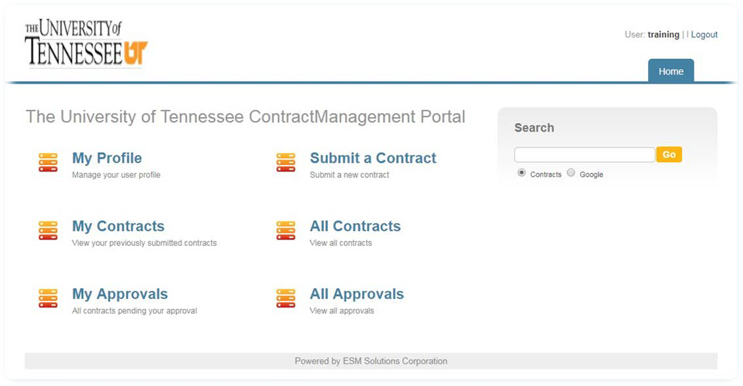
You will only see these two options if you are set up as an approver in IRIS (SAP)
y

ICON | Description
Home | The “Home” tab is located in the upper right hand corner of all screens within the Contract Management System. Always use this tab to navigate back to the home screen.
My Profile | Approvers may click this icon to set an as-needed substitute to approve contracts in their absence. Employees who simply enter contracts will not need to use this tab.
Submit a Contract | Click the “Submit a Contract” icon to enter a new contract.
My Contracts | Click “My Contracts” to view a table of all of the contracts you have entered for the university.
All Contracts | Click “All Contracts” to view a table of all contracts for the entire university system. Contracts marked “private” will only be visible to the requesting department.
My Approvals | Approvers may click the “My Approvals” button to view contracts requiring their approval, however most approvers will approve contracts via email. If you do not have approval authority, you will not see “My Approvals.”
All Approvals | Approvers may click “All Approvals” to view all approvals for their approval group. If you do not have approval authority, you will not see “All Approvals.”

Setting Up a Back-up Person in “My Profile” (Contract Approvers Only)

Contract approvers who have a permanent substitute in IRIS (SAP) do not need to complete this step. Permanent substitutes in IRIS will automatically receive approval emails from the Contract Management System.

Contract approvers who prefer to use “as needed” substitutes in IRIS (SAP) may set the “as needed” substitute or “backup” person in the contract system.

To set an as-needed substitute in the Contract Management System:
- Click “My Profile” on the home page.
- Select the “Contact Information” tab if not already selected.
- Start typing the backup person’s name “Backup Person” field, and select that person from the drop-down.

To activate your backup person:
- Change the working status to “On Vacation.”
- Enter a return date. Type the date in the format MM/DD/YYYY, or click the calendar icon to select it.
The backup person will become inactive on the return date. During your absence, you will continue to receive approval emails; you have simply given your backup person permission to approve contracts in your absence.

Entering a New Contract

Click on “Submit a Contract”
NOTE:
If an IRIS (SAP) vendor record does not exist for your vendor company, request a new vendor company record using one of the following methods:
- For Payable Contracts: Request a new payable vendor using IRIS (SAP) transaction ZXK1. New IRIS (SAP) vendors are loaded into the Contract Management System three times daily: mid-morning, mid-afternoon, and overnight.
- For Receivable or Zero-dollar Contracts: Request a new receivable or zero-dollar vendor company record by submitting the Perfectform found at https://procurement.tennessee.edu. In the left pane, expand the drop-down menu for “Contract Management System” and select “Company Number Request Form.” Complete the form and submit. You will receive an email when the vendor company record is created. Note that the email will contain a vendor company ID number, not a payable IRIS (SAP) vendor number.
- Please note that UTHSC has a separate process for receivables. Please contact your campus contract office for more information.

Select a vendor by searching for the vendor (company) name:
All payable IRIS 1 and 3 vendor numbers are available for selection in the Contract Management System.
- Click the magnifying glass next to the vendor “Company Name” field.
- In the pop up screen, select “String” and “Company Name.”
- Type all or part of the vendor name in the “Search again” box and click “Go.”
- Click the red arrow next to the correct vendor to import it into the contract.

To Search by IRIS (SAP) Vendor Number:
- Click the search icon (magnifying glass) next to the vendor “Company Name” field.
- In the pop up screen, select “String” and “All linked fields.”
- Type the vendor number in the “Search again” box and click “Go.”
- Click the red arrow next to the correct vendor to import it into the contract.

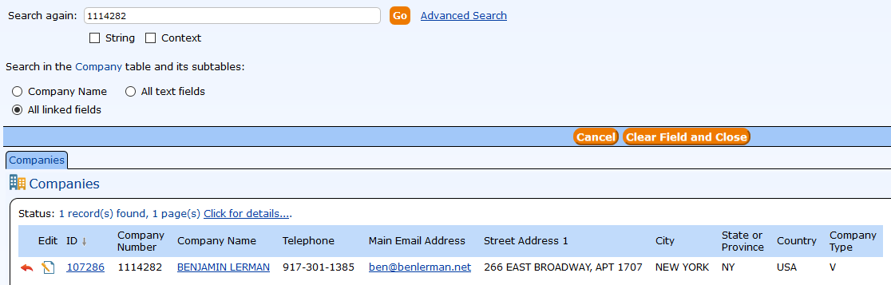

Contract Title
- Type a one-sentence description of the contract in this field.

Record Type

The record type defaults to “new contract” when you are entering a contract from the “Submit a Contract” table. If you need to process a contract amendment, please reference the section titled “Creating an Amendment.”

Financial & Budget Entity Information
- Type the account number in the account number field, wait for it to appear in the drop-down list, and then click on the account number in the drop-down list or you can click on the magnifying glass to search.

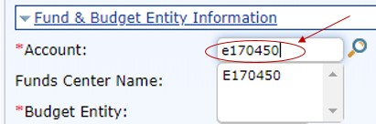

All other fields in this section will auto-populate.

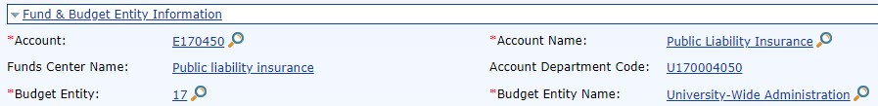

NOTE:
Please enter your base account fund number in the “Account” field. The account number entered here does not encumber, and it does not affect which accounts pay or receive funds – it simply determines the appropriate approval workflow.

Contract Description
- Enter a brief overview of the “Who, What, When, Where, Why, and How” of the contract.
- You will upload your contract and supporting documents in the documents tab. Please do not copy and paste the terms and conditions of the contract here.

Contract Categories
- Choose the appropriate contract category from the drop-down list. Your selection will display or hide the remaining fields needed for the contract.

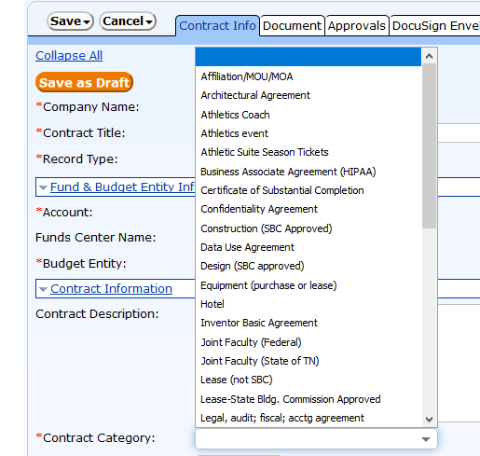

Contract Type
- Choose the appropriate contract type from the drop-down list. Your selection will display or hide the remaining fields needed for the contract.

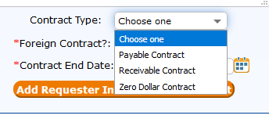

NOTE:
If you select the wrong contract type, you must delete any dollar amount that was associated with the incorrect contract type before selecting the correct contract type. If you realize that you have selected the wrong contract type, finish your contract entry, save your contract as a draft, and then refer to “Change an Incorrect Contract Type.”

Payable/Receivable Contract
If your contract will be both a payable and a receivable contract, you will need to enter it as a payable. Otherwise, if it is entered as a receivable, you will not be able to make payments against it. Please make a notation in the notes field that this will be a payable/receivable.

Encumbrance
Contracts do not encumber in IRIS (SAP). If you need to encumber your contract, the best practice is to use the funds reservation transaction in IRIS (SAP).
You should only select “yes” in the “Encumbrance?” field if the supplier will require a purchase order in addition to the contract. When you select “yes,” the contract management system will notify the campus procurement office to create an encumbered PO once the contract has been signed and activated. Once the contract is activated, it will be an “Active PO Contract” and payment must be made against the PO and not the contract using the MIR7 transaction in IRIS (SAP).
Otherwise, payments against a contract are made using the IRIS (SAP) transaction ZAP_Entry.
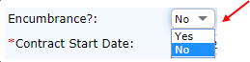

NOTE:
- If you have questions about whether or not to encumber a contract, please contact your business office.
- If you have questions about the functionality of encumbering a contract, please contact your campus contract office.

Foreign Contract
- Choose “Yes” if the contract is between UT and a foreign vendor.
- Choose “No” if the contract is between UT and a domestic vendor.

Contract Start and End Dates
- Enter the contract start and end dates and then click “apply.”
- The contract end date must not be earlier than the contract start date.
- Except under certain, limited circumstances, you should never have an open-ended end date (ex: 12/31/9999). Payable contracts can never have an indefinite term.

Notification Names
As the contract requester, you will automatically receive an email notification when your contract has been made active or, for certain types of contracts, when it is about to expire. It is not necessary to add yourself to the notification list.

If others in your department need to receive notifications, you may add their names in the “Notifications Names” field.

To add your department head to email notifications:
- Click the orange “Add requester info to notification list” button. (This will also display your name.)

Add Additional Relevant Employees to Email Notifications:
- Click the search icon (magnifying glass) next to the “Notification Names” field.
- In the pop up screen, select “String” and “Full Name.”
- Type the full name in search field, and click “Go.”
- Check the box to the left of the person’s name.
- Click “Import/Append.” To add multiple names, click “Import/Search Again.”

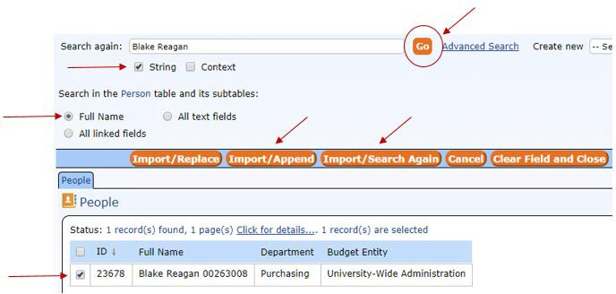

Remove a Name from Email Notifications:
- Click the orange circle with the minus sign to the left of the name.
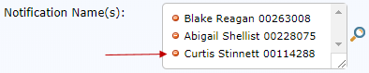
NOTE:
Adding or removing names from the notifications field does not affect approval workflow.

Payable Amount
This field will only display for the payable contract type.
- Enter the payable amount in the field.

Receivable Amount
This field will only display for the receivable contract type.
- Type the receivable amount in this field.

Competitive Type
- Select “Bid” or No Bid” from the drop-down list.

Existing Purchasing Requisition Number
This field will only display if you selected “Bid.”
- Enter the requisition number. You must enter an actual requisition number from the bid. Do not leave the field blank or make up a number.

No-Bid Explanation (for Sole Sources)
- Enter a detailed explanation of why the contract was not bid if the competitive type is “no bid,” the contract type is “payable,” and the contract amount is greater than or equal to $10,000.
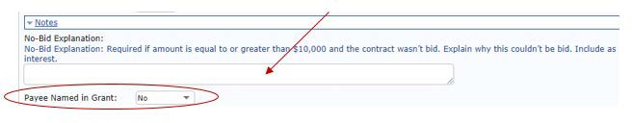
- If you are entering a grant, please choose yes or no depending on whether the payee (the vendor company) is named in the grant.

Purchase Order Information
No action needed.
Do Not enter information in this field. The purchasing office will enter information here if needed.

Vendor Number
No action needed.
NOTE:
The “Vendor Number” field contains the IRIS (SAP) vendor number.
- The field will auto-populate for IRIS (SAP) vendor companies.
- The field will be blank if the vendor company was created as a zero-dollar or receivable vendor company record that exists only in the Contract Management System.

Vendor Contact
The Contract Management System requires a company contact person for each vendor company record. You will need to enter a vendor contact that will be the point of contact for the contract office.

Search for Vendor Contact
Your first step should be to search the system to see if your vendor contact already exists.
Click on the magnifying glass and a new search window will pop up. Type in the name of the contact and click go.
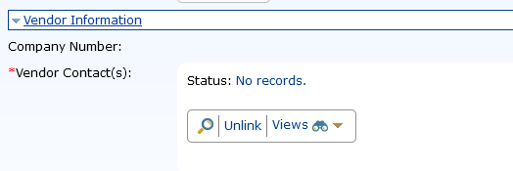

Select the box next to the contact’s name and then click “Import/Replace.”
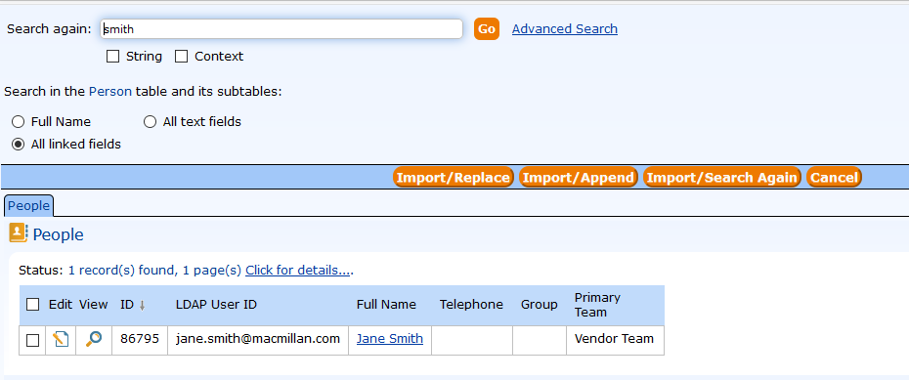
If you cannot find the vendor contact by searching, you can add that person in the New Vendor Contact section.

Add a Vendor (Company) Contact to the “Vendor Information” Section:
- Enter data in the following fields in the “New Vendor Contact” section at the bottom of the “Contract Info” tab.
- Click on “Save Company Contact.”
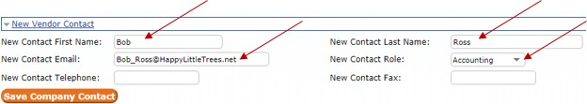

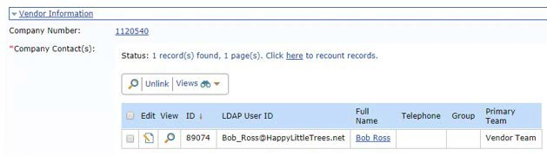

NOTE:
Important Notes about Vendor Company Contacts
It is best practice to add a generic email address for the vendor contact, if possible. This way if a vendor contact leaves the company, you will still have a working email address for communication purposes. For example: sales@xyzcompany.com

Save as Draft
If you do not have all of the information you need to submit your contract into workflow, you may click on “Save as Draft” at the top of the page. This will allow the information you’ve entered already to be saved, so you can go back and work on the contract entry at a later time.

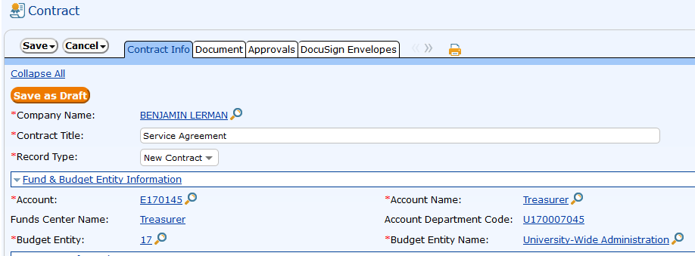

You will see that, after saving as a draft, you will be given a contract ID number and a 95 contract number.

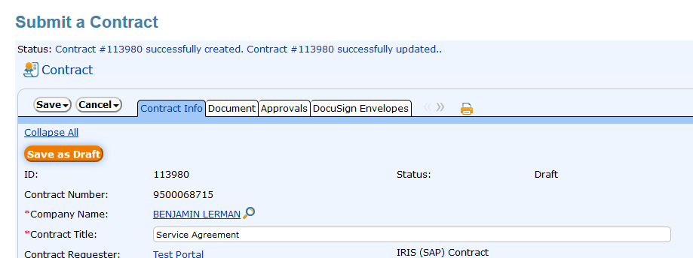

Completing the “Contract Info” Tab
If you have entered all information on the contract info tab you must click on “Save and Go to Next Tab.”
- When you click “Save and Go to Next Tab,” the system will assign a contract number and saves it as a draft.
- Do not click “Save.” The “Save” button will close the contract. If you close the contract while you are on the “Contract Info” tab, before a contract number is assigned, you will lose your contract entry, and you will need to start over.

Document Tab
Tip: Pop-ups must be enabled on Firefox or Chrome before you attempt to upload documents on the “Document” tab.
Upload your contract or amendment, and any supporting documentation on the “Documents” tab. Documents should be in Word or an original PDF format (no scans or scanned PDFs). You will not be able to submit your contract entry for review until you have uploaded a document.

Upload a Document:
Click the “Add New Document” button to open the “Contract Document” pop-up window.

NOTE:
Upload each document file separately (one document file at a time). Click the “Add New Document” button for each document file that you need to upload.
If you select multiple document files to upload at once, the system will compress all of the document files into one file.

Title
- Type the document/file title.

Document Type
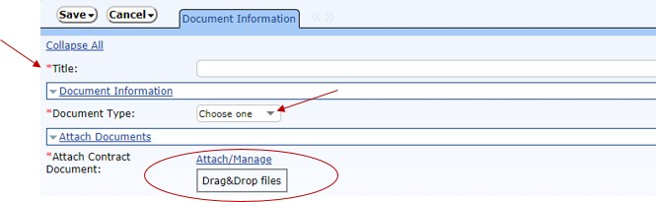
- Select “Draft Contract” or “Other.” The “Final Contract” type is reserved for the contract offices.

Attach Contract Documents
- Select either the “Attach/Manage,” or the “Drag & Drop” method to attach a document.
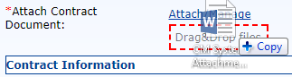
Drag and Drop Upload Method:
- Navigate to the document on your computer.
- Drag the document to the “Drag & Drop Files” box.
- Hover until the “Drag & Drop Files” box turns red.

- Click “Save.”
Manual Upload Method
- Click the “Attach/Manage” link.
- Click the orange “Attach File” button.

- Navigate to the document on your computer.
- Highlight the document to select it.
- Click “Open.”
- Click “Finish.”
- Click “Save.”

NOTE:
You cannot remove documents that you have uploaded to the Contract Management System. Make sure you have uploaded the correct document before you click “Save.”

Preloaded Documents
Two documents have been preloaded into the CM system: “Insurance Certificate” and “Tax Exemption.”
The “Insurance Certificate” is UT’s certificate of self-insurance, and it is not on UT letterhead. Similarly, the “Tax Exemption” is UT’s certificate of tax exemption, and it will not contain the name of the vendor. It is best not to use either of the pre-loaded documents. Instead, please add a note in the approvals tab stating that the vendor needs UT’s tax exemption certificate.

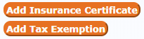

Documents Table
The documents table is displayed midway down the “Documents” tab. It becomes visible after you attach a document. The table contains information about uploaded documents as well as a link to each file.

It is very important to add just once document at a time.
When you want to view documents in the documents table, it is important that you click on the view/search (magnifying glass) icon and not the hyperlink. If you click on the hyperlink, and there are multiple documents attached, you will only see one. If you click on the view/search icon, you will see all of the uploaded documents.
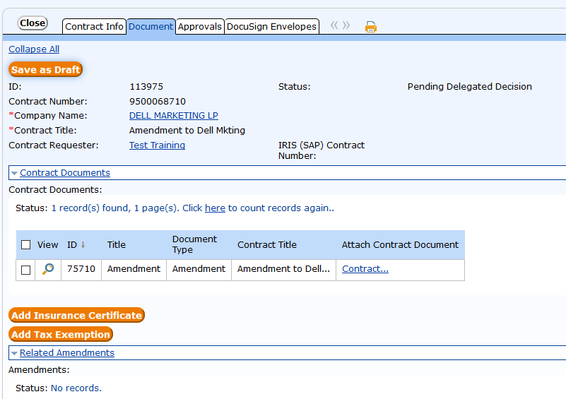
DO NOT CLICK HERE
In this example, someone incorrectly added multiple documents at once. If you click the hyperlink, you will only see one document.

CLICK HERE
Use the search icon to open documents to make sure you see all uploaded documents

When you are Finished Uploading Documents
- Click “Save and Go to Next Tab” to continue working.

Receivable Info Tab

This tab is used by the Health Science Center and may be skipped by all other campuses.

Approvals Tab

Approval Notes
- Enter approval notes, if needed, in the approval notes box. If you need to format the notes, click the orange “Edit” button and enter notes in the pop-up box.
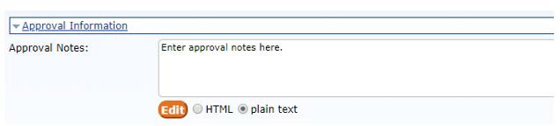

Submit for Review

To submit your contract for review, click “Submit for Review.”

To close the contract and continue later, click “Save.”

NOTE:
Reference Note: “Approval Information”
Later, when your contract is in “In Review” status, you can return to the approvals tab to view approval workflow. Refer to “Check Workflow Status of a Contract” for instructions.

Creating an Amendment

The Contract Management System links all amendments to the original contract. To create an amendment, you must navigate to the original contract. You cannot amend an amendment.

To create an amendment:
- Search for and open the original contract. Refer to “Searching in the Contract Management System” as needed.
- Click the orange “Create Amendment” button.

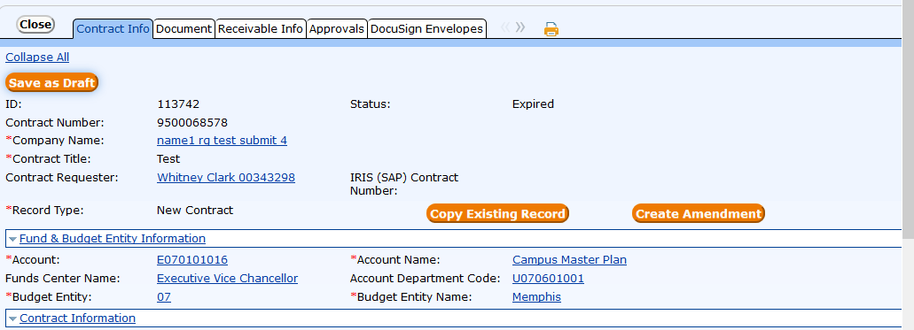
- A new “Contract Info” tab will open. Most fields will auto-populate with data from the original contract.
- Refer to “Entering a New Contract” as needed to complete the following steps.
  - Enter additional comments in the “Contract Description” field.
  - Complete the remaining fields on the “Contract Info” tab.
  - Upload your amendment on the “Document” tab.
  - Navigate to the “Approvals” tab.
  - Click “Submit for Review.”

NOTE:
If you are amending the amount of a payable or receivable contract, enter only the dollar amount of the
amendment. The Contract Management System will calculate the cumulative amount of the contract.

Copy an Existing Contract

The copy function is helpful if you are creating multiple agreements with the same vendor company. You may copy your own contracts or contracts that other departments have created. You may copy contracts that are in any contract status.

To copy a contract:
- Search for and open the contract. Refer to “Searching in the Contract Management System” as needed.
- Click the orange “Copy Existing Record” button in the header section of the “Contract Info” tab.
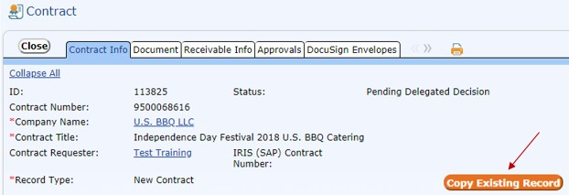

- A new contract info tab will open. The vendor “Company Name”, account information, and “Contract Category” fields will auto-populate with data from the original contract. You may edit these fields as needed.
- Refer to “Entering a New Contract” as needed to complete the following steps:
  - Complete the remaining fields on the “Contract Info” tab.
  - Upload your contract document(s) on the “Document” tab.
  - Navigate to the “Approvals” tab.
  - Click “Submit for Review.”

What Happens to my Contract After I Submit for Review?

After you submit your contract for review, it will route electronically to your campus contract office for a pre-review, which includes a delegation decision, and an assignment to a campus or university contract office. This is the “Pending Delegated Decision” contract status.

If the contract office discovers missing or incorrect data, they may send the contract back to you for changes. If the contract office returns a contract, you will receive an email letting you know that changes are required. You will find the returned contract in your “My Contracts” table as a “Draft.”

When the campus contract office completes the pre-review of your contract, they will submit the contract into workflow. The contract status will change to “In Review,” and the contract will route to your department head and other approvers. The contract will not have workflow specified on the Approvals tab until your campus contract office submits the contract into workflow after its pre-review.

Complete a Contract Previously Saved as a Draft

To open an existing contract:
- From the “Home” tab, click on “My Contracts” or “All Contracts.”
- Search for the contract. Refer to “Searching in the Contract Management System” as needed.
- Click either the “Edit” icon, or the “Contract Title” to open the contract.
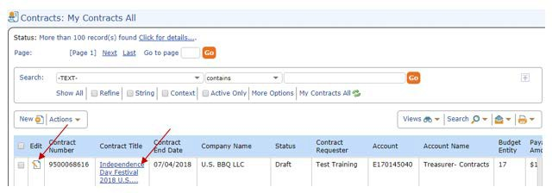
You may edit your own contracts that are in “Draft” status. You may view all other contracts in the contracts table.

Locked Records

This symbol indicates that a contract record is in use by the contract requester or a contract officer. You may view, but not edit a contract when this symbol is displayed.

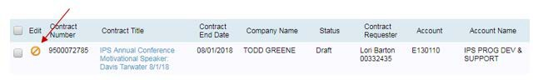

Check Contract Status
You may view the workflow status of any contract with a status of “In Review.” 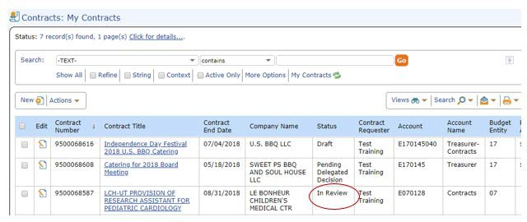

Check Approval Status
- Search for and open the contract.
- Click on the “Approvals” tab.
- Scroll to the bottom of the “Approvals” screen to view workflow status.
- Here you can view any approval notes that the contract offices have entered. This can let you know more specifics about where the contract is in the approval process.

NOTE:
Contract Management System approvers are carried over from IRIS (SAP).

If there are multiple approvers for a particular account and approval step, you will see one approver’s name followed by “…” Click on the search icon (magnifying glass) to the left of the approval step to view all of the approvers’ names. Only one of the listed approvers must approve the contract.

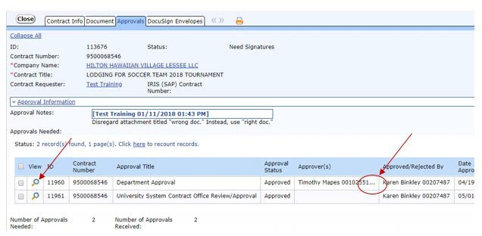

Searching in the Contract Management System

To perform any of these functions, it is necessary to understand how to search for existing contracts. Please note you may search all contracts from either “My Contracts” or “All Contracts.”

There are two ways to search for contracts in the Contract Management System. You can perform a simple text search, or you can select search criteria in the search bar.

Text Search
The text search method is similar to a “Google” or internet search.

To search for contracts using a text search:
- From the “Home” tab, click on “My Contracts” or “All Contracts.”
- Locate the “Text” box in the upper right hand corner of the screen.
- Type in descriptive words for your search.
- Click “Go.”

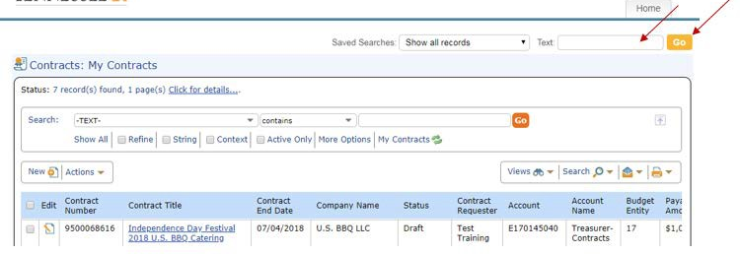

The Contract Management System will display all contracts matching your search criteria in the contracts table.

Search Bar
To search for contracts using the search bar:
- From the “Home” tab, click on “My Contracts” or “All Contracts.”
- If the search bar is not visible, click “Search” or select “Expand Search Options” from the search drop-down menu.
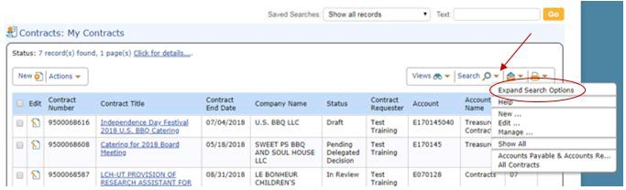

- Select the field by which you wish to search from the drop-down menu in the first search box. Commonly searched fields include “Account”, “Contract Requester”, “IRIS (SAP) Contract Number”, and “Company
Name.”
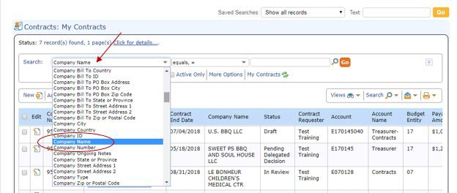

- Select an operator for the search in the second search box.
  - Select “equals” to search for an exact match or a number. For example, if you are searching for contract # 8500041541.
  - Select “contains” to search for an approximate match. For example, if you are searching for a contract with a BBQ vendor, but you do not remember the exact vendor company name.
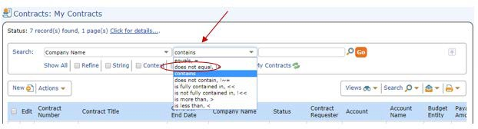

- Enter a value for your search.
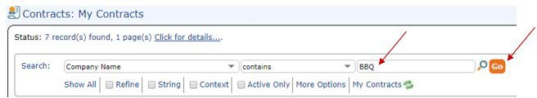
- Click “Go.”

View Amendments Associated with a Contract

To view amendments associated with an original contract:
- Search for and open the original contract. Refer to “Searching in the Contract Management System” as needed.
- Click on the “Documents” tab.
- Scroll to the bottom of the “Documents” screen to view all amendments associated with the contract.

To navigate to an amendment from the original contract:
- Search for and open the original contract. Refer to “Searching in the Contract Management System” as needed.
- Click on the “Documents” tab.
- Scroll to the bottom of the “Documents” screen to view the table of amendments.
- Click on the “Contract Title” or “ID” of the amendment you wish to view.

To navigate to an original contract from an amendment:
- Search for and open the amendment. Refer to “Searching in the Contract Management System” as needed.
- On the “Contract Info” tab, locate the “Amendment Information” section just below the header.
- Click on “Original Contract ID”, “Original Contract Title”, or “Original Contract Number” to view the original contract.

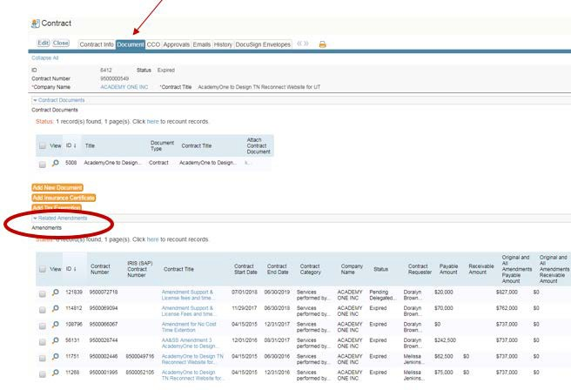

Change an Incorrect Contract Type
If you select the wrong contract type on the “Contract Info” tab, you must delete any dollar amount that was associated with the incorrect contract type before selecting the correct contract type.
Finish your contract entry, save your contract as a draft, and then follow the instructions below.
Correct the Contract Type:
- From the home screen click on “My Contracts.”
- Search for the contract
- Click the “edit” icon to the left of the contract ID number to open the contract.

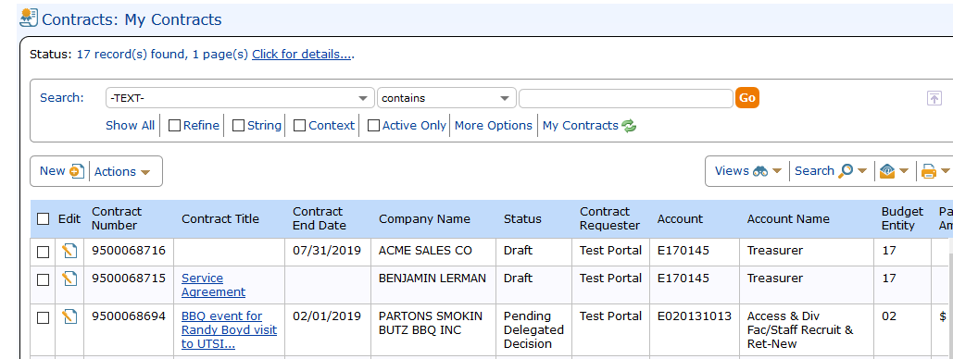
- Scroll down to the payable or receivable amount field
- Change the amount to $0
- Click the black and white “Save” button
- Select the correct contract type from the drop-down in the “Contract Type” field.
- Enter the dollar amount in the payable or receivable amount field.
- Click “Save and Go to Next” tab.
- If you are ready to submit the contract, click on “Submit for Review.”
- If you are not ready to submit, click on “Save” to close the contract

Change an Incorrect Record Type
Occasionally, there is a need to change a record type from Amendment to New Contract.
Correct the Record Type:
- From the home screen click on “My Contracts.”
- Search for your contract.
- Click the “edit” icon to the left of the contract ID number to open the contract.
- Locate the amendment information section just below the header.
- Click on the magnifying glass next to “Original Contract ID Field.”
- When the search window opens, click the orange “Clear Field and Close” button.
- Click the black and white “Save” button.
- Select “New Contract” in the “Record Type” field.
- Click “Save and Go to Next Tab.”
- If you are ready to submit the contract, click on “Submit for Review.”
- If you are not ready to submit, click on “Save” to close the contract

Department Approval

Department approvers can review and approve contracts through the link in an email they will receive or by directly logging into the Contract Management System.
Accessing through the Contract Management System
- Using Mozilla Firefox or Google Chrome, navigate to https://irisweb.tennessee.edu.
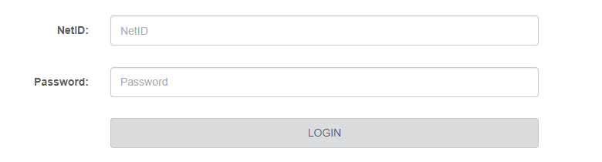
- Enter your UT net ID and password.

- Select the “Other” tab.
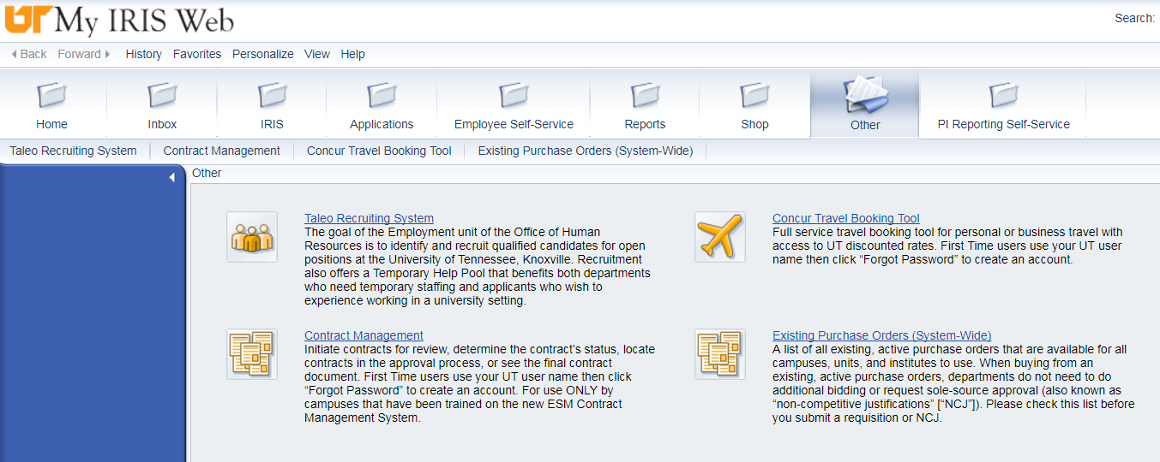
- Click the “Contract Management” link.
- Click “My Approvals.”
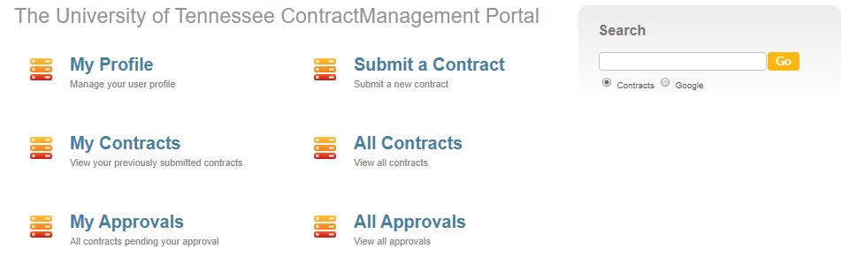
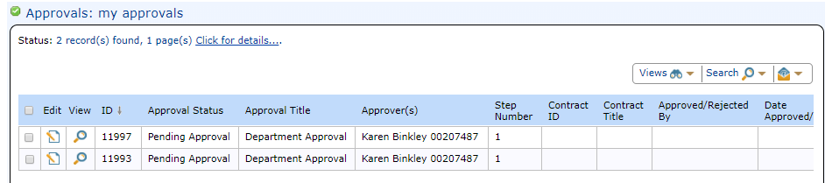
- In the approvals table, click the “Edit” button for the contract you wish to approve.

- Take the appropriate action.
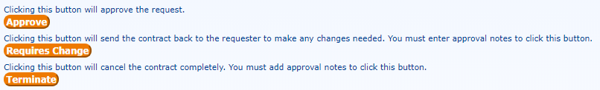

Understanding Contract Status in the Contract Management System
Contract Status | Explanation
Draft | - Requester completes entry on the “Contract Info” tab.  - Requester saves the contract, but does not submit it for pre-review.  - Requester can make changes as long as the contract is in draft status.
 | Note: If a contract officer or approver requires changes, the contract returns to the requester in draft status. When the requester makes the required changes and re-submits for review, the contract routes back to the contract office.
Pending Delegated Decision | - Campus contract officer pre-reviews the contract for accuracy and checks attached documents.  - If needed, campus contract officer may send the contract back to the requester to require changes.  - Campus contract officer completes additional tasks and submits the contract into workflow.  IMPORTANT REMINDER: CONTRACT MOVES INTO WORKFLOW AFTER THE CONTRACT OFFICE COMPLETES THIS STEP.
In Review | - Contract is in workflow routing for approvals.  - Anyone may view workflow on the “Approvals” tab of the contract record.  - If needed, approvers may send the contract back to the requester to require changes.
Pending 3rd Party Review | - This optional status occurs between the “in review” and “active” statuses.  - The contract office is waiting for a third party to review and return the contract.
Needs Signatures | - The contract office is waiting for a third party to review and return the contract.  - Contract office assigns the contract document to appropriate parties for signatures.
Pending DocuSign Signature | - Contract routes to appropriate parties, both internal and external to the university, for signature.
Active | - Contract is Active
Active PO Contract | - This status results when a requester chooses “yes” in the encumbrance field during the contract entry process.  - Contract is active and the purchasing office issues a PO.  - Department pays against the PO number in MIR7.
Expired | - The contract end date has passed.  - Depending on the contract category, the requester receives an email notice 90 days before the contract expires.
Cancelled | - Contract office cancels the contract during the “pending delegated decision” step.  - Example: there is an existing master agreement with the vendor.  - This is a permanent decision; the office cannot resubmit the contract into workflow.
Rejected | - An approver chooses to terminate the contract during the “In Review” step.  - If an approver terminates a contract by mistake, the department may contact the University Contract Office to request that the contract be moved back into workflow.

Key Points to Remember
- Campus contract offices pre-review contracts BEFORE submitting them into workflow. This is the “Pending Delegated Decision” status.
- Approvers view and approve contracts only AFTER the campus contract office completes its pre-review. This is the “In Review” status.
- All users can view workflow on the contract “Approvals” tab except during the “Pending Delegated Decision” or pre-review step.

