**Contract Management System Overview for CCO/UCO Users**

**______________________________________________________________________________**

**The University of Tennessee**

**Version 3, Revised December 2020**

Contents

Getting Started 4

Important Notes 5

Logging out of a contract entry 5

Logging out of the contract management system 5

Enabling Pop-Ups 5

Data Feeds 5

The Home Screen 6

Entering a Contract 7

Contract Info Tab 8

Document Tab 15

Receivable Tab 16

CCO Tab 17

Approvals Tab 17

Emails Tab 18

History Tab 18

DocuSign Envelopes Tab 19

CCO/UCO Review 20

Changing a Contract 20

Returning Contract to End User 21

Cancel Contract 21

Gatekeeper Step/Delegation Decision 22

Contract Office Requirements 22

Submit for Approval 24

Preview Workflow 25

Contract Ready to be Reviewed 25

Resubmitted Contracts 26

Reviewing the Contract 26

Pending Vendor Review/Legal Review 26

Needs Signature 27

Mark as Signed 29

Check Status of Contract 30

Approving or Rejecting for Someone Else 34

Appendix 1 -Delegation Decision 36

Appendix 2 - Workflow Overview 38

# Getting Started

* Using Mozilla Firefox or Google Chrome, navigate to <https://irisweb.tennessee.edu>.
* Enter your UT NetID and password.

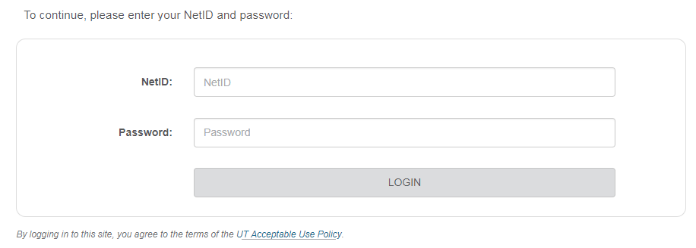

* Select the “Other” tab.
* Click the “Contract Management” link.

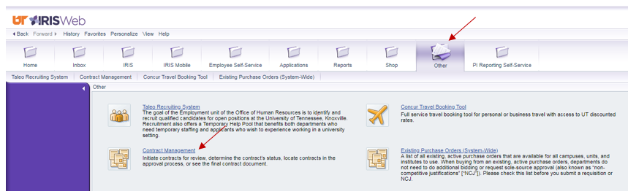

# Important Notes

## Logging out of a contract entry

When you are finished looking at a contract or editing a contract, it is important to close out of that contract entry completely so the record will not get locked. If you leave the contract entry open, no one else will be able to access it (for review or editing) until you close out completely.

To log out of a contract record, please click either “Save” or “Cancel”



## Logging out of the contract management system

When you finish working in the Contract Management System, ***complete ALL of the following steps:***

1.  Click the “Logout” button in the upper right hand corner of the Contract Management System.

2.  Click the “Log off” button in the upper right hand corner of the IRIS Web Portal.

3. **Close your internet browser.**

## Enabling Pop-Ups

Choose your preferred web browser, Mozilla Firefox or Google Chrome and enable pop-ups. If pop-ups are not enabled, you will not be able to use the contract management system.

# Data Feeds

It is important that all CCOs and UCOs understand the basics of data feeds related to the contract system. IRIS (also known as SAP) is the University’s enterprise resource planning (ERP) and accounting system. Several data feeds exist between ESM and IRIS.

Data feed direction:

From ESM to IRIS: (each data feed from ESM to IRIS occurs once per night)

Activated contracts: This data feed sends contract numbers to IRIS when the following types of contracts are activated in ESM:

* Payable contracts (excludes “Active PO” status)
* Zero-dollar amendments to payable contracts

Changes to active contracts: If you change dates, the vendor number, etc., within 14 days of the contract’s activation date in ESM, ESM will send the changes to IRIS. Changes made outside of this 14-day window are not transported to IRIS automatically.

From SAP to ESM:

Vendor numbers: This data feed occurs 3 times per day, at approx. 10 AM ET, 2 PM ET, and overnight. The data feed sends new vendor numbers from SAP to ESM. Please note that an end user will receive a notice from PaymentWorks about their vendor being setup a few hours before the vendor number is in ESM.

Cost centers, approvers, and users: These data feeds occur once per night. These data feeds transport cost centers/funds centers, approvers, and users from SAP to ESM.

# The Home Screen

Your home screen should look similar to the screen below.

# 

* When you log in, you will see the view from your last session.
* Please note the left pane, which contains your folders.
  + To expand a section, click the “+.”
  + To collapse a section, click the “-.”

Click “Logout” in the upper right-hand corner to log out of the system. Then log out of the IRIS Web portal and close your internet browser.

# Entering a Contract

To enter a new contract, expand the “Tables” icon and click on the “Contracts” table.

In the “Contracts” table, click “New.”

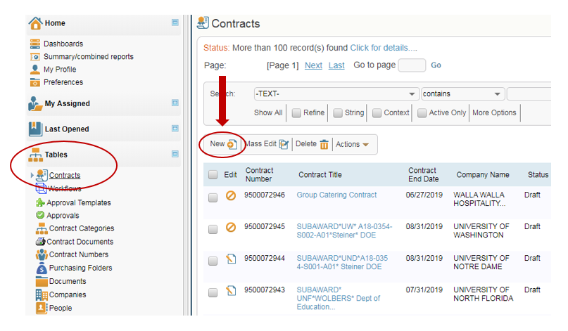

The screen will look similar to the screenshot below:

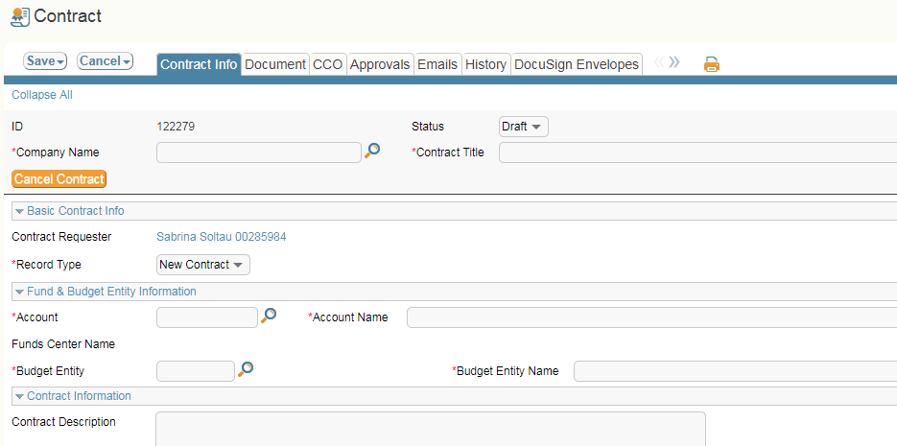

## Contract Info Tab

1. **Vendor (Company) Name**: To search by name, you can begin typing it into the company name field and in the dropdown that pops up, select the vendor you want. Or if you know the vendor number, you can click on the magnifying glass and a new window will open allowing you to search with more criteria.

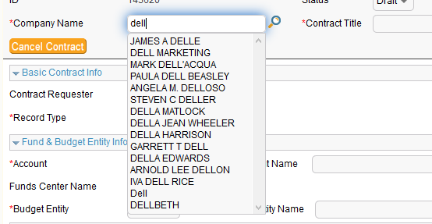

If you search for the vendor using the magnifying glass, when the correct vendor pops up, you will need to click on the red arrow to import that vendor.

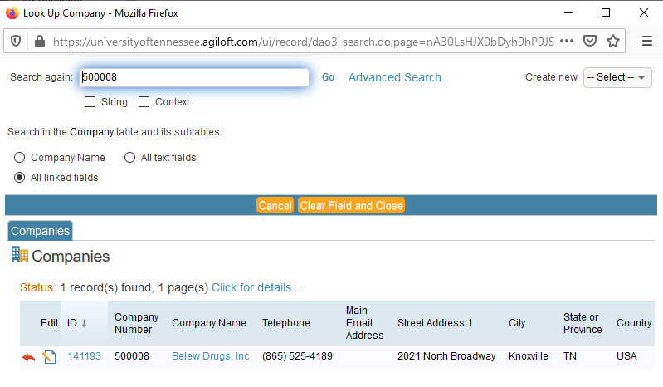

1. **Contract Title:** Please choose a concise, yet descriptive title for your contract. For example: Media Buying Contract. Do not use “Amendment” or “Contract” as your contract title. These titles end up as the only description of the contract in reports to the state legislature, so please ensure that the title describes the contract so that it would make sense to a third party reviewing the title.

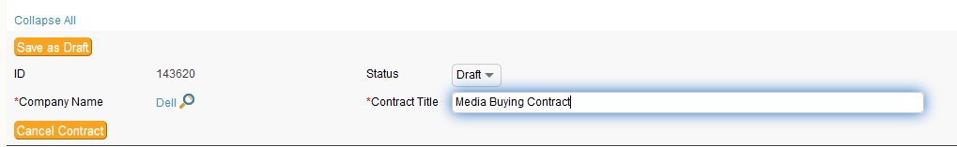

1. **Record Type**: You have the option of selecting **new contract** or **amendment**

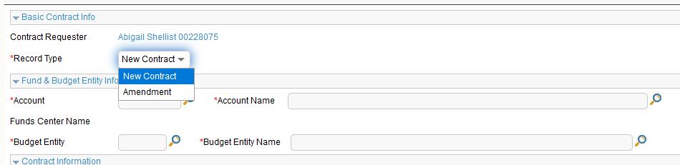

If you choose amendment, you will need to have the original contract ID handy to enter it in the

original contract ID field. The remaining fields in this section will auto populate.



1. **Account**: Here you will enter in the department account number and select it from the dropdown menu and click enter. The rest of the fields will auto populate. Please note that the only purpose of the account number is to drive workflow. The contract system does not encumber funds. Many times, end users will forget this, and will ask you to change the account number or ask you to reject a contract entry so that they can change the account number because the end user is concerned about an encumbrance on the wrong account number.

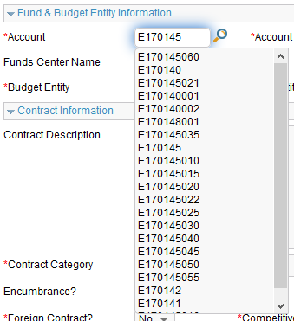

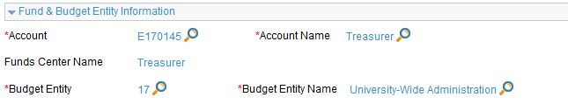

1. **Contract Description**: Enter a thorough description of what the contract’s purpose is.

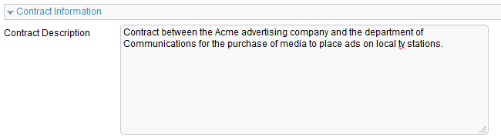

1. **Contract Category**: Click on the drop-down menu and select the contract category that best describes the type of contract this is.

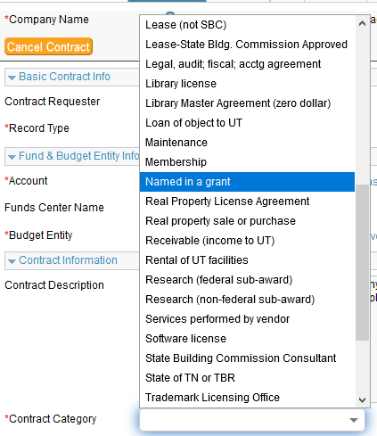

1. **Contract Type**: Choose if this is a payable, receivable or zero-dollar contract. If it is a payable/receivable contract, you will need to select payable.

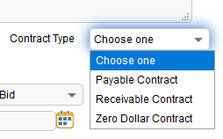

1. **Encumbrance**: This is a yes or no and defaults to “no.” Only mark this yes if the vendor will require a PO in addition to the contract or the department wants this contract to be encumbered. By marking “yes,” the applicable purchasing office will create a PO and the department will not be able to pay against this contract. Instead they have to pay against the PO.
2. **Foreign Contract**: Select yes or no accordingly.
3. **Competitive Type:** Was this bid, sole source or a GSA/Cooperative? If you choose “no bid,” you will be required to fill out the no-bid explanation field below. If you select bid, a field will pop up requiring the requisition (transaction) number for that bid.

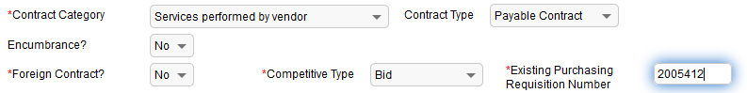

1. **Contract Term**: Enter the start date and end date for the contract.



1. **Notification Names**: As the requestor of this contract, you will **automatically** receive notifications on this contract so there is no need to click on the “add requestor to notification” button. If there are other people in departments who need to be notified, please add their names. Click on the magnifying glass to search for people.



Once you find the name you want to use, click on the box next to the ID number and choose Import/Replace if this is the only name that needs notification or Import/Append if there are multiple people who need notification.

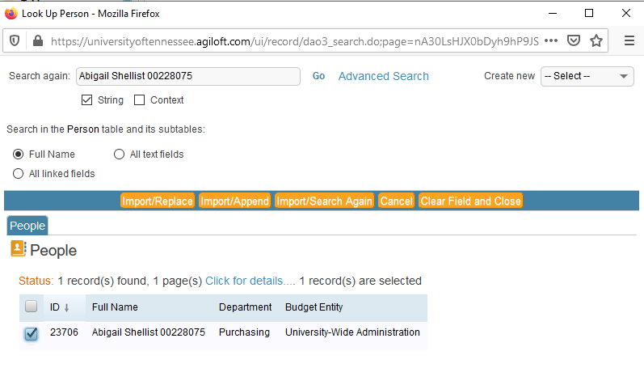

To delete a name from the “Notification Name(s)” list, click the orange and white minus sign to the left of the name.

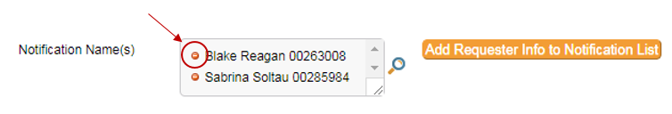

The notification names field serves a second purpose. If a contract is marked “private” on the CCO tab, anyone listed in the notification names field will be able to see the contract.

1. **Payable/Receivable Amount**: Enter the amount that will be paid to vendor or received from vendor.

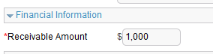

1. **Purchase Order Info**: This will be filled in at a later date by a buyer if encumbrance was marked “yes.”
2. **Company Information:** This is the section where a company contact will be listed or entered. If a contact was already listed but was not the correct contact, you could choose to “unlink” that contact from this contract. Please note that unlinking does not remove that person from the vendor record, it only removes them from your contract entry. The person you select should be the person who you have been working with on the contract or the person who will sign the contract.

Remove a Contact: Click on the box next to edit and then select “unlink.”

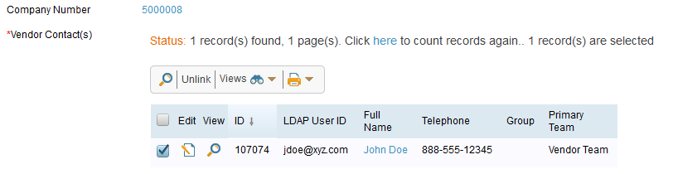

Add a Contact: You must enter a name, email address, and a contact role for the contact you are adding. After you have added this information, click “Save Company Contact.”

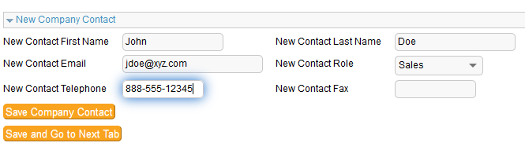

Once you save, you can see the information you added will populate under the vendor number:

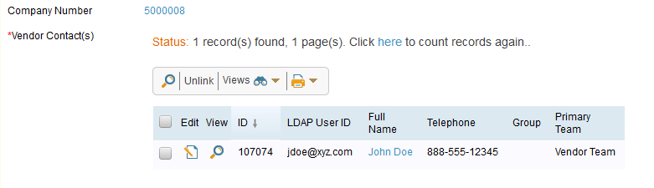

**Click “Save and Go to Next Tab”**

## Document Tab

This is where you will add the contract document and any other relevant documents.

1. **Add Document**: Click on “Add New Document” to upload a document.

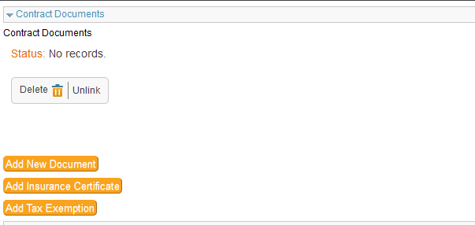

A new window will open so you can enter information about the document. You will need to name the document and choose what kind of document type it is.

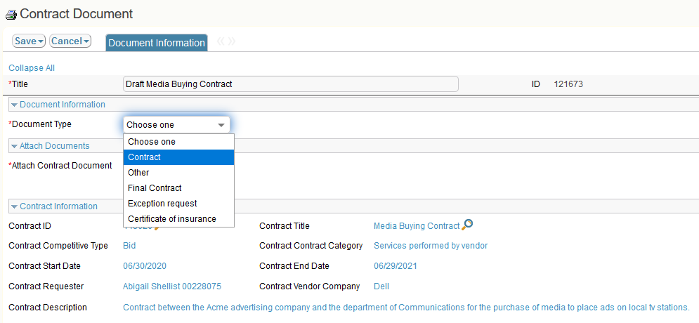

1. **Attach File**: You can drag your document into the drag and drop files field or you can click on the “Attach and Manage” link to search for the contract in your files. Click save.

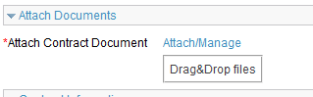

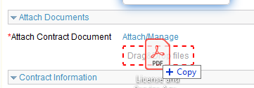

DO NOT attach multiple documents to one document entry. If you have additional documents to upload, please repeat the process above.

**Click “Save and Go to Next Tab”**

## Receivable Tab

This tab is for use by the Health Science Center only. If you are a UTHSC employee, please contact your director of contracts to get additional information.

**Click “Save and Go to Next Tab”**

## CCO Tab

The CCO tab is where you will choose whether the contract is delegated or non-delegated, according to FI0420, Contracts fiscal policy (see Appendix 1). You can also assign the contract to a specific person in your office for review by choosing the appropriate person from the “Campus Contract Officer” drop-down list.

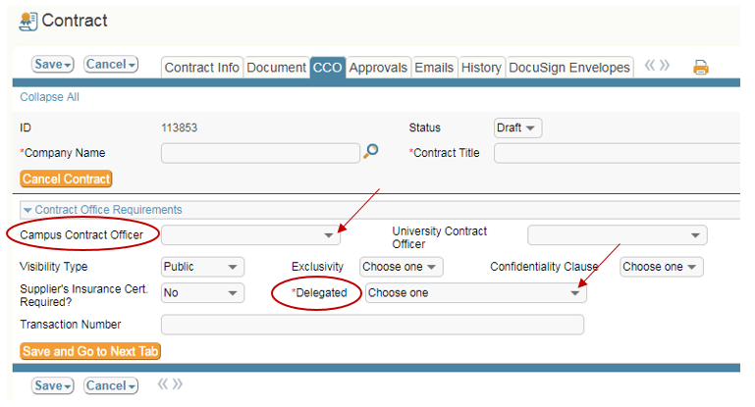

Supplier’s Insurance Certificate Required is a mandatory field. You will need to select yes or no. Selecting “yes” will result in the contract system sending an automated email to Risk Management when the contract is activated.

**Click “Save and Go to Next Tab”**

## Approvals Tab

In the Approvals tab, you can preview the approval workflow, and submit the contract data and contract document into workflow for review.

* + In the “Approval Notes,” you can add pertinent notes for the workflow approvers. If you enter notes in the “Approval Notes” field, please click “Save” before doing anything else with the contract. If you do not click “Save,” the contract system will not be able to change the status from “In Review” to “Needs Signatures.” And, when that happens, you will not be able to activate the contract by clicking “Mark as Signed.”

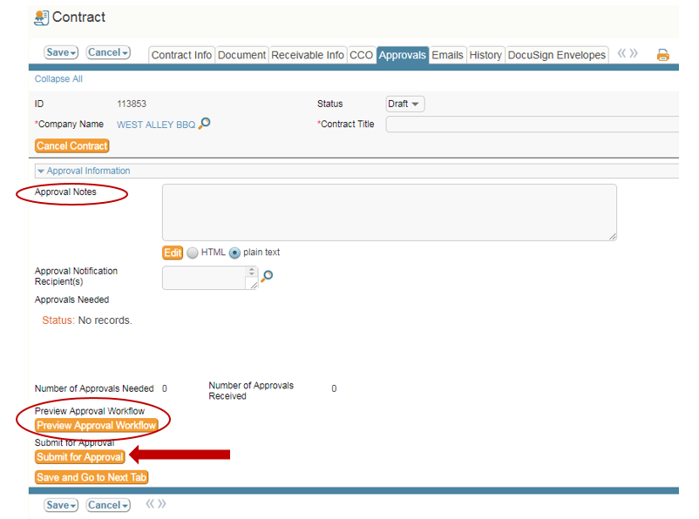

If you are ready to submit your contract, click on **“Submit for Approval.”**

## Emails Tab

The System Contract Office recommends that you do not the email function within the contract management system.

## History Tab

The information within the history tab may be difficult to interpret but it provides a record of all changes to the contract record.

You can see who the contract record was created by as well as the date created along with the name of the person to last update it and the date it was updated.

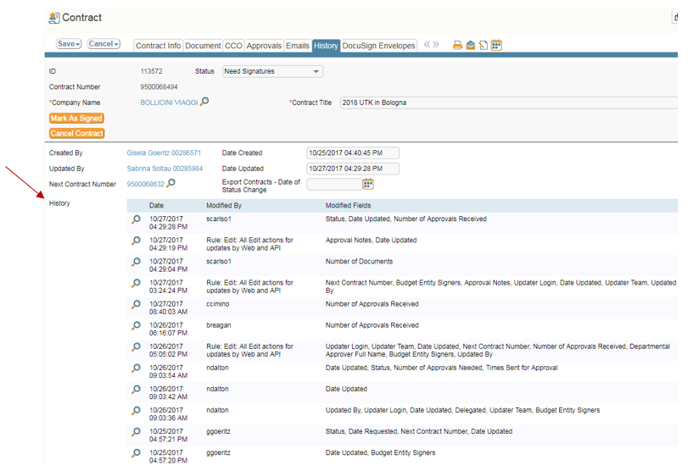

## DocuSign Envelopes Tab

The System Contract Office recommends that you do not use this functionality. There have been serious integration issues with DocuSign and the contract management system. As a side note, the System Contract Office attempted to have these integration issues resolved, but was unsuccessful. DocuSign blamed Agiloft for the problems, and Agiloft blamed DocuSign.

# CCO/UCO Review

After an end user submits the contract data and contract document for review, it routes to the CCO/UCO’s inbox for the delegation decision step.

The inbox is labeled “**Delegation Decision – Unassigned**.”

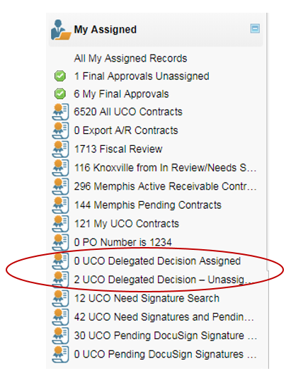

* The first step in the review process is to determine if the submitted document is actually a contract. Departments should not submit personal agreements or online terms. If the document is just a quote with no referenced terms and conditions and is with a domestic vendor, it should most likely be processed through a purchasing office. If the document is just a quote but it is with a foreign vendor, the department needs to fill out the international goods or services agreement template (depending on whether the purchase is a good or a service).
* At this step, the CCO/UCO will check the contract data against the contract document for accuracy.
* The CCO/UCO will either fix any errors, or return the record to the contract requestor, so that the contract requestor can fix the errors.

## Changing a Contract

Certain mistakes in the contract record may need to be returned to the department for correction. These include such things as incorrect contract type and incorrect record type.

## Returning Contract to End User

To return the record to the end user for changes:

* + - * In the “Approvals” tab, enter the reason for the return in the “Approval Notes” section.
      * Click the orange and white “Requires Change” button.

## Cancel Contract

If the contract needs to be canceled, click on “Cancel Contract.”

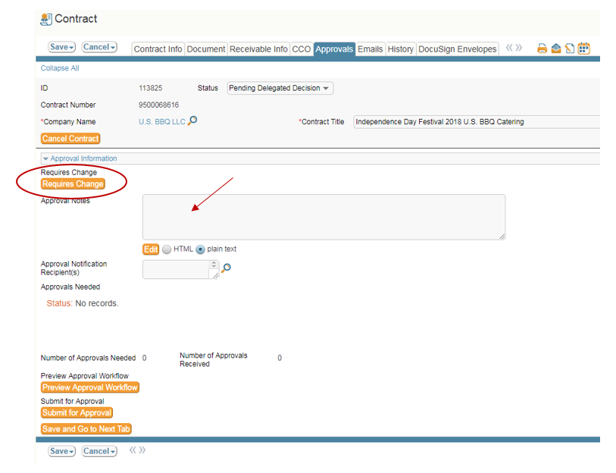

Before the contract record can be returned, you will have to make a delegation decision in the CCO tab. Make this decision based on FI0420 (see Appendix 1).

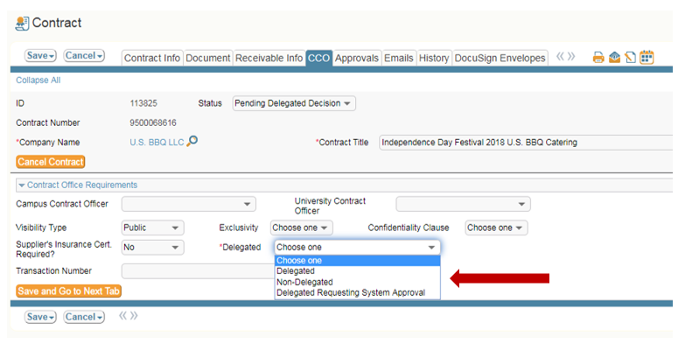

# Gatekeeper Step/Delegation Decision

## Contract Office Requirements

If the contract does not need to be returned to the department you can proceed with making the delegation decision.



**Assignment**

Select the CCO you want to assign the contract to.

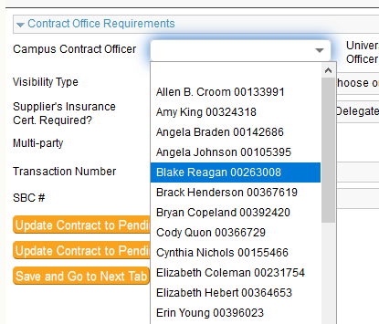

**Delegation decision**

Refer to Appendix 1 for information on delegated and non-delegated contracts.



**Visibility/Exclusivity/Confidentiality Clause**

When reviewing the contract, you should take note if there is an exclusivity obligation, confidentiality clause, or if the contract’s visibility should be public or private. Please note that marking a contract “private” will not exempt that contract from public records requests. If you mark a contract as private, viewing access for this contract will be limited to only those people who are in the approval steps or in the notification field. Use the drop-down menus to make selections based on your review.

Contracts with foreign vendors are automatically changes to private when the contract is activated. This is because there can be sensitive banking information associated with these contracts. The private setting for foreign contracts cannot be changed.

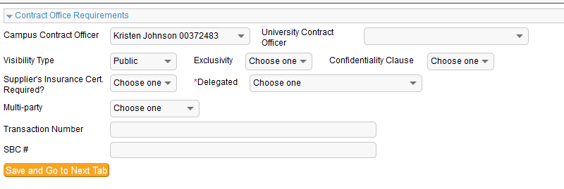

**Insurance Certificate**

Before you can submit into workflow, you must choose yes or no for the supplier’s insurance certificate requirement field. Check with the Insurance and Bonding Guidelines to determine if a certificate of insurance will be needed. If so, it is the CCO/UCO’s responsibility to obtain the COI (certificate of insurance) from the supplier. If you have questions about insurance requirements, you should contact the office of Risk Management. If the COI is required, you will need to mark “yes” in the “Supplier Insurance Cert. Required” field.

**Transaction Number**

This field is reserved for The UTHSC contract office and for the Office of Facilities Planning.

**SBC #**

This field is used by the Office of Facilities Planning (Capital Projects).

## Submit for Approval

After you have taken all the steps in the gatekeeper role, you are ready to put the contract into workflow. You will do this in the approval tab by clicking “Submit for Approval.” This step does not activate the contract. Depending on the type of contract it is, it could go to the purchasing office for NCJ approval, the CBO, and/or the CFO before it comes back to the CCO/UCO’s inbox for the actual contract review.

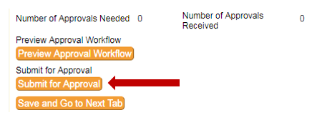

## Preview Workflow

The CCO/UCO can preview the approval workflow by clicking the “Preview Approval Workflow” button in the Approvals tab.

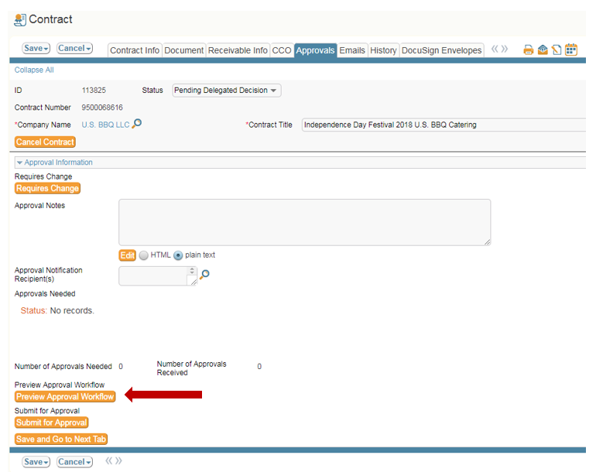

## Contract Ready to be Reviewed

After the contract has received all workflow approvals, it will be routed back to either your “My Final Approvals,” or “Final Approvals – Unassigned” folder for the final workflow approval step.

* + My Final Approvals: Contracts that were assigned to you for review during the pre-review/delegation decision step.
  + Final Approvals – Unassigned: Contracts that were not assigned to a specific staff member for review during the delegation decision step.

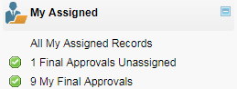

## Resubmitted Contracts

If someone in your office assigns a contract to you, and the contract is rejected for some reason, the assignment does not get wiped out when the contract is rejected.  In other words, rejecting a contract doesn’t change the assignment.  If the department resubmits the contract, it will end up in the CCO (or UCO) Delegated Decision Assigned inbox.  See below.

The counters on these searches aren’t very reliable, so even if it says “0,” it’s a good practice to check the search boxes regularly, just in case.

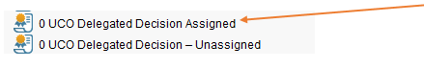

## Reviewing the Contract

This is the step where you will review, edit, and negotiate the contract.

## Pending Vendor Review/Legal Review

You can indicate if your contract is with the vendor for their review or with the Office of General Counsel by selecting one of those options in the CCO Tab.

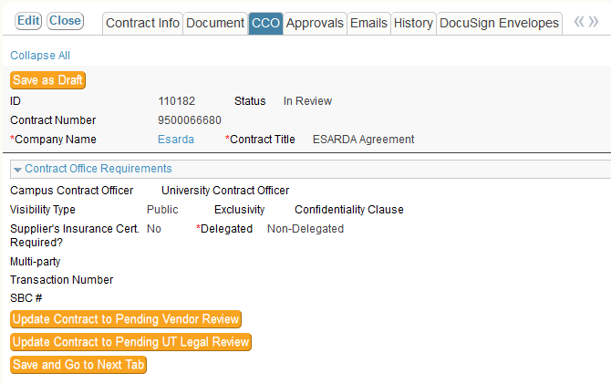

## Needs Signature

After you have a final, negotiated version of the contract document, you are ready to approve it through the final workflow approval step.

Click the orange and white “Approve” button to approve the contract.

* The contract will complete the CCO or UCO final workflow approval step.
* The contract status will change from “In Review,” “Pending Vendor Review,” or “Pending UT Legal Review” to “Need Signatures.”

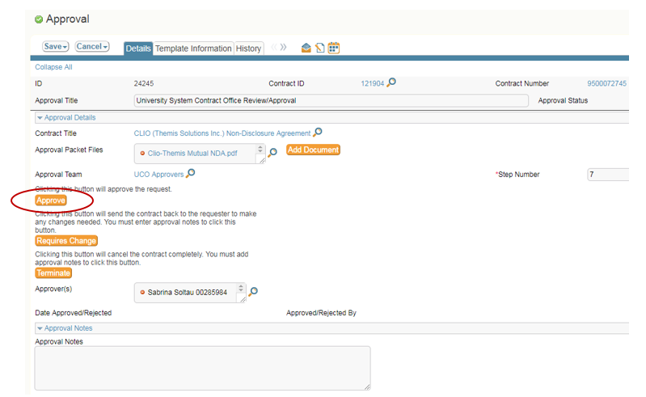

If you do not approve the contract in this workflow step, you can either return it to the contract requester as a “Draft” status, or terminate the contract.

* To return the contract to the contract requester, click the orange and white “Requires Change” button, and add an “Approval Note” to explain the reason for the return.
* To terminate the contract, click the orange and white “Terminate” button, and add an “Approval Note” to explain the reason for the termination.

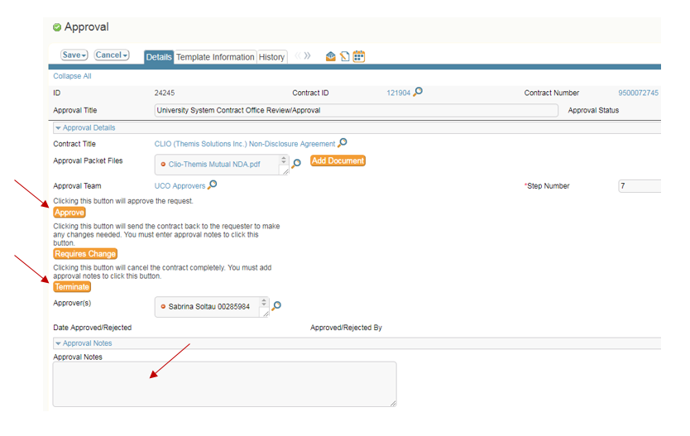

## Mark as Signed

Once you are in the “Needs Signature” step, your next approval will be to “Mark as Signed.” This final step activates the contract. The data feed to SAP (IRIS) is only once per night for activated contracts. The data feed sends over activated payable contracts and amendments to payable contracts, even if the amendment is a zero-dollar amendment.

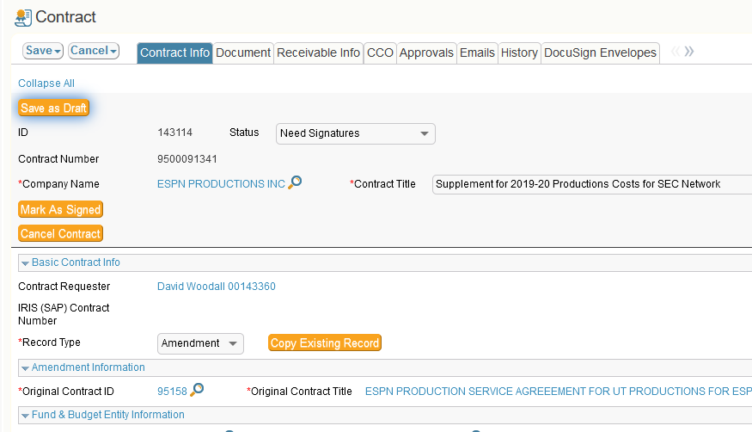

## Check Status of Contract

To check the status of a contract, or to find out where it is in the review process, search for the contract using either the “Contracts” table, or the “All UCO Contracts” table (this may read “All [*insert campus name here*] Contracts,” depending on your campus) under the “My Assigned” icon. Please also remember that the contract system will not populate workflow until after a contract leaves the “pending delegation decision” step (the gatekeeper stage). End users often get confused when they submit a contract, and then the contract has no workflow. Once the UCO or CCO processes the contract at the gatekeeper stage and submits the contract to workflow, the contract system will populate a workflow path.

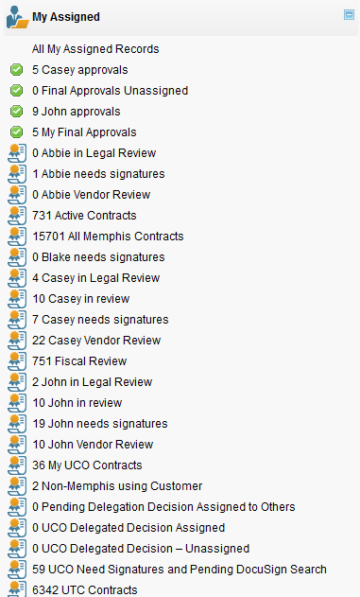

The search bar will look similar to the image below. If you do not see the search bar, click on “Search” to display it.

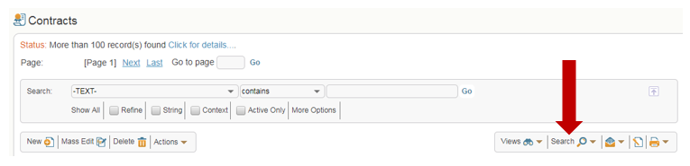

Choose the field within which you will search.

* Click the inverted triangle to access the drop-down list.
* Select the correct field from the list.
* Examples of some searches that you can run:
  + Contract number
  + Account number
  + Contract title
  + IRIS (SAP) Contract Number
  + Requestor LDAP User ID
  + Company name
  + Company Number

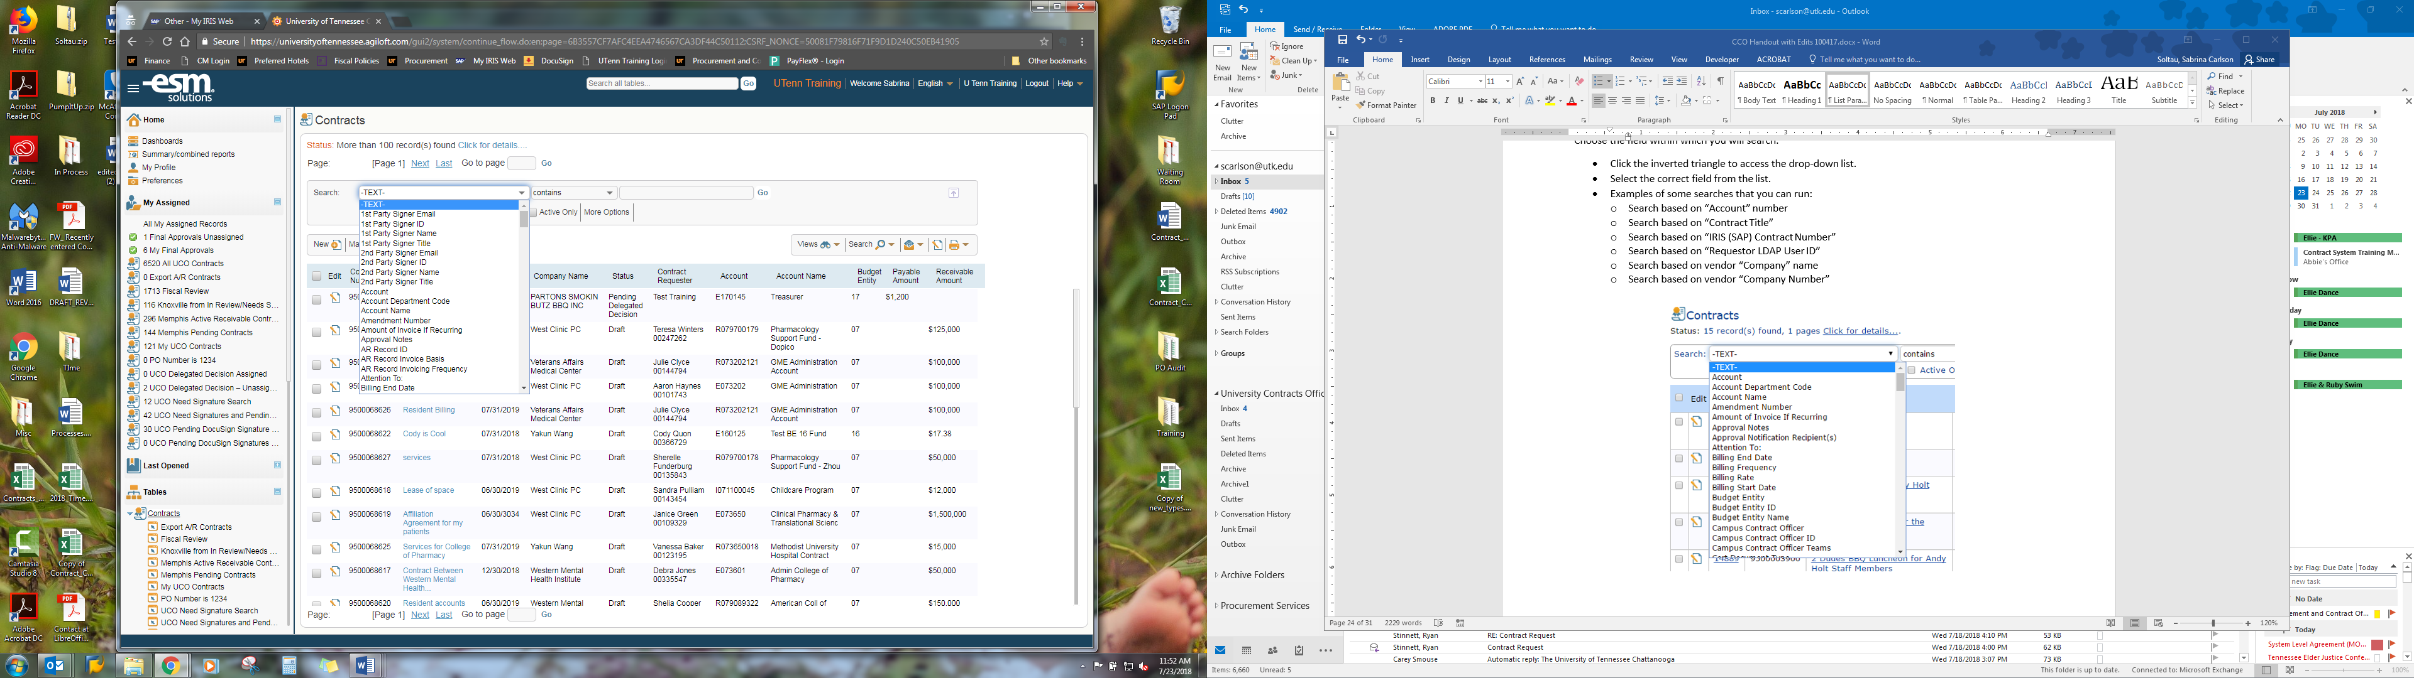

* Choose the operator that you will use to search
  + Click the inverted triangle to access the drop-down list.
  + Most frequently used operators:
    - “equals, =”
      * This will search for an exact match.
    - “contains”
  + Highlight the operator.

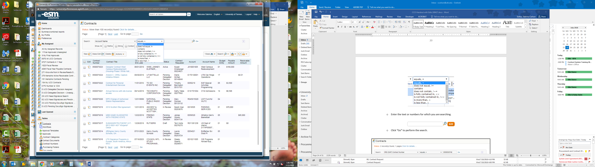

* Enter the text or numbers for which you are searching.
* Click “go” to perform the search

You can click on either the “Edit” icon, or the “Contract Title,” to open the record.

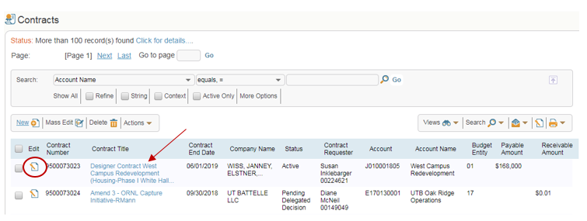

Click on the Approvals tab of any contract to see the approval information.

* The approval information includes the approval status, approval title, approver group, the person who approved or rejected the contract, and the date and time it was approved or rejected.

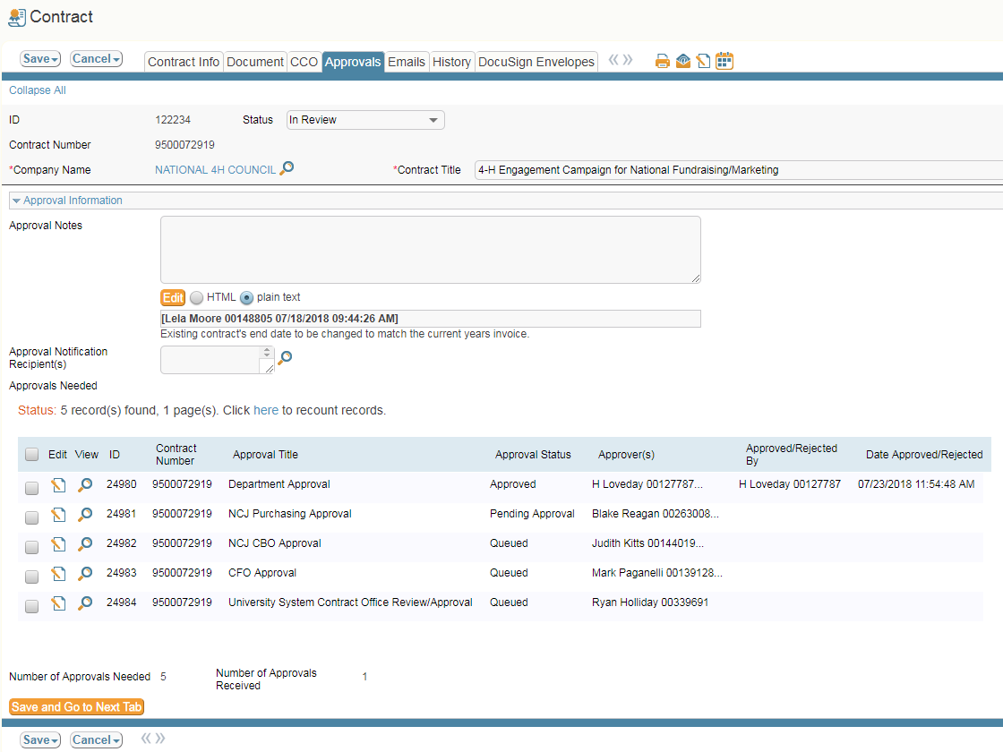

## Approving or Rejecting for Someone Else

CCO/UCO team members can approve or reject a contract on someone else’s behalf.

Locate the contract that is in review and open the contract record. Click the “Approvals” tab. Then, look at the Approvals Needed area.

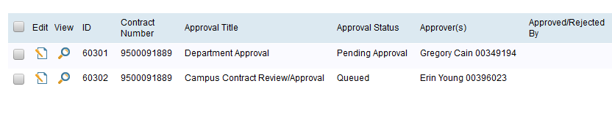

Click the Edit icon for the approval line that you want to access.

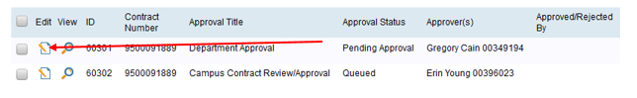

You can take action on the approval record as if you were the approver. Your name will show up as the approver under the “Approved/Rejected by” column.

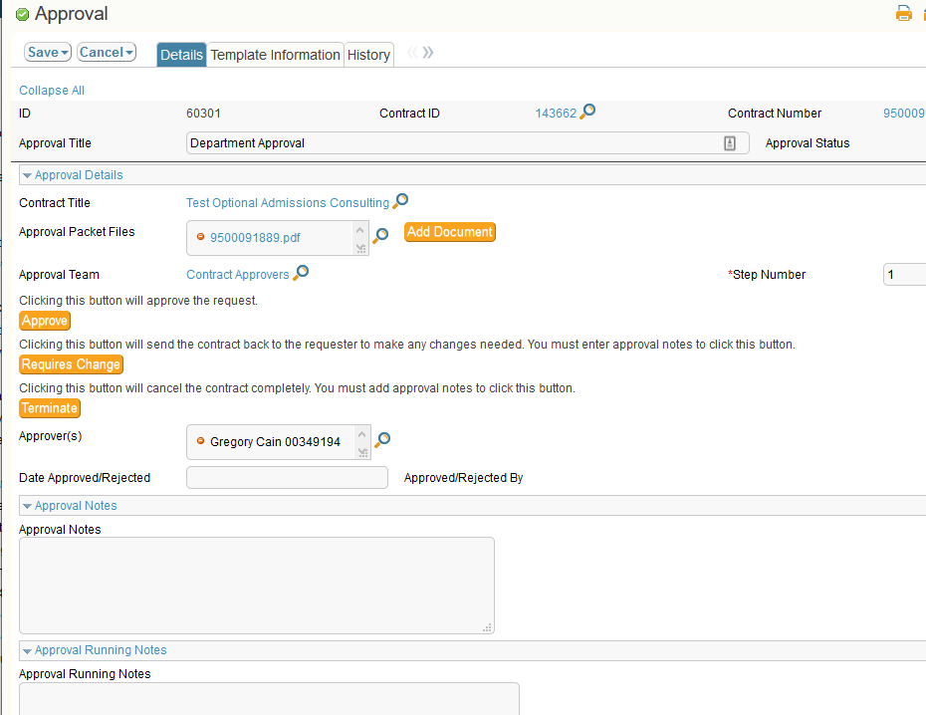

If you reject a record, please add the rejection reason in the Approval Notes field. If you approve a contract on behalf of someone else, please upload an email thread documenting that the person gave you permission to approve the contract on their behalf.

# Appendix 1 -Delegation Decision

|  |  |
| --- | --- |
| Delegated  Contracts that fall into either of the categories below: | |
| All contracts involving the transfer of funds to or from the University in the amount of $249,999.99 or less. | **All contracts, regardless of amount, in one of the following categories:** |
|  | 1. Contracts with domestic government agencies (note: contracts with the state of Tennessee of its agencies for employee services must comply with Fiscal Policy FI0445); |
|  | 1. Contracts for licensing of university facilities and contracts between the university and its students for university housing; |
|  | 1. Contracts with domestic companies who recruit international students to attend the university; |
|  | 1. Contracts for scheduling athletics events; |
|  | 1. Employment contracts with athletic coaches and athletic directors, which must be signed by the chancellor of the campus; provided that all such contracts must be approved by the Office of General Counsel prior to being signed by the chancellor. |
| Non-Delegated  Contracts that fall into either of the categories below: | |
| All contracts involving transfer of funds to or from the University in the amount of $250,000 or greater. | **All contracts, regardless of dollar value, in the following categories:** |
|  | 1. Leases of real property to or by the university if the amount is more than $50,000 per year or the term is longer than five years; |
|  | 1. Contracts with foreign governments, international corporations located outside of the U.S.; and contracts with individuals who are citizens of a foreign country; |
|  | 1. Contracts that impose an exclusivity obligation on the university; |
|  | 1. Contracts for purchase or sale of real property; |
|  | 1. Memoranda of agreement to establish endowments; charitable remainder annuity trust agreements; and charitable remainder unitrust agreements; |
|  | 1. Contracts for participation in bowl games and regional or national athletic tournaments above $249,999.99; |
|  | 1. Employment contracts with executive officers, including the president (this does not include standard offer letters processed through human resources), but excluding employment contracts with athletic coaches and athletic director; |
|  | 1. Contracts for indicia licensing, promotions, and sponsorship agreements, including the university’s endorsement of goods or services; |
|  | 1. Contracts with teaching hospitals for graduate medical education programs and with faculty physical practice plans; |
|  | 1. Contracts for accounting, auditing, banking, or fiscal management services; |
|  | 1. Post-retirement service contracts and retirement incentive agreements; |
|  | 1. Settlement agreements (Note: settlement agreements must be approved and executed in accordance with BT0012 - Policy on Settlement of Claims and Litigation, as applicable); |
|  | 1. Contracts for the provision of administrative, technical, professional, management, or executive services by a university employee to another party (except the State of Tennessee and its agencies) under the direction and control of the other party, including but not limited to an agreement to lease or loan a University employee to another party. |

# Appendix 2 - Workflow Overview

