University of Tennessee – Shop, Cart, Checkout

Table of Contents

Getting Started 3
Shop 3
Exercise 3
How to Shop 3
Checkout 7
Exercise 7
How to Checkout 7
Appendix A 12
Search Function 12
Appendix B 13
Creating Accounting Favorites 13

Getting Started

Shop
Upon logging into the easyPurchase system the user is taken to the Shop page. The Shop page contains catalogs for the user to shop from.

Exercise

How to Shop

- Log in to UT My Iris with Single Sign On
- Select > Shop Tab from UT My Iris.
- The University of Tennessee Marketplace will appear.
- The Shop, Cart, Checkout tabs will appear.
- Select > Shop
- You will see a list of catalogs.
- To Shop, select from one or more of the catalogs that appear.
  - The catalogs available to you are determined by the System Administrator. You could have a mixture of Punch-Out Catalogs (these are catalogs that will take you to the vendor’s web site) or Hosted catalogs (which are excel files).
  - See Appendix A to shop using the Search function.
- Select items from the catalog(s).
- Enter quantity for each item(s).
- Select > Add to Cart to place items into the shopping cart.
  - This process is for a Hosted catalog.
- If the catalog is a Punch Out catalog, you will need to go to “MyCart” on the supplier’s site and Select >Check Out.

10. Once inside the Cart checked your items, then Select > Complete Checkout (For Punch-Out Catalogs).
11. This will place all the items in the “Cart” section of easyPurchase.
12. Check your items in the Cart.
13. You can delete items, update quantities in the Cart.
14. Once you are satisfied that you have the correct items in the Cart, Select > Continue.
15. This will move the items to the Checkout Tab.

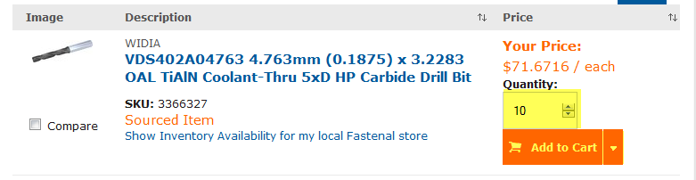

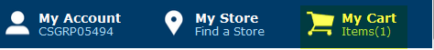

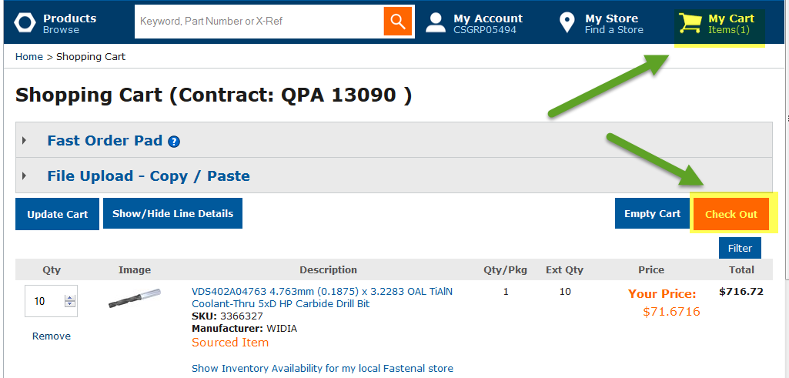

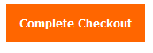

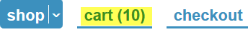

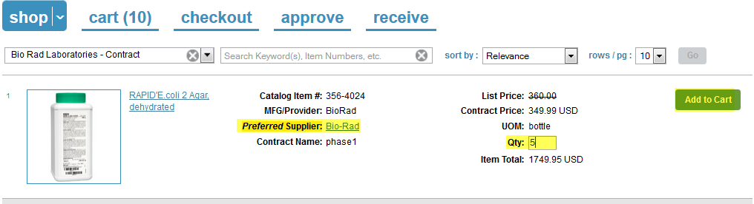

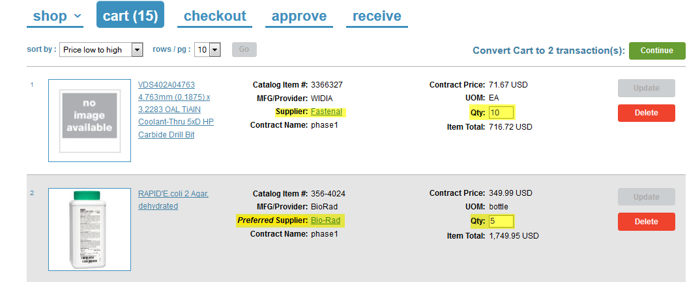

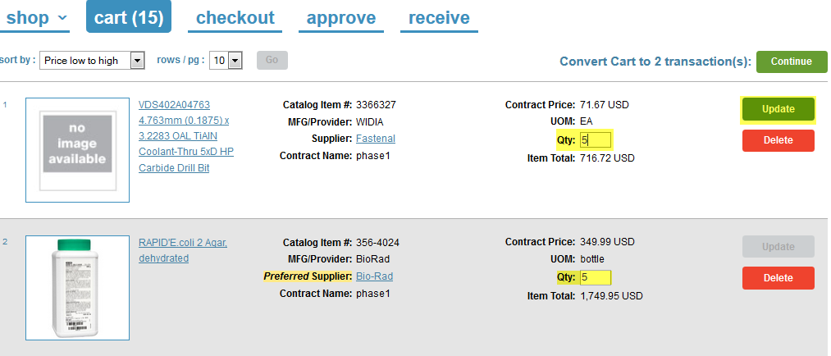

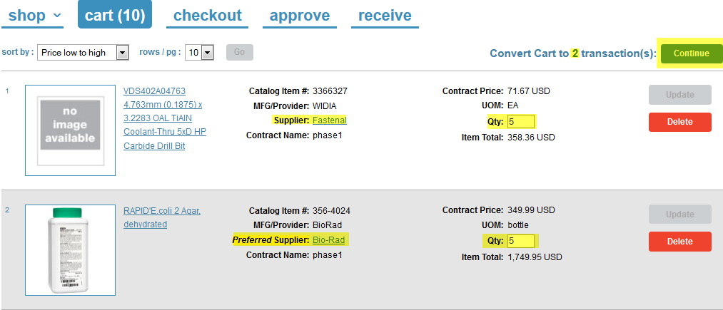

Checkout
Once the user has moved item(s) from the Cart, the Cart is then transfer to the Checkout Tab. From the Checkout Tab the user will assign account code(s), select payment method, add Work Order # and process the transaction to the supplier.

Exercise

How to Checkout
- Once you selected Continue from the Cart Tab, the item(s) and supplier(s) were moved to the Checkout Tab.
- The Checkout Tab provides you the ability, (based on the organizations requirements) to enter Work Order number, GL Account information, Asset and external and internal notes and attachments.
- The Checkout Tab displays the transaction information in the header. You can see the requestor of the transaction, the supplier, the total and the number of items for this transaction.
- Select > Payment Option. If set up by the organization you will have the ability to select either Credit Card or PO as the form of payment for this transaction.
- You can also add external and internal notes and attachments. The supplier will only see any external attachments or notes. Internal notes are only seen by the originator of the transaction and approver.
- Select > Work Order # and type in the work order number for this transaction if applicable.
- Select > NIGP Code. This is a drop down selection.
- Select > Other. Fill in addition information as instructed or needed to complete the order.
- Ship To Attn – This field is on the header and line item level. If various items from the vendor are going to different users, open the header by clicking on the blue triangle and expanding the header. The user can then change the Ship to on each line item.
- Select > Acct Assignment. If you have created “favorities” (See Appendix B) select an Account Assignment from the drop down.
- Select > Update.
- Click the Blue Triangle.
- This will expand the header area into the line item detail level
- On the line item level you can select a Need by Date, add notes and attachments (internal and external), change the Ship to and Bill to, change the quantity and change the account assignment.
- Once all changes have been completed Select > Update.
- Select > Validate
- If this transactions needs to be approved, Select > Request.
- The transaction will be routed to the approver to approve. Once approved, the transaction is returned to the Checkout Tab for further processing.
- If the transaction does not need approval or has just been approved, Select > Check. The check process checks the accounting information and the user against the records in SAP. If this is a valid account number and user, then the status will change to Pass.
- Once the transaction has passed the GL Check, a dialogue box will appear stating that the action resulted in a transmitter to the supplier.
- At this point you can View the PO
- A dialogue box will appear stating that the action will result in a transmitter to the supplier.
- If this was a Credit Card order, once the Check process is validated, the user(s) will Select > Prepare, to prepare the Credit Card order.
- On the Credit Card Order form, fill in the credit card number, expiration data and type of Credit Card.
- Select > Continue.
- At this time, user can also Print a copy of the order.
- Once Continue is selected a dialogue box will appear asking the user if they wish to place the order.
- Select > Place Order.
- A dialogue box will appear stating order was successfully submitted to supplier.
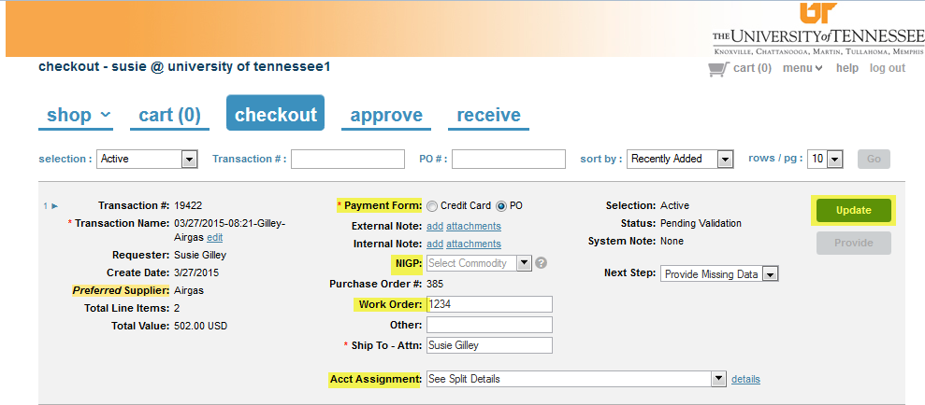

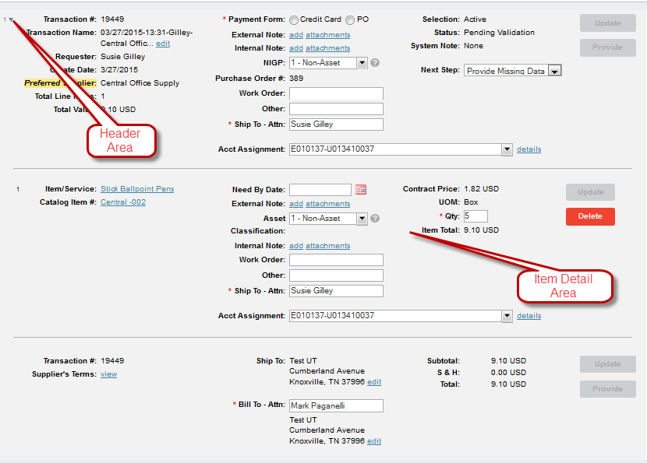

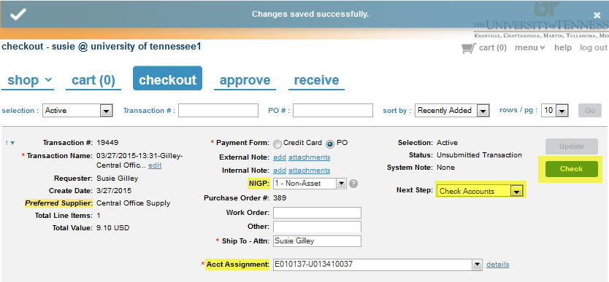

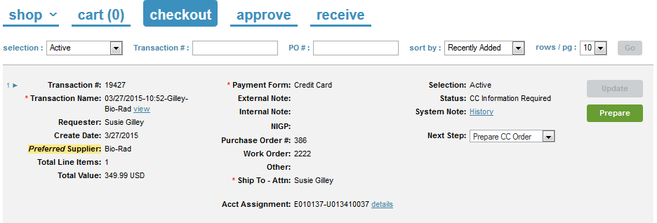

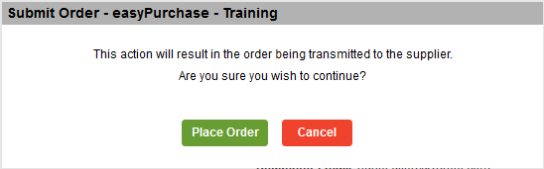

Appendix A

Search Function

The Search Function allows the user to search for items across multiple catalogs. Follow the instructions below to use the Search function.

- To search for items across multiple catalog, type the name of the items you are searching for in the search header. (See example below)
- Select > Go.
- Items that fit that description will appear below.
- The purpose of this type of search is so the user can compare prices across multiple vendors at one time.

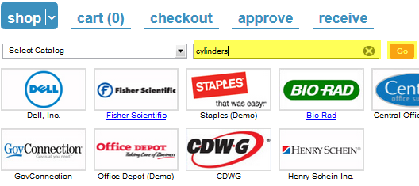

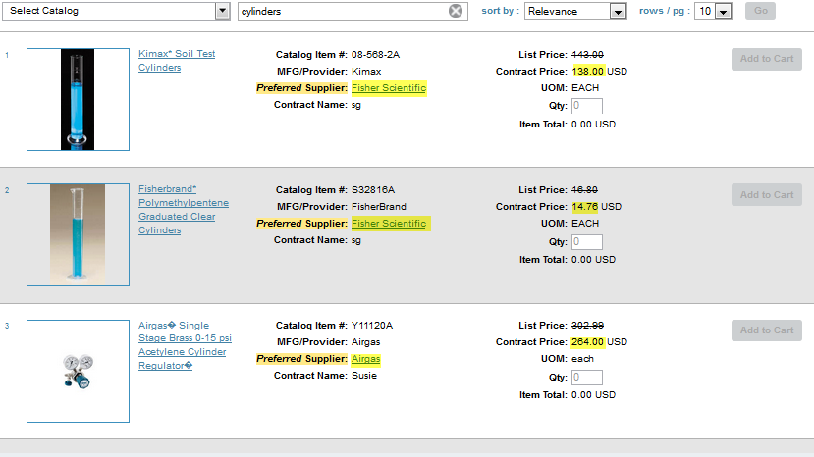

Appendix B

Creating Accounting Favorites

The user has the ability to create favorite account assignment. The purpose behind creating favorites is so the user will not have to search for accounting codes. They can select their favorites from the drop down menu on Account Assignments.
Follow the exercises below to create Account Assignment favorites.

- To start to create account assignment favorites Select > Details beside Account Assignment, located on the Checkout tab.
- Account Code Detail Form will open.
- The Chart of Account will automatically default.
- Type in the Fund you wish to add or select the fund from the drop down menu.
- The Fund Account and the Fund description will populate.
- Once you have selected a fund, the Update will turn blue.
- Select > Update.
- Once you select update, the account assignment will be added to the favorite.
- Select > Apply, to save favorite.
- To delete an account assignment, check the delete box and Select > Apply.

