University of Tennessee easyPurchase™ Access to Order Summary Screen

Table of Contents

Getting Started 3
Activating Order Summary at the Entity Level 3
Activating Order Summary at the User Level 3
Using Order Summary 4
Accessing Order Summary 4
Search Criteria 4
Running an Order Summary to the Screen 4
Exporting an Order Summary 5
Order Summary for New Users 6
Adding for New or Existing Users 6

Getting Started

Activating Order Summary at the Entity Level
- ESM Solutions Support can activate Order Summary for an entity under ESM Admin> Entity Functionality and checking Order Summary box and clicking Update.

Activating Order Summary at the User Level
- ESM Solutions Support can activate Order Summary for a user under ESM Admin > Administer Entities/Suppliers, then enter the entity name and click Go.
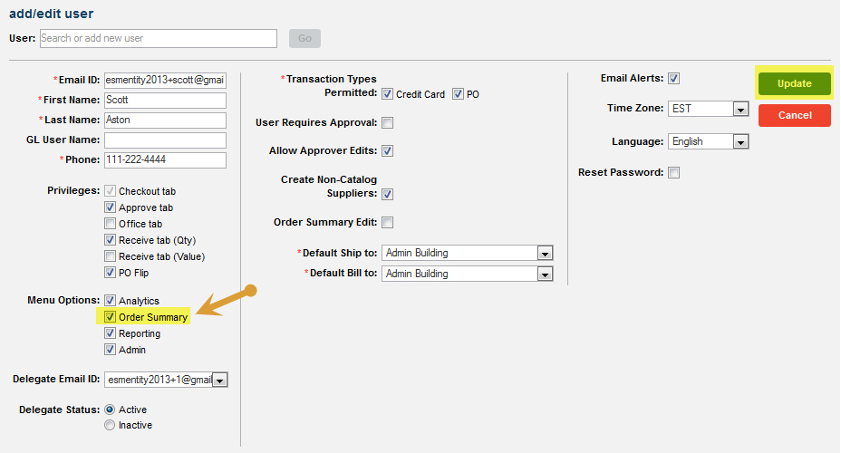
- Select Function > General Settings > Add/Edit Users and search for a user to get to the screen below.

- Under Menu Options, check the box for Order Summary and click Update.
Note: All existing Admin users for the entity will now have Order Summary enabled.

Using Order Summary

Accessing Order Summary
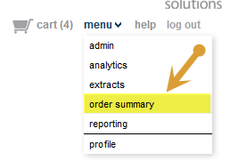
- A user may access Order Summary for an entity under Menu> Order Summary as shown below.

Search Criteria

- The search screen allows the user to use any combination of the following fields:
  - Purchase Order #
  - Create Date (start/end range)
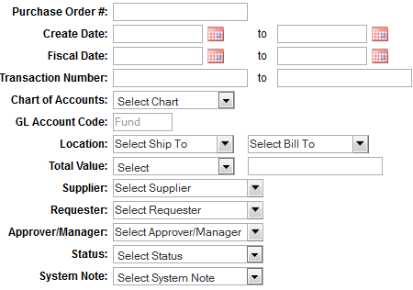
  - Fiscal Date (start/end range)
  - Transaction Number
  - Chart of Accounts
  - GL Account Code
  - Location (Ship To and/or Bill To)
  - Total Value ( =, > , >= , < , <= )
  - Supplier
  - Requestor
  - Approver/Manager
  - Status
  - System Note

Running an Order Summary to the Screen

- Enter the search criteria and click Search.

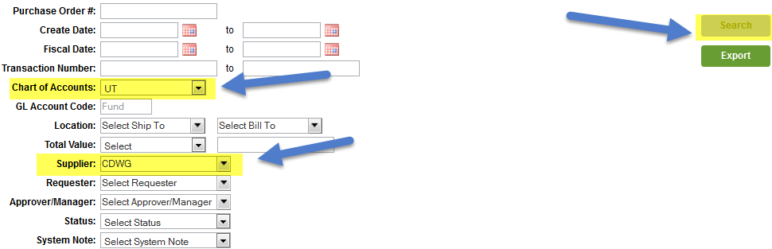

- The Order Summary Results will be displayed to the screen.

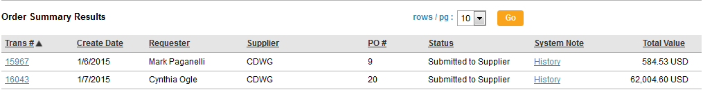

Exporting an Order Summary

- Click on Export button to have the Order Summary Results in an excel.csv format sent via email.

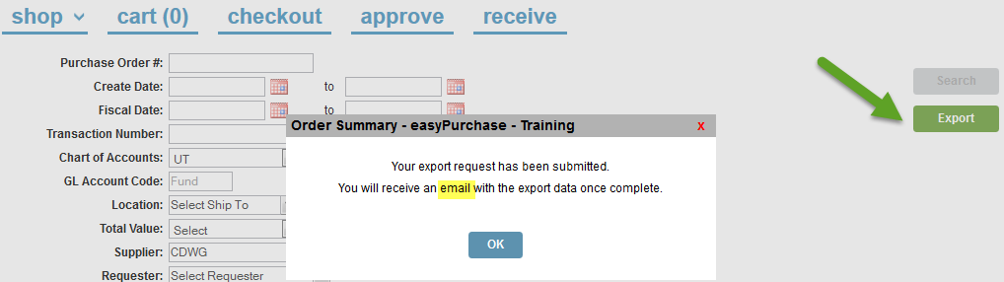

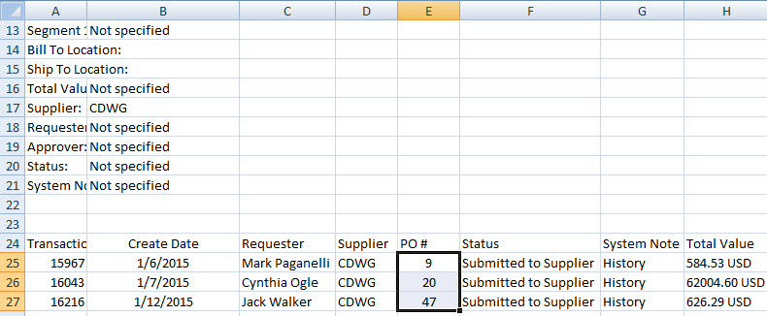

Order Summary for New Users

Adding for New or Existing Users
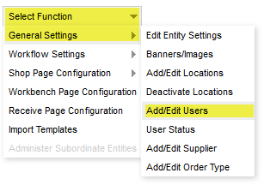
- An Administrator can add Order Summary for new users by going to Menu > Admin > Select Function > General Settings > Add/Edit Users as shown below.

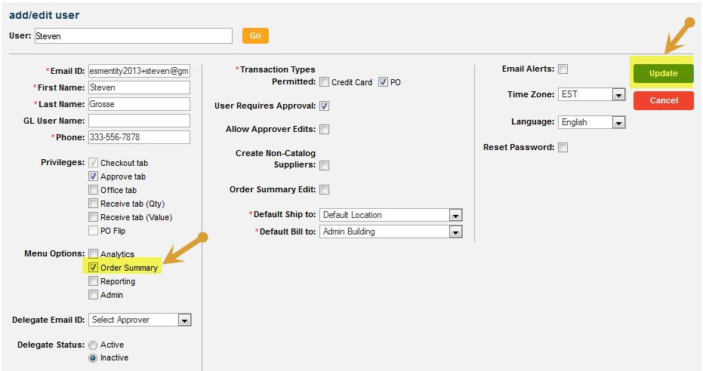
- Check the box for Order Summary and click Update

