The University of Tennessee
easyPurchase™ Transfer Originator’s Cart

{This page left intentionally blank.}

Table of Contents

Getting Started 3
Activating Transfer Originator’s Cart at the Entity Level 3
Activating Transfer Originator’s Cart at the User Level 3
Using Transfer Originator’s Cart 4
Login as a Transfer Originator’s Cart User 4
Shopping in easyPurchase and Transferring the Cart 4
Approval of the Transferred Items 5

Getting Started

Purpose
The purpose of the Transfer Originator’s Cart functionality is to allow an entity the flexibility of utilizing additional resources in the shopping experience while maintaining complete control over the approval process. These users (such as summer interns or graduate assistants) can be configured to only access the Shop and Cart tabs and will be configured to transfer all transactions to another user for purposes of completing the transaction (account codes, workflows, etc.) and approving the purchase. These users may log in to easyPurchase and shop as directed, however the items in their cart will be transferred to a designated Approver in the department for Approval and Checkout.

Activating Transfer Originator’s Cart at the Entity Level
- ESM Solutions Support can activate Transfer Originator’s Cart for an entity under ESM Admin> Entity Functionality and checking Order Summary box and clicking Update.

Activating Transfer Originator’s Cart at the User Level
- ESM Solutions Support or a User with Admin privileges can activate Transfer Originator’s Cart for a user.
  - Under ESM Admin > Administer Entities/Suppliers, enter the entity name and click Go.
- Select Function > General Settings > Add/Edit Users and search for a user to get to the screen below.

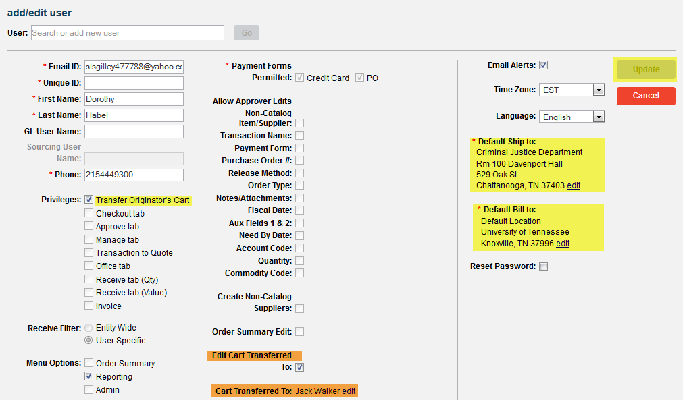

- Under Privileges, check the box for Transfer Originator’s Cart.
- Under Edit Cart Transferred To, check the box if the user will need to edit the name associated with Cart Transferred To during vacation, illness, etc.
- Under Cart Transferred To, select the name of the person to whom the cart will be transferred for Approval.
- Select the Default Ship To/Default Bill To and click Update

Using Transfer Originator’s Cart

Login as a Transfer Originator’s Cart User
- The Transfer Originator’s Cart user will only see Shop and Cart while in easyPurchase.

Shopping in easyPurchase and Transferring the Cart

- The user will shop in easyPurchase by, as any other user would, clicking on the catalogs available and selecting the items needed. The Cart tab will show the total number of items that will be transferred to another user for Approval.
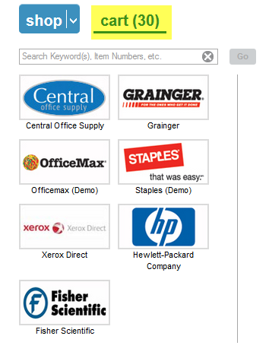

- From the Cart tab, the user may edit quantities, edit Transfer Cart to or click on the Continue button to convert the Cart into transaction(s).
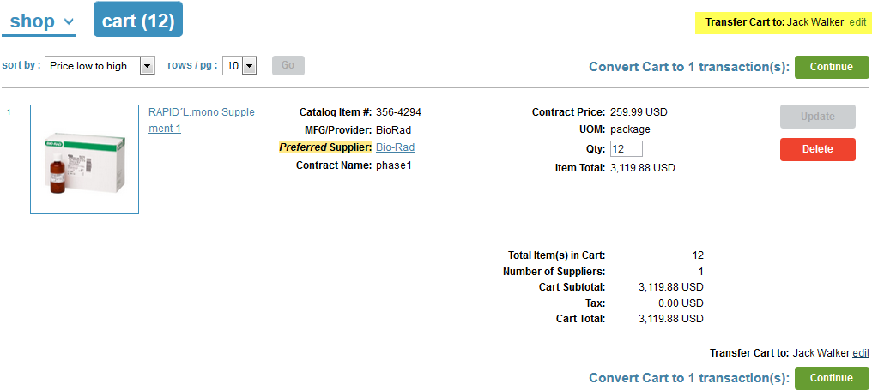

- To edit the Transfer Cart to, Select > Edit
- A User Search box will appear.
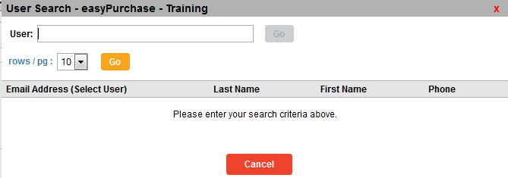
- Type in user id or a letter to search for the person you wish to transfer the cart to
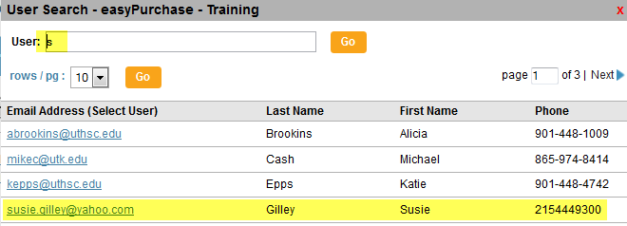
- Select the user by clicking on the email address.
- The cart will now be forward to the new approver.
- After converting to transaction(s), the Transfer Originator’s Cart now shows Zero items

Approval of the Transferred Items
- If Email Alerts are enabled, the Approver will receive an Email Alert from the Originator.
- Login as the Approver.
  - Note: The items from the Originator’s cart do not show in the Approver’s cart.
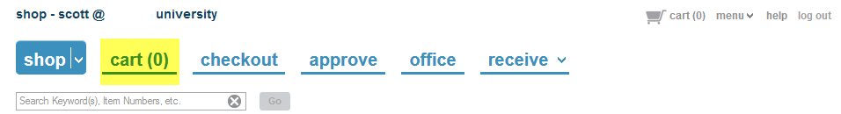

- The Approver can continue and approve the order.
- Note: The next steps shown may vary based upon the workflow criteria that are set up for the entity.

