University of Tennessee - easyPurchase™ Ship to Bill to User Profile

Table of Contents

Getting Started 3
Accessing User Profile 3
Editing Ship to Bill to addresses 3

Getting Started

Purpose
The purpose of the Ship To Bill To functionality is to allow the user the flexibility of changing their shipping and billing addresses as they change positions or re-locate to another facility on campus. The users can change their ship to and bill to addresses by accessing the information in their user profile.

Accessing User Profile
- Upon logging into the system, the user will Select > Menu > Profile
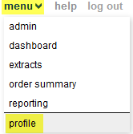

Editing Ship to Bill to addresses
  - Upon entering the user profile information form, the user will notice a default Ship to Bill to address already associated with their profile.
.
To edit the Ship to Profile, Select > Edit under the Default Ship or Default Bill to.
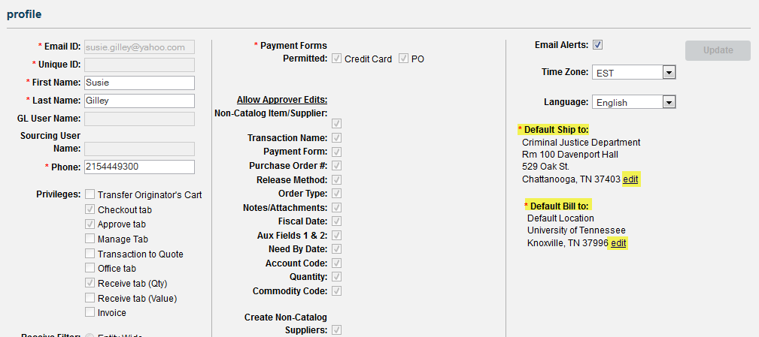

- A Location dialogue form will open.
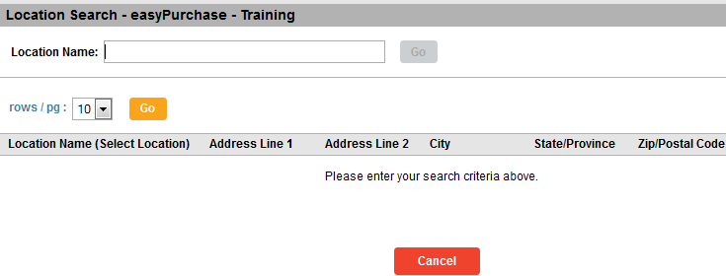
- In Location Name, type in the name of the new location, Select > Go.
- Select the location you wish to become either the Default Ship To/Default Bill To by clicking on the hyperlink under the location name.
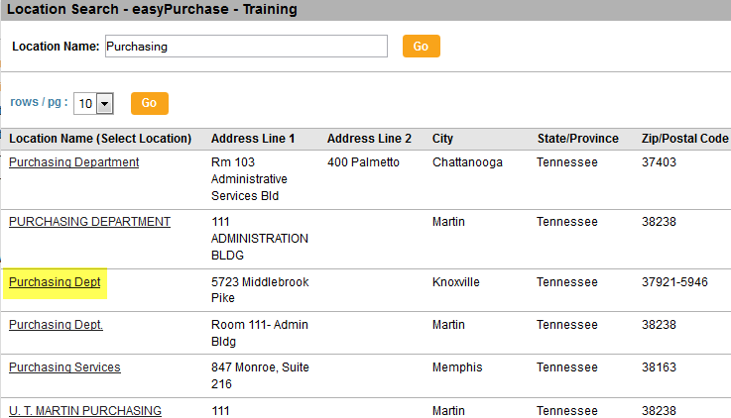

- The address you select can now be seen in your user profile.
- Select > Update to save the new address.
- Repeat Steps 1-6, if you need to change the Bill to or Ship to address.

