University of Tennessee
easyProject™

Training Manual for easySourcing™ Users

{This page left intentionally blank.}
Table of Contents

Introduction 5
Purpose 5
Additional Resources 5
Basic Navigation 6
Logging In 6
Web Browsers 6
Web Address 6
System Overview 7
Project Overview 8
Getting Started 8
Project Screen Area 8
Project Category and Description 9
Project Navigation Bar 9
Prepare 9
Create 9
Modify 9
Exercises 9
Creating a Project 9
Project Attachments 9
Exercises 10
Creating an Attachment 10
Delete Attachment 11
Exercises 11
Deleting an Attachment 11
Project Notes 11
Exercise 12
Creating a Note 12
Response Checklist Items 12
Exercise 13
Including a Checklist Item 13
Exercise 14
Removing a Checklist Item 14
Exercise 14
Adding a Checklist Item to an existing Project. 14
Project Prepare – View Project 15
Project Prepare – Modify Project 15
Project Prepare – Modify a New Project 15
Project Prepare – Copy Project 16
Exercise 16
Coping a Project 16
Project Specific Terms and Conditions ` 18
Project Prepare – Additional Project Terms and Conditions 18
Appendix A 19
Terminology 19
Appendix B 20
Project Status 20
Tab 20
Submenu Option 20
Activity Performed 20
Document Version 22

Introduction
The ESM Solutions easySourcing™ system is designed to automate the projecting lifecycle. The University of Tennessee will use this system to manage line item projects, construction projects and projects. The system will be used to facilitate and award projects.
The University of Tennessee has implemented this Software-as-a-Service (SaaS) tool for the following reasons:
- To streamline the entire sourcing process from requisitions to award to created catalogs
- To have better control of campus spending by creation of function groups
- To have the ability to view events from the Sourcing Event Board

Purpose
The purpose of this document is to provide the University of Tennessee system and campus staff with detailed information about system functionality and practice exercises to reinforce understanding of the common tools and functionality needed to manage Projects and awards. This document is intended for users that manage purchasing agreements, such as buyers and purchasing directors; however, staff with other responsibilities in the University of Tennessee’s projects and awards may also benefit from this document.

Additional Resources
Additional resources for training, help and support can be found at the University of Tennessee Marketplace Training website, or the following web address:

http://treasurer.tennessee.edu/purchasingsystem/sourcing/index.html

Please contact the following University of Tennessee easySourcing™ system administrators for additional assistance or questions:

Jack Walker 865-974-0326 jwalk117@utk.edu
David Marks 865-974-0326 dmarks@tennessee.edu

Basic Navigation
The purpose of this section is to provide detailed information and practice exercises for logging into the easySourcing system and for navigating the various project types and reports available.

Logging In

Web Browsers
Because browser versions are constantly changing, the easySourcing system is typically certified to work with the browser’s current full release version, as well as one full release version back. It is important to note that easySourcing, like so many other web-based applications, does not work well with Internet Explorer 8. Thus, it is recommended to Internet Explorer users to only use Internet Explorer 9 or higher.
If you have any questions about or experience any difficulties with web browsers on your workstation, please contact the University of Tennessee system administrator.

Web Address
After opening a web browser, navigate to the login page by entering the system URL. Note that there are different URLs for the Training and Production environments.
The following is the Training environment URL:
https://universityoftennessee.enterprisewizard.com/logins/utenntraining-login.htm
If you have any questions about the login page, please contact the system administrator.
.
Username & Password
On the ESM Solution Login page, enter the University of Tennessee number, your User Name and Password. The User Name will be the first initial of your first name and a combination of your last name depending on the length of your last name. The User Id will be given to you by the system administrator.
If you cannot remember your password, select the “Forgot Password?” link next to “reset your password”. To reset your password, you must be able to provide your username or email address, so that an email message can be sent to you with the new password and instructions. If you cannot remember your username or experience any issues with or have questions about your username and password, contact the system administrator.

System Overview
The easySourcing system has the following solutions areas:
- easyBid Line Item
- easyBid Discount
- easyQuote
- easyProject
- Sourcing Event Posting Board
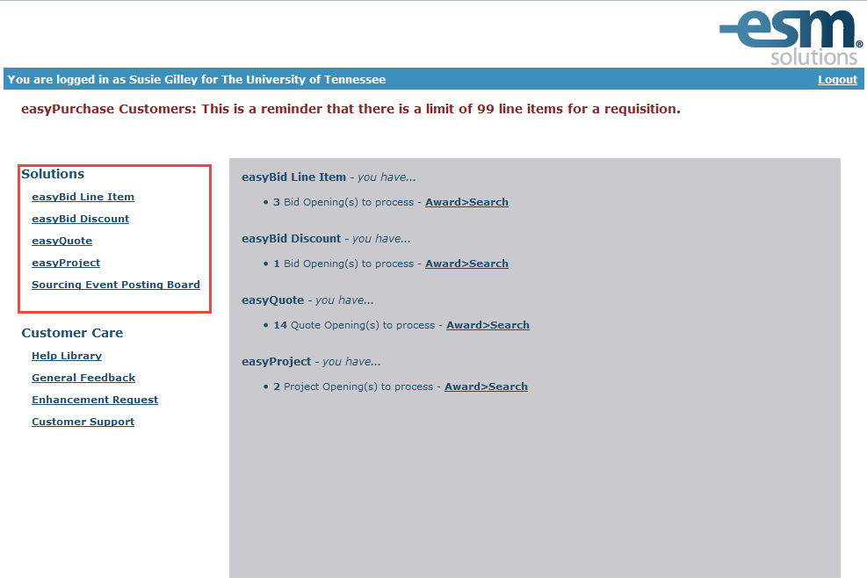
Each of these areas has specific functionality that is made accessible to users based on the permissions assigned.

Project Overview
The Project Prepare screen allows for the creation, modification and copying of projects. Upon first entering easyProject, the user is presented with a layout similar to easyBid Line Item. Both are formal, sealed projects that do not allow the project facilitator to view any vendor responses before the predetermined Open Date and Time.

Upon entering the easyProject tab, the default screen is the Create Project Screen.

Getting Started

The process of creating the project is identical to creating a bid in easyBid Line Item and easyBid Discount– all the fields are the same with the exception Project Due Date, Project Sealed Date and Public Responses. If Public Responses is checked, this will allow both the public and vendors to respond to the project.

Project Screen Area

The Project screen is divided into two parts; Header and Detail.

Header: This refers to the area and the fields in that area requiring the project. In other words, the information in this area is applied to the entire content.

Detail: Refers to the individual lines that contain item detail information. One line = one unique item.

In the Header, the following fields are required for a project; Description, Category, Project Due By, Project Sealed Until, Required Quoted as Specified Response and Public Responses. See Appendix A for Terminology.

In the Detail, the following fields are required; Item Number, Description, and Quantity Required. See Appendix A for Terminology on all fields.

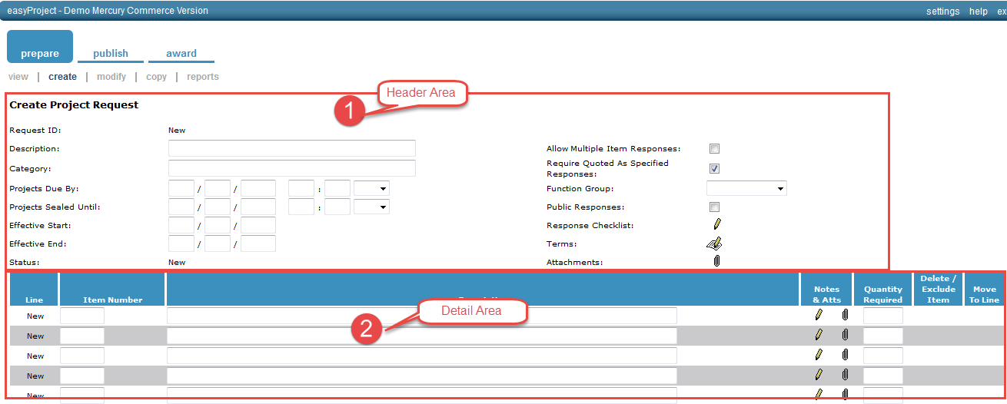

easyProject is suitable for Construction and RFP’s projects.

Project Category and Description
Free form fields for the category and description of the project.

Project Navigation Bar
The project navigation bar contains Prepare, Publish and Award.

Prepare
The Prepare tab has four options, View, Create, Modify and Copy. The View Project Request on the Prepare Tab will give a status and detail of every project for your organization (that you have access to). You can see where each project is in the process and, if a change needs to be made, you can do that in the Modify screen.
In the Prepare>View screen you will not see details, such as vendor responses. You will be able to view the project items, description and dates.

Create
In this section, the user creates the line item project, discount, or project

Modify
The Modify Project screen displays all projects that are at a status of New through the Award Required. Projects that are under review or awarded are not available here.

Exercises
The purpose of this exercise is to practice “Create a Project” in easySourcing.

Creating a Project
- Select Project from the “Create” screen
- The Project screen will open
- Enter the Description in the description field
- Enter Category information
- Enter the Project Due Date and the Project Sealed by Date
- Add any Checklist Items, Terms or Attachments (See below on how to add)
- Enter Item Number (If you have an internal number then use that)
- Fill in the Description
- Tab to the next field, Quantity Required
  - You can add notes and attachments to each line item
- Continuing adding items, use the Update button frequently as not to lose any information
- When you have reached the bottom of the page (each page only holds 5 lines items), Select Next Page to continue with items
- Select Update when you have finished adding all items
- Once you select Update the Project ID will change from New to a number

Project Attachments
Project Attachments are optional. The presence of the paper clip in the header or in the line item detail indicates the capability to attach files to projects.
The process for attaching a document is the same for both types of attachments. Any data file is acceptable – it is important to note that the vendors must have the same software used to create the file. If you are attaching a form, the vendors can download the form, fill it out, and then attach the modified document in the response.

Exercises

The purpose of this exercise is to practice attaching an attachment.

Creating an Attachment

- Click on the paper clip

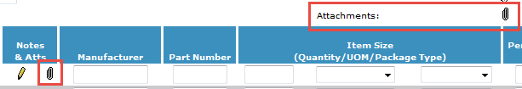

- Click on Header Level Paper Clip - The Modify Project Attachments- Attach dialog box will open

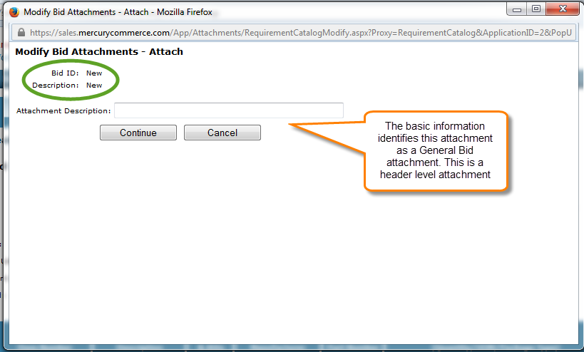

- Click on Line Item paper clip - Indicates Line Item Level Attachment

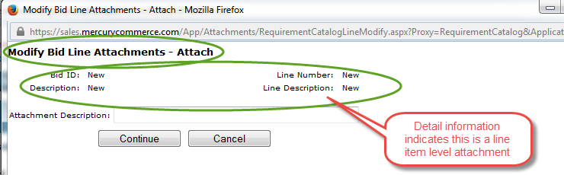

- Enter a description for your attachment
- Click the Continue Button
- Click on the Browse button to locate the file
- The Choose File Dialog Box will open. Search for your file. Click on the file and then click on the Open Button
- The file and its path should appear in the Attach File Field
- Click Continue and the file has now been attached as evident by or
- Click Update to save changes
- Click the Attach button to add additional files

Delete Attachment
Deleting an Attachment removes it from the project but not from the original location on your hard drive, network drive or other storage location.

Exercises
The following exercises are related to deleting an attached file in a project.

Deleting an Attachment
- Double Click on the diskette image
- The Modify Attachment Dialog Box opens
- Click in the Delete Column to the far right of the attachment
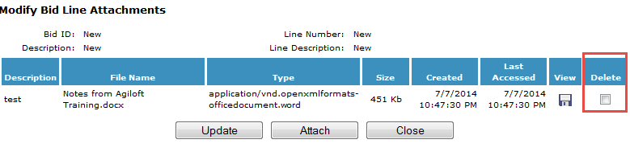
- Click the Update button, the dialog box will refresh, showing the attachment is no longer there
- Click the Close button

Project Notes
Project Item Notes provide an extra 4,000 characters of information to be added to a line item. Project Notes can contain anything additional to the item description such as;
- Acceptable brands/substitutes
- Purpose of the product
- If you would like a sample of the product
- Unacceptable characteristics in the item
- Any information relevant to the line item
Like Terms and Conditions, Notes do not have any formatting characteristics. Use the Space Bar and capital letters to emphasize any message.
- When copying a past Project, all notes are copied into the new project.

Exercise
The following exercise is related to creating a note in a project.

Creating a Note
- Click on the Notes icon 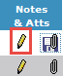
- The Notes window will open
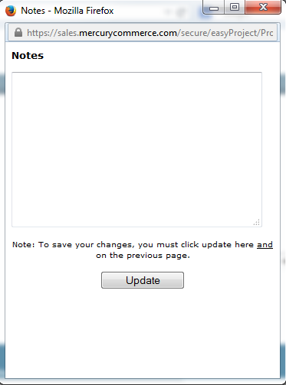

- Click in the Text box to begin entering notes for the item
- When you finish with the Notes window, click the Update button
- You can modify or delete notes by clicking on the notes icon and either modifying the text or deleting the entire contents. Once you have finished, Click Update button to ensure your changes are saved

Response Checklist Items

The Buyer creates response checklist items based on the institution’s requirements. Response checklist items will be presented to the vendor upon submission of their project response. The vendor is required to check off the items before they can submit their project response. Be sure the language of the response checklist is such that checking it off acknowledges that they have read and understand the obligations/expectations as defined in the checklist and Terms and Conditions.

Exercise
The following exercise is related to including Response Checklist Items.

Including a Checklist Item

- Open or Create a project
- Select the Vendor Response Checklist Icon

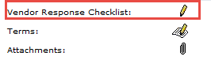

- Modify Vendor Response Checklist will open
- Select the Include Checkbox for the checklist items you wish to add to the project

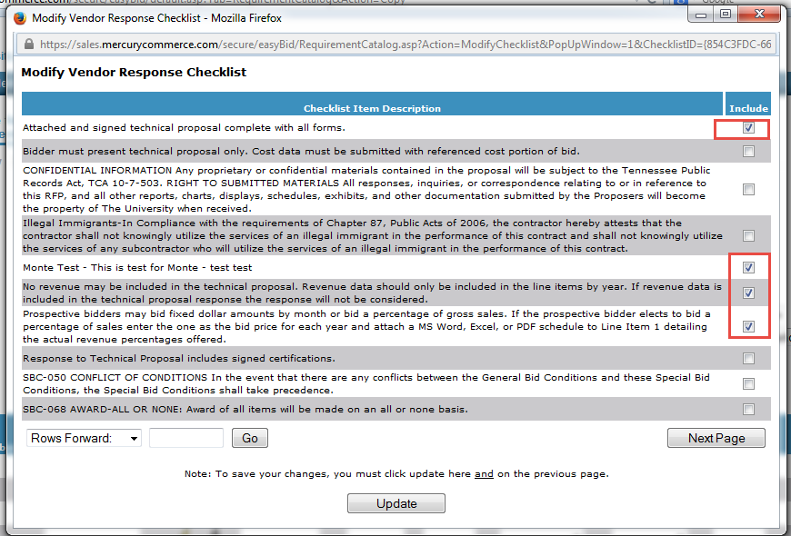

- Select the Update button when you are finished
- The Dialog box will close
- Select the Update button on the project page
- The Response Checklist icon will change. This will indicate additional checklist items

Exercise

The purpose of this exercise is to practice removing a checklist Item with a project.

Removing a Checklist Item

- Open the project that requires removal of the response checklist item.
- Click on the Vendor Response Checklist icon
- The Modify Response Checklist dialog box will open
- Uncheck the Include status check box to remove response checklist items
- Select the Update button
- The modify Vendor Response Checklist dialog box will close, returning you to the project
- Click the Update button on the project page
- There will be no change to the icon, unless you removed all the checklist items from the project. If all checklist items are removed from the Project, the icon will change back to the pencil

Exercise

The purpose of this exercise is to practice adding a checklist item to an existing project.

Adding a Checklist Item to an existing Project.

- Open the Project that requires an additional checklist item
- Click on the Vendor Response Checklist Icon.
- The Modify Response Checklist dialog box will open
- Check the Include status checkbox for each additional response checklist item you would like to add
- Click the Update button when you are finished
- The Modify Vendor Response Checklist dialog box will close.
- On the project screen, click the Update button
- There is no change in the icon unless there are no checklist items associated with the project

Project Prepare – View Project
The View Project Summary on the Prepare Tab will give a status and detail of every project for your institution (that you have access to). You can see where each project is in the process and, if change needs to be made, you can do that in the Modify screen.
Projects are listed with the most recent projects at the top of the first screen.
In the Prepare > View screen you will be able to view the following:
- Request Id
- Description
- Project Type
- Due Date and Sealed Date
- Status
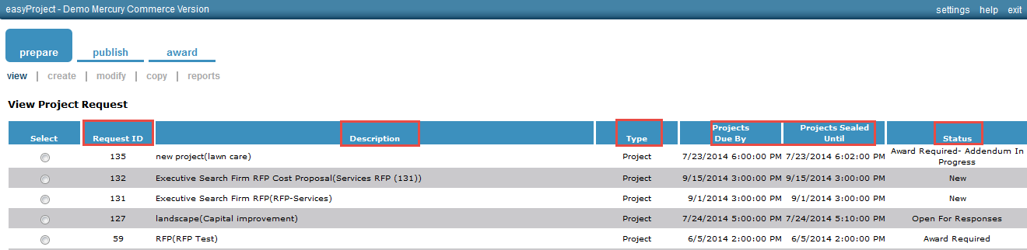
See Appendix B for Status Descriptions.

Project Prepare – Modify Project

A project may be modified at any time. However, this is an optional feature so it will depend on the configuration for your organization. If the project is visible in the Prepare>Modify screen, it can be modified. If you do not see it, then it cannot be modified.

The only sourcing application that does not have vendor addendums is the easyBid Discount type bids. Addendums are not available at this time.

Project Prepare – Modify a New Project

Modifying a new project will have no impact on any requestor or vendor because of its new status. Once you have created a project and ended your sessions, that project can be viewed in the Prepare>Modify screen.

Once you have located your project, proceed with the modification of your project according to the instructions found in Creating a Project section.
Project Prepare – Copy Project

A project may be copied while at any status other than new. This is valuable for either lengthy and/or detailed projects. A project can be copied once (and any time after) the project has been published to the vendor. If the project has passed the status of new, the project may be copied.

Exercise

The purpose of this exercise is to practice copying a project.

Coping a Project

- Open the Copy Tab in the Prepare Section

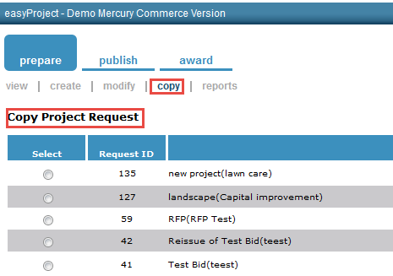
- Click > Select Button
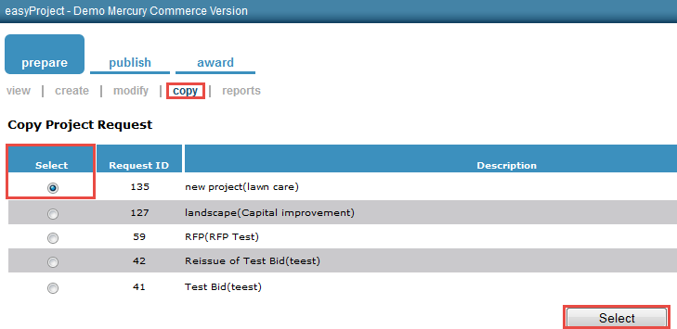

- The “Include in progress addendums for the new Project Request” check is unchecked. This means the project will include addendums from the one being copied

Leave the “Include in progress addendums for the new Project Request” checkbox, unchecked,

- Click the Copy Button.

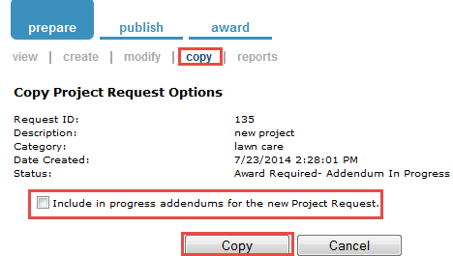

- Click the Cancel Button to Return to the Copy Project Screen.
- The new project will have a new project ID assigned and all information (with the exception of attachments) will be recreated. The quantities from the copied project will populate the Quantity Requirement field and can be edited.
- Make sure the Project Description is modified – the prefix “Copy of” should be removed to reflect the project’s current description.

Project Specific Terms and Conditions `

Project Prepare – Additional Project Terms and Conditions

The University of Tennessee has specific terms and conditions that will be used by all campuses. There may be times when additional terms and conditions need to be stated for a particular project. In order for the buyer to add additional terms for the items listed on the project, follow the steps below.

- Select the Project that requires additional Terms and Conditions
- Select the Terms Icon
- The Terms and Condition Dialog will open
- The institution’s Standard Terms and Conditions will be listed in the top block
- To specify additional terms and conditions, place this information in the Project Terms & Conditions box
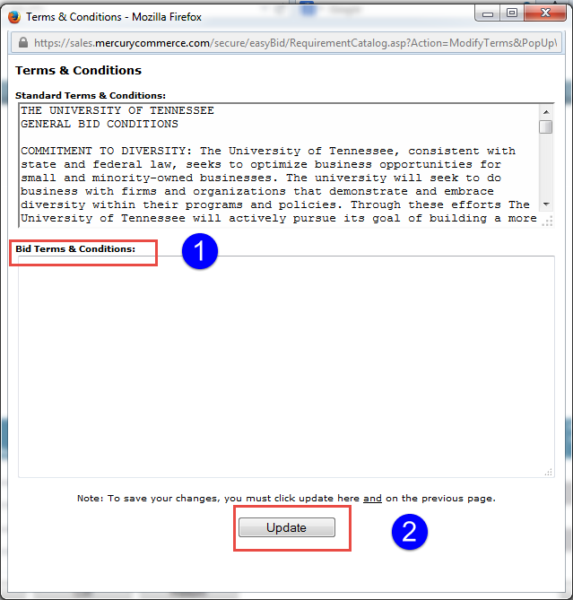

- Once you completed adding additional Project Terms and Conditions, click the Update button to save changes

Appendix A

Terminology

Allow Multiple Item Responses – If this box is checked, it will allow the vendor to respond to a line item multiple times.

Projects Due By – The date and time that the project is due.

Projects Sealed Until – The date and time that the project is sealed until. The project cannot be opened until after the noted date and time.

Category – This can be NIGP code or category (such as computer, office supplies) that the University has created.

Description – Free form field that gives identity to the project.

easyProject Item – A sealed project by item

Function Group- This is not a required field. A function group is set up when a customer wants to segment users based on campuses, agencies, etc.

Public Responses – If this box is checked, it will allow vendors, besides the vendors that it will be published to, to see the project and bid.

Required Project as Specific Response – The vendor is required to respond to the project as the buyer has determined.

Appendix B

Project Status

Status | Where can Project be accessed?
 | Tab | Submenu Option | Activity Performed
New | Prepare | Modify | Modify New Project
Open For Requirements | Requirement Response | Create or Modify | Create or Modify Requirement Response
 | Distribute for Requirements | Publish | Distribute project to additional constituents or distribute project addendums
 | Prepare | Modify, Copy | Modify for constituent addendum, copy to create a new project
 | Manage Requirements | Request Status | Monitor constituent activity
Open for Projects | Prepare | View, Modify  Copy | Modify for vendor addendum,copy to create a new project
 | Publish | Publish  Extension | Publish project to vendors,extend the due date of the project
Award Required  (Note: Be sure to extend the due date and time for the project to allow the vendors sufficient time to review and respond) | Prepare | View, Modify  Copy | Modify for vendor addendum  Copy to create a new project
 | Publish | Extension, Re-Publish | Extend the due date of the project
 | Award | Response Status  Create | Check the vendor response  Open the project for awards
Projects Under Review | Prepare | View, Copy | Copy to create a new project
 | Award | View, Modify | Continue to review projects from the modify screen
 | Award | View, Publish | Publish the project results to the vendors
Awarded | Prepare | Copy | Copy to create a new project
 | Award | Convert | Convert the awarded project contract into a requisition(s), catalog in purchasing, warehouse catalog
Awarded to No Vendors | Prepare | View, Copy | Copy to create a new project.
 | Award | View | View only

The following information is provided as supplemental information to the topics presented, as well as basic document history.

Document Version
Version | Date | Modified By | Description
1.0 | 06/28/2014 | Susie Gilley | The original version of this document.

