University of Tennessee
easyQuote™

Training Manual for easySourcing™ Users

{This page left intentionally blank.}
Table of Contents

Introduction 5
Purpose 5
Additional Resources 5
Basic Navigation 6
Logging In 6
Web Browsers 6
Web Address 6
Username & Password 7
System Overview 7
Quote Overview 8
Getting Started 8
Quote Screen Area 8
Quote Specific Terms and Conditions 9
Quote Category and Description 9
Quote Navigation Bar 9
Prepare 9
Create 9
Modify 9
Exercises 10
Creating a Quote 10
Quote Attachments 10
Exercises 10
Creating an Attachment 10
Delete Attachment 11
Exercises 12
Deleting an Attachment 12
Quote Notes 12
Exercise 13
Creating a Note 13
Response Checklist Items 14
Exercise 14
Including a Checklist Item 14
Exercise 15
Removing a Checklist Item 15
Exercise 15
Adding a Checklist Item to an existing bid. 15
Quote Prepare – View Bid 16
Quote Prepare – Modify Quote 17
Quote Prepare – Modify a New Quote 17
Quote Prepare – Copy Quote 17
Exercise 17
Coping a Quote 17
Quote Specific Terms and Conditions 19
Quote Prepare – Additional Bid Terms and Conditions 19
Appendix A 20
Terminology 20
Appendix B 21
Quote Status 21
Tab 21
Submenu Option 21
Activity Performed 21
Document Version 23

Introduction
The ESM Solutions easySourcing™ system is designed to automate the quote lifecycle. The University of Tennessee will use this system to manage line item bids, construction projected and quotes. The system will be used to facilitate and award bids.
The University of Tennessee has implemented this Software-as-a-Service (SaaS) tool for the following reasons:
- To streamline the entire sourcing process from requisitions to award to created catalogs.
- To have better control of campus spending by creation of function groups.
- To have the ability to view events from the Sourcing Event Board.

Purpose
The purpose of this document is to provide the University of Tennessee system and campus staff with detailed information about system functionality and practice exercises to reinforce understanding of the common tools and functionality needed to manage bids and awards. This document is intended for users that manage purchasing agreements, such as buyers and purchasing directors; however, staff with other responsibilities in the University of Tennessee’s bids and awards may also benefit from this document.

Additional Resources
Additional resources for training help and support can be found at the University of Tennessee Marketplace Training website, or the following web address:

http://treasurer.tennessee.edu/purchasingsystem/sourcing/index.html

Please contact the following University of Tennessee easySourcing system administrators for additional assistance or questions:

Jack Walker 865-974-0326 jwalk117@utk.edu
David Marks 865-974-0326 dmarks@tennessee.edu

Basic Navigation
The purpose of this section is to provide detailed information and practice exercises for logging into the easySourcing system and for navigating the various bid types and reports available.

Logging In

Web Browsers
Because browser versions are constantly changing, the easySourcing system is typically certified to work with the browser’s current full release version, as well as one full release version back. It is important to note that easySourcing, like so many other web-based applications, does not work well with Internet Explorer 8. Thus, it is recommended to Internet Explorer users to only use Internet Explorer 9 or higher.
If you have any questions about or experience any difficulties with web browsers on your workstation, please contact the University of Tennessee system administrator.

Web Address
After opening a web browser, navigate to the login page by entering the system URL. Note that there are different URLs for the Training and Production environments.
The following is the Training environment URL:
https://universityoftennessee.enterprisewizard.com/logins/utenntraining-login.htm
If you have any questions about the login page, please contact the system administrator.
.

Username & Password
On the ESM Solutions Login page, enter the University of Tennessee number, your User Name and Password. The User Name will be the first initial of your first name and a combination of your last name depending on the length of your last name. The User Id will be given to you by the system administrator.
If you cannot remember your password, select the “Forgot Password?” link next to “reset your password.” To reset your password, you must be able to provide your username or email address, so that an email message can be sent to you with the new password and instructions. If you cannot remember your username or experience any issues with or have questions about your username and password, contact the system administrator.

System Overview
The easySourcing system has the following solutions areas:
- easyBid Line Item
- easyBid Discount
- easyQuote
- easyProject
- Sourcing Event Posting Board
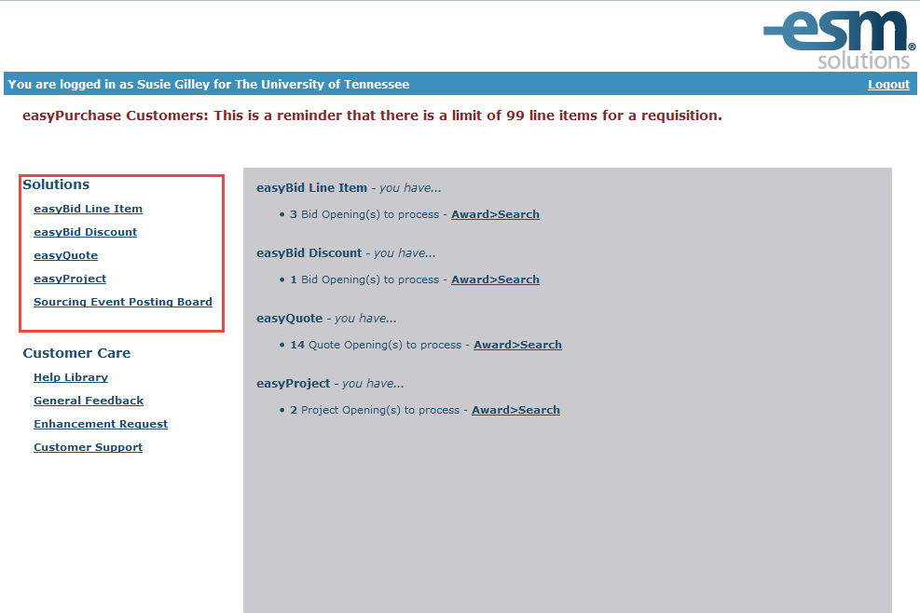
Each of these areas has specific functionality that is made accessible to users based on the permissions assigned.

Quote Overview
The Quote Prepare Tab allows for the creation, modification and copying of bids. Upon first entering the Quote tab in easyQuote, the user is presented with four submenus: View, Create, Modify and Copy (Reports are discussed in a separate training material). Quotes are non-sealed events.

Upon entering the Quote tab, the default screen is the Create Quote Screen

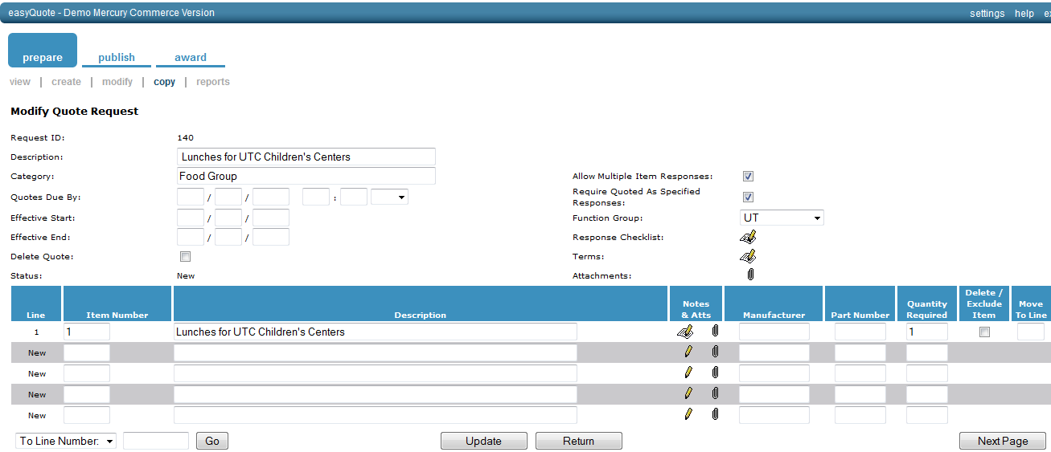

Getting Started

Quote Screen Area

The quote screen is divided into two parts; Header and Detail.

Header: This refers to the area and the fields in that area requiring the bid. In other words, the information in this area is applied to the entire content.

Detail: Refers to the individual lines that contain item detail information. One line = one unique item.

In the Header, the following fields are available for a bid: Description, Category, Quotes Due By, Effective Start, Effective End, Allow Multiple Item Responses Required Quoted as Specified Response, Function Group, Response Checklist, Terms, and Attachments. Description, Category, Quotes Due By, and Function Group are required fields. See Appendix A for Terminology.

In the Detail, the following fields are available: Item Number, Description, Manufacturer, Part Number, and Quantity Required. Description and Quantity are required. See Appendix A for Terminology on all fields.

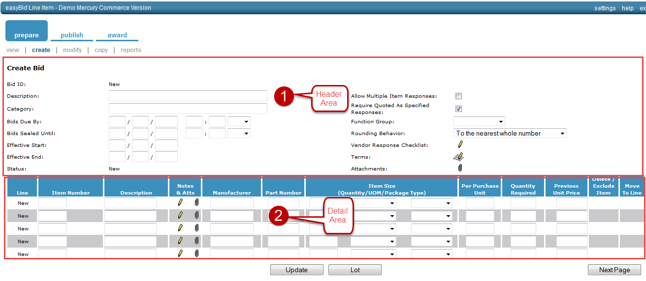

The quote is suitable for a number of different product types. A quote is treated as a private, informal solicitation or price check. A quote can be opened immediately after first response is submitted. Vendors can respond for 30 days after the Quote Due By date unless the quote is awarded. A quote does not have Quantity/UOM and Package-type fields, and can be converted into a requisition and/or purchase catalog.

Quote Specific Terms and Conditions
Please refer to this section in the Terms and Conditions.

Quote Category and Description
Free form fields for the category and description of the bid.

Quote Navigation Bar
The quote navigation bar contains Prepare, Publish and Award.

Prepare
The Prepare tab has three options, View, Create, and Modify. The View Quote Request on the Prepare Tab will give a status and detail of every bid for your organization (that you have access to). You can see where each bid quote is in the process and, if a change needs to be made, you can do that in the Modify screen.
In the Prepare>View screen you will not see details, such as vendor responses. You will be able to view the quote items, notes, Standard Terms and Conditions, and quote-specific Terms and Conditions.

Create
In this section, the user creates the line item bid, quote, discount or project bid.

Modify
The Modify Quote screen displays all quotes that are at a status of new through the Award Required. Quotes that are under review or awarded are not available here.

Exercises
The following exercises are related to creating a quote in easySourcing.

Creating a Quote
- Select Quote from the landing page
- The quote screen will open
- Enter the Description in the description field
- Enter Category information
- Enter the Quote Due Date
- Add any Checklist Items, Terms or Attachments (See below on how to add)
- Enter Item Number. (If you have an internal number then use that)
- Fill in the Line Item Description
- Use the tab key to move over to the next two fields; Manufacturer and Part Number. These two fields are optional and can be left blank.
- Enter the manufacturer name for the product – if you have a preference. If you populate this field, the vendor is obligated to respond with that manufacturer, or else indicate in notes that they are responding with a different manufacturer than specified. If you leave the field blank, the vendor will fill the information with the Manufacturer Name and Number they are responding with
- Tab to the next field, Quantity Required.
- Continuing adding items, use the Update button frequently as not to lose any information
- When you have reached the bottom of the page (each page only holds 5 lines items), Select Next Page to continue with items
- Select Update when you have finished adding all items
- Once you select Update the Quote ID will change from new to a number

Quote Attachments
Quote attachments are optional. The presence of the paper clip in the header or in the line item detail indicates the capability to attach files to bids.
The process for attaching a document is the same for both types of attachments. Any data file is acceptable – it is important to note that the vendors must have the same software used to create the file. If you are attaching a form, the vendors can download the form, fill it out, and then attach the modified document in the response.

Exercises
The following exercises are related to attaching a file in a quote.

Creating an Attachment

- Click on the paper clip

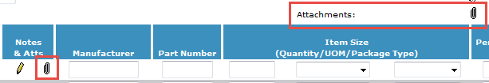
- Click on Header Level Paper Clip - The Modify Bid Attachments- Attach dialog box will open

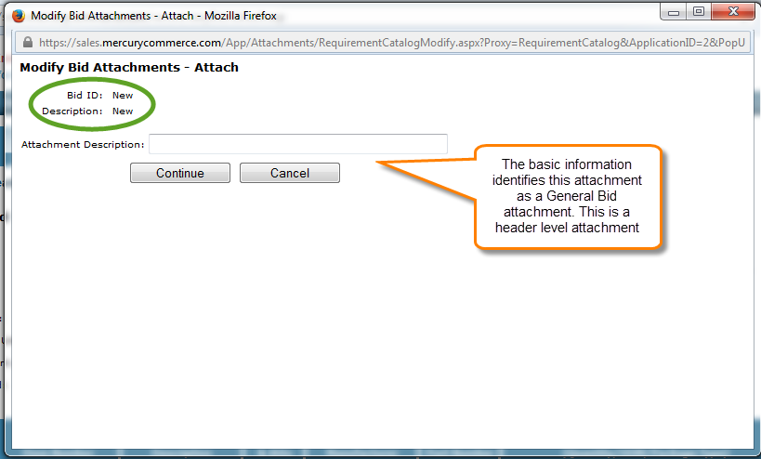

- Click on Line Item paper clip - Indicates Line Item Level Attachment

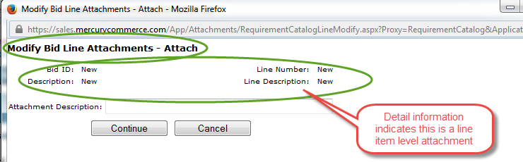

- Enter a description for your attachment
- Click the Continue Button
- Click on the Browse button to locate the file
- The Choose File Dialog Box will open. Search for your file. Click on the file and then click on the Open Button
- The file and its path should appear in the Attach File Field.
- Click Continue and the file has now been attached as evident by or
- Click Update to save changes
- Click the Attach button to add additional Files

Delete Attachment
Deleting an Attachment removes it from the quote but not from the original location on your hard drive, network drive or other storage location.

Exercises
The following exercises are related to deleting an attached file in a quote.

Deleting an Attachment
- Double Click on the diskette image
- The Modify Attachment Dialog Box opens
- Click in the Delete Column to the far right of the attachment
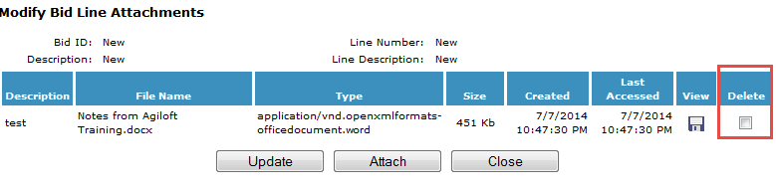
- Click the Update button and the dialog box will refresh, showing the attachment is no longer there
- Click the Close button

Quote Notes
Quote item notes provide an extra 4,000 characters of information to be added to a line item. Bid notes can contain anything additional to the item description such as;
- Acceptable brands/substitutes
- Purpose of the product
- If you would like a sample of the product
- Unacceptable characteristics in the item
- Any information relevant to the line item
Like Terms and Conditions, notes do not have any formatting characteristics. Use the space bar and capital letters to emphasize any message.
- When copying a past quote, all notes are copied into the new bid.

Exercise
The following exercise is related to creating a note in a quote.

Creating a Note
- Click on the Notes icon 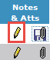
- The Notes window will open
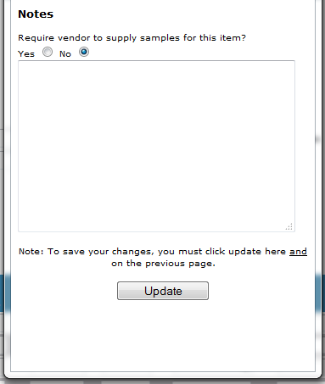
- Click in the text box to begin entering notes for the item
- If you require samples, Select the Yes option button in the notes dialog box
- When you finish with the notes window, click the Update button
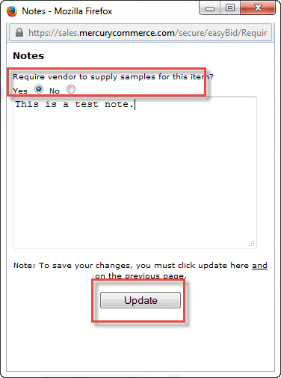
- You can modify or delete notes by clicking on the notes icon and either modifying the text or deleting the entire contents. Once you have finished, Click Update button to ensure your changes are saved

Response Checklist Items

The System Administrator creates response checklist items based on the institution’s requirements. Response checklist items will be presented to the vendor upon submission of their bid response. The vendor is required to check off the items before they can submit their bid response. Be sure the language of the Response Checklist is such that checking it off acknowledges they have read and understand the obligations/expectations as defined in the checklist and Terms and Conditions.

Exercise
The following exercise is related to including response checklist items.

Including a Checklist Item

- Open or Create a quote
- Select the Vendor Response Checklist icon

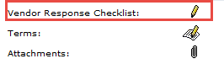

- Modify Vendor Response Checklist will open
- Select the Include Checkbox for the checklist items you wish to add to the bid
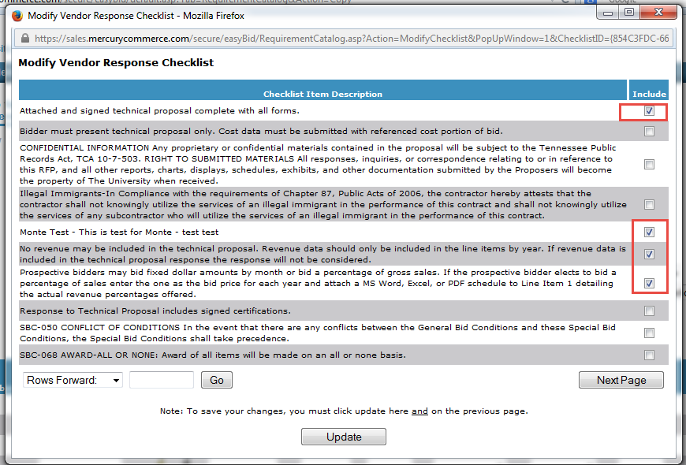

- Select the Update button when you are finished
- The Dialog box will close
- Select the Update button on the bid page
- The Response Checklist icon will change, this will indicate additional of the checklist item

Exercise
The following exercise is related to removing response checklist items.

Removing a Checklist Item

- Open the quote that requires removal of the response checklist item
- Click on the Vendor Response Checklist icon
- The Modify Response Checklist dialog box will open
- Uncheck the Include status check box to remove the response checklist items
- Select the Update button
- The Modify Vendor Response Checklist dialog box will close, returning you to the bid
- Click the Update button on the bid page
- There will be no change to the icon, unless you removed all the checklist items from the bid. If all checklist items are removed from the bid, the icon will change back to the pencil

Exercise
The following exercise is related to adding a checklist item to an existing quote.

Adding a Checklist Item to an existing bid.

- Open the quote that requires an additional checklist item
- Click on the Vendor Response Checklist Icon
- The Modify Response Checklist dialog box will open.
- Check the Include status checkbox for each additional response checklist item you would like to add
- Click the Update button when you are finished
- The Modify Vendor Response Checklist dialog box will close.
- On the quote screen, click the Update button
- There is no change in the icon unless there are no checklist items associated with the quote

Quote Prepare – View Bid
The View Quote Request on the Prepare Tab will give a status and detail of every quote for your institution (that you have access to). You can see where each quote is in the process and, if change needs to be made, you can do that in the Modify screen.
Quotes are listed with the most recent quotes at the top of the first screen.

In the Prepare > View screen you will be able to view the following:
- Request Id
- Description
- Type
- Quotes Due by
- Status

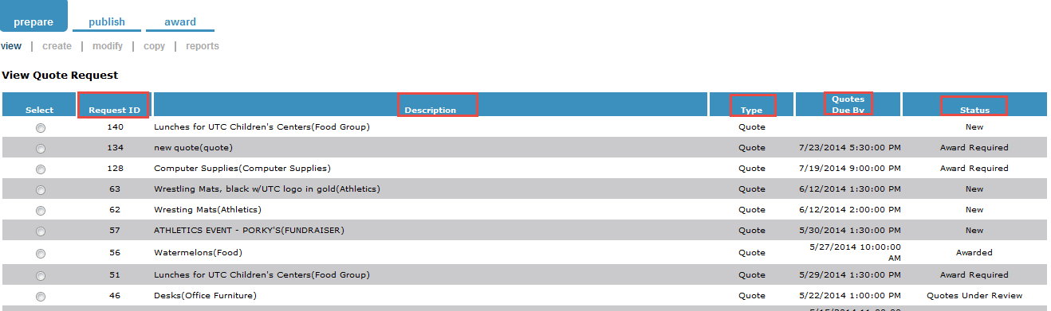
See Appendix B for Status Descriptions.

Quote Prepare – Modify Quote

This is an optional feature, so it will depend on the configuration for your organization If the quote is visible in the Prepare>Modify screen, it can be modified. If you do not see, it cannot be modified.

The only sourcing application that does not have vendor addendums is the easyBid Discount type bids. Addendums are not available at this time.

Quote Prepare – Modify a New Quote

Modifying a new quote will have no impact on any requestor or vendor because of its new status. Once you have created a quote and ended your sessions, that quote will now be found in the Prepare>Modify screen.

Once you have located your quote, proceed with the modification of your quote according to the instructions found in Creating a Quote section.

Quote Prepare – Copy Quote

A quote may be copied while at any status other than new. This is valuable for either lengthy and/or detailed quotes. A quote can be copied once (and any time after) the bid has been published to the vendor. If the quote has passed the status of new, the quote may be copied.

Exercise
The following exercise is related to copying a quote.

Coping a Quote

- Open the Copy Tab in the Prepare Section.

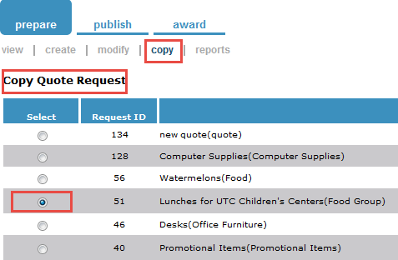

- Click the Select Button

- Click the Copy Button.

- The new quote will have a new quote ID assigned and all information (with the exception of attachments) will be recreated. The quantities from the copied quote will populate the Quantity Requirement field and can be edited.
- Make sure the quote description is modified – the prefix “Copy of” should be removed to reflect the quote’s current bid description.

Quote Specific Terms and Conditions

Quote Prepare – Additional Bid Terms and Conditions

The University of Tennessee has specific terms and conditions that will be used by all campuses. There may be times when additional terms and conditions need to be stated for a particular bid. In order for the buyer to add additional terms for the items listed on the bid, follow the steps below.

- Select the Quote that requires additional Terms and Conditions
- Select the Terms Icon
- The Terms and Condition Dialog will open
- The institution’s Standard Terms and Conditions will be listed in the top block
- To specify additional terms and conditions, place this information in the Quote Terms & Conditions box
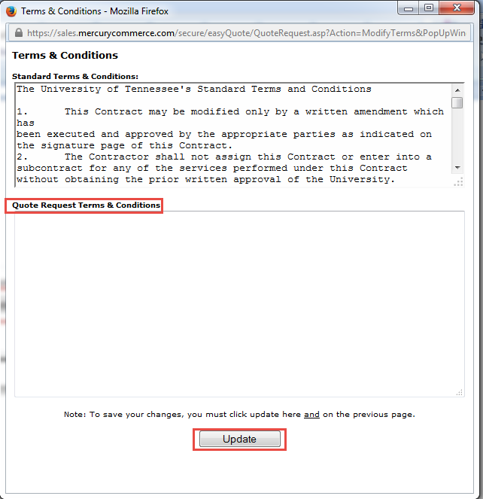

- Once you completed adding additional Quote Terms and Conditions, click the Update button to save changes

Appendix A

Terminology

Allow Multiple Item Responses – If this box is checked, it will allow the bidder to respond to a line item multiple times.

Quote Due By – The date and time that the bid is due.

Category – This can be NIGP code or category (such as computer, office supplies) that the University has created.

Description – Free form field that gives identity to the bid.

Function Group- This is not a required field. A function group is set up when a customer wants to segment users based on campuses, agencies, etc.

Required Quoted as Specific Response – The bidder is required to bid as the buyer has determined.

Appendix B

Quote Status

Status | Where can Bid be accessed?
 | Tab | Submenu Option | Activity Performed
New | Prepare | Modify | Modify new bid
Open For Requirements | Requirement Response | Create or Modify | Create or modify requirement response
 | Distribute for Requirements | Publish | Distribute bid to additional constituents or distribute bid addendums
 | Prepare | Modify, Copy | Modify for constituent addendum, copy to create a new bid
 | Manage Requirements | Request Status | Monitor constituent activity
Open for Bids | Prepare | View, Modify  Copy | Modify for vendor addendum  Copy to create a new bid
 | Publish | Publish  Extension | Publish bid to vendors  Extend the due date of the bid
Award Required  (Note: Be sure to extend the due date and time for the bid, to allow the vendors sufficient time to review and respond). | Prepare | View, Modify  Copy | Modify for vendor addendum  Copy to create a new bid
 | Publish | Extension, Re-Publish | Extend the due date of the bid
 | Award | Response Status  Create | Check the vendor response  Open the bid for Awards
Bids Under Review | Prepare | View, Copy | Copy to create a new bid
 | Award | View, Modify | Continue to review bids from the modify screen
 | Award | View, Publish | Publish the bid results to the vendors
Awarded | Prepare | Copy | Copy to create a new bid
 | Award | Convert | Convert the awarded bid contract into a requisition(s), catalog in purchasing, warehouse catalog
Awarded to No Vendors | Prepare | View, Copy | Copy to create a new bid
 | Award | View | View only

The following information is provided as supplemental information to the topics presented, as well as basic document history.

Document Version
Version | Date | Modified By | Description
1.0 | 06/28/2014 | Susie Gilley | The original version of this document.
1.1 | 08/08/2014 | Susie Gilley | Corrections

