The University of Tennessee
easySourcing™

Training Manual for Awarding a Bid

{This page left intentionally blank.}
Table of Contents

Introduction 4
Purpose 4
Additional Resources 4
Basic Navigation 5
Logging In 5
Web Address 5
Username & Password 5
Award Tab – Overview 6
Award Search General Information 6
Opening a Bid 7
Award Tab 12
Exercise 12
Award Bid 12
Appendix A 13
Terminology 13
Document Version 14

Introduction
The ESM Solutions easySourcing™ system is designed to automate the entire sourcing lifecycle. The University of Tennessee will use this system to manage bids and RFPs. The system will be used to facilitate and maintain automated renewal processes, including notifications and approvals.
The University of Tennessee has implemented this Software-as-a-Service (SaaS) tool in order to:
- Streamline the entire sourcing lifecycle, from creation of a bid through award of a bid
- Reduce sourcing administration and maintenance time and costs
- Improve sourcing process compliance and minimize risk
- Capture data electronically that is currently in paper form
- Provide reporting capabilities

Purpose
The purpose of this document is to provide the University of Tennessee system and campus staff with detailed information about system functionality and practice exercises to reinforce understanding of the common tools and functionality needed to award bids. This document is intended for users that create bids, such as buyers and purchasing directors; however, other staff members that have responsibilities in the University of Tennessee bids and awards may also benefit from this document.

Additional Resources
Additional resources for training, help and support can be found at the University of Tennessee Marketplace Training website, or the following web address:
http://treasurer.tennessee.edu/purchasingsystem/sourcing/index.html

Please contact the following University of Tennessee easySourcing system administrators for additional assistance:

Jack Walker 865-974-0326 jwalk117@utk.edu
David Marks 865-974-0326 dmarks@tennessee.edu

Basic Navigation
The purpose of this section is to provide detailed information and practice exercises for logging into the easySourcing system and for navigating the various tools and displays available.

Logging In

Web Address
After opening a web browser, navigate to the login page by entering the system URL. Note that there are different URLs for the Training and Production environments.
The following is the Training environment URL:
https://universityoftennessee.enterprisewizard.com/logins/utenntraining-login.htm
If you have any questions about the login page, please contact the system administrator.

Username & Password
On the easySourcing Login page, enter the University of Tennessee ID, your username and password. The username will be the same as your University of Tennessee LDAP User ID and the password will be the same as your Personnel Number, which can be found on your University of Tennessee ID card.
If you cannot remember your password, select the “Forgot your password?” link next to “reset your password.” To reset your password, you must be able to provide your username or email address, so that an email message can be sent to you with the new password and instructions. If you cannot remember your username or experience any issues with your username and password, contact the system administrator.

Award Tab – Overview

The Award Tab consists of several areas:
- Award Search
  - Search Criteria
  - Search Results
- Links and Action

Award Search General Information
The Award Search section gives the buyer the ability to search for bids by various methods:
- Bid ID
- Status
- Creator
- Description
- Date Ranges
- Links (All)
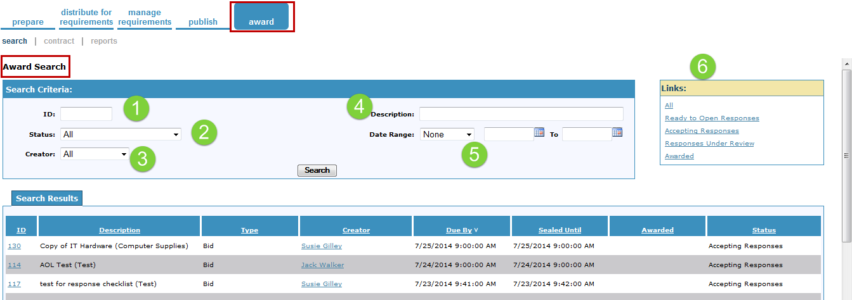
The following screenshots show Search Results when searching by the Status > Accepting Responses and the Status > Responses under Review. Notice that the status section reflects the criteria used in Search Results.

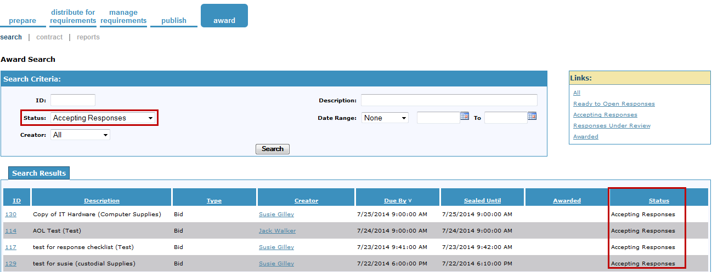
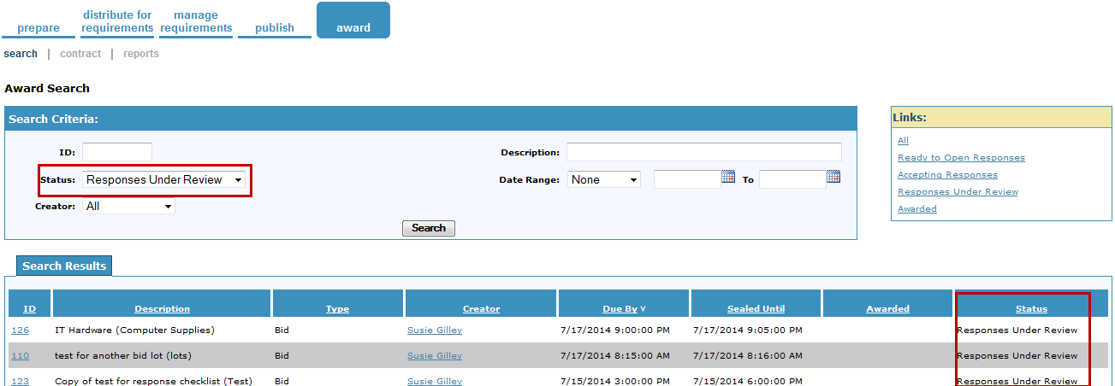

Opening a Bid
A bid cannot be opened and awarded until the bid date (or bid sealed date) has passed.
- easyBid Line Item, easyBid Discount and easyBid Quotes are sealed events and cannot be opened until after the Bid sealed date.
- easyBid Quote can be opened after the bid date.
- A Bid needs a status of Ready to Open Responses, to open and award.
There is a status field next to each vendor that received a bid invitation. The status field indicates if the vendor submitted a response, or received notification and did not place a response to the bid (this will have the status of Notified).

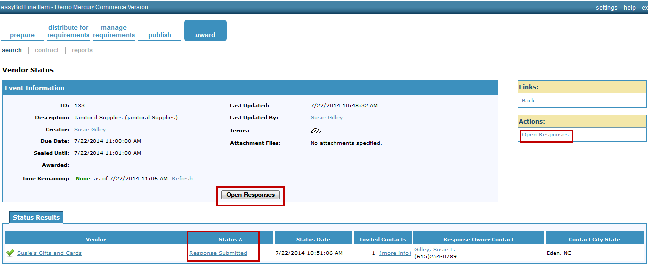

To open the bid Select >Open Responses and a dialog box will appear requesting approval to open.

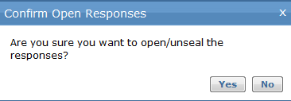

Once you have opened the bid, you will see a list of vendors, contact information, whether the vendor was compliant, which vendor submitted the lowest price, and how many items each vendor responded to.

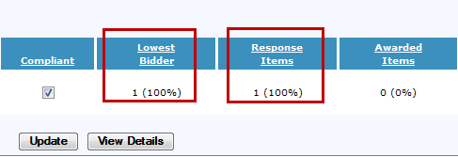

Select > View Detail to open the response from that vendor.

The line item information from the buyer is listed under View Detail.

In order to see the response of the vendor and decide whether to award all or part of that line item, the buyer will click on the hyperlink under the line item number.

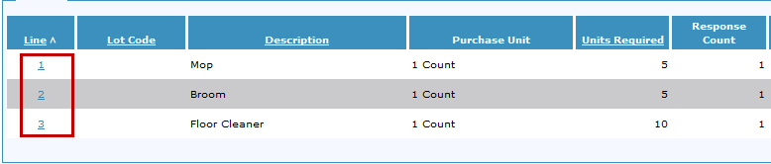

The image below displays the bid price, unit cost and bid total. At this point, the buyer can award the item to the vendor in three different ways; Award, Quantity Award or Override under the Action Tab.

In order to award part of the bid by Quantity Award, Select>Quantity Award. A dialog box will appear. Enter the quantity you wish to award to this bidder. Select>OK.
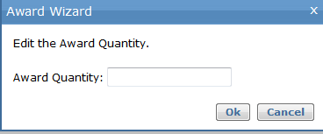

To override any part of the award, Select >Override. The Response Item Override Dialog Box will appear. The areas that have “Edit” beside them indicate that you are allowed to override or edit. Here you can increase the UOM, the quantity or adjust the price. On the right hand side of the Override Box, the buyer can place notes in regards to the edits that were made. Once you have completed your edit, Select >Update.

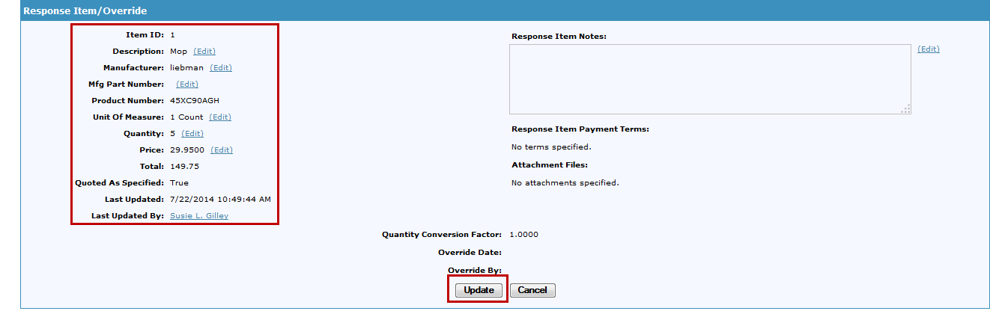
Once you have reviewed all submitted bids, you can award the bid. Upon awarding the bid, a blue ribbon will appear beside the vendor(s) name.

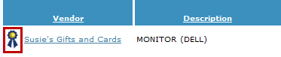
The line items will also have the “blue ribbon”

Once you have awarded all the vendor(s) and line items, you are now ready to publish the award(s). To publish an award, Select>Publish Award from the Actions section.

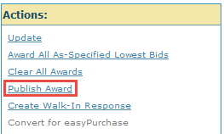

A confirmation award dialog box will appear asking if you are ready to publish. Select >Yes.

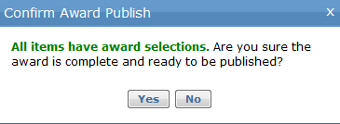
After selecting Yes, you will receive a notification that the award has been published and the vendor(s) has been notified.

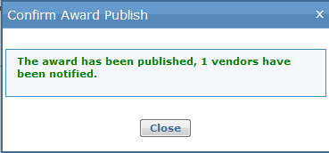

Award Tab
You have successfully awarded a bid (Line Item, Quote or Project).
Complete the exercise below to award a bid.

Exercise
The following exercise is related to awarding a bid from the easySourcing system.

Award Bid
- Go to the Award Tab> Award submenu
- Select >Bid
- Notice that the bid must have a status of Ready to Open Responses in order to award bid to a vendor(s)
- The Award screen will open
- Vendors that responded or were notified are listed in the Responses area
- Select > Vendor
- Select >View Details
- View each of the items
- On one item, Select >Override
- Complete the Override Process
- On one item, Select>Quantity
- Complete the Quantity process
- Select>Back (from the Links area)
- Select another Vendor and repeat Steps 6-11
- Upon completion of awarding vendors, Select>Publish Award

Appendix A

Terminology

Notified – Vendor contact has received an email notification of the invitation to participate in the bid.

Returned to Owner- Vendor contact has submitted the response and someone at your organization with access to the Publish Tab has chosen the option to return the bid to the original contact for modifications. This can only be done if the Sealed Until date and time have not passed.

Submitted – Vendor contact has completed and submitted their response to the specific bid.

The following information is provided as supplemental information to the topics presented, as well as basic document history.

Document Version
Version | Date | Modified By | Description
1.0 | 07/01/2014 | Susie Gilley | The original version of this document.

