The University of Tennessee
easySourcing™

Training Manual for Publishing a Bid

{This page left intentionally blank.}
Table of Contents

Introduction 4
Purpose 4
Additional Resources 4
Basic Navigation 5
Logging In 5
Web Browsers 5
Web Address 5
Username & Password 5
Publish Tab – Overview 6
Publish Tab General Information 6
Extending a Bid 6
Search Criteria 6
Search Results 8
Selection Pending Publish 9
Publish Bid 9
Links and Actions 10
Publish Tab 12
Exercise 12
Publish Bid 12
Exercise 13
Extending the Bid 13
Exercise 13
Extending the Bid 13
Appendix A 14
Terminology 14
Document Version 15

Introduction
The ESM Solutions easySourcing™ system is designed to automate the entire sourcing lifecycle. The University of Tennessee will use this system to manage bids and RFPs. The system will be used to facilitate and maintain automated renewal processes, including notifications and approvals.
The University of Tennessee has implemented this Software-as-a-Service (SaaS) tool in order to:
- Streamline the entire sourcing lifecycle, from creation of a bid through award of a bid
- Reduce sourcing administration and maintenance time and costs
- Improve sourcing process compliance and minimize risk
- Capture data electronically that is currently in paper form
- Provide reporting capabilities

Purpose
The purpose of this document is to provide the University of Tennessee system and campus staff with detailed information about system functionality and practice exercises to reinforce understanding of common tools needed to publish bids. This document is intended for users that create bids, such as buyers and purchasing directors; however, other staff members that have responsibilities in University of Tennessee bids and awards may also benefit from this document.

Additional Resources
Additional resources for training, help and support can be found at the University of Tennessee Marketplace Training website, or the following web address:

http://treasurer.tennessee.edu/purchasingsystem/sourcing/index.html

Please contact the following University of Tennessee easySourcing system administrators for additional assistance:

Jack Walker 865-974-0326 jwalk117@utk.edu
David Marks 865-974-0326 dmarks@tennessee.edu

Basic Navigation
The purpose of this section is to provide detailed information and practice exercises for logging into the easySourcing system and for navigating the various tools and displays available.

Logging In

Web Browsers
Because browser versions are constantly changing, the easySourcing system is typically certified to work with a browser’s current full release version, as well as one full release version back. It is important to note that the easySourcing system, like so many other web-based applications, does not work well with Internet Explorer 8. Thus, it is recommended to Internet Explorer users, to only use Internet Explorer 9 or higher. The preferred browser choice for the system is Firefox.
If you have any questions about or experience any difficulties with web browsers on your workstation, please contact the University of Tennessee system administrator.

Web Address
After opening a web browser, navigate to the login page by entering the system URL. Note that there are different URLs for the Training and Production environments.
The following is the Training environment URL:
https://universityoftennessee.enterprisewizard.com/logins/utenntraining-login.htm
If you have any questions about accessing the login page, please contact the system administrator.

Username & Password
On the ESM Solutions Login page, enter the University of Tennessee number, your username and password. The username will be the same as your University of Tennessee LDAP User ID and the password will be the same as your Personnel Number, which can be found on your University of Tennessee ID card.
If you cannot remember your password, select the “Forgot your password?” link next to “reset your password.” To reset your password, you must be able to provide your username or email address, so that an email message can be sent to you with the new password and instructions. If you cannot remember your username or experience any issues with your username and password, contact the system administrator.

Publish Tab – Overview

The Publish Tab consists of several areas:
- Publish Tab General Information
- Search Criteria
- Search Results
- Selection Search Results
- Links and Action

Publish Tab General Information
After selecting a bid, the Publish Bid Information section will populate with the Bid ID number, the Description, Author and Status. The Bids Due By and Bids Sealed Until will populate if this is a Line Item Bid, Discount Bid, Quote and Project.
- Quote only has Bid Due By.
- Discount Bid requires Effective State Date and Effective End Date.
- If a bid has been published and you need to extend the date, extend the date under the Publish tab in Bids Due By and Bids Sealed Until. If this is an easyProject, extend the Projects Due by and Project Sealed Until Dates.
(Note that the title of the window will change by bid type.)

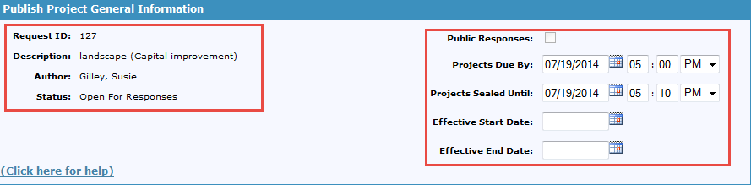
Extending a Bid
A bid can be extended after the bid has been sealed (published) and before the bid has been awarded. To extend a bid
- Open the bid under the Publish tab
- Select Reset Entries
- Change the appropriate dates and time
- Select Update Entries
- Select OK when the confirmation appears (this will notify the vendors of the date and time change)
- Close the dialog box.

Search Criteria
This section gives you the ability to search for a vendor by various criteria. You can search by Name, Status, State, and Vendor list, NIGP Code, Diversity Classification or ESM Category.

- The System Administrator creates Vendor List based on the recommendations of the institution.
- Select Advance Search in Search Criteria to search by Contact information (Last Name, First Name, City, etc)
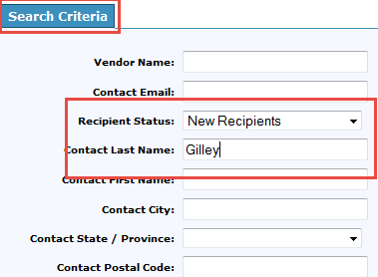
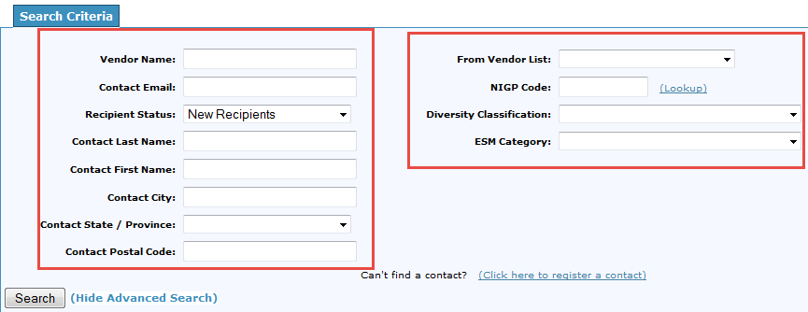
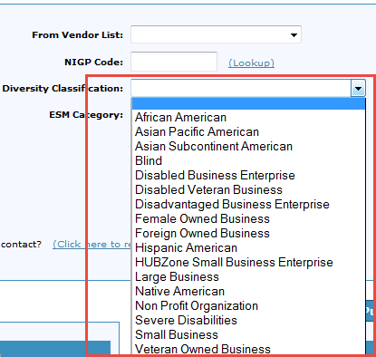

Once you have filled in the Search Criteria to select a vendor(s), the criteria will populate the Search Results.

Search Results
The Search Results page displays all the vendors with the criteria from the Search Criteria section on the left hand section of the screen. At this point, you can place all the vendors in the Section Pending Publish (on the right hand section of the screen) or you can select only one or a few vendors.
Vendor information will include Vendor Name, Vendor email address, Phone Number, Vendor Address and Vendor Contact.

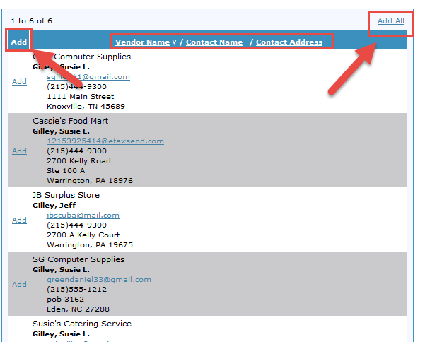

Selection Pending Publish
Vendors that you selected from the Search Results are listed under Selection Pending Publish. You can review your selection and remove any vendor or remove all vendors and start over.
Once you have confirmed that the vendors in the Selections Pending Publish are the ones you want to send a bid invitation to, you are ready to Publish the Bid.

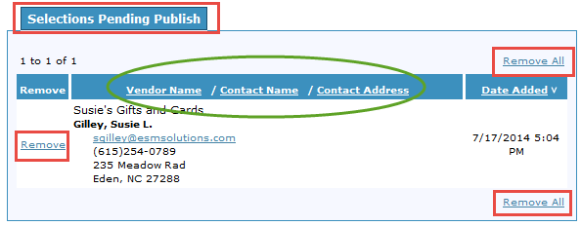
Publish Bid
Once you have the list of vendors you wish to invite to the bid process, you are ready to publish the bid. Begin by selecting Publish Bid under the Actions Tab.
A notification of the Bid that contains the Bid information will appear. This is to confirm Bid ID, Description and Bid Due by and Sealed by Dates.
After the confirmation, an Action Complete notification appears.
The vendors have now been invited to participate in this bid.

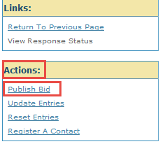

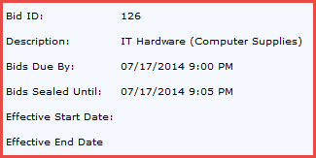

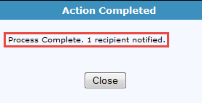
Links and Actions
We have already discussed a few of the Links and Actions, Reset Entries and Update Entries.

- Re-publish a Bid is used when you wish to publish a bid that has already been published, to another vendor(s). The bid dates remain the same.
- Register a New Vendor Contact is used when a new contact needs to be added to the existing vendor. By clicking on the Register a New Vendor Contact, you can enter information regarding a new contact for the vendor. Once you have completed entering in all information, select the Register button to save this contact
- View Response Status

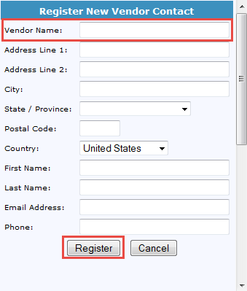
The View Response Status presents a snapshot of which vendors have responded to the bid, which vendors have been notified, along with dates for Last Activity, Last notification Sent, Accepted Date, Submitted Date and Last Returned Date.
- A bid can be returned to the vendor if the vendor has notified the buyer that there is an error or if there are additional adjustments that the vendor needs to make. In order to do this, the buyer will select the Return Response Tab in the Publish submenu, select the bid number, and then select Return.
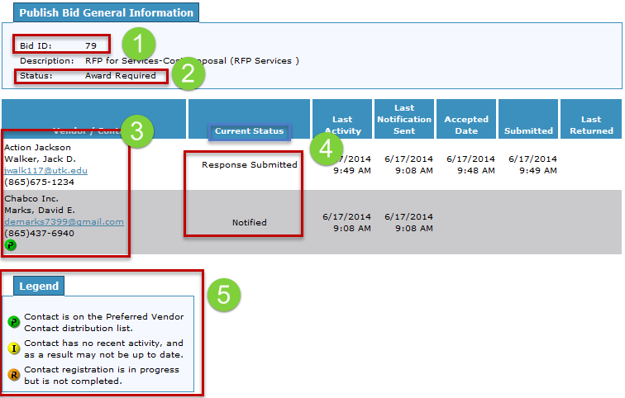
- For a Vendor to become Preferred, a distribution list is created by the Systems Administrator, on recommendations from the buyers.

Publish Tab
You have successfully created a bid (Line Item, Quote or Project) and now the bid is ready to be published to vendor(s).
Complete the exercise below to publish a bid.

Exercise
The following exercise is related to publishing a bid from the easySourcing system.

Publish Bid
- Go to the Publish Tab> Publish Submenu

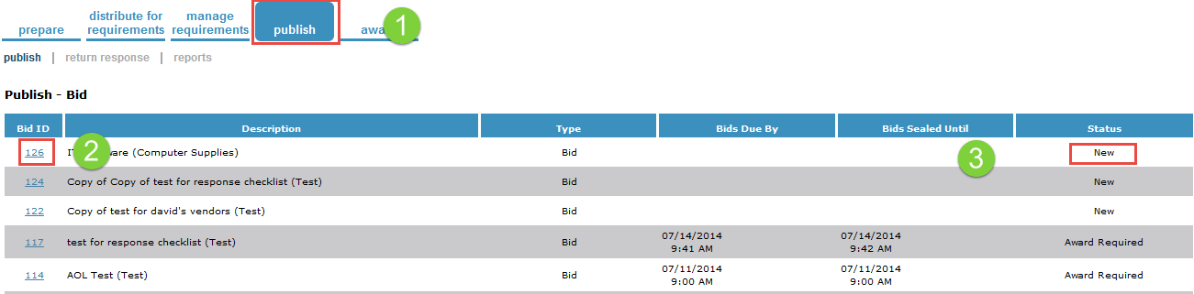
- Select the Bid to be Published
- Notice that the bid must have a status of New in order to publish to a vendor(s). A status of Award Required or Awaiting Review means vendors have responded to the bid invitation and are under review or are in the award process.
- The Publish screen will open
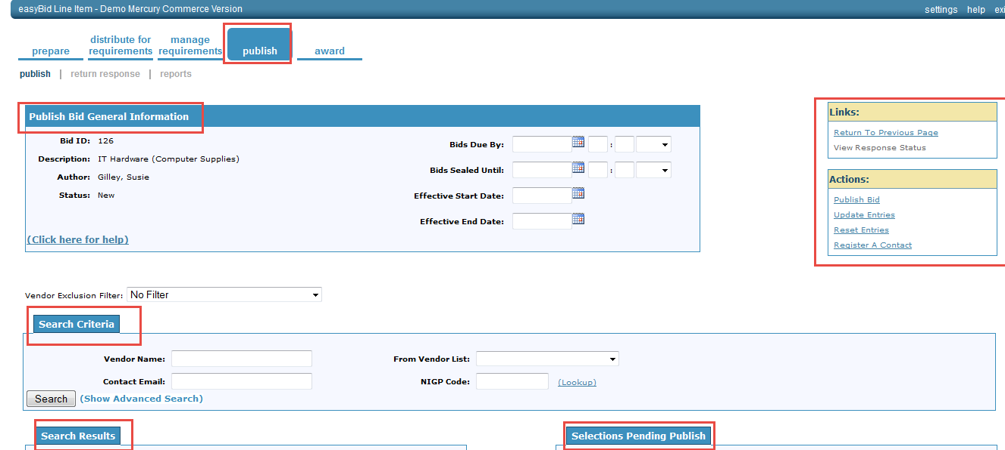
- The bid id, description, author, status and bids due by and bids sealed until, should match the bid you select
- Select >Search Criteria
- Fill out the search criteria for the vendors you wish to extend an invitation to participate in this bid
- Select >Vendors
- Click > Publish Bid
- Select>OK
- Select>Close

Exercise
The following exercise is related to extending a bid from the easySourcing system.

Extending the Bid
- Open the bid you just created
- Select >Reset Entries
- Change the Dates on the Bid
- Select > Update Entries
- Make sure Notify All Vendor Recipients is checked so that vendors who had recently received an invitation will be notified of the new dates
- Select > Finish
- Select > OK

Exercise
The following exercise is related to re-publishing a bid from the easySourcing system.

Extending the Bid
- Select > Bid
- Click>Search Criteria
- Enter >Contact Last Name (or NIGP Code, Diversity Classification)
- Select > Search
- Select >Vendors >Search Results
- Add Vendor(s) to Pending Publish Results
- Select>Re-publish Bid
- Select>Finish on Confirmation Dialog Box
- Close Action Complete Dialog Box

Appendix A

Terminology

Bids Due By – The date and time the bid is due.

Bids Sealed Until – The date and time the bid is sealed. The bid cannot be opened until after the noted date and time.

Re-Publish Bid – Publishing a bid, which has already been published, to additional vendor(s).

Register A Contact – Register additional Contact(s) for a Vendor.

Reset Entries – The bidder is required to bid as the buyer has determined.

View Response Status – View the response status of vendors to which a bid invitation was sent.

The following information is provided as supplemental information to the topics presented, as well as basic document history.

Document Version
Version | Date | Modified By | Description
1.0 | 07/01/2014 | Susie Gilley | The original version of this document.

