UCO/CCO New User Interface

When you log into the contract system the home page will now look like this. Some users report that their view is a blank page (without the Procurement Services website information) with the blue ESM contract menu across the top of the page.
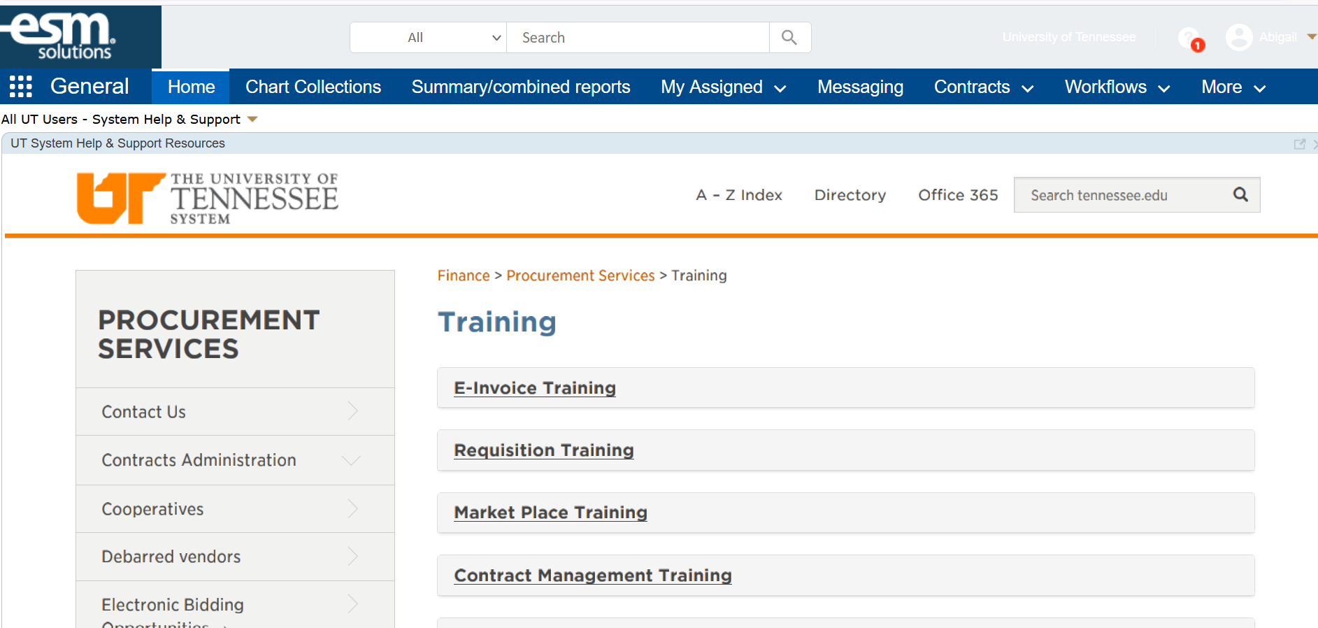

Accessing your Contracts

From the home screen, click on “my assigned”
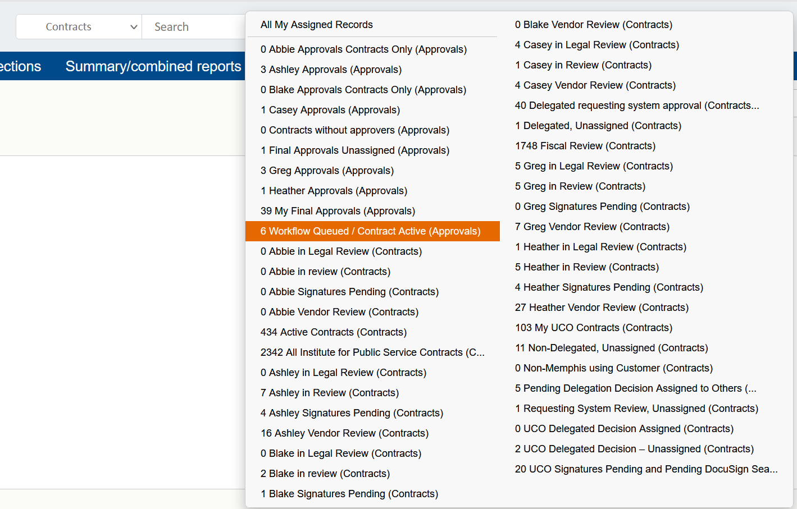

General Searching

There is a search bar at the top of the page that allows you to search but you cannot search by contract number this way. You can search by text.
In this example, when I search by Altius using “all,” It brings up the people table, company table, and contracts table with Altius in the text.
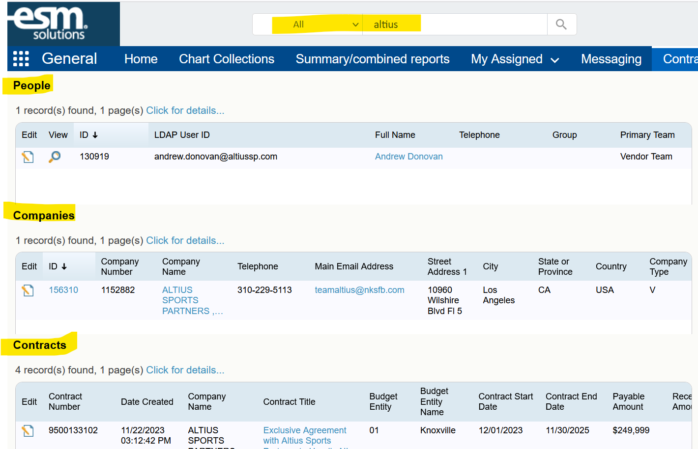

If you select “contracts” from the search dropdown, you can only search on the contract ID and not the contract number (95 number).
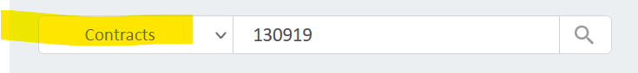

Searching Contracts

In the blue menu bar, click on contracts
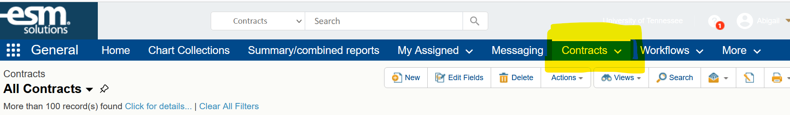
Click on “search” and then click “add filters”
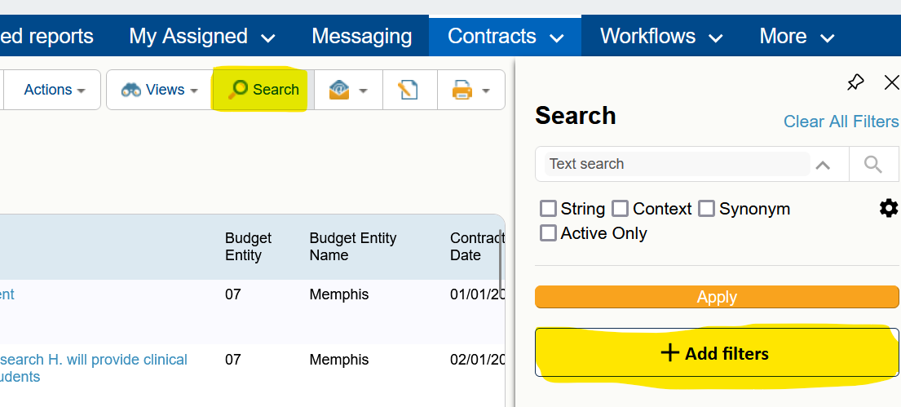

Once you click on “add filters” you will see field, operator, and value filters.
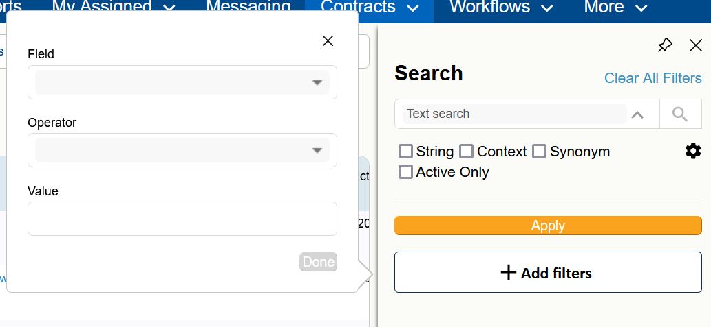

Click on the dropdown arrow in the field filter and you will see all the data points you can search on.
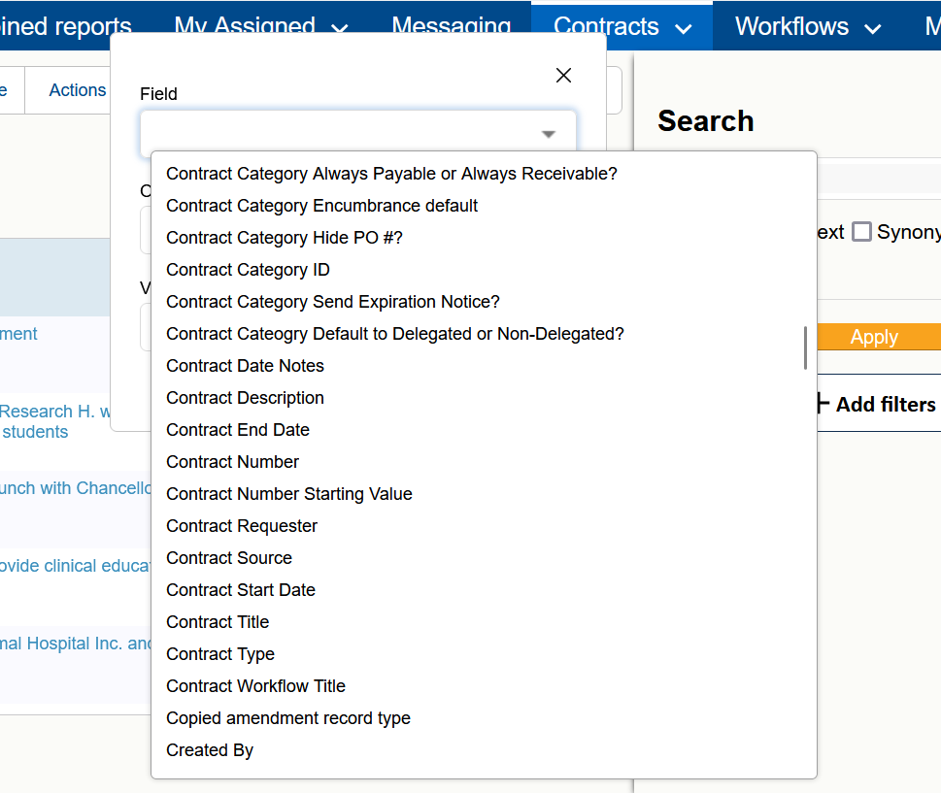

After you make the field selection, you can choose the operator
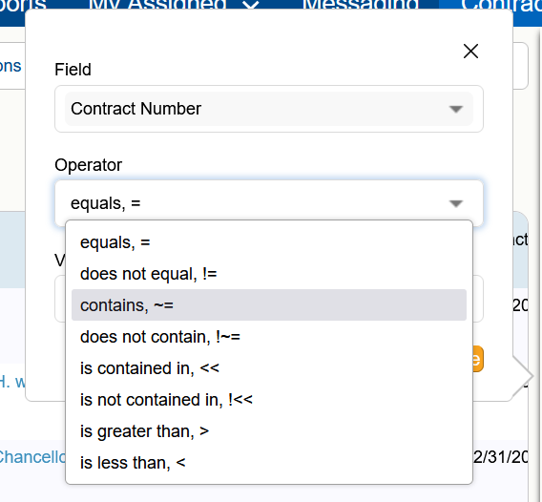

Saved Searches

To access the saved searches, click on the dropdown arrow next to contracts
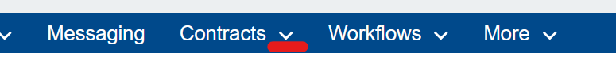
This will bring up the menu of saved searches.
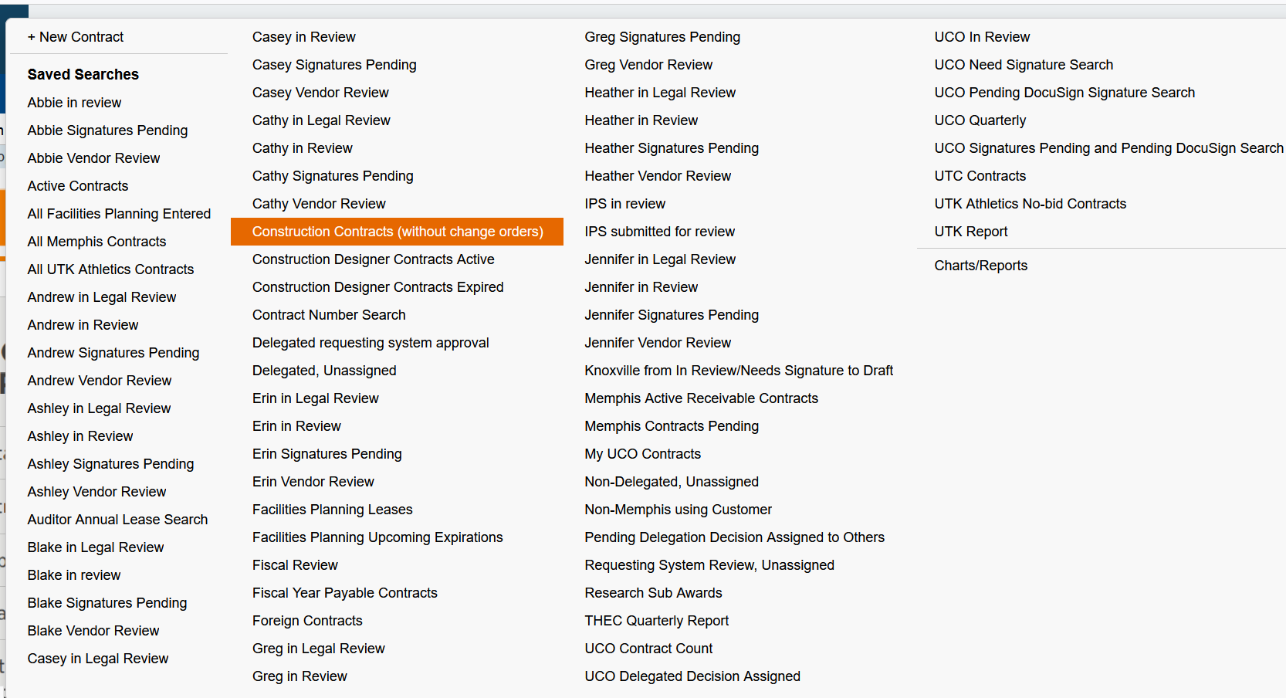

To edit one of the saved searches, choose the search (see above). Once that search opens, click on the dropdown arrow next to the search’s name.
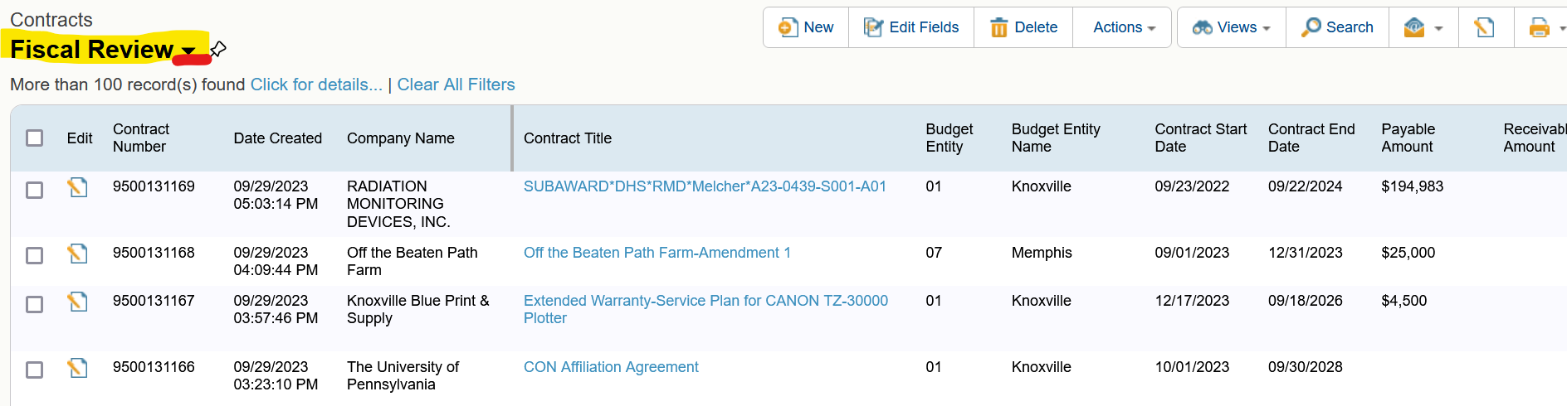

You will see an option to edit.
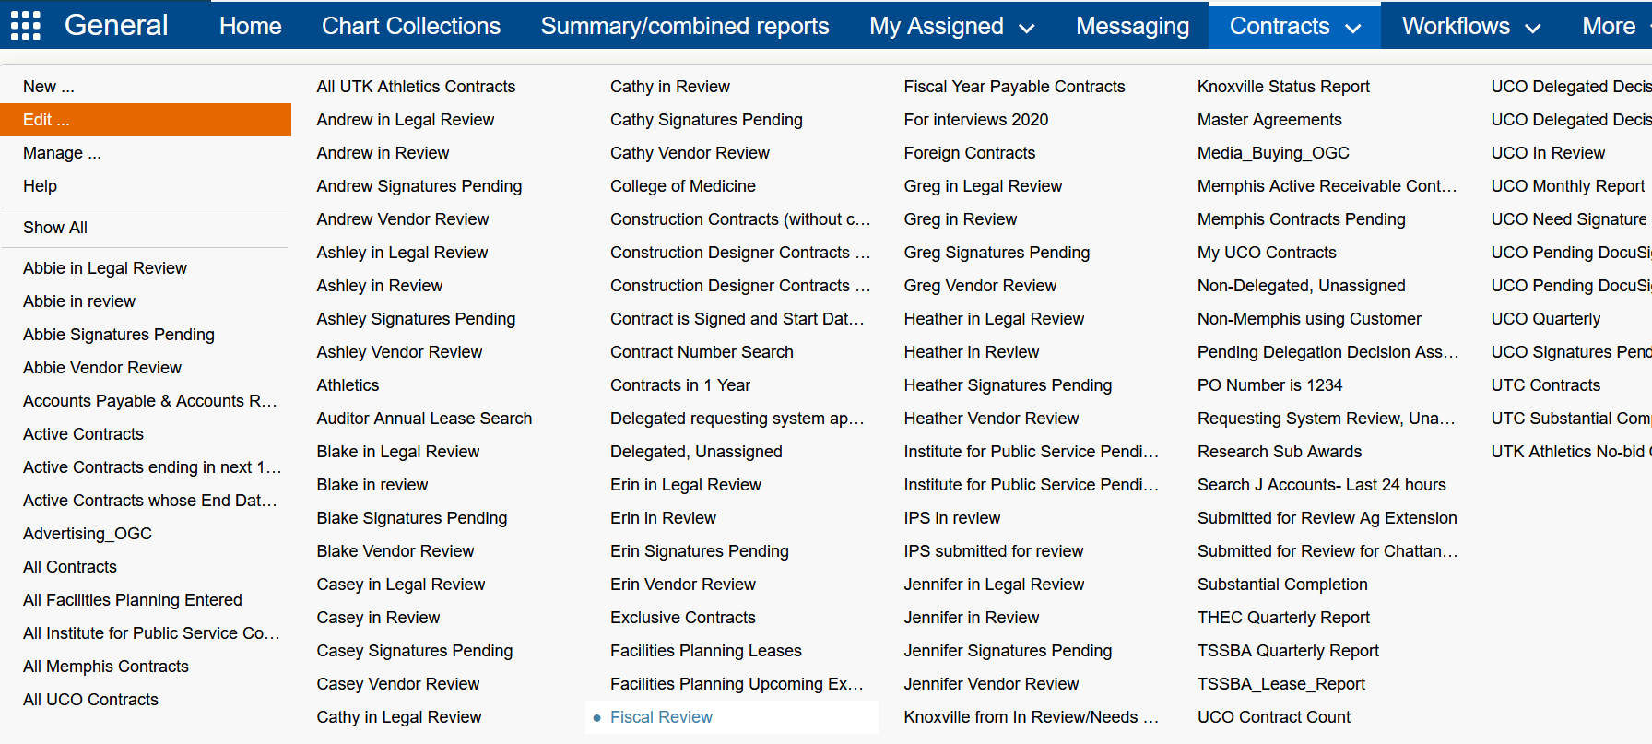
After you click edit:
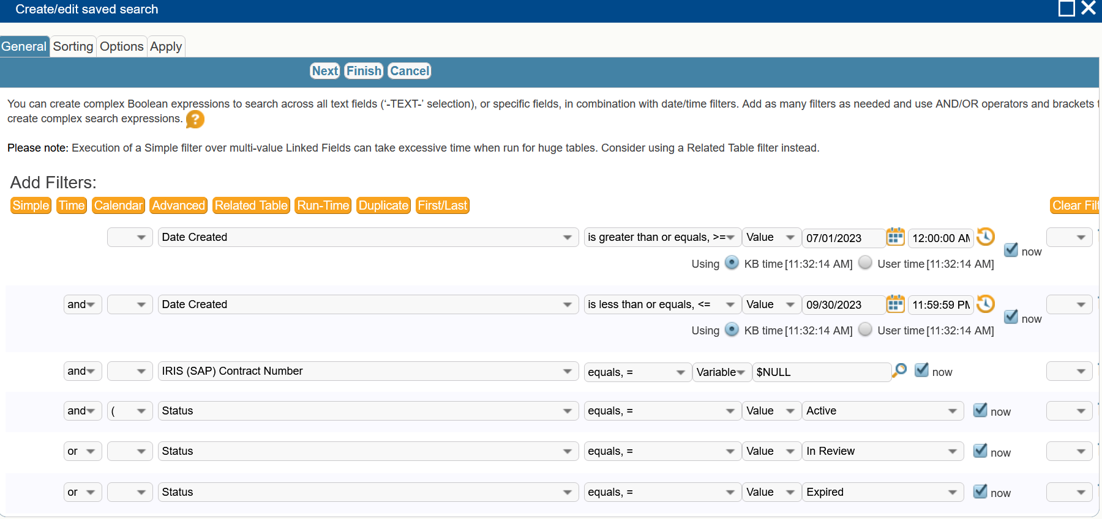

Views and Editing Views

