Sourcing Instructions: New User Interface

Moving a Requisition to the Sourcing System
Assigned requisitions can be accessed through your manage tab. At the bottom of the requisition you will click on the sourcing button.
NOTE: It is important to know that if you need to make any changes to the line items when you do a bid, or if you need to change the order type from standard to framework, you must do so BEFORE you push the req over to the sourcing system. Once you have pushed to sourcing, you can change the line items but those changes will not be reflected when you push it back to Purchase in order to create the PO.
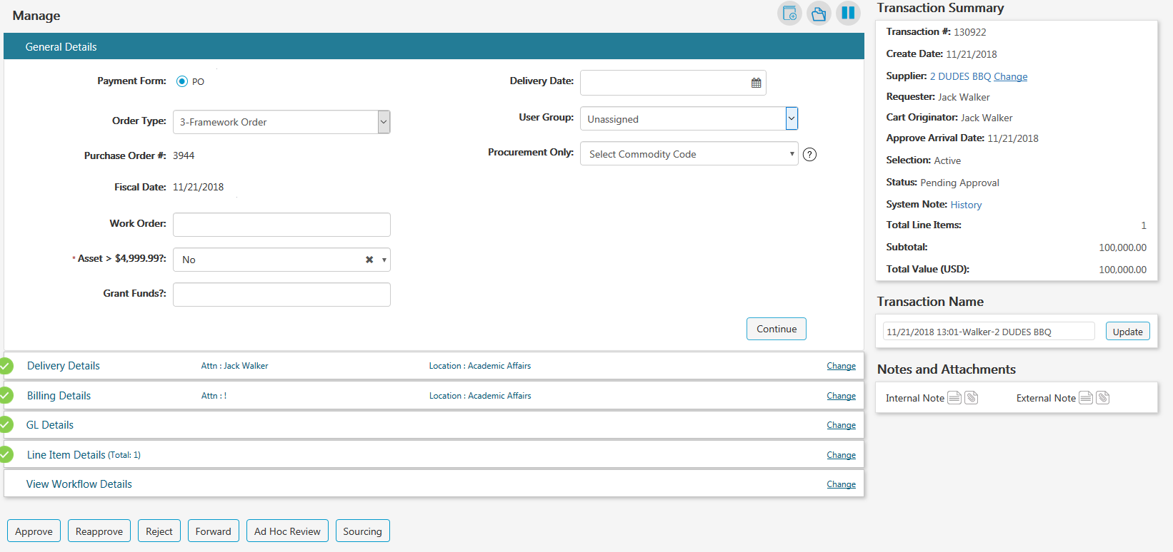

NOTE: All required fields will be noted with a red asterisk in the sourcing system

Template Selection
You have three choices: RFQ, RFP or RFQ-S. If you are in the System Office, you will need to select the template that starts with “System.”
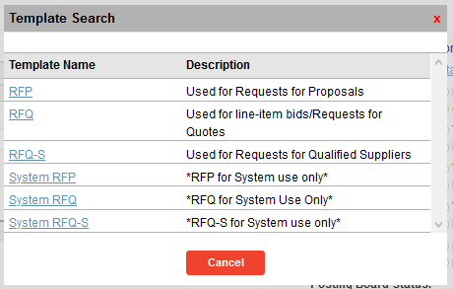

**System Office** – Please see Addendum 1 for system-specific instructions on the bid templates.

Accessing Sourcing System (top)

From the Menu, select Applications and click on ESM Sourcing
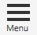
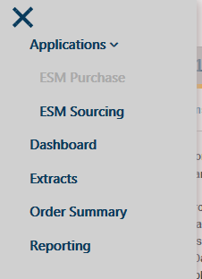

Search for your event, and then click on the event name.
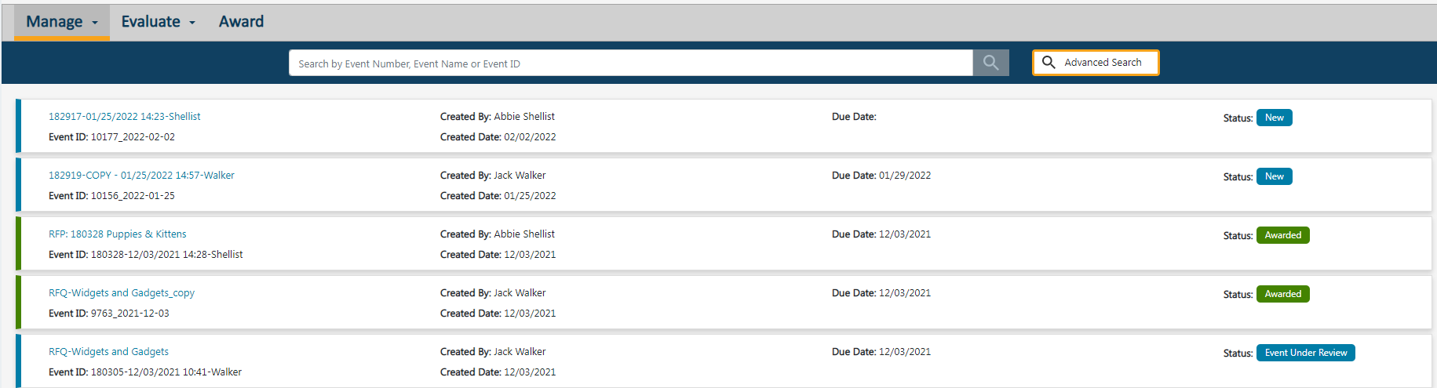

Event Header: General Details

Naming the Event
Drag or cut and paste the Event Name into the Event ID field and change the Event Name using the following format:
Type of Bid: Requisition Number, brief description of the sourcing event
Example: RFP: 1084531, Labrador Retriever Puppies
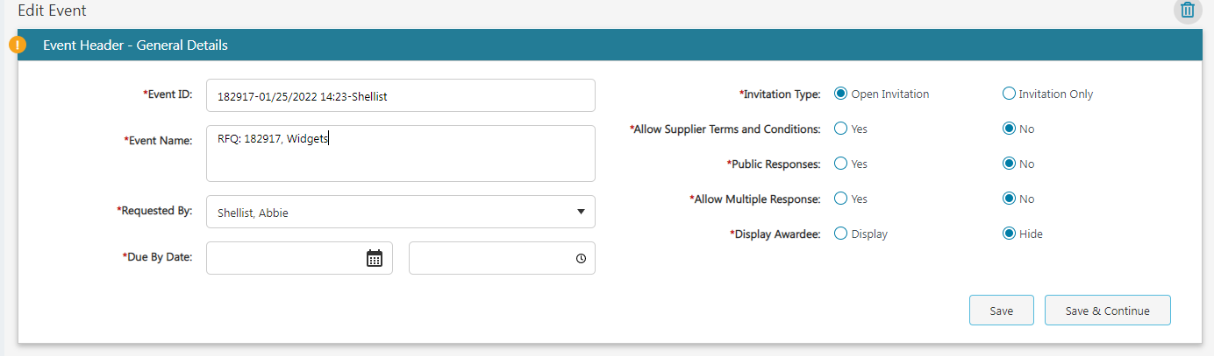

Requested By
This is a VERY IMPORTANT step
The requested by field is populated with the name of the person who created the requisition. You will need to replace this person’s name with your own name by entering it into the search field.
*If you do not change the requested by field to your name, the email notification that goes out to all potential bidders will have the name and email address of the department person who entered the requisition in it and not the buyer contact info.
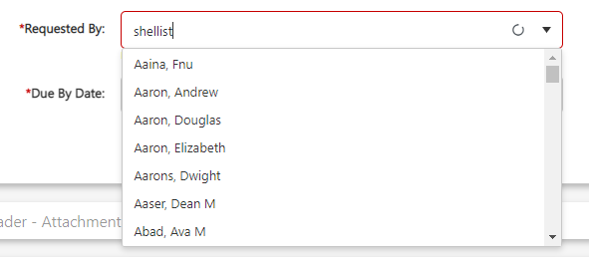

Mandatory Fields:
Fill out the following mandatory fields:
- Event ID
- Event Name
- Due by Date and time (you can use the drop down or type in the time)
- Invitation Type
- Allow Supplier Terms and Conditions: this defaults to no
- Public Responses: this defaults to no
- Allow Multiple Response: this defaults to no
- Display Awardee: make sure this is always set to “hide” otherwise all non-awarded suppliers would be able to view the awarded supplier

Click save and continue
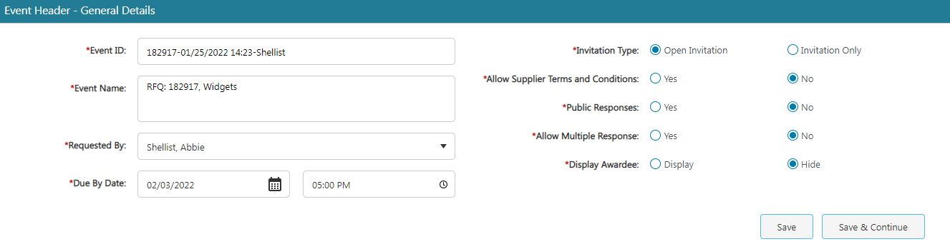

Event Header: Attachments, Terms and Conditions

In this section you can view the terms and conditions if those have been imported and you can add event specific terms and conditions*, assigned commodities, and internal notes.
*Please do not use event specific terms and conditions. Any event-specific terms should be included in your RFP or RFQ-S template and any event-specific terms for an RFQ should be included in the Purpose, Scope and Background.

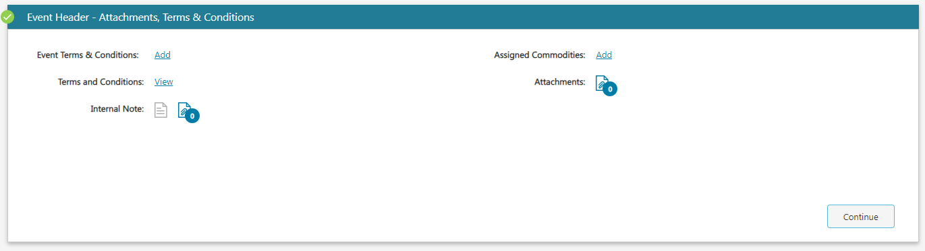
When you click on assigned commodities, you can enter NIGP codes or keywords. Click “update” once you’ve made your selections and then “continue” to the next tab.
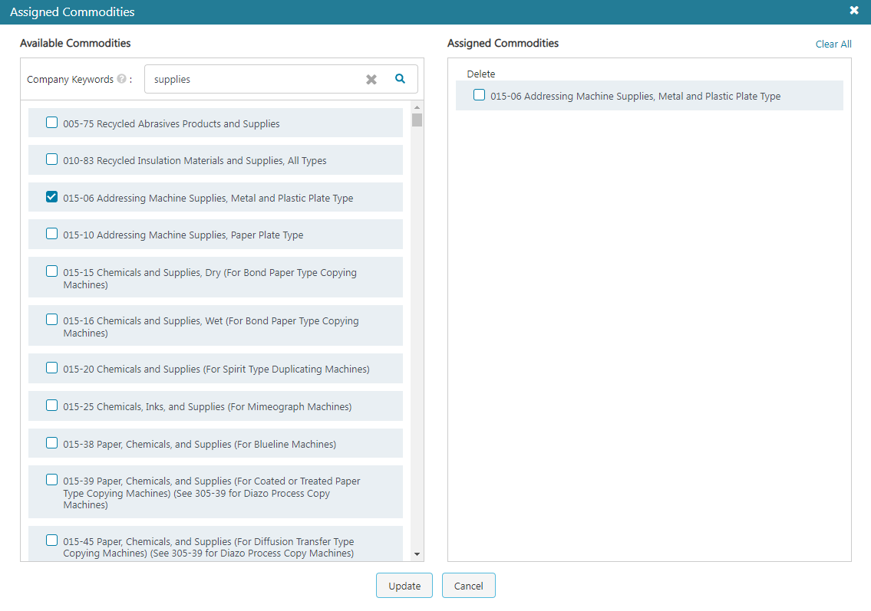

Event Header: Dates

Sealed Event: You must always choose that the event is a sealed event. Without selecting sealed event, the responses would be open for viewing at any time.
Sealed Until Date: This date should match your due by date and time
Effective Start and End Dates: These dates can be left blank
Q&A Cutoff Date & Time: The ESM Sourcing System contains a section called Q&A. We do not want to use this functionality since the solicitation documents advise proposers to submit questions via email directly to the solicitation coordinator.
Right before you are ready to post your bid, please set the Q&A cutoff date and time to the minute or two after you will be posting the bid. This will ensure that proposers will not be able to use the Q&A functionality.
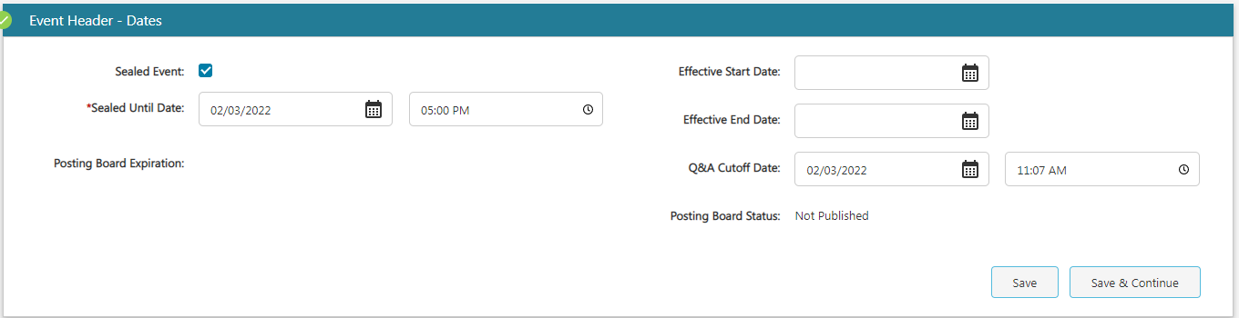

Event Sections
The RFQ, RFP and RFQ-S templates will load into the event section box (depending on which solicitation type you choose). In addition, the DBE introduction letter and business classification form load into each bid.

Templates
When you select the RFP or RFQ-S templates, Event Section 1 RFP, Section 1 RFQS, or Section 1 RFQ will include directions for submission.
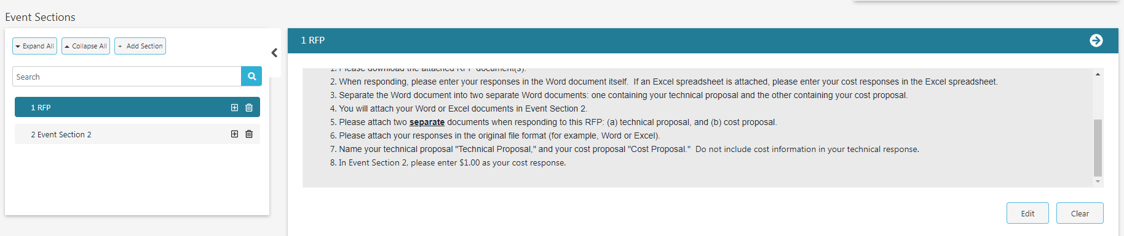

The section named with the Event ID is the line-item detail. For an RFP or RFQ-S, rename that section “Event Section 2” and click update. This corresponds with the directions to proposers.

Allow Attachments (top)
Be sure to click on the boxes for Supplier Attachments. This is what will allow the supplier to attach their RFP or RFQ-s responses. If you do not check these boxes, the suppliers cannot attach anything.
You can also add attachments here.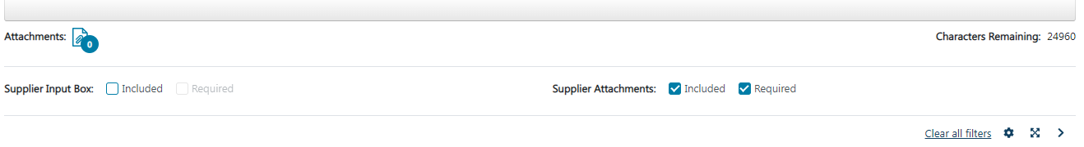
If you select “included” for supplier input box this will allow the supplier to enter notes if they want to.

Adding Event Sections (top)

To add an additional section, just click on the “add section” button and choose the type of section to add from the “select section” drop-down menu.
To add a line item it is best to do so in the grid that shows the line items that transferred over from the requisition. Please note that any line items or changes you make to the line items will not convert over to the PO when you award your sourcing event. It is preferable to add line items or make changes to the line items before you convert the requisition to sourcing.
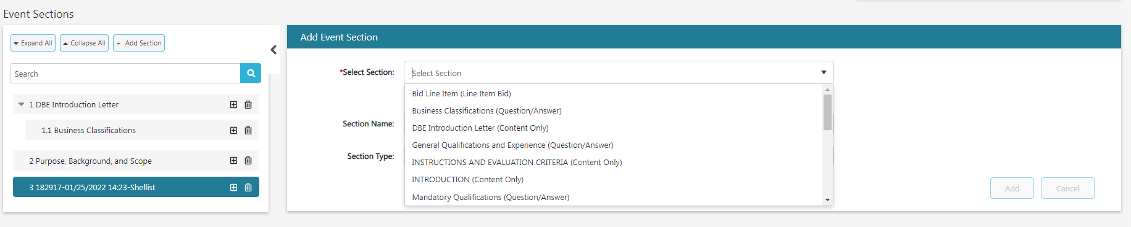

Line Item
Click on the event ID to get the line items
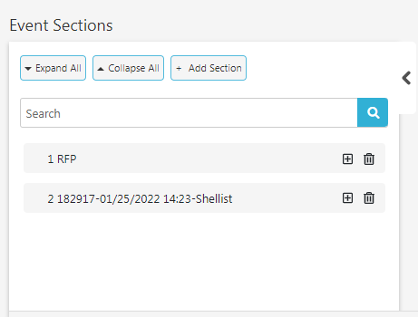
Click on the settings icon and click on “edit column configuration.”
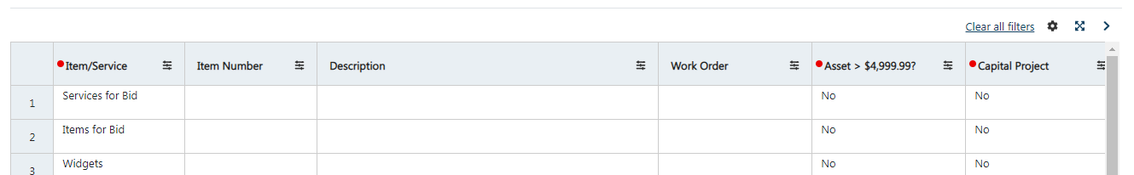

For column labels Aux 1 and Aux 2, click on hidden for both supplier & entity then click Update.

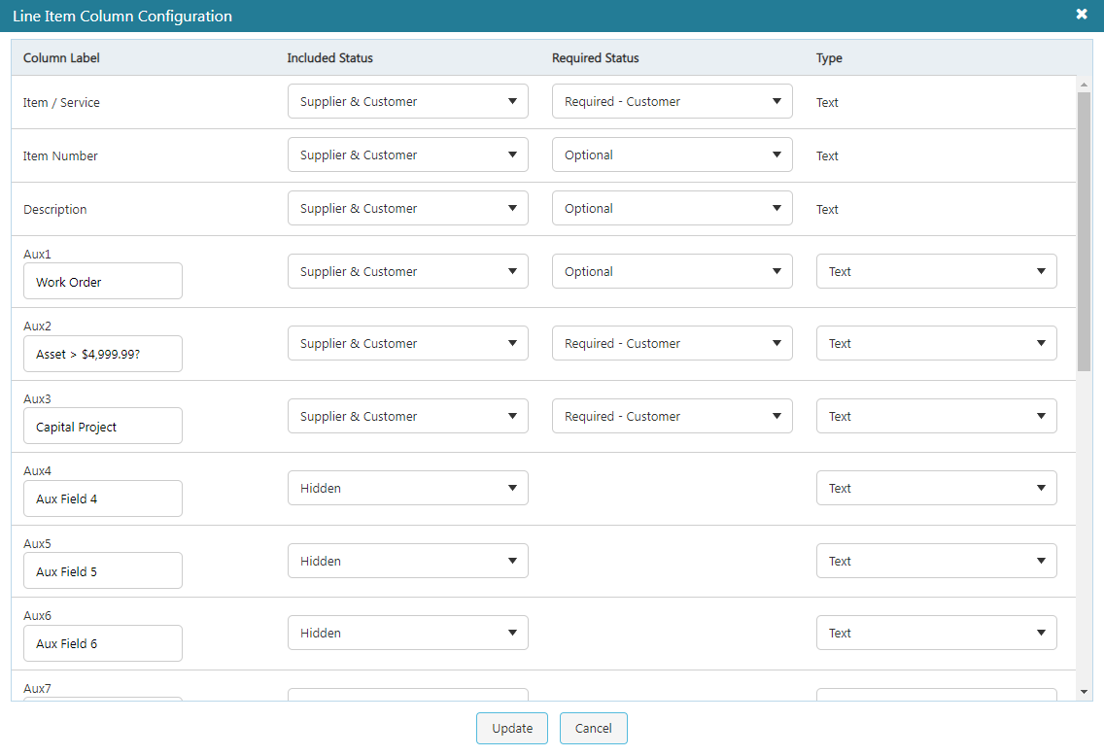

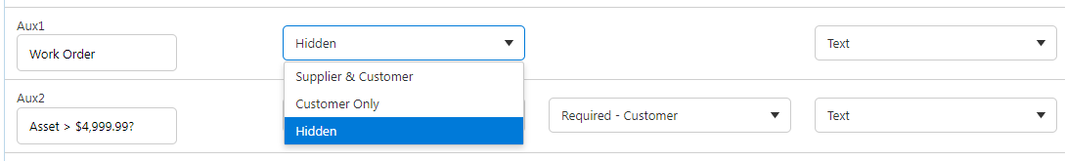
It is very important to make the unit bid price required. If you set this to “required- supplier,” then the supplier cannot submit their bid without entering an amount in this field.
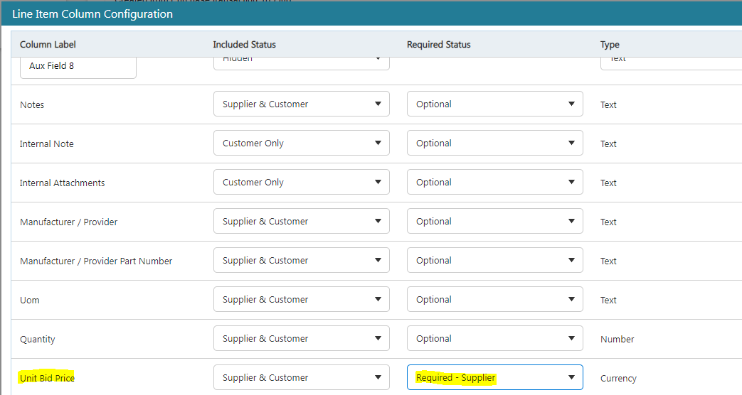
Then click update.

Changing the Order of Sections
You can rearrange the order of the columns by clicking on the settings icon and then “set column order” and drag the column headers into the order you want them. The click update.

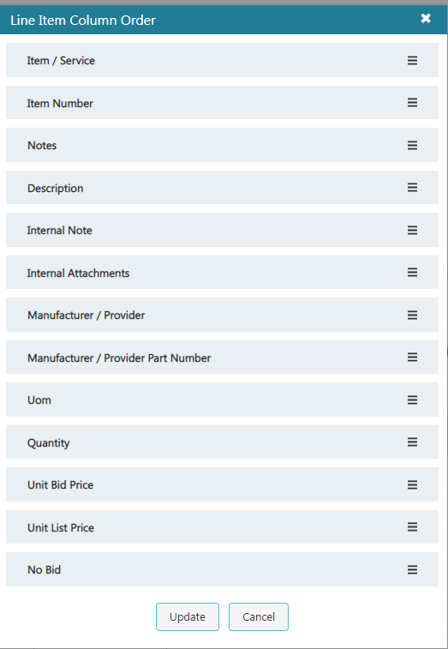

*Columns with a blue circle in the header are only visible to the buyer and not to the suppliers.
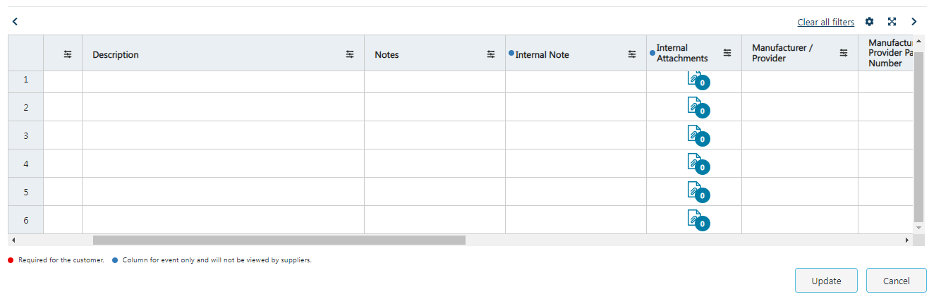

Importing a Spreadsheet (top)

**Note, currently the ESM system will not convert altered line items in a bid to transfer over into the purchase order. You must change the line items in the requisitions BEFORE pushing that requisition to the sourcing system.
If you have a spreadsheet of line items, you can copy and paste them into the line-item section.
First copy the spreadsheet you want to import. In the first cell of the line-item section, use control v to paste the copied spreadsheet.

Internal Attachments at Line-Item Level
You can attach a document at the line-item by clicking on the document icon. These attachments are only visible to the buyer.
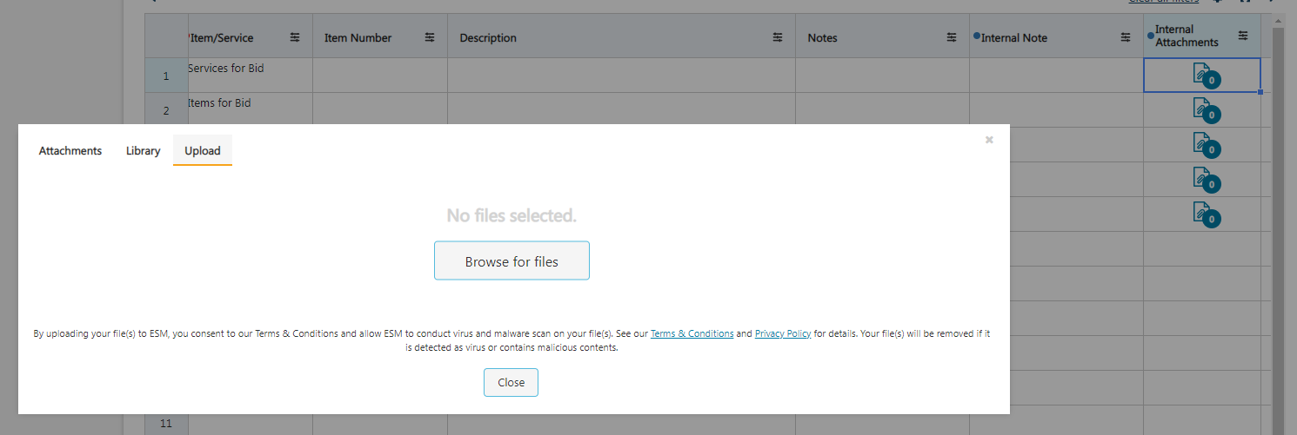

Attachments Visible to Bidders
Any attachments you enter here are visible to the bidders.
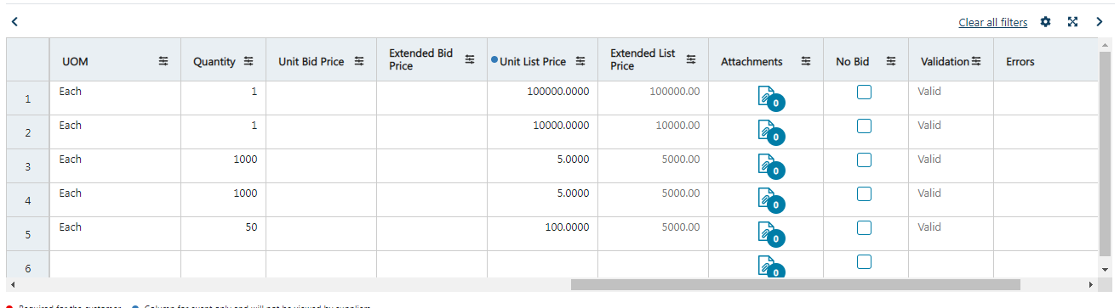

Saving a Copy of Your Bid for the Bid File (top)
You can “print” your bid prior to the bid closing to make sure you have a copy of the bid to attach in IRIS as part of your bid file. Click on the printer icon and a message will pop up that your browser will open once the files have downloaded.
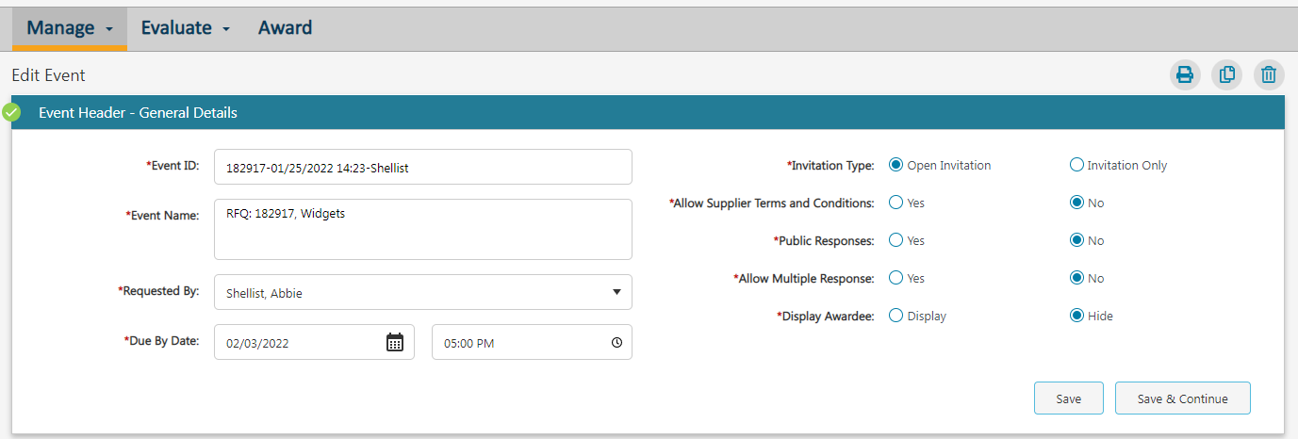

Other menu options include copying the sourcing event and deleting it.

Publishing Your Bid
When you click “publish,” the bid will be published to the supplier database.
You must then click on “publish to the posting board.”
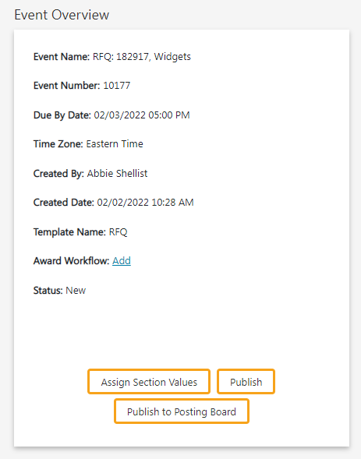
*do not use “assign section values.”

Once your bid has been published and posted on the posting board, you will have the option to remove it from the posting board or create an addendum.
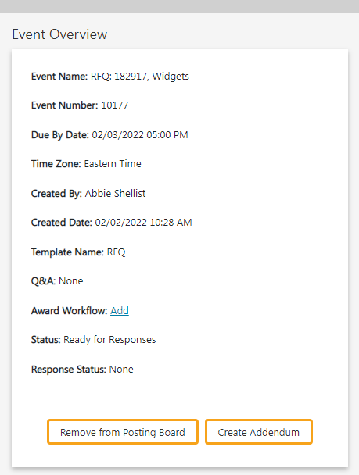

Addendum
If you need to make an addendum, go to the Sourcing System and select your sourcing event. Click on “create addendum.”
Make the changes to your event (for example, change the due by date).
It is a best practice to create a document and number it Addendum #1, #2, etc. You can upload the document before publishing the addendum to the Posting Board.
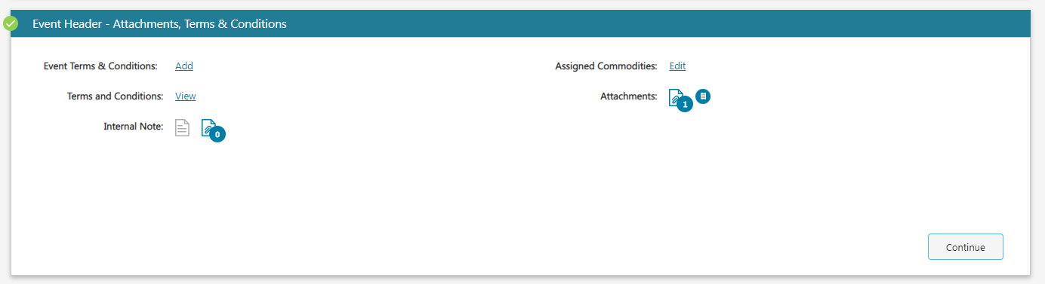

Now you have the option to publish your addendum or delete it.
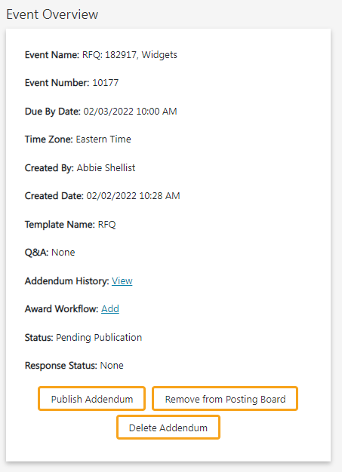
You will get a window that pops up to review changes you have made and you can enter information in the addendum note field. Once you’ve reviewed your changes, you can publish.
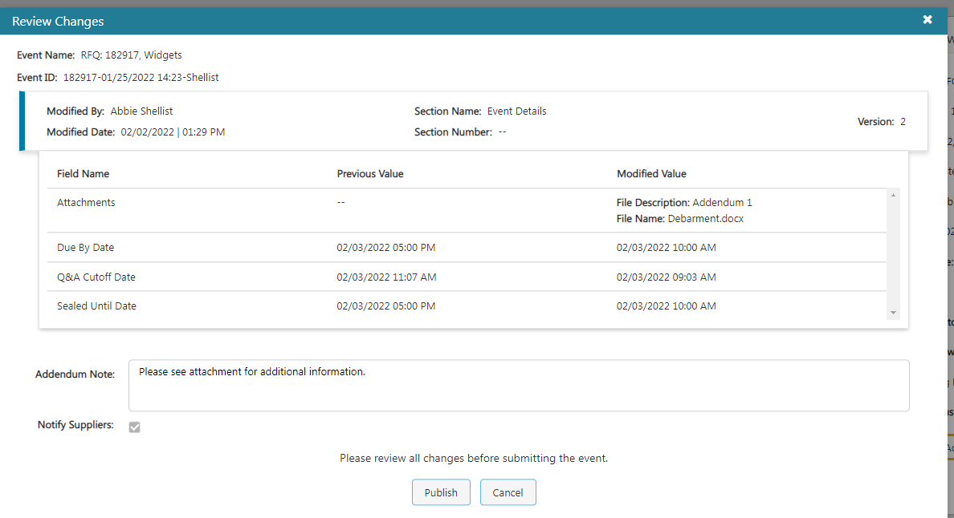

Addendum History
In the event overview section of your bid, you can check the addendum history by clicking “view.”
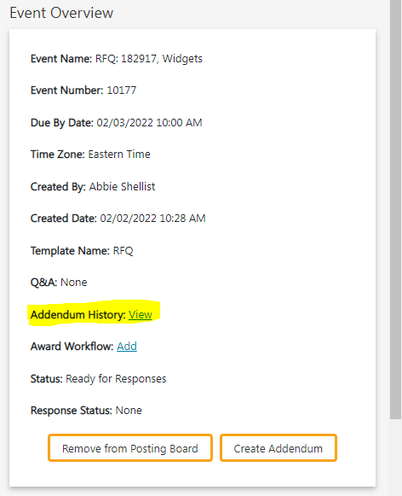
This will give you a log of all the changes made to the bid through addenda. Because this screen isn’t printable, it is best practice to issue your addenda as Word documents so you will have a record for your bid file.
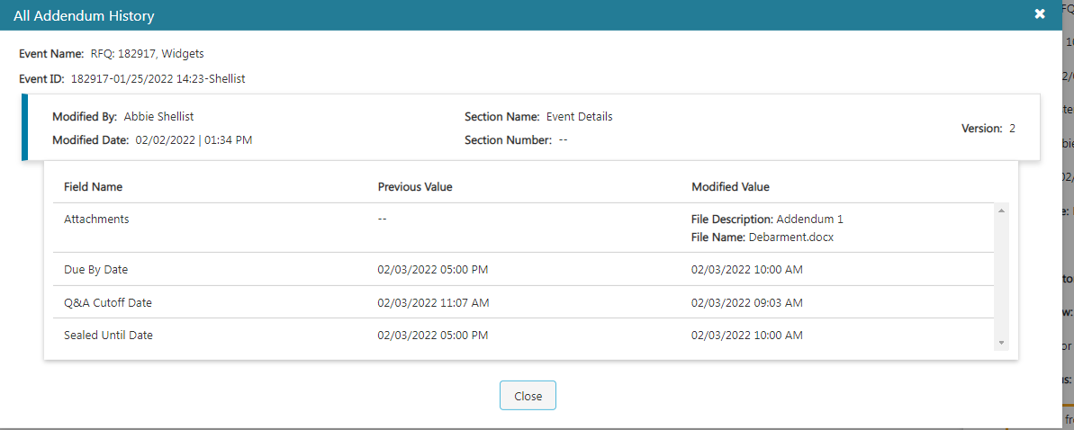

Checking Response Status (top)
You can click on “response status” to see how many people have viewed and responded to the bid. Please note that walk-in bids will not show in this view.
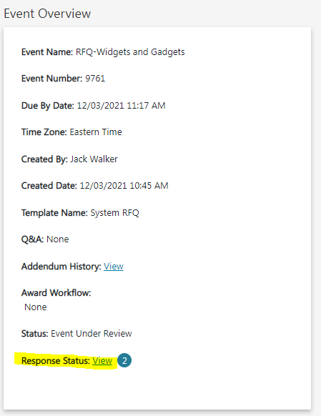

Reviewing Bid Responses
Click on the Award tab and choose the event you want to open/unseal. When you click on yes, the bid will unseal so you can review the responses.
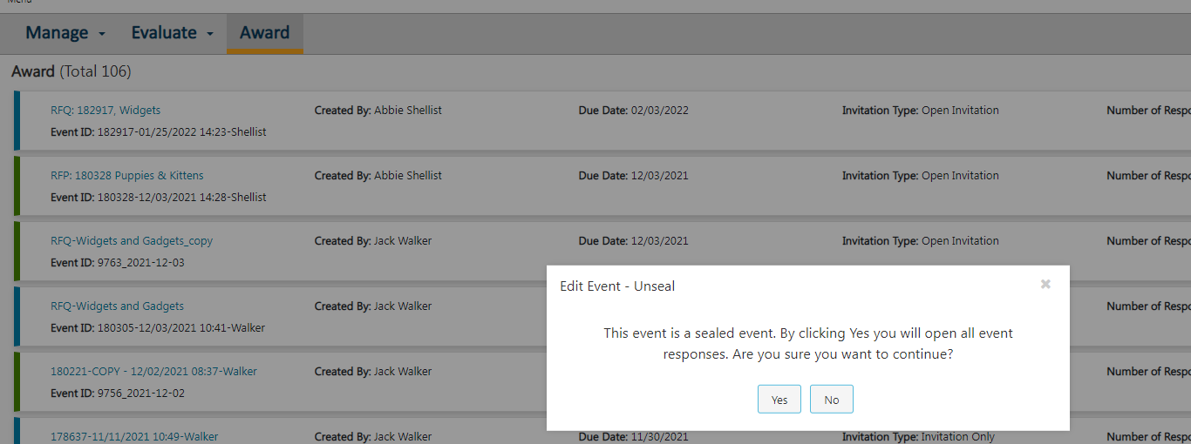

Click on the line item in the left pane.
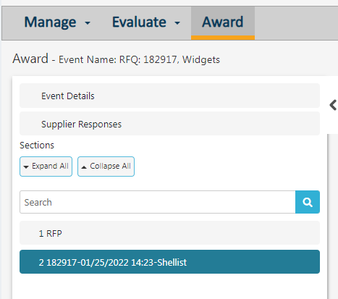
Then click on the bid price total link.
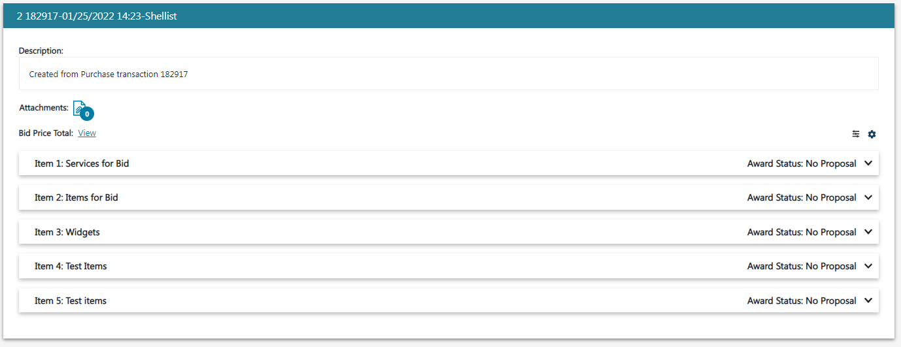
The total bid price for each supplier who bid will show.
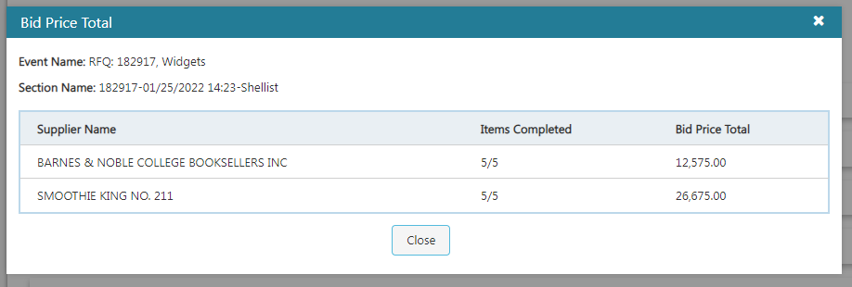
For multiple line items, you can look at a price comparison by line item by clicking on each item. You will propose an award to each line item here.
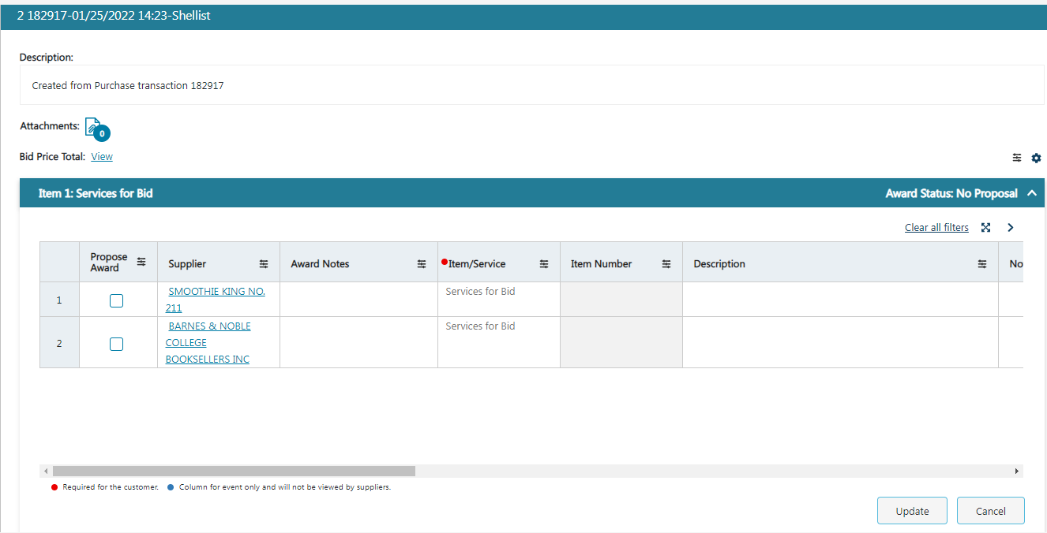

You can award to none by clicking on “award no responses.”
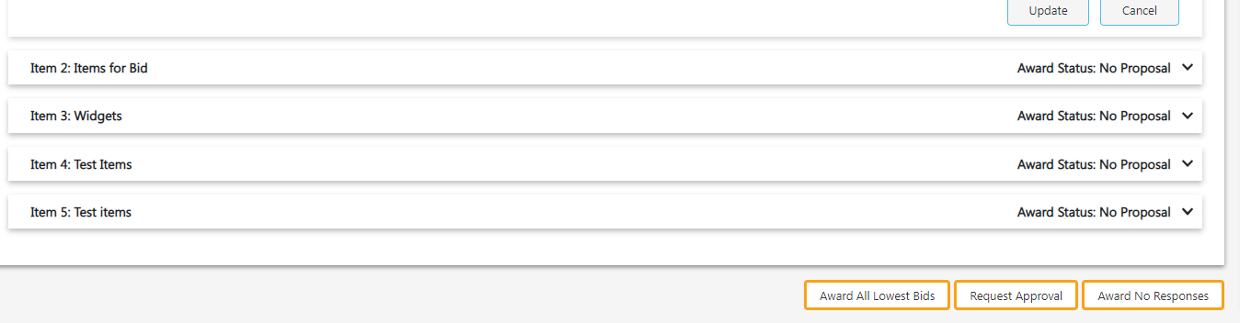
*We advise that you do not “award to all lowest bids.

***PLEASE NOTE: THE WALK-IN BID FUNCTION DOES NOT WORK. ESM IS WORKING OUT A BUG IN THE SYSTEM AND YOU WILL BE ALERTED WHEN IT IS FUNCTIONAL***

Walk-In Bid
You can create a walk-in bid before or after the sourcing event has closed. In the upper right corner click on the walk-in bid icon.
Enter a supplier into the search bar and select the supplier you want to enter the bid for.
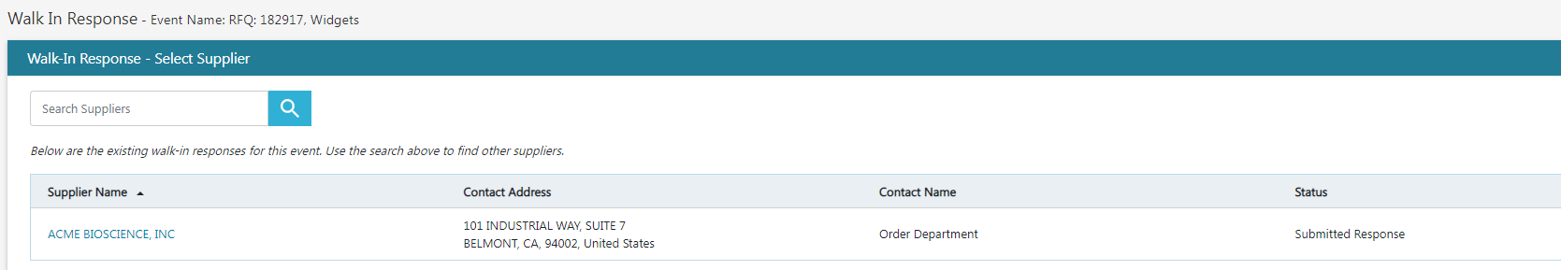
You will then enter the pricing information for each line item and attach any required documents. Then submit the bid response.
After entering a walk-in bid you can check the bid price total and see the walk-in.
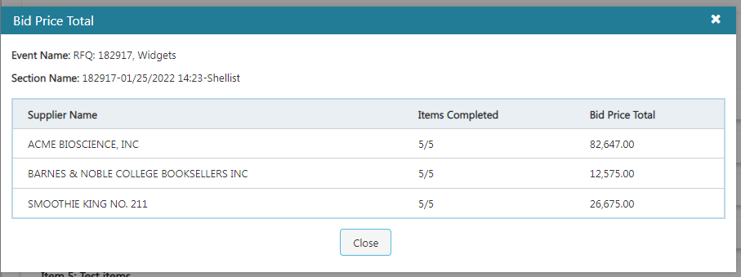

You can click on the full screen icon to enlarge the view of each line item.
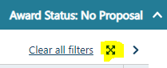

Supplier Response: Printing Results
If you click the print icon, a zip file will download the bid results in an Excel spreadsheet.
You will need to click on the Excel tab that is named “1” to see the pricing.
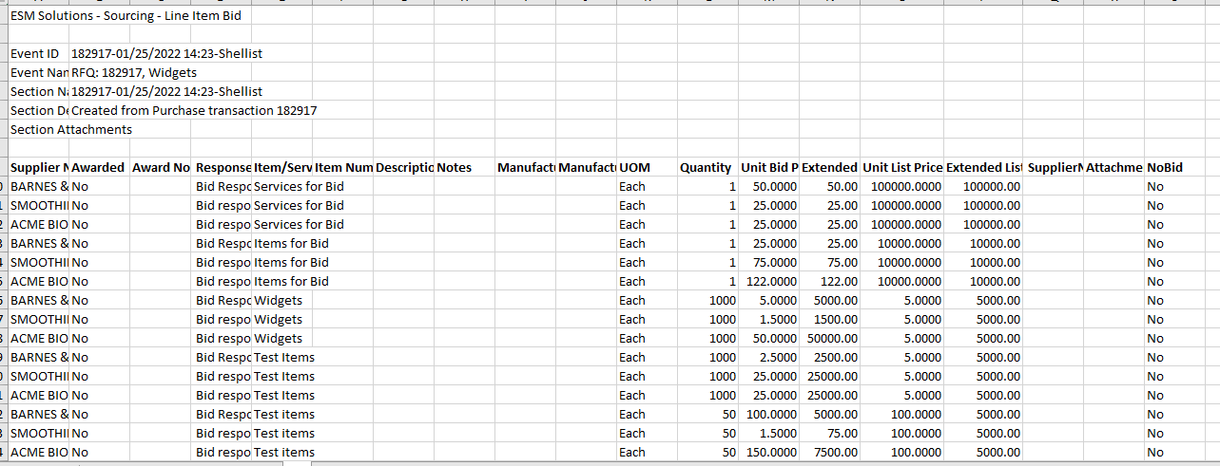

Bid Tab Report
To get your bid tab into a more readable comparison (especially when you have multiple line items being bid) you will need to run a report.
- From the Market Place menu, select “Reporting.”
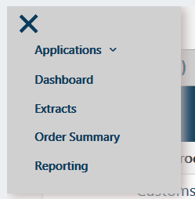
- Go to the Sourcing folder and select Supplier Tabulation Report and export it to Excel.
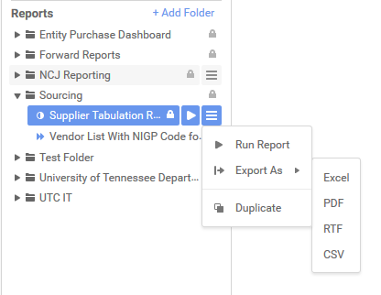
- In the report filter, enter the event number and click OK.
- Your report will generate and look like this:
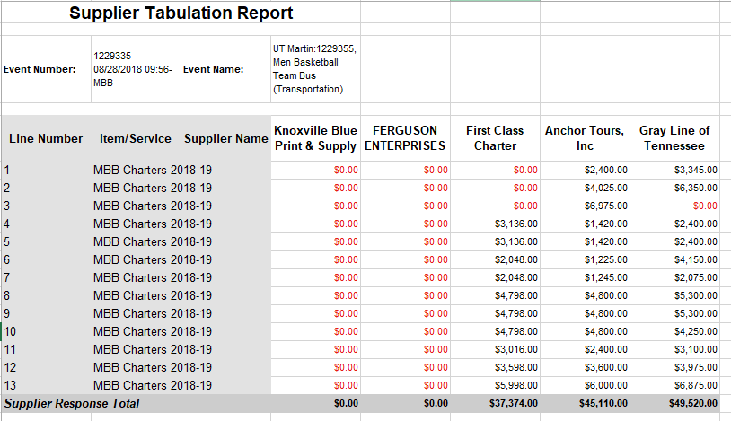

Remove Bid from Posting Board
Once your bid has closed, please remove it from the posting board.
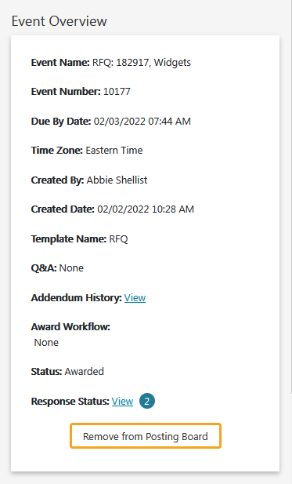

Linking the Vendor
Before you can push the award to the purchase system, you must make sure your vendor is “linked” to a vendor that has a vendor number in SAP. If you make a mistake and link to the wrong vendor, you can change the link to the correct vendor but only prior to awarding the bid.
Click on “Supplier Responses.” If the supplier you are awarding to has a broken link below their name, you will need to link them to a vendor.
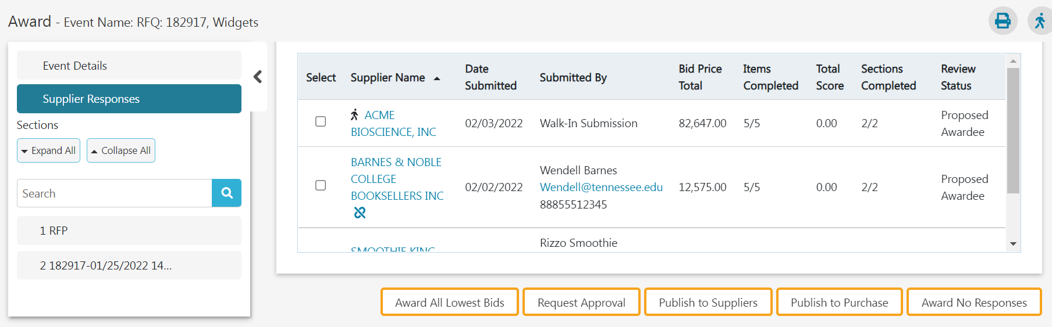
Enter the name of the supplier in the search bar.
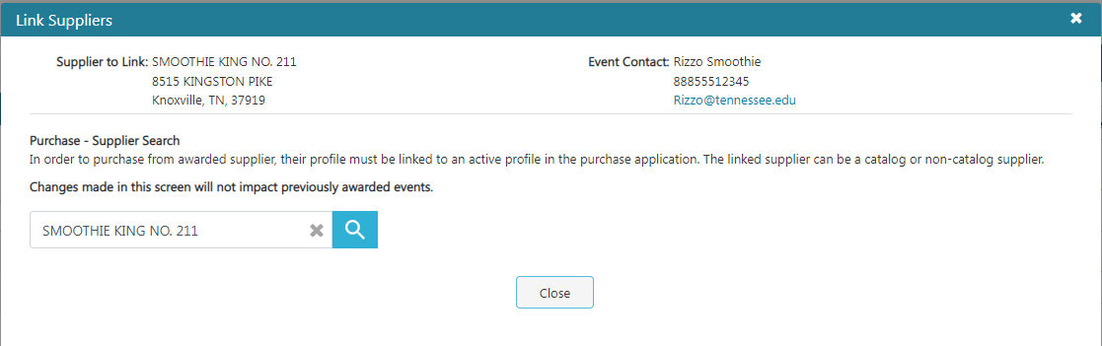

When you see the correct vendor, click on the link next to it to link it to the bidder.

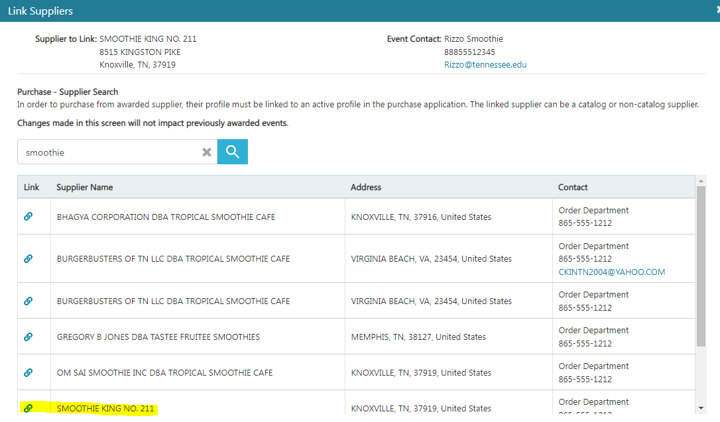

Making the Award
You will need to award by line item by placing a check mark next to the vendor who is awarded that line item. Once you have made award selections for all line-items, you will click on “publish to purchase.”
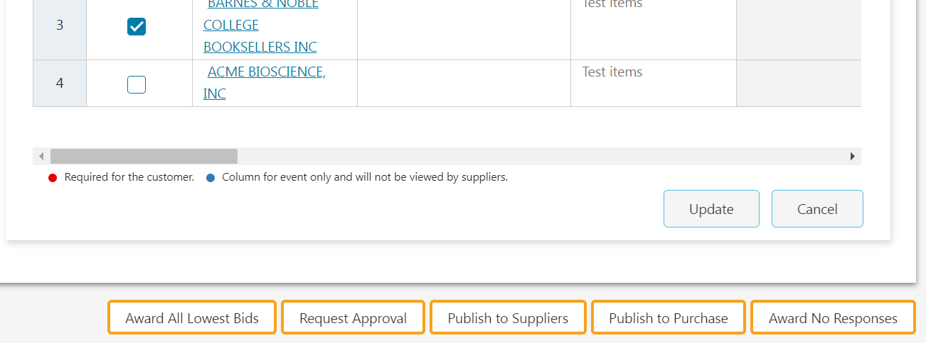

If you get the following message after you click on publish to purchase, you will need to go in and link the bidder to a vendor that is in ESM.
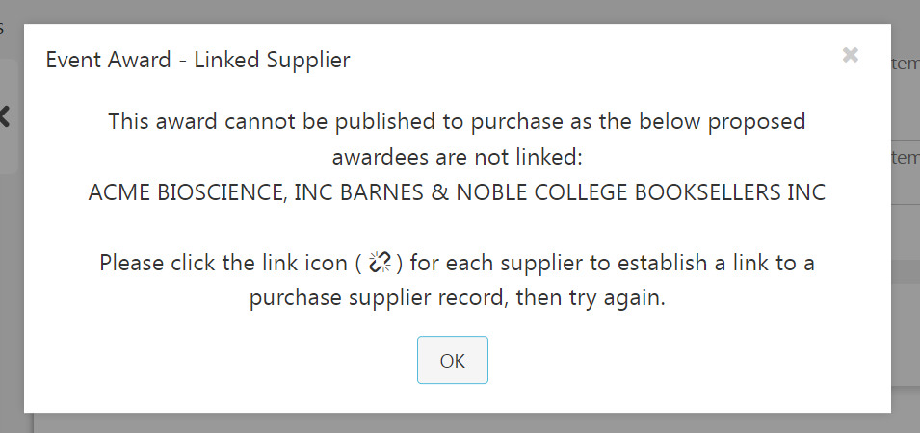

Making an Award
When you are ready to make an award you will need to first publish to purchase which sends the information over to the purchase order system.
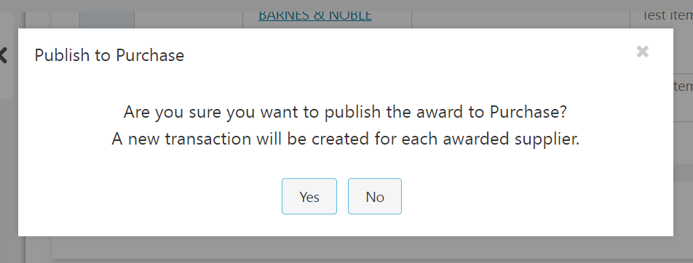
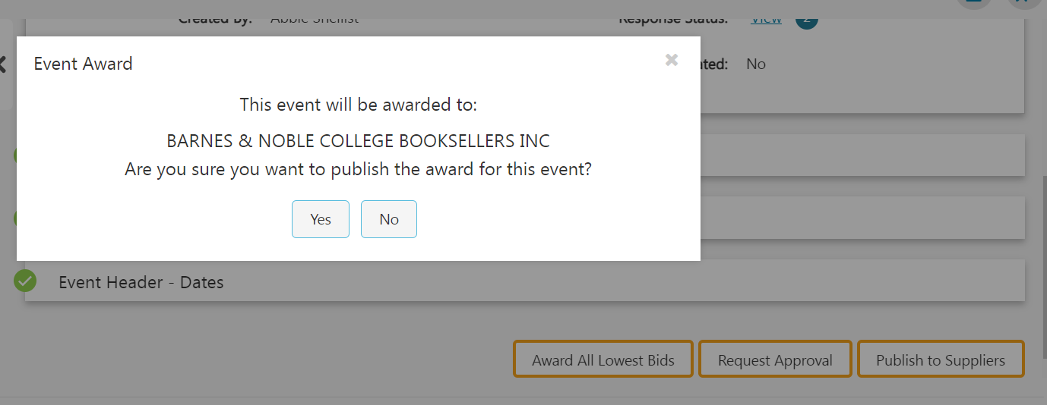
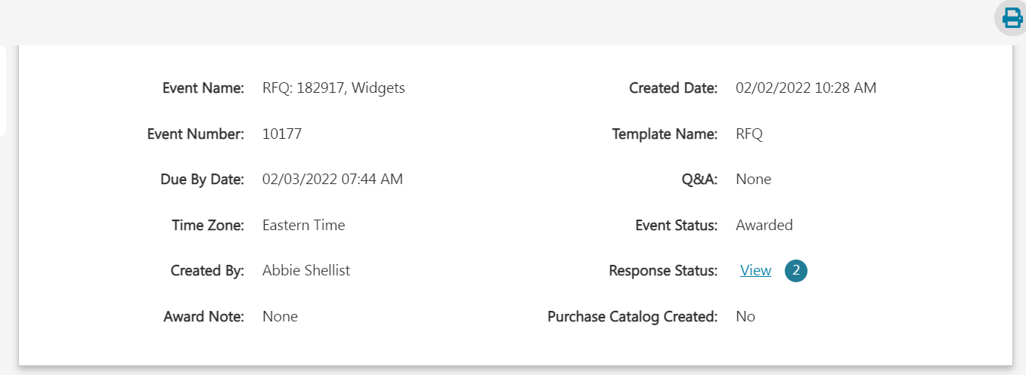

Retracting an Award
If you’ve made an error and need to retract the award you can select “retract award.” You have the option to send an email notification or not. You may publish the award to a different supplier after the retraction is complete.
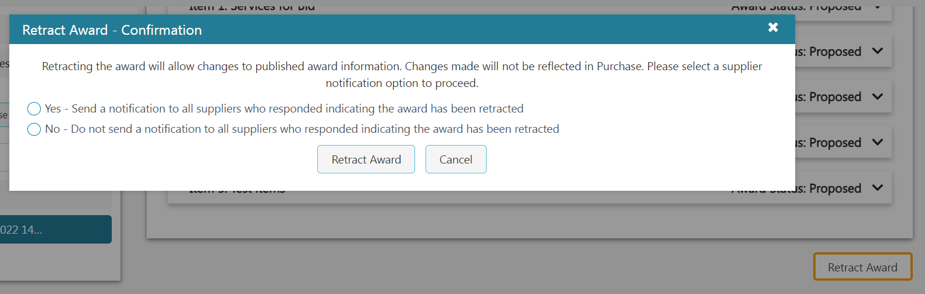

Award to No Responses
If you will not be making an award, choose “Award to No Responses.” You can enter a note that will be emailed to all bidders.

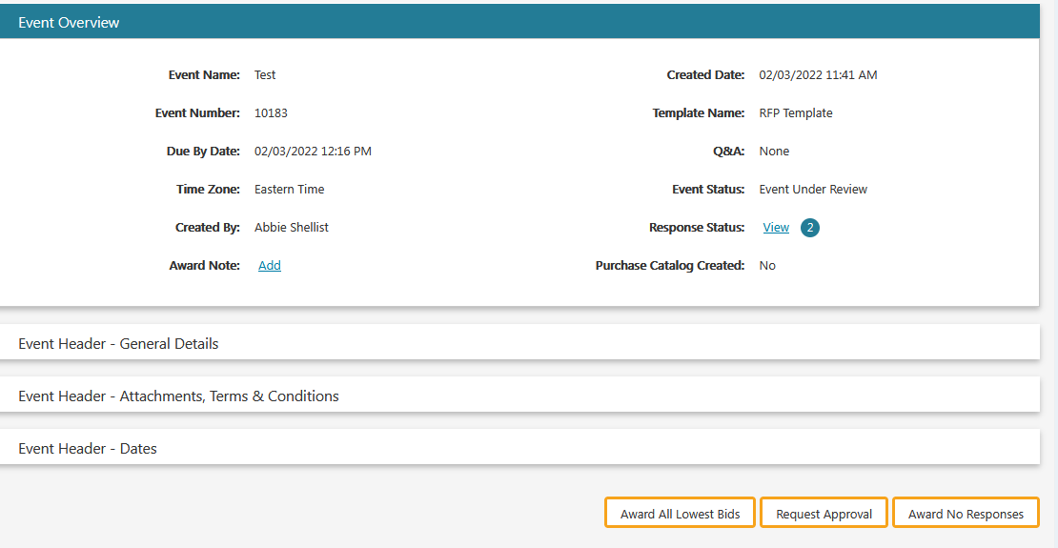
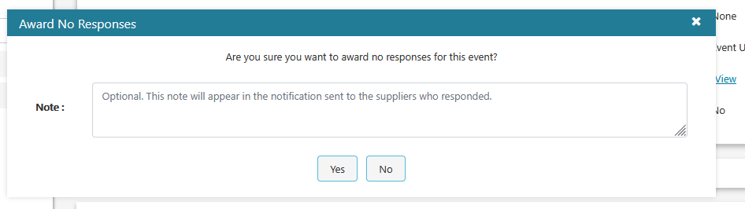
When you award to none, the requisition associated with that bid goes back to the purchase system (your manage tab). You can edit the requisition in purchase.

Publish to Suppliers
After you have clicked on “publish to purchase,” you will now need to publish to suppliers
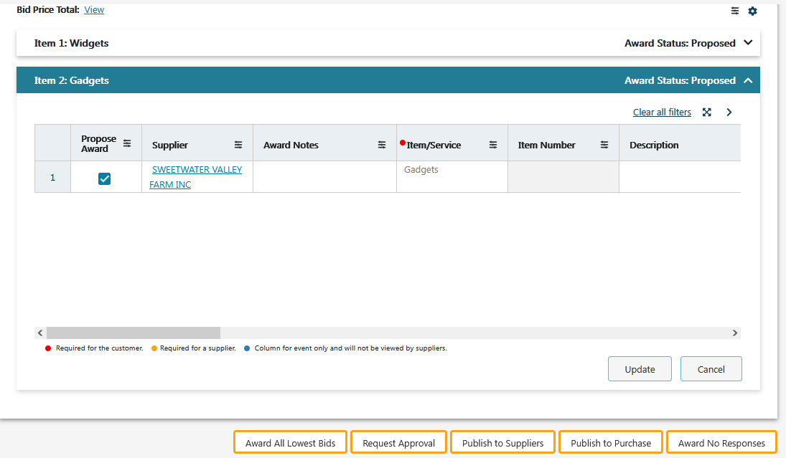
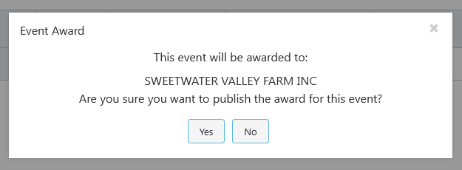

Remove from Posting Board
Once your bid has closed, you will need to remove it from the posting board.
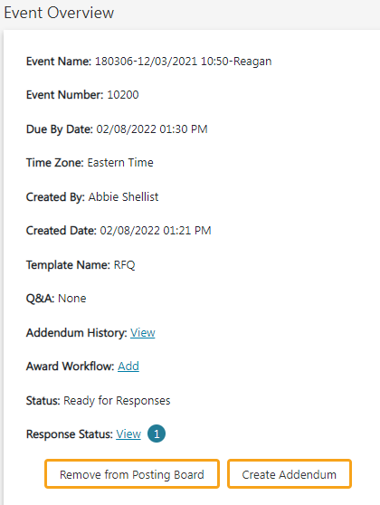

Addendum 1

System Office Instructions

When you select “System RFP, RFQ, or RFQ-S” templates, the field with terms and conditions will no longer be populated with the Purchasing Terms & Conditions. The terms and conditions are now included in all bid templates. Instead, it will say the following:
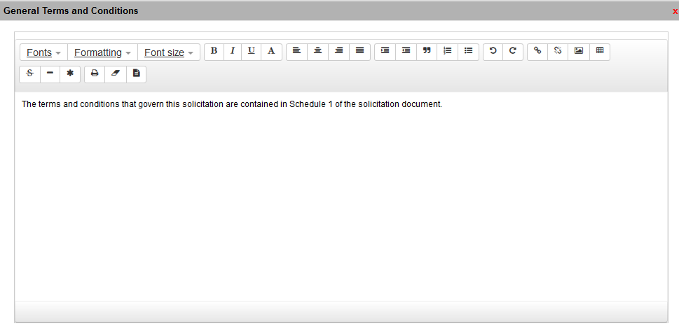
You will attach your bid template, and any other relevant attachments into the event header section.
For the RFP and RFQ-S templates, Event Section 1 will be populated with instructions.
In Event Section 2 (line item) you will need to put some instructions in the description field otherwise the field will default to “created from purchase transaction 123456.” Make sure you enable suppliers to be able to make attachments.
For RFQs it is very important to put instructions into the line-item section so bidders will understand that there is a Word document attached at the header level with instructions and specifications.
